**Report of Cross Country Skiing in the Jemez Mountains on Ladera Trail**

**on Los Griegos Mountain on Saturday, February 1, 2025**

Sam Beard

On Saturday, February 1, Michael Arndt and Sam Beard attempted to ski the lower part of Ladera Trail on Los Griegos Mountain in the Jemez Mountains. After finding about a dozen trees across this trail between the trailhead and Lower Road, we decided to follow a “short cut” back to the parking lot on NM-4. In the shaded parts of the trail we found about 3 inches of loose snow over crust. In the sunny parts, the snow was either very thin or completed melted.

Past the intersection with Lower Road about one mile from the trailhead, the route went into more groves of trees where we thought that we would have additional trees down. We walked down Lower Road that was too steep to ski down until we came to Black Dog Canyon, named many years ago after Noreen and Roger Breeding’s black dog Scamp who always went with them. We skied down this canyon through fairly open forest to the highway where we hiked about a quarter-mile back to the parking lot. As we finished lunch. David Torney, a Ski Club member who lives near Los Griegos, stopped, and we chatted with him about the poor snow conditions.

After lunch we drove NM -4 to the east past Corral Canyon Trailhead and the Missing Trailhead where there was little snow. Little or snow was visible in the tall brown grass in Valle Grande where we turned around. More snow was visible in the Coyote Call meadows on the south side of the highway, but it was primarily near the trees and not near the highway. As we passed Redondo Campground, we could see snow covering the shaded CG roads, but the snow had melted in areas exposed to the sun.

We certainly need more snow in the Jemez Mountains.

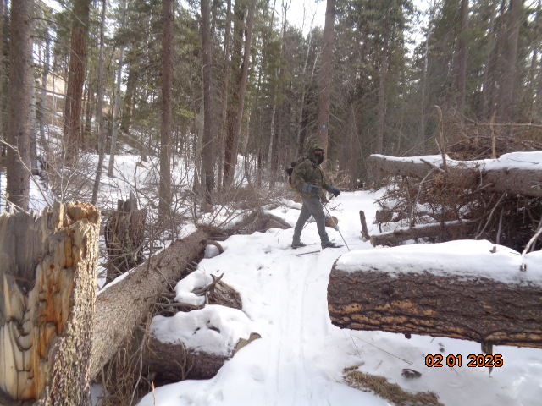

Michael standing in the major log “train wreck” that occurred about three years ago on Ladera Trail near the parking lot.

Soon after these trees fell, we cut about a half-dozen logs to make a skiable path. All photos by Sam Beard

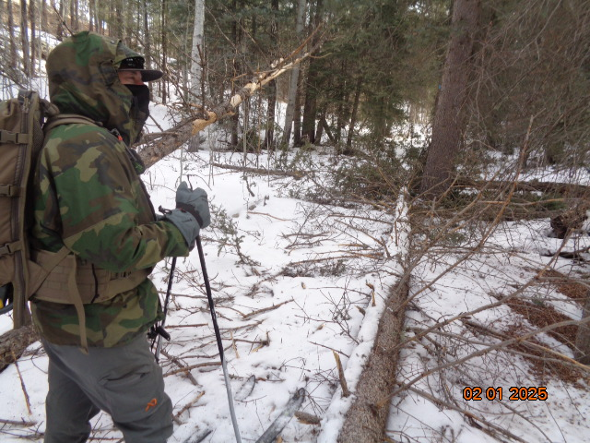

The first log that we found across the trail near the trailhead. Fortunately, earlier skiers had broken several

branches so that we could step over the log.

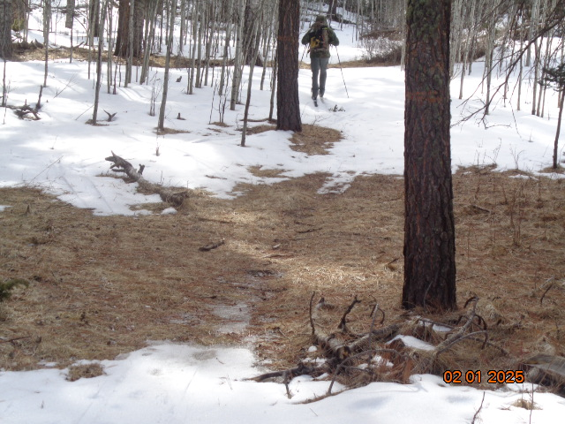

Typical bare place on the trail that was exposed to the sun.

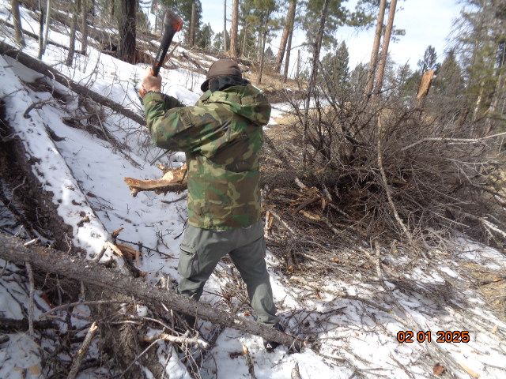

The end of this 6-inch diameter tree was blocking the trail. Michael is using his axe to cut off about 10 inches of the trunk.

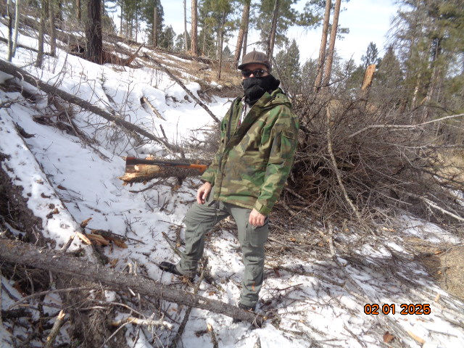

We went around the end of this tree after Michael had completed his cut. This log was located about one-half mile

below the intersection with Lower Road. After finding more logs across Ladera Trail,

we decided to terminate our tour and return to near the highway on Lower Road.