Report of Trail Maintenance on the East Fork Trail and East Loop Trail in the Jemez Mountains
on Friday, October 17, 2025

Sam Beard and Michael Arndt

On Friday, Oct. 17, Sam and Michael removed all 20 fallen trees across the connector trail between the Las Conchas Burn Trail and the East Fork Ridge Trail, the East Loop Trail, and part of East Fork Ridge Trail leading to the west to the upper end of the Burn Trail. We found ponderosa pine, Douglas fir, and spruce trees across the trails. The diameter of the largest log cut was 20 inches. It was a beautiful day, and we saw a bull elk with very large antlers.

Photos of some of the trees removed from the trails are presented below.

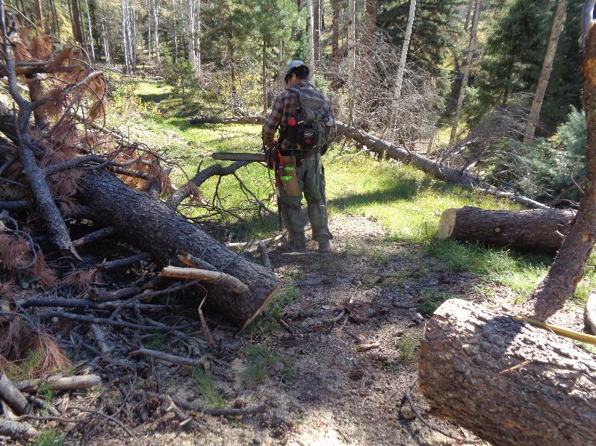
Michael cut this log on the connector trail between the Las Conchas Burn Trail and the East Fork
Ridge Trail. All photos by Sam Beard
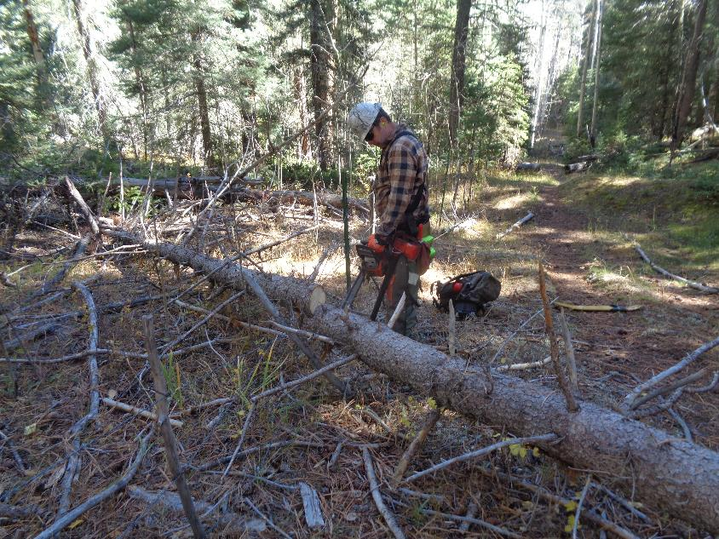
Michael cutting a small log on connector trail.
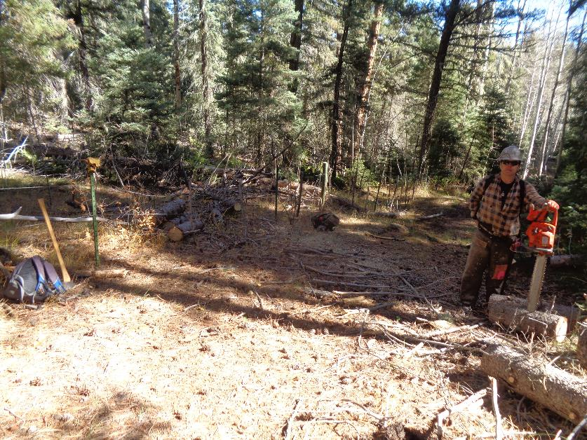
Michael removed all of this log where the trail follows an old logging road.

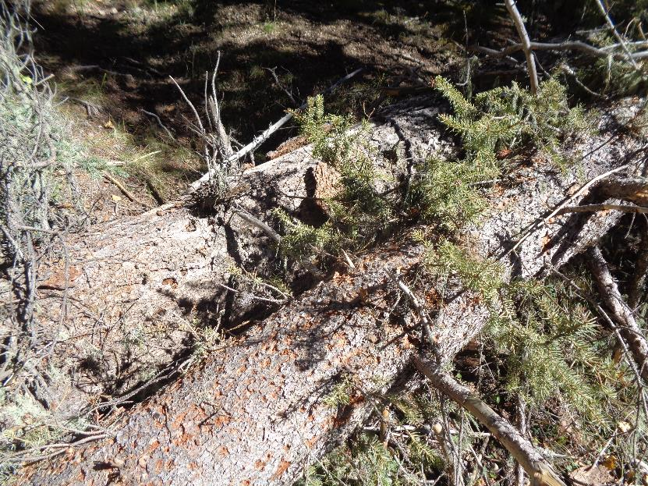
Two logs on the north side of East Fork Ridge on the East Loop Trail where the snow is usually excellent.

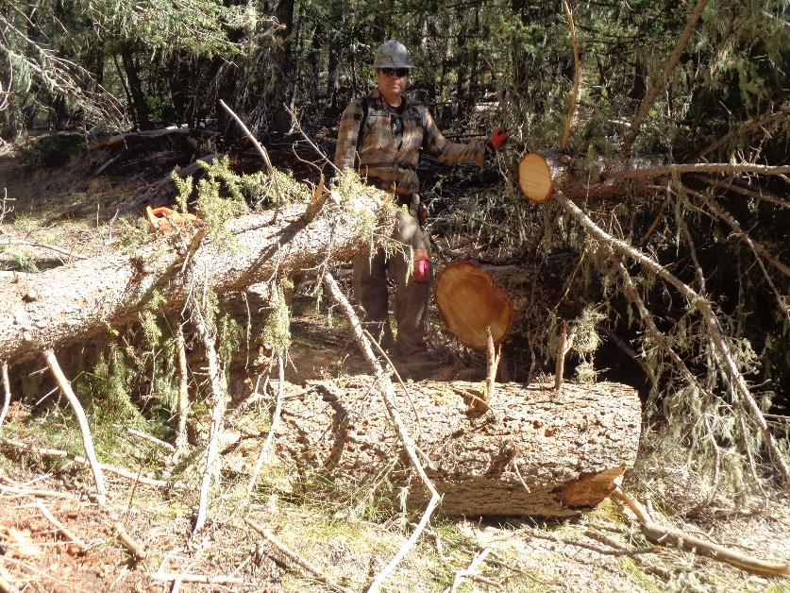
Michael has cut a small log and a large log to open the trail here on the Loop Trail.

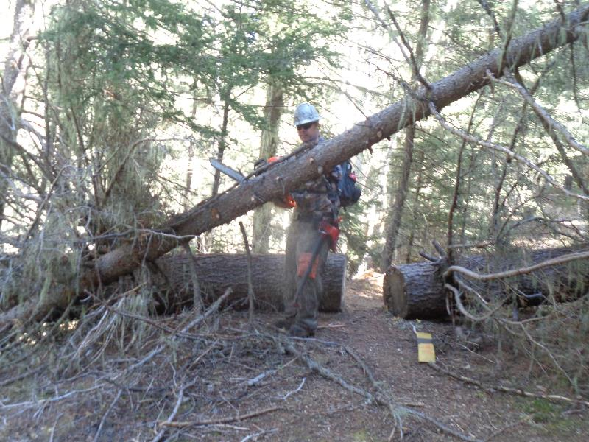
Michale cutting a small hangup on the Loop Trail. He also cut two corners off the
log behind him to make that passage a little wider.

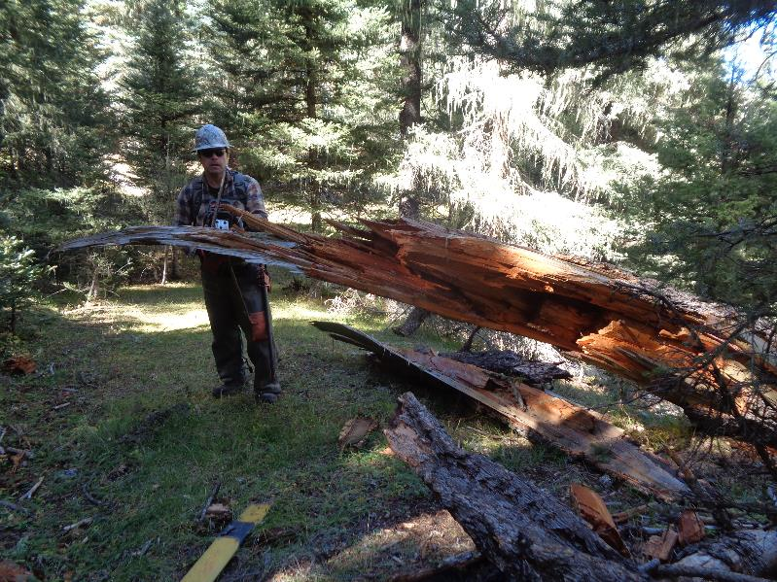
This large log fell across the Loop Trail. The large splintered stump is on the hillside left of the photo.
The dark orange color of the center of this Douglas fir indicates that it was rotten.

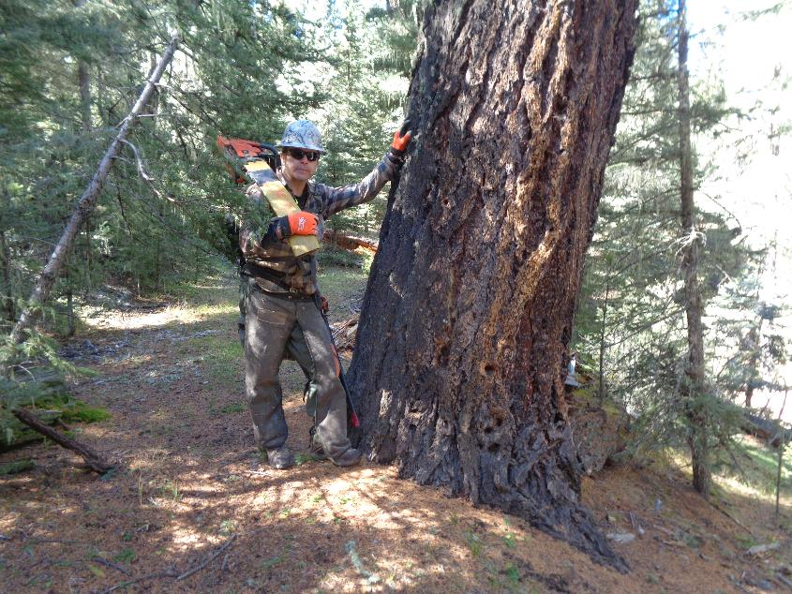
Michael standing beside a very large Douglas fir tree near the east end of the Loop Trail.
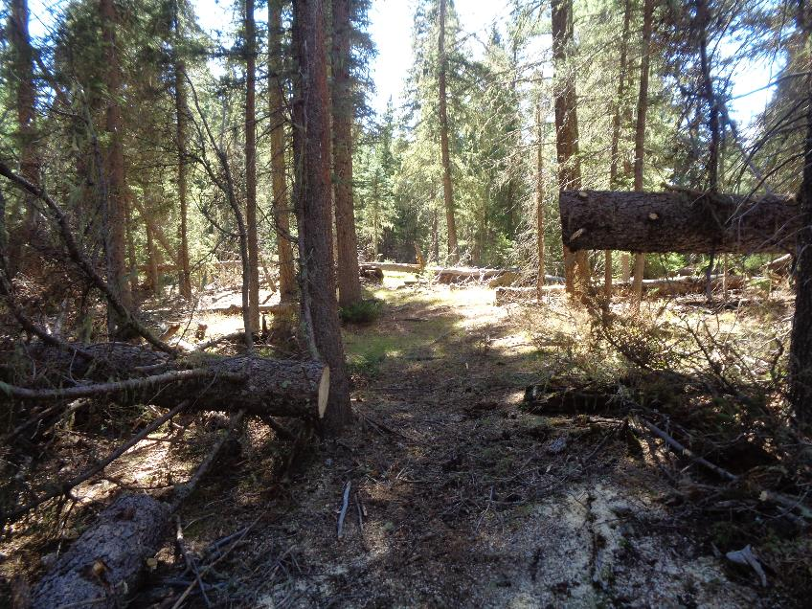
A cut spruce log on the south side of the loop.

