Report of Maintenance of Corral Canyon Trail in the Jemez Mountains
on Friday, October 24, 2025

Sam Beard
On Friday, October 24, Michael Arndt, Mike Meirer (from Los Alamos), and Sam Beard hiked Corral Canyon Trail and removed eleven trees that had fallen across the trail. This trail is located in the Jemez Ranger District of the Santa Fe National Forest about one-half mile from the west end of Valle Grande on the Valles Caldera National Preserve. This trail goes to the south from NM-4 and climbs to the top of a ridge on the south rim of the caldera where skiers can see the Sandia Mountains in the distance.
On the return trip, Michael and Sam stopped at a very large slash pile where extensive forest thinning was being done across the highway from Redondo Campground. They took pictures of the heavy equipment being used in the thinning.
Pictures of the trail work and heavy equipment are presented below.
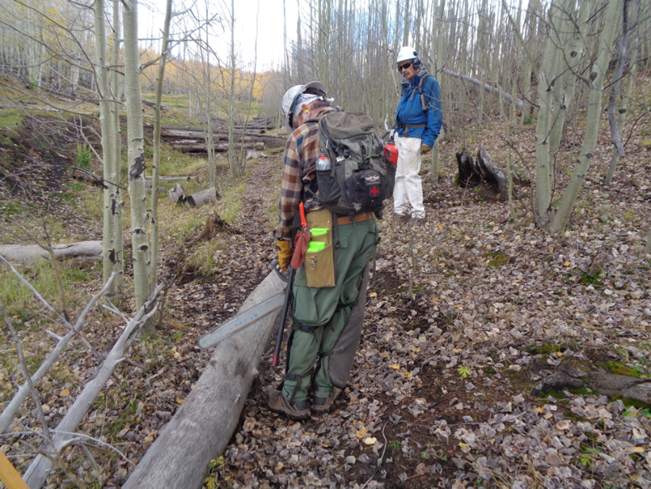
Michael Arndt bucking a small aspen across the upper part of Corral Canyon Trail just below the intersection
with a Forest Service Road. Ski Club member Mike Meirer from Los Alamos is observing. All photos by Sam Beard
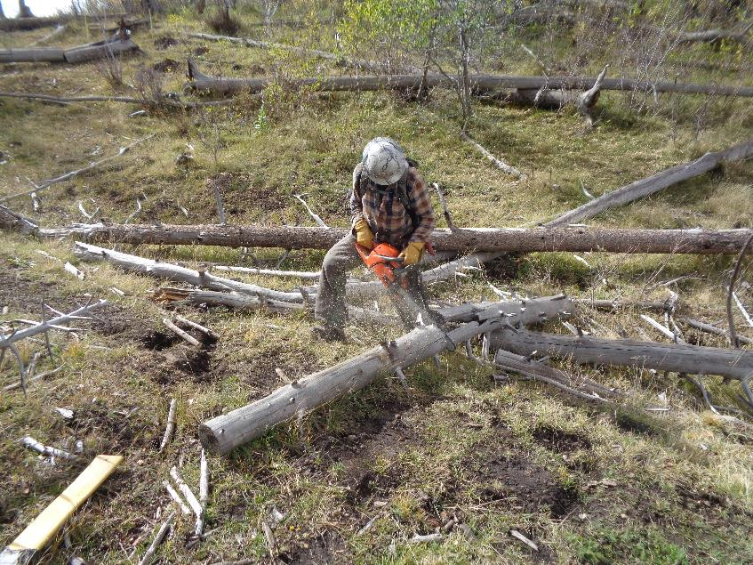
Michael bucking another small log on the upper part of Corral Canyon Trail.
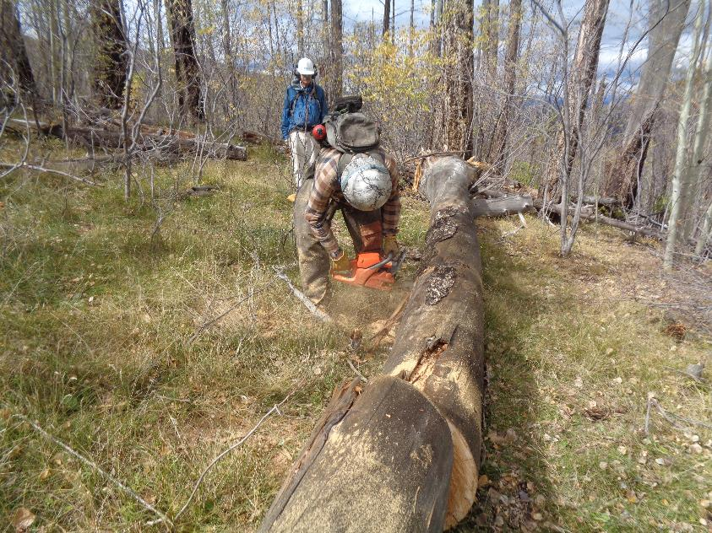
Michael bucking the largest log that we found on the trail today.
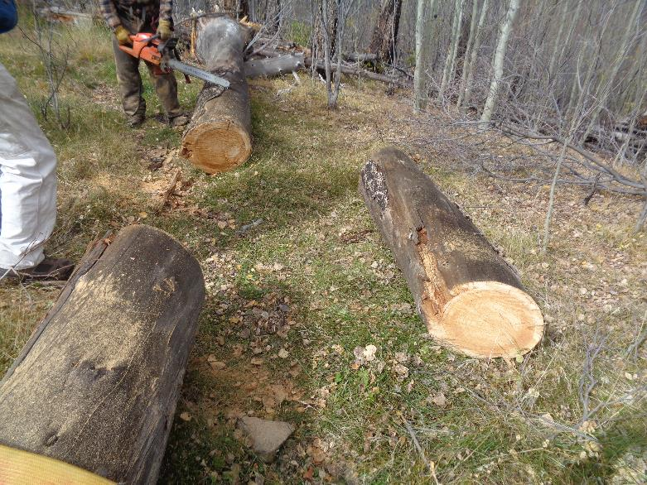
The log rolls out without being pushed, because Michael made two angle cuts so that the upper side of the log was
shorter than the lower side of the log. This bucking technique is taught by USFS sawyers when volunteers are certified.

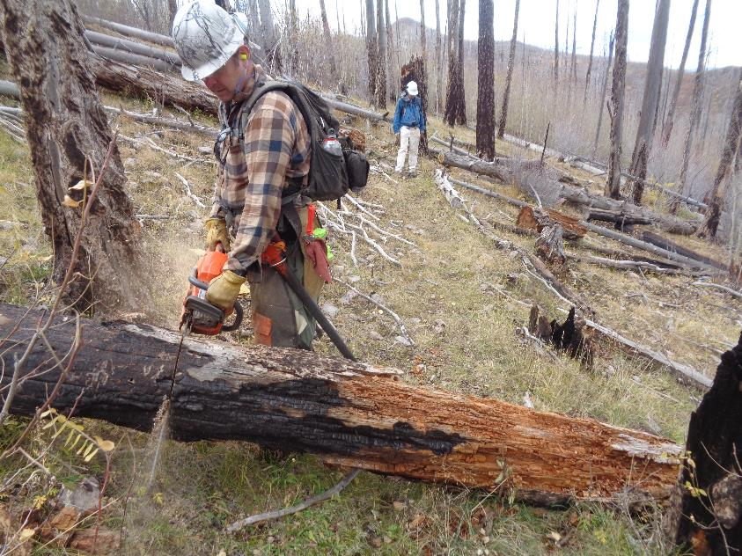
Michael bucking a log that was burned in the wildfire here.
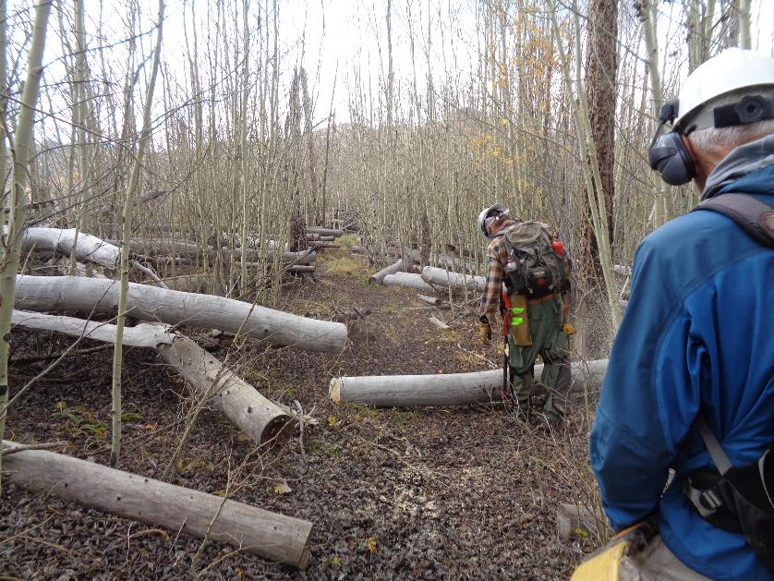
Michael bucking another small aspen a short distance from the Sandia Mountain Overlook where we ate lunch.
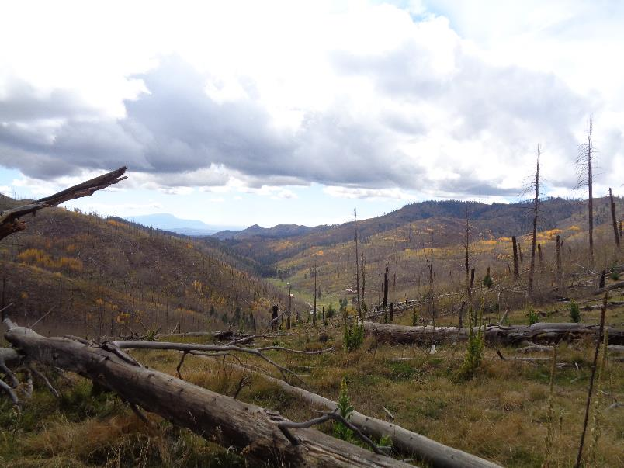
Looking down Peralta Canyon where several cabins are located on private property. The blue outline of the Sandia Mountains
is just visible at the top of the photo.
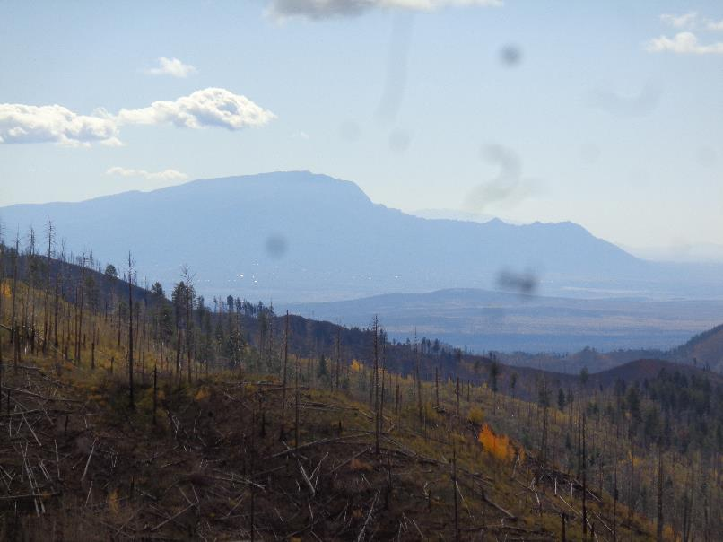
A telephoto picture of the Sandia Mountains at Albuquerque. The highest ridge in the photo is the east slope of the
mountain, and the lower part to the right of the high ridge is the Rincon Ridge around Juan Tabo Canyon.
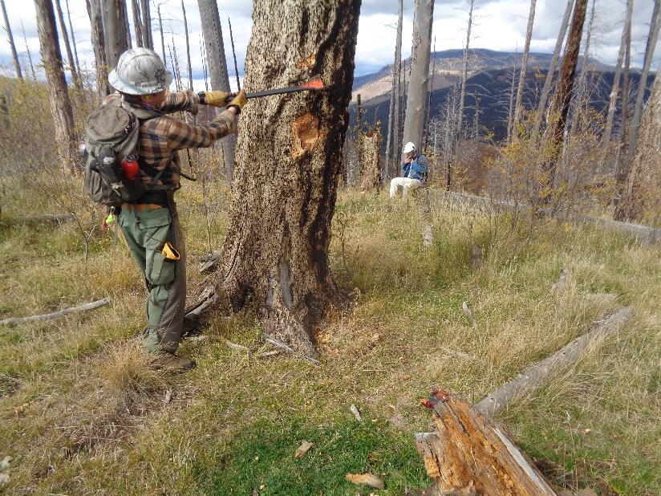
Michael making two blazes in a dead tree where the trail turns to the right and descends to Tee Intersection.
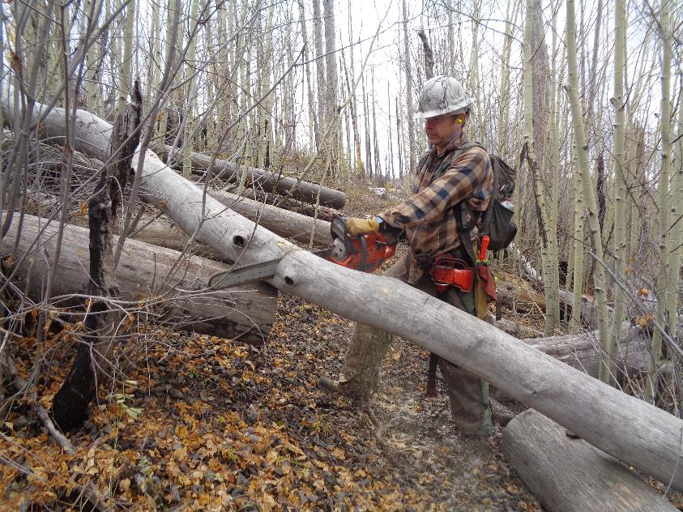
Michael bucking another aspen on the trail from the overlook.
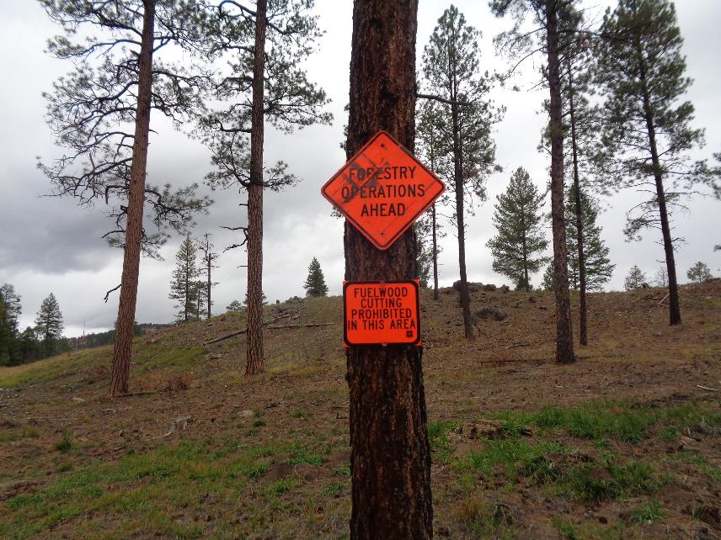
Signs in an area near Redondo Campground where extensive thinning is being done with heavy equipment.
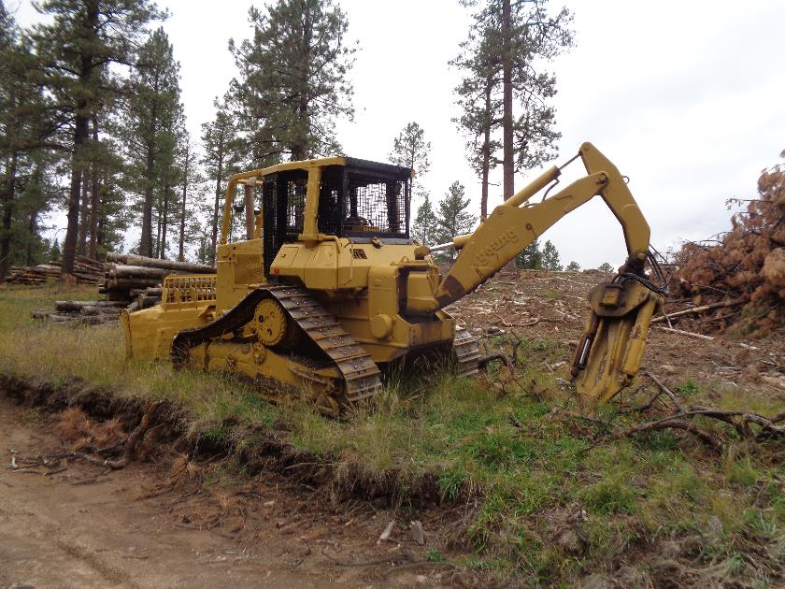
A large caterpillar with an arm on the back for picking up logs. Note the large piles of logs in the background.
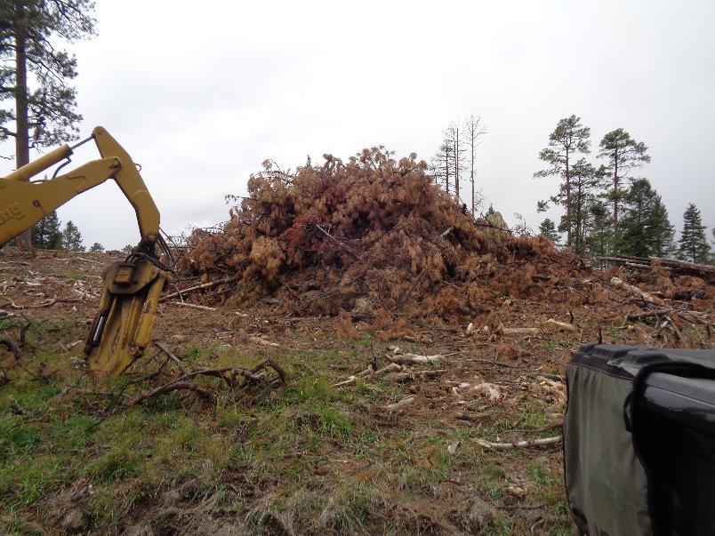
HUGE slash pile of small trees and branches that will be burned after it dries. The pile burns will probably be done
when there is snow on the ground to reduce the chance of wildfire.
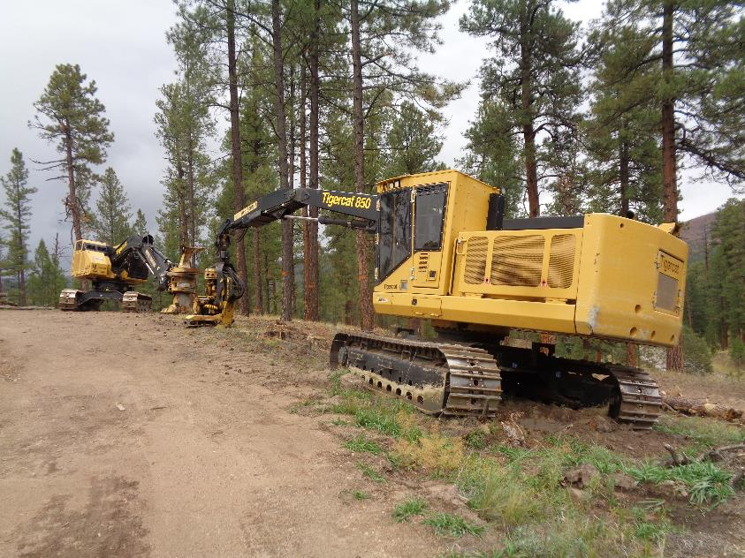
Large logging harvesters used to fell, limb, and pile trees removed in the thinning operation.
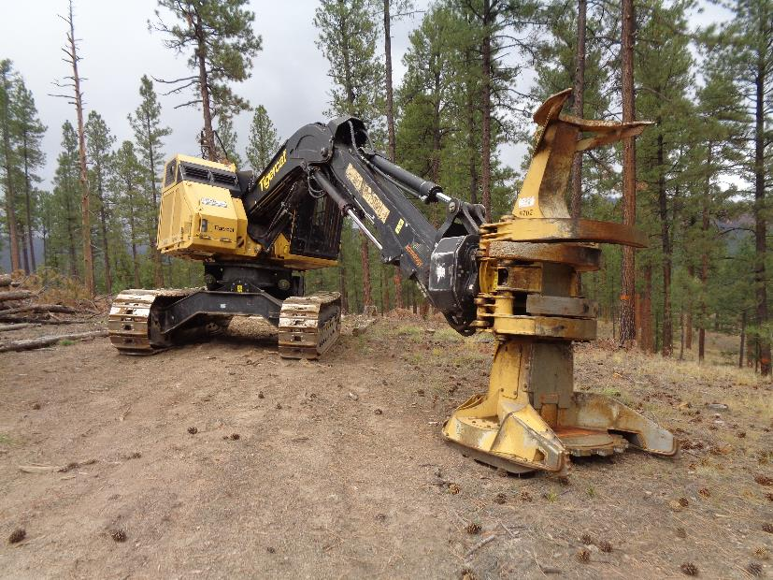
It appears that his harvester is used to grab and fell large trees.
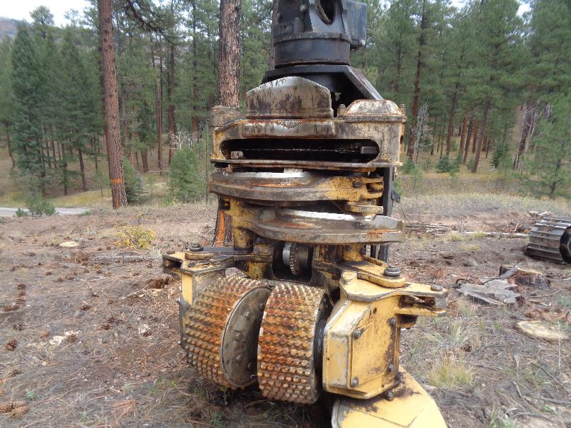
This machine has a chain saw bar at the bottom and at the top. It appears that the round cylinders with knobs on them
maybe used to push the tree through the two arms to remove branches.

