Report of Maintenance of Two Ski Trails in the Redondo Campground Area in the Jemez Mountains
by NMCCSC Volunteers, Saturday, November 22, 2025

Sam Beard
On Saturday, November 22, Ski Club members Michael Arndt, Cathy Taylor, and Sam Beard completed fall maintenance of two ski trails in the Redondo Campground area in the Jemez Mountains. They parked in the large lot at the San Diego Canyon Overlook across NM-4 from the campground. They crossed the highway, hiked through the campground entrance, and followed the Redondo Campground Loop Trail in the forest around the CG. After passing through a meadow north of the CG, the trail returned to the highway at the site of a large deep hydrothermal explosion crater where the crew ate lunch.
These craters were caused by the exposure of ground water to very high temperature magma near the surface of cooled Banco Bonito eruption lava. The explosion is caused by the very rapid violent flashing of the water to steam. The Banco Bonito eruption was the last one in the Valles Caldera (13 miles in diameter) that was formed 1.25 million years ago. Fifty-four of these craters have been identified in the Banco Bonito lava field. No other craters like these were found on the topographic map of the Jemez Mountains. These craters can be a few hundred feet in diameter and nearly a hundred feet deep. Another large crater is located near the parking lot across the highway from the CG entrance.
From the Crater Spur Trailhead located at the large deep crater south of the CG, this trail passes by a small shallow crater and makes a loop adjacent to NM-4. From this trailhead, the crew hiked to the CG and back to the vehicles. They hiked a total of approximately 3.5 miles (2.5-mile Loop Trail and 1.0-mile Spur Trail) and found no snow. The trails in and near the CG are generally Class I and easy. About a dozen fallen trees were removed from the trails, and the largest log was about 8 inches in diameter.
Three outing photos are presented below.
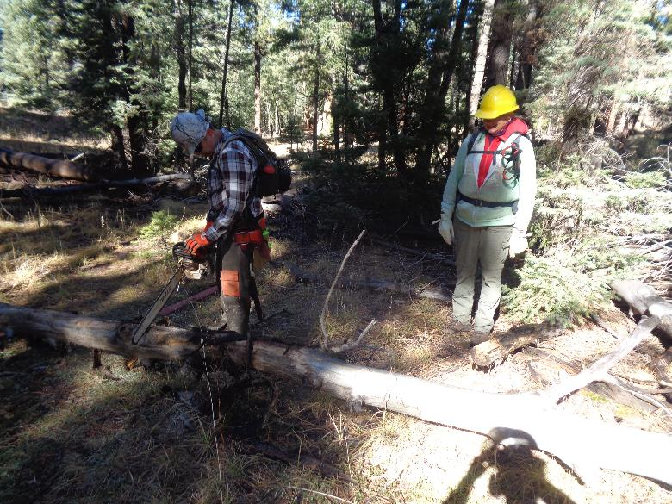
Michael Arndt beginning to cut an 8-inch log across the Crater Spur Trail in a level area between the very large deep
hydrothermal crater and the small shallow crater. Cathy Taylor from Jemez Springs is waiting to move the log after Michael
has completed the cut. Photos by Sam Beard
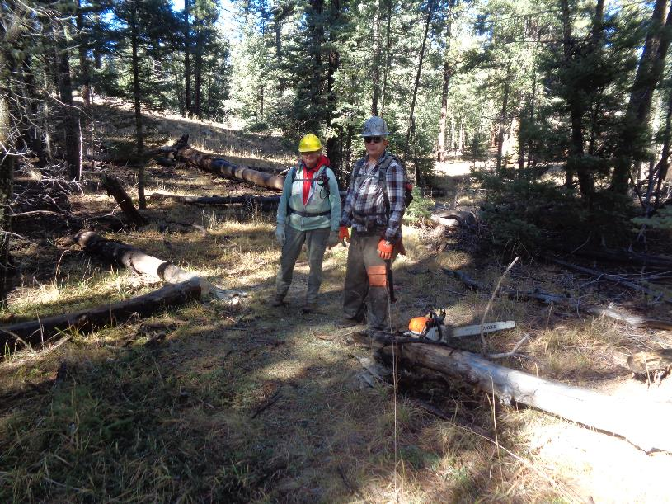
Cathy and Michael standing on the cleared trail. Obviously, there was no snow on the ground.

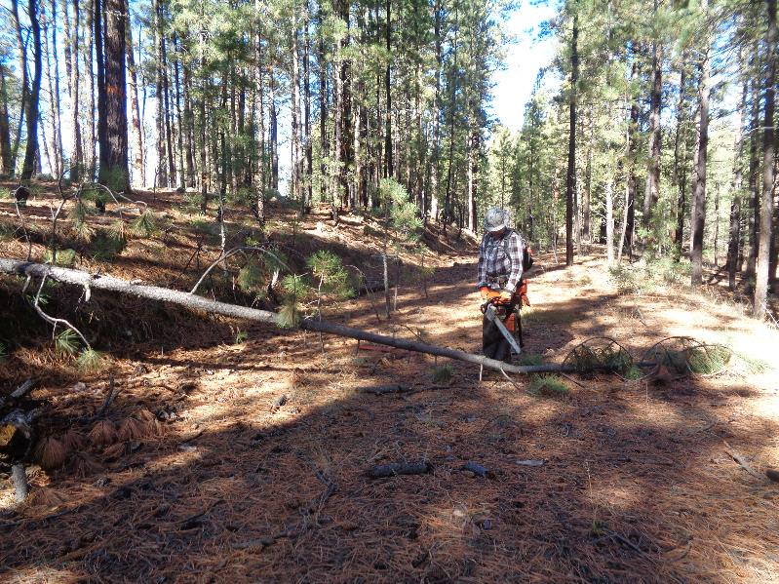
Michale cutting a small pine tree across the Crater Spur Trail loop on a section of the old NM-4 highway.
Note that the old dirt road was very wide here.

