Report of Ski Outing to the Jemez Mountains on Sunday, January 11, 2026
Sam Beard and Michael Arndt
On Sunday, January 11, Sam and Michael skied in the Rabbit Mountain area on the Valles Caldera National Preserve after finding little snow in the Redondo Campground area. The Rabbit Mountain area was formerly named Coyote Call.
From the Rabbit Mountain Trailhead, they skied a very easy route on an old road to the west a distance of about 1 and ¼ mile. They were on the trail about 3 hours including 30 minutes for lunch. The weather was sunny, and temperatures were generally above freezing.

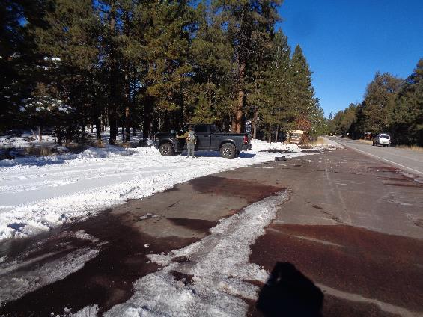
We stopped at the San Diego Canyon Overlook across NM-4 from Redondo Campground to check
snow conditions. After seeing the small amount of snow here, we decided to go to the
Rabbit Mountain area on the Valles Caldera National Preserve (VCNP). All photos by Sam Beard
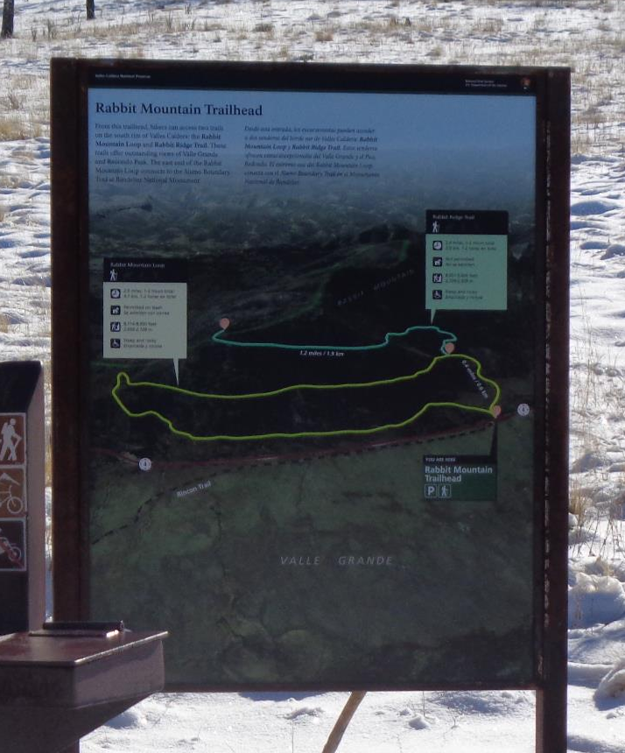
The Rabbit Mountain Trailhead sign with a map of Rabbit Mountain Loop and the Rabbit Ridge Trail.
This area was formerly named Coyote Call.

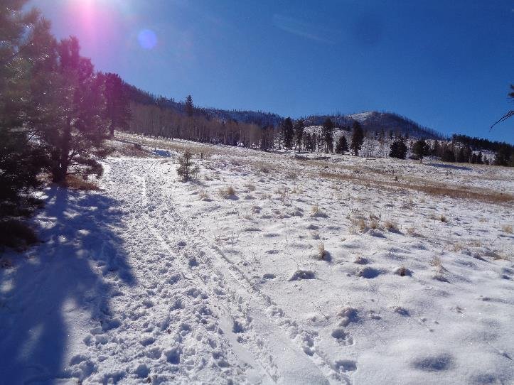
Rabbit Mountain Loop Trailhead with Rabbit Mountain in the background. The snow depth was about 4 inches.

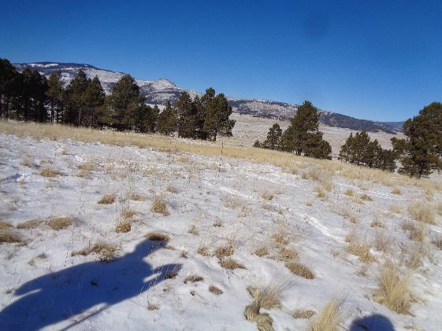
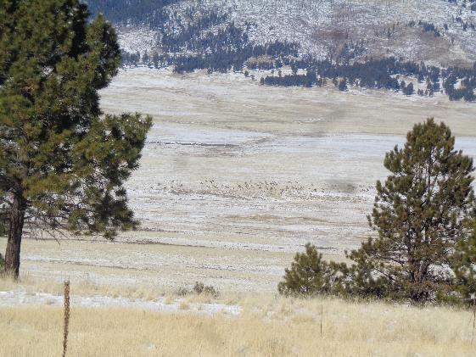
Top: Central part of Valle Grande with Redondo Peak and Redondito in the background. The very small
dots in the center of the photograph are elk. Bottom: Telephoto of elk grazing in Valle Grande.
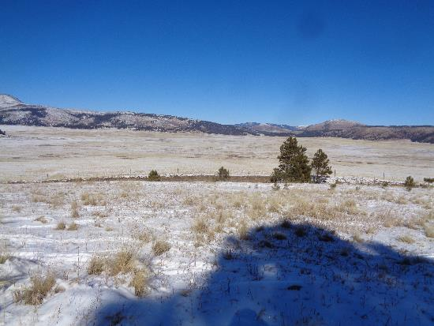
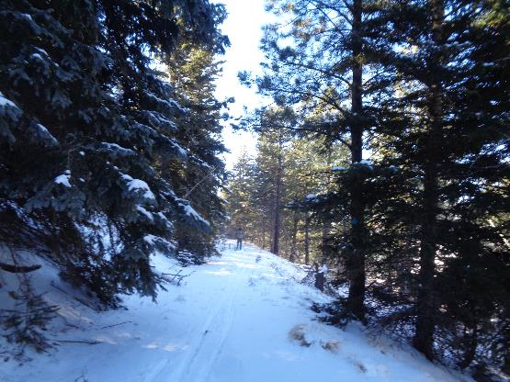
Top: Valle Grande across NM-4 from Rabbit Mountain area. Bottom: Michael Arndt
skiing on old road in the forest. Highway is down the slope to the right.

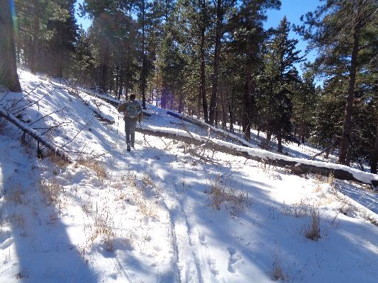
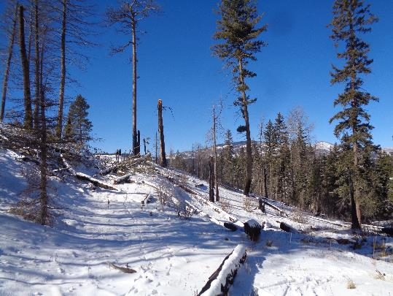
Top: Michael skiing around a couple of logs. He was skiing on 4 inches of snow over grass.
Bottom: Tree down on the old road near where we ate lunch.

