Report of New Mexico Cross Country Ski Club Outing
to the Jemez Mountains, Sunday, January 25, 2026

Sam Beard
On Sunday, January 25, four Ski Club members enjoyed skiing around Redondo Loop Trail and Crater Spur Trail in the Jemez Mountains near Redondo Campground. The weather was sunny, and the maximum snow depth was 8 to 10 inches.

The skiers were Michael Arndt, Debbie Bryant, Cathy Taylor, and Sam Beard.

Outing photographs are presented below.

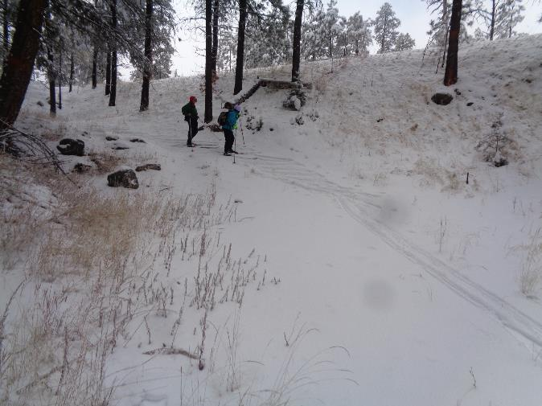
Cathy and Debbie forward side-stepping down this rocky slope at a curve in the Redondo Loop Trail. NM-4 is behind them, and this curve in the trail is about one-quarter mile north of the Redondo Campground entrance.
Photo by Sam Beard

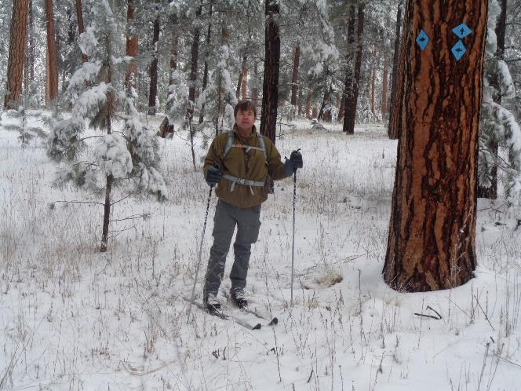
Michael Arndt at the junction of Redondo Loop Trail and Twin Craters Trail. Here we turned left and skied about 1/8-mile to two small shallow hydrothermal explosion craters. Photo by Sam Beard
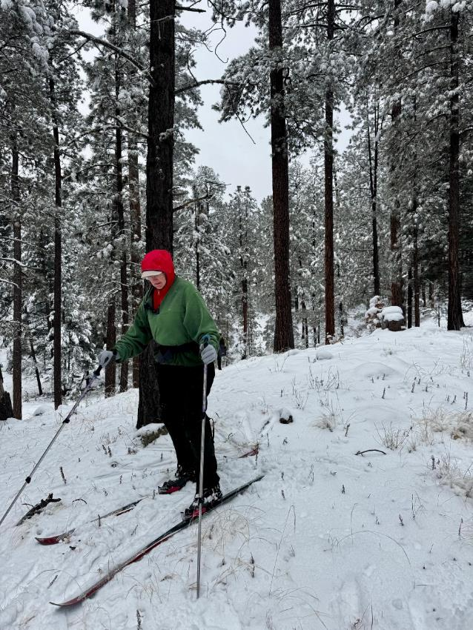
Cathy with a small crater in the background.
All photos by Debbie Bryant unless noted otherwise
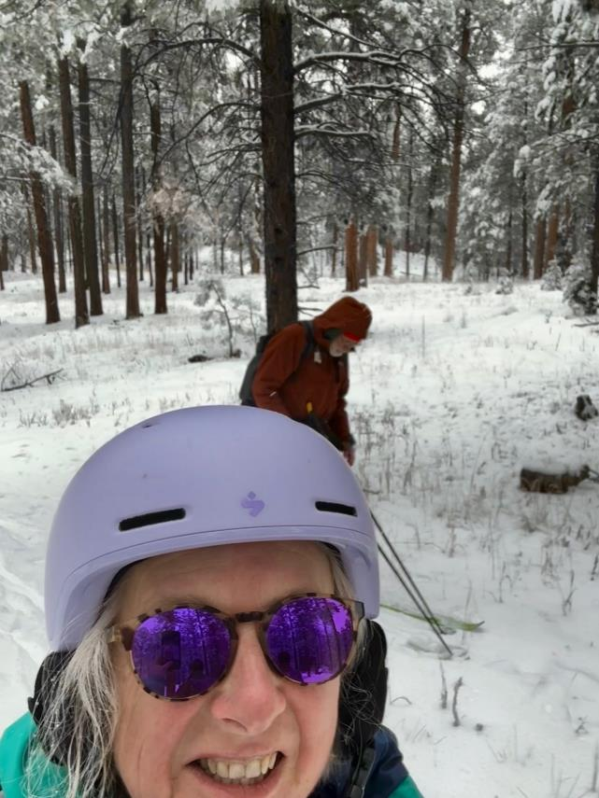
A selfie by Debbie with Sam in the background.
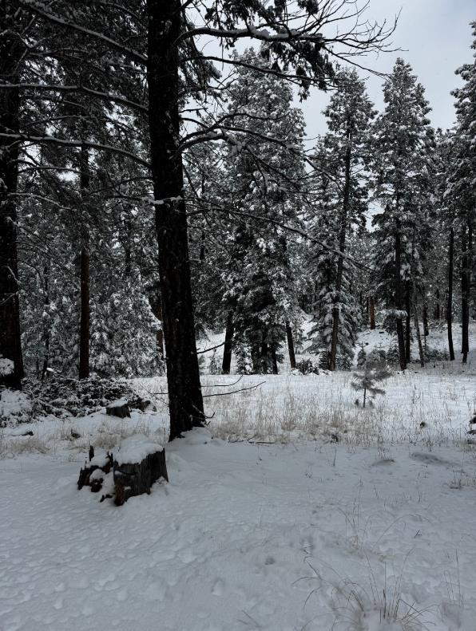
One of the shallow craters on Twin Craters Trail. Hydrothermal craters in the Banco Bonito lava area
were formed when ground water mixed with the extremely hot underground magma. The resulting
steam explosion caused the ejection of stone and soil and the creation of 54 craters on the Banco Bonito area.
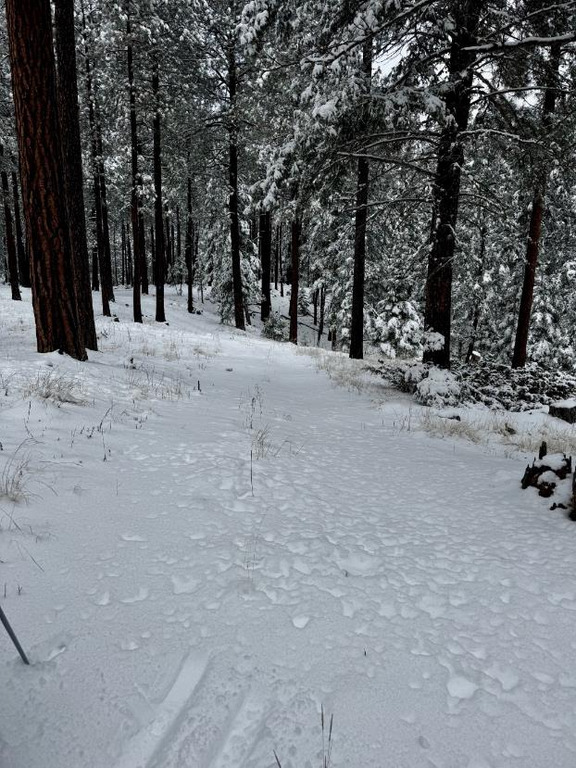
The rim of the other shallow crater.

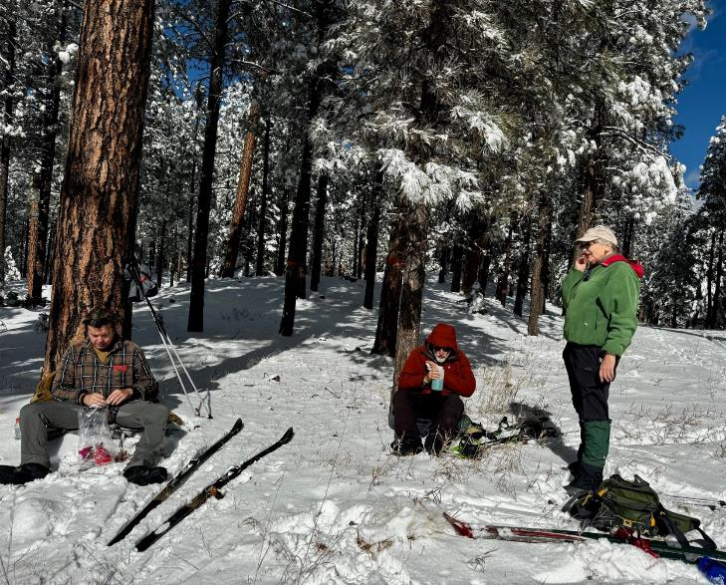
Eating lunch at the junction of the Loop Trail and Crater Spur Trail.
L to R: Michael Arndt, Sam Beard, and Cathy Taylor.

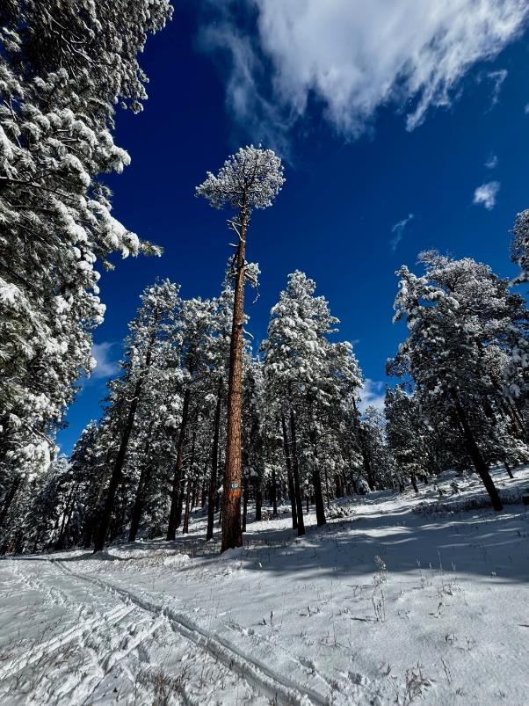
The large pine tree at the junction of the Loop Trail (to the left) and
Crater Spur Trail (to the right).

