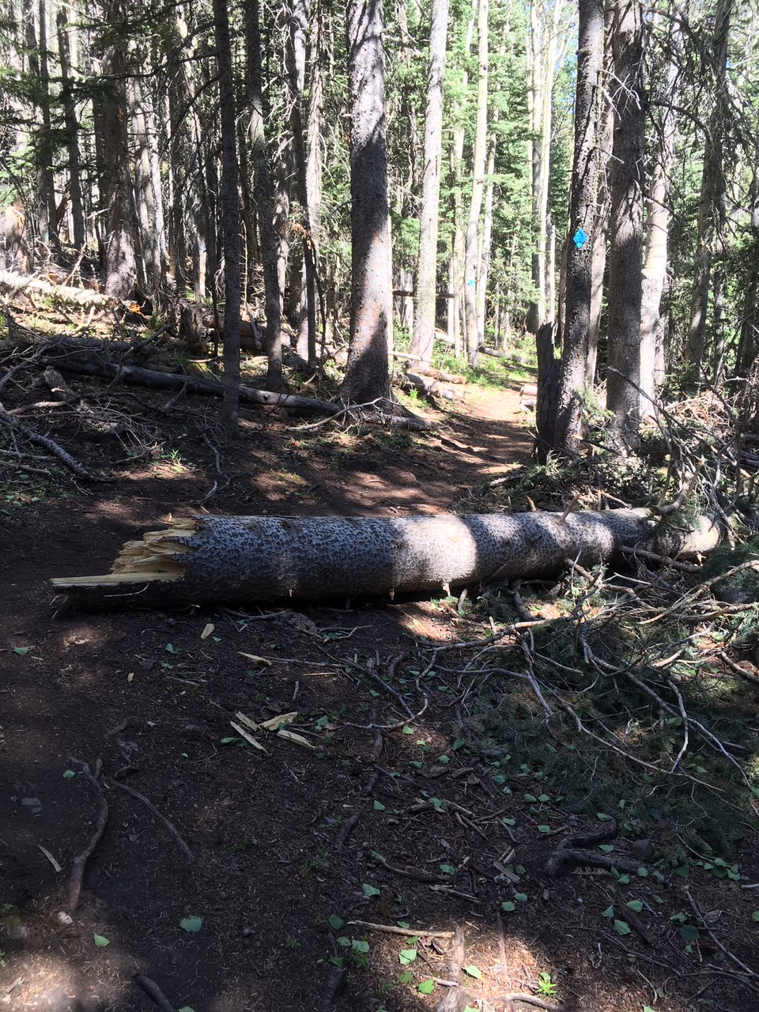
This 16-inch diameter dead fir had fallen across Lower
Switchback Trail. A short walkaround had developed on
the uphill side.
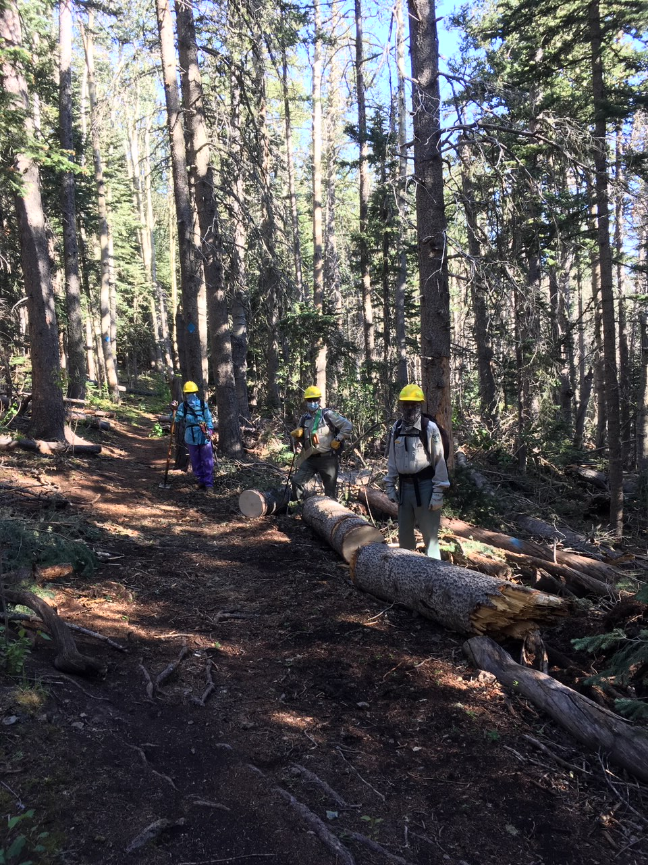
After two cuts with a one-person crosscut saw, the tree
in the previous photo has been cleared from the trail
and the original trail tread restored. The walkaround
was covered with debris.
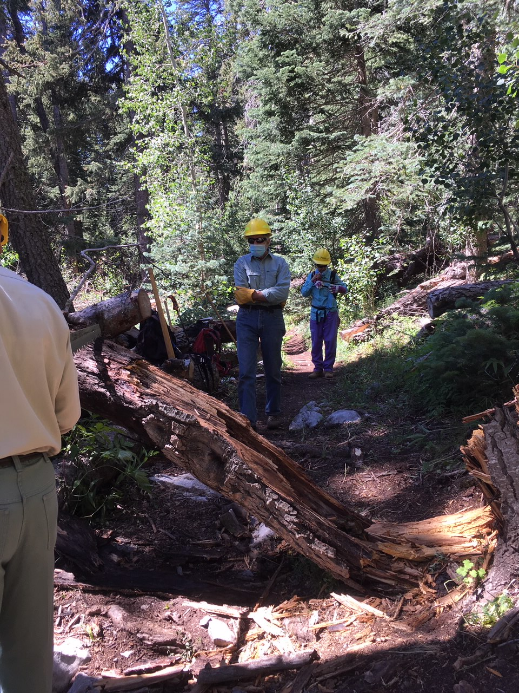
This old, very rotten 14-inch diameter fir tree had fallen over 10K South Trail a short distance north of the first ski run. A first cut with a one-person crosscut saw is beginning in this photo. It was soon discovered that the tree was so rotten that the cut could be finished with a 21-inch pruning saw. The top of the tree fell safely away on the uphill side of the trail and the remaining lower portion was removed to clear the trail.

