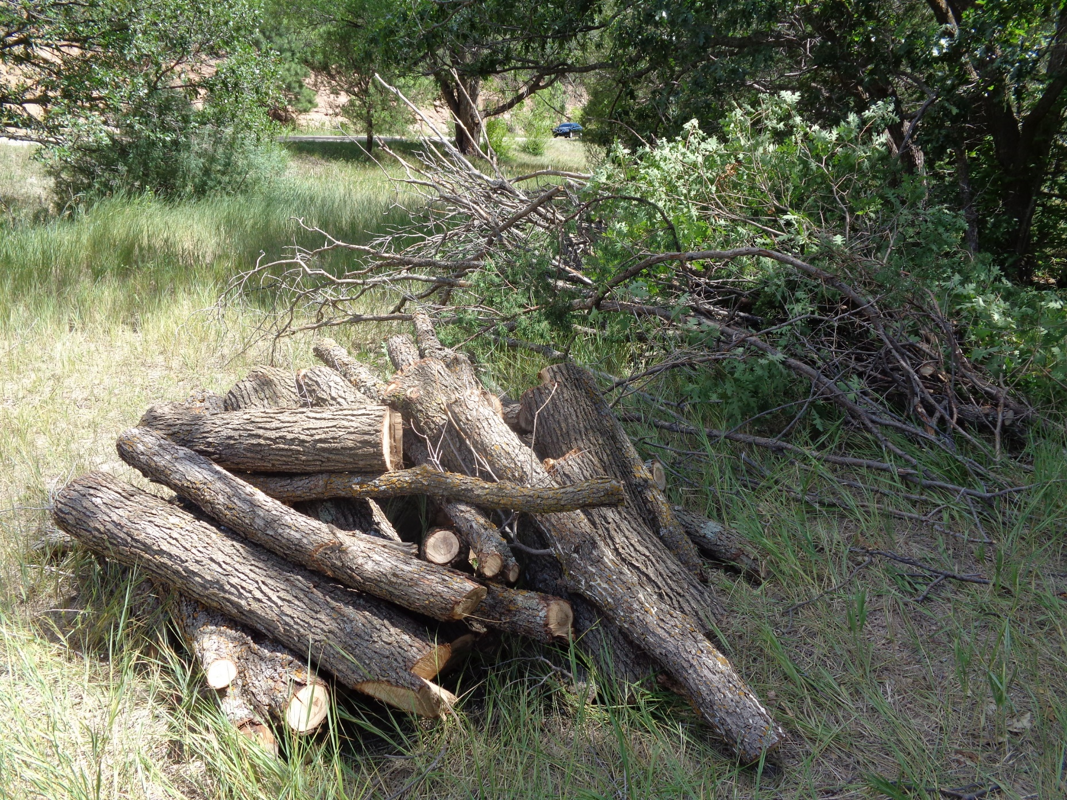

Firewood and slash from felling seven Gambel Oaks near Shelter B in Doc Long Picnic Area. All photos by Sam Beard

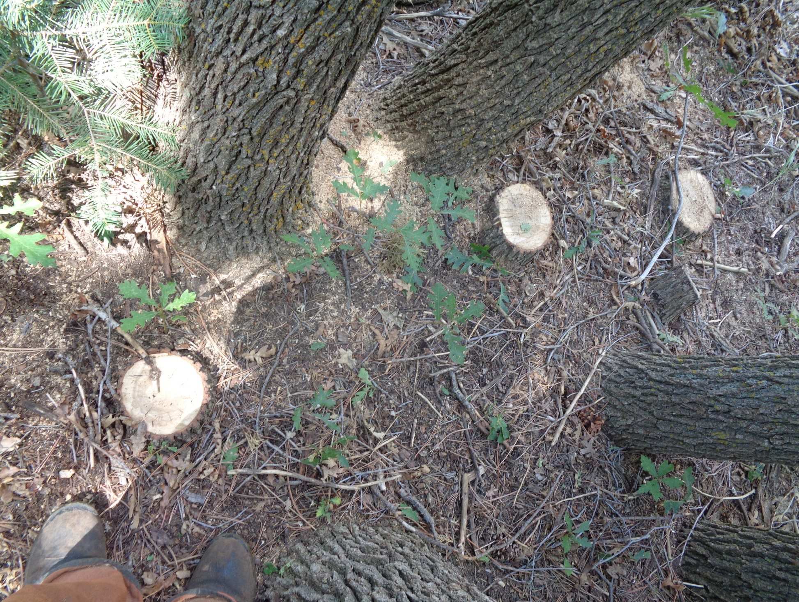

Stumps of three oaks showing how crowded they were in this grove.

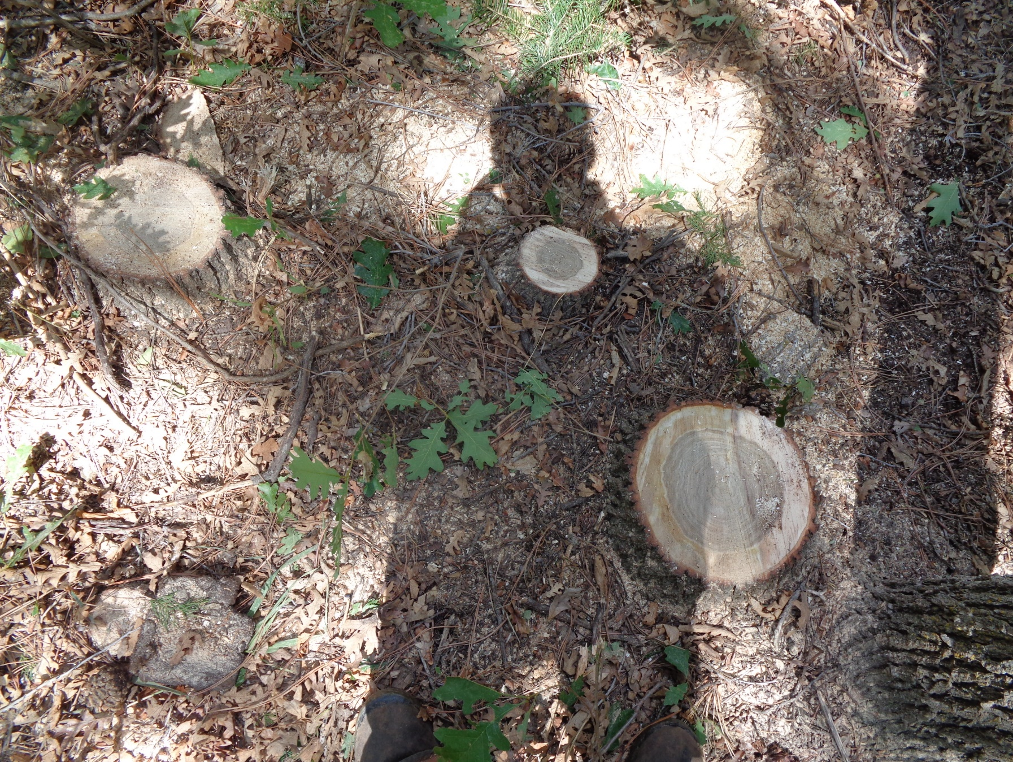

Three other stumps that were even closer together.