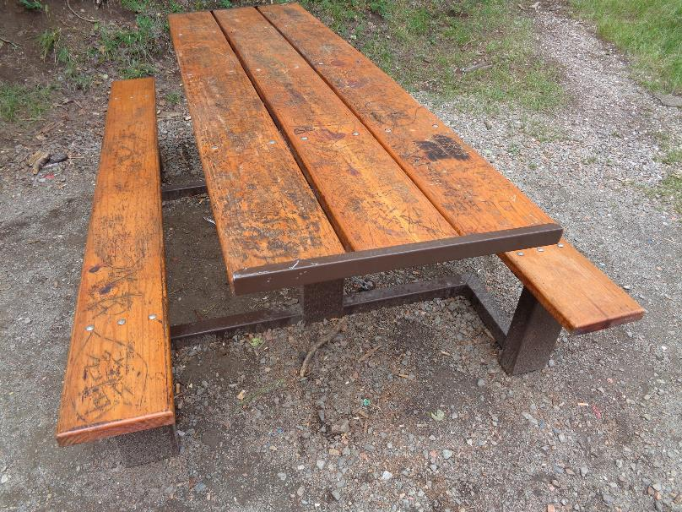

Picnic table near gate on road leading to Kiwanis Meadow with graffiti and carving damage. All photos by Sam Beard

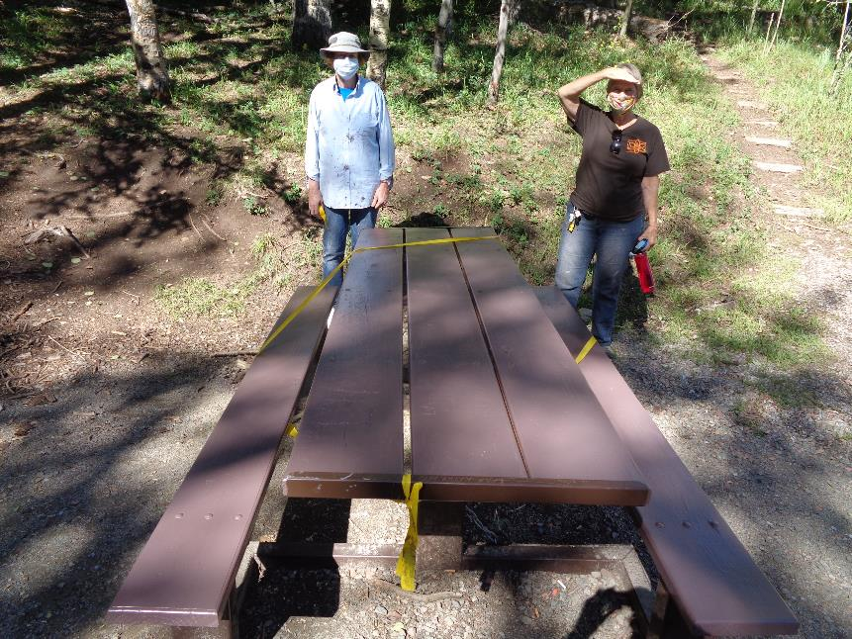

Table near Kiwanis Meadow Road gate after it was painted Forest Service brown.

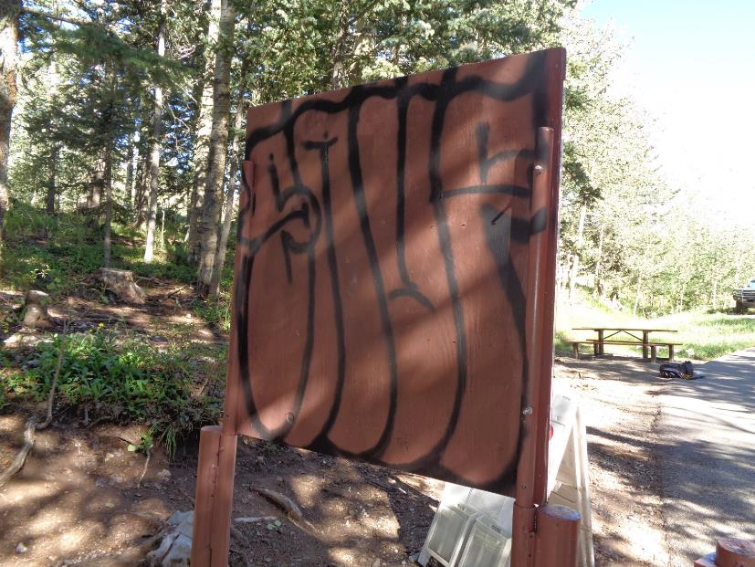

Graffiti on back of information sign at Kiwanis Meadow Road gate.

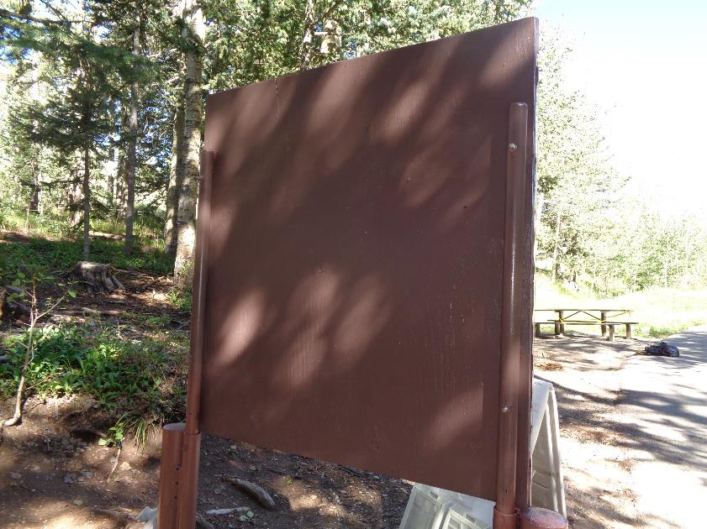

Back of sign after it was painted brown.

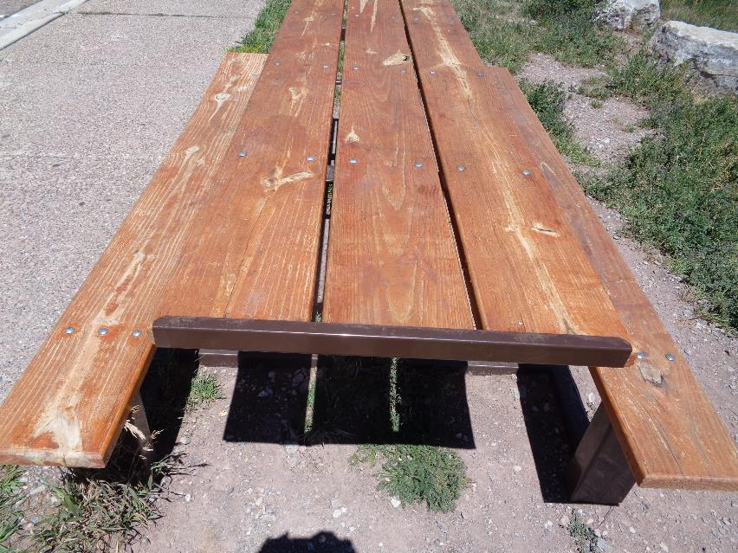

Table at 10K North Trailhead that was treated with Penofin wood finish in 2019.

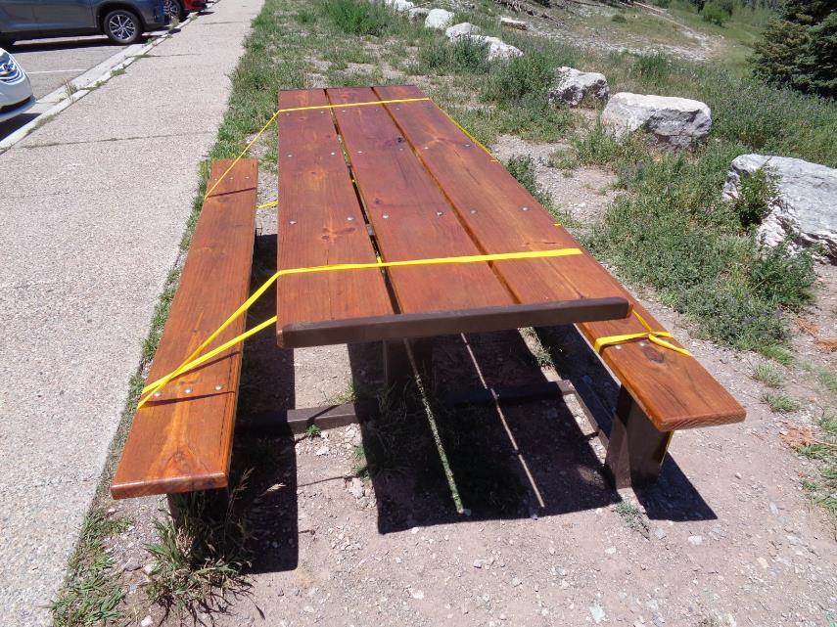

10K North Trailhead table after application of Penofin finish.

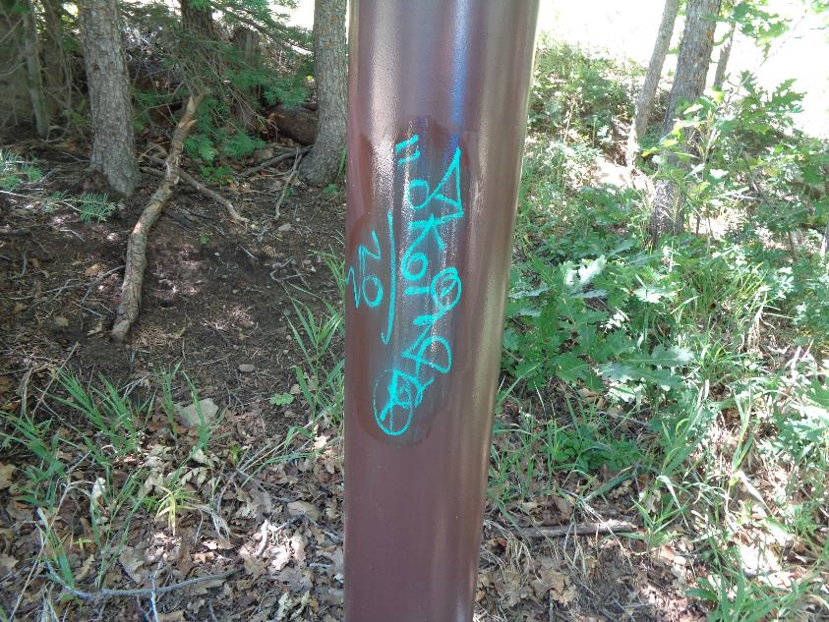

Graffiti on Capulin Picnic Area lower area gate post after first application of remover.

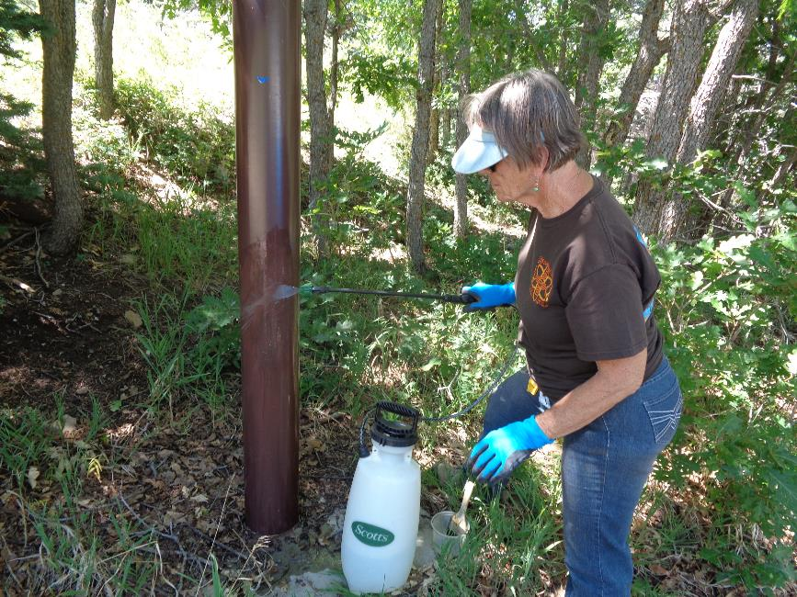

Nancy Peterson is using water to wash graffiti and remover from post after three applications of remover.

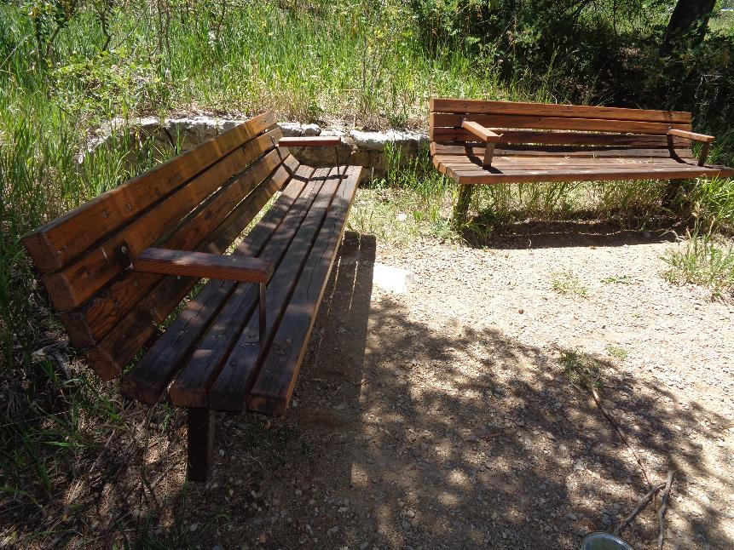

Bird Log benches that were treated with Penofin in 2019.

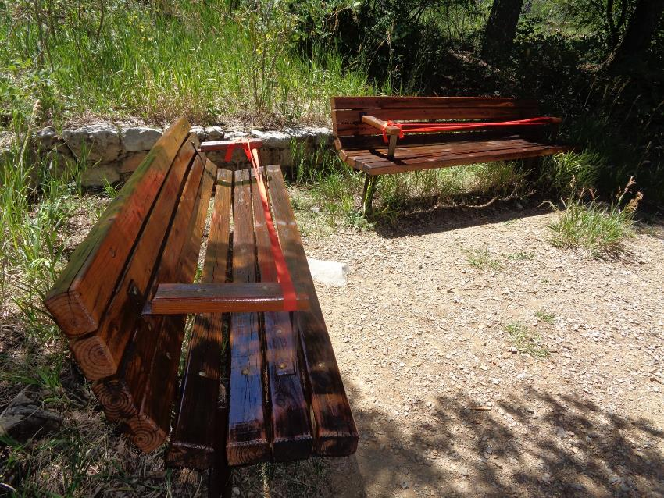

Bird Log benches after application of Penofin.

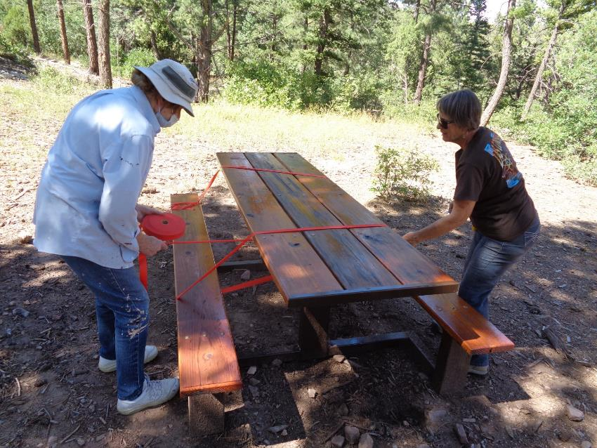

Anne Hickman and Nancy Peterson tying ribbon around table at Cienega Horse Trailer Parking Lot after the application of Penofin.