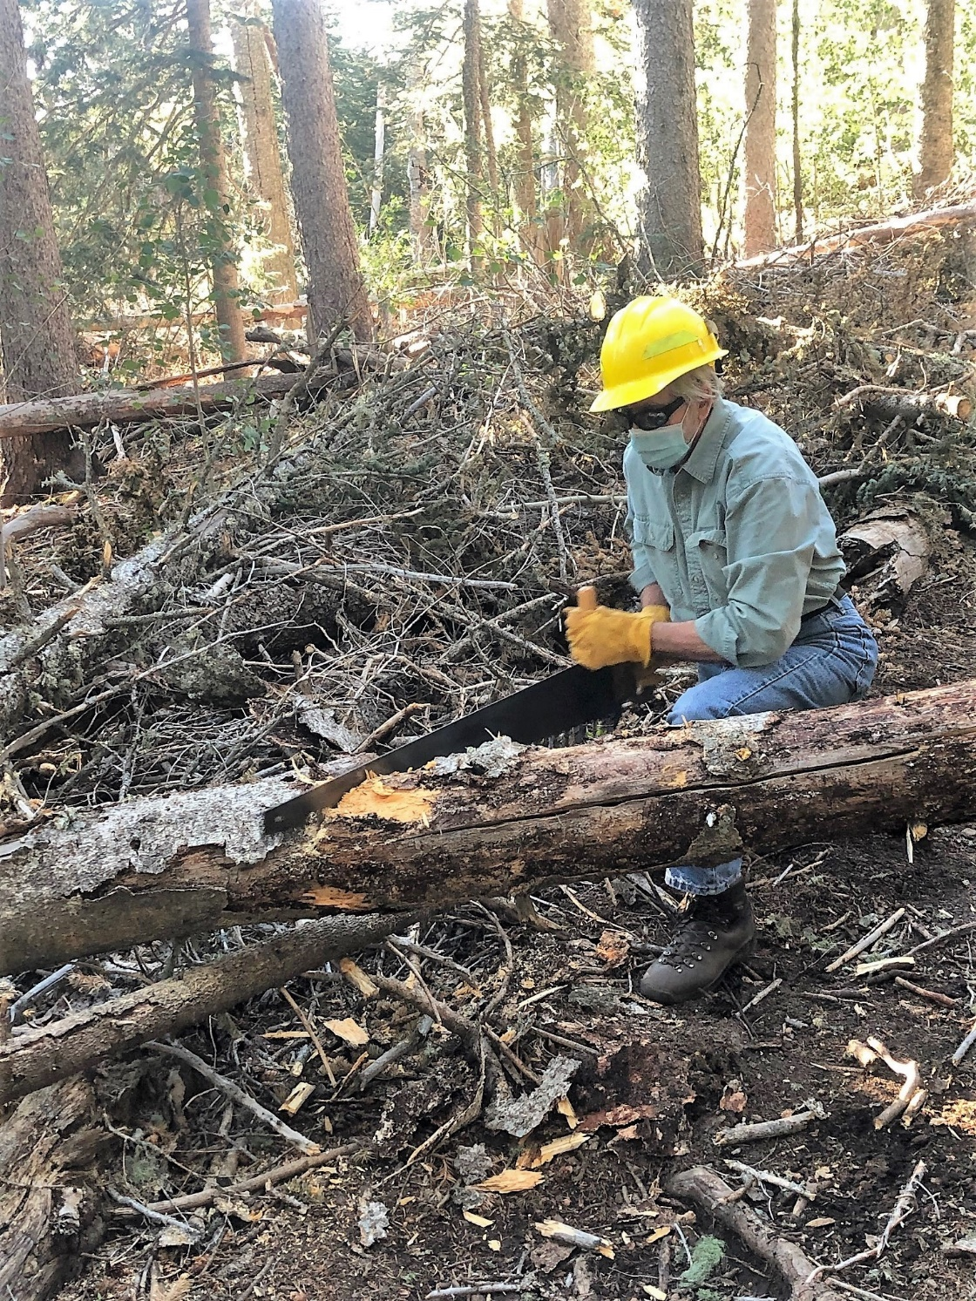
Byron making the first cut on the last remaining log from
the train wreck on Lower Switchback Trail. Debris in background had been previously removed.

(Photo by Cleve Sharp)
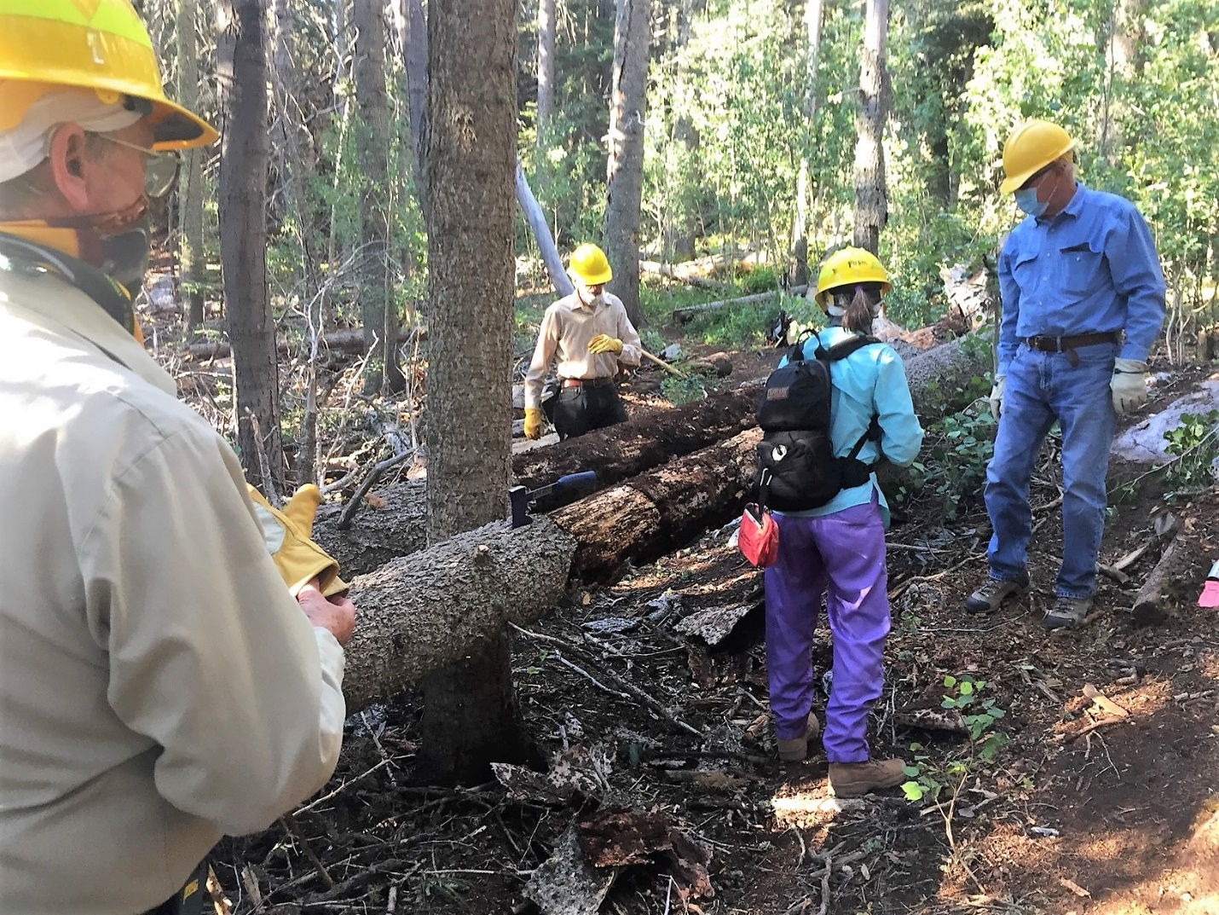
Rav Staring the first cut on a log that is part of a three-tree train wreck on Rocky Point trail. A large amount of debris has already been removed.

(Photo by Bill Savage)
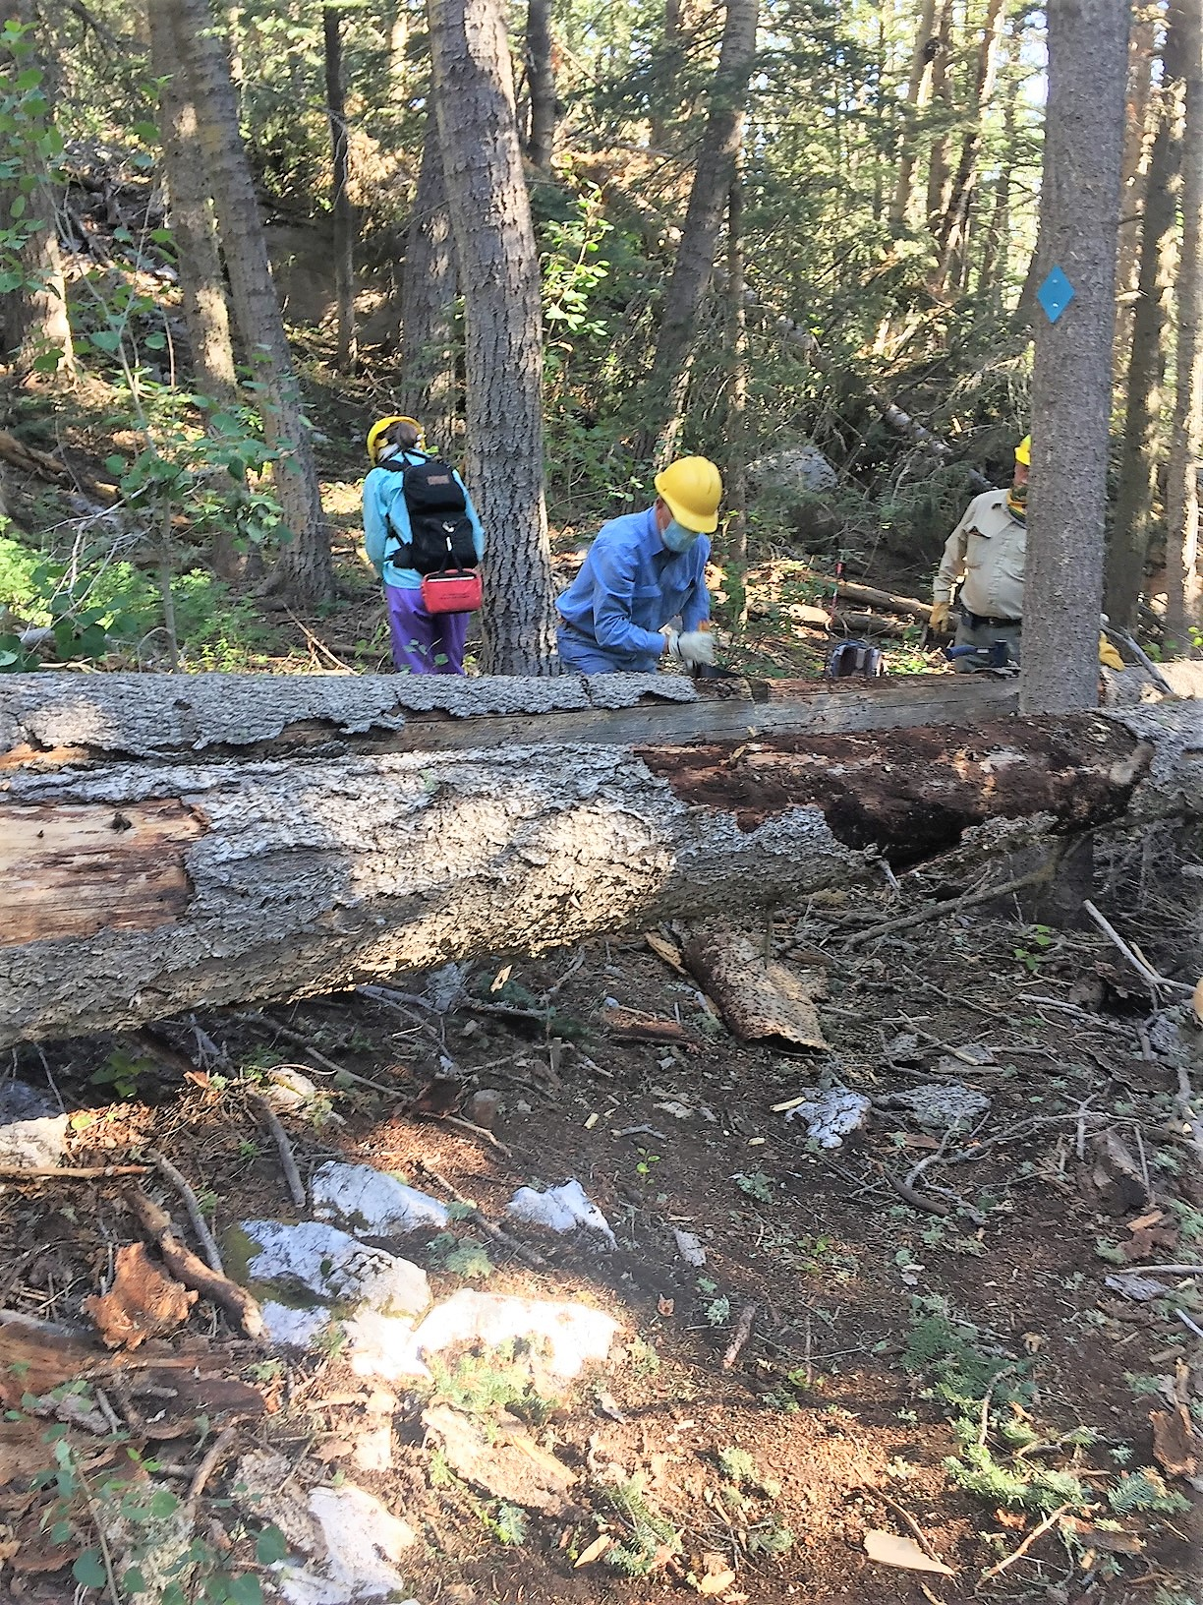
Jerry taking his turn at the Rocky Point trees.

(Photo by Bill Savage)

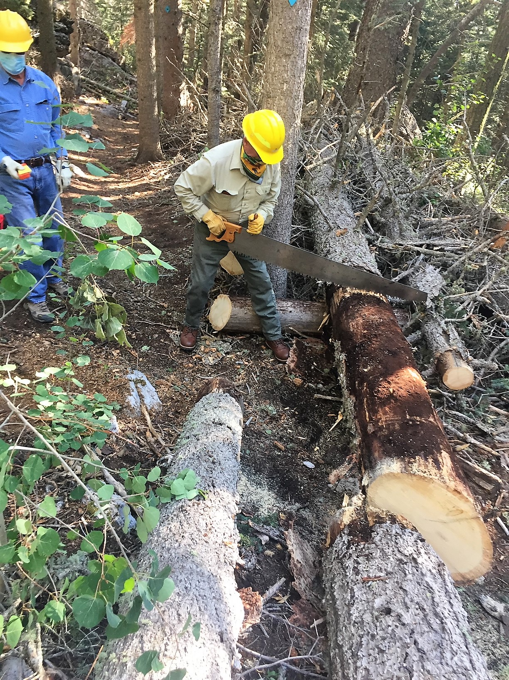
Jim starting the last cut on the Rocky Point trees.

(Photo by Bill Savage)
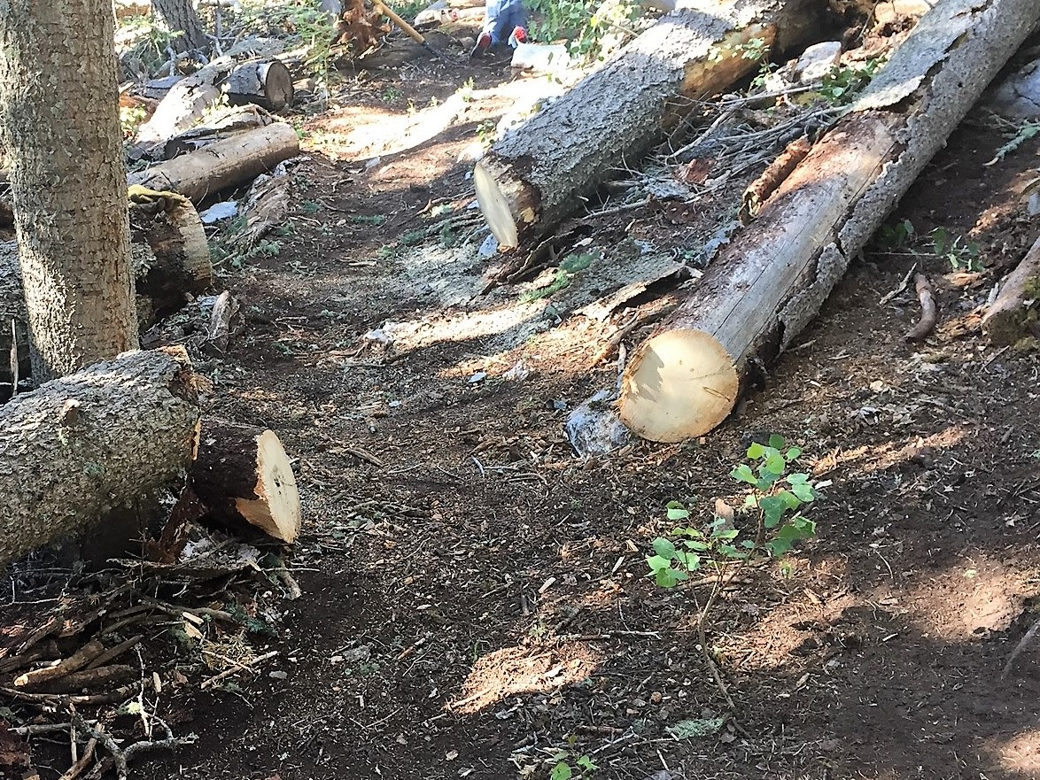
The blockade on Rocky Point has been removed.

(Photo by Bill Savage)

