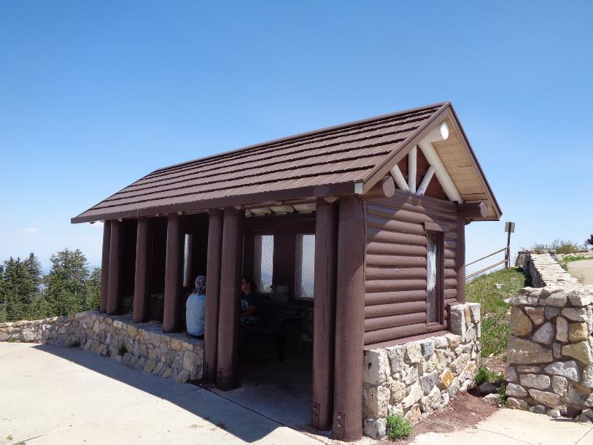

Exterior of shelter over bench at the upper Crest parking lot was painted. All photos by Sam Beard

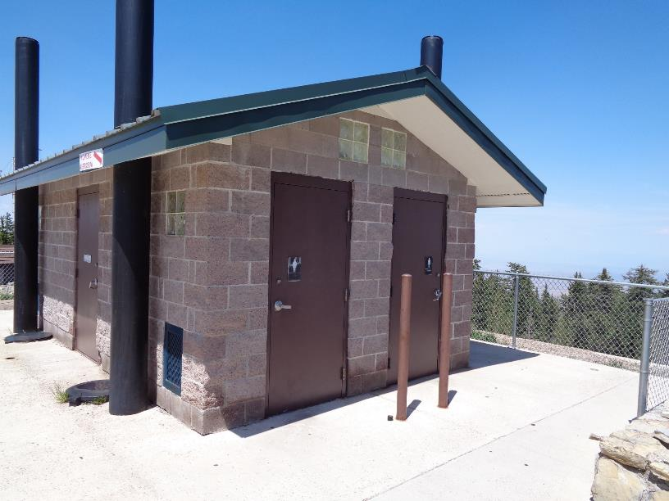

Two-tone gray doors were painted brown at restrooms near Crest House

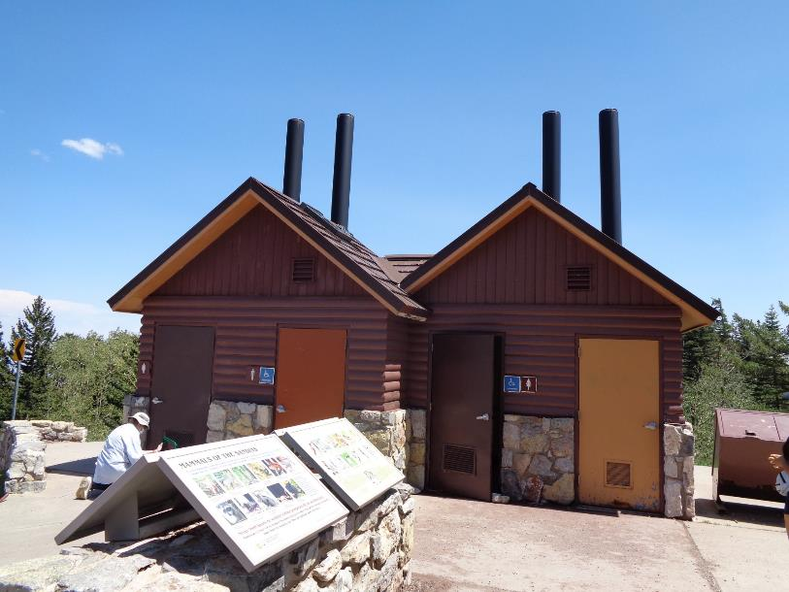

Left doors on these two restrooms at the south end of the Crest parking area were painted brown.

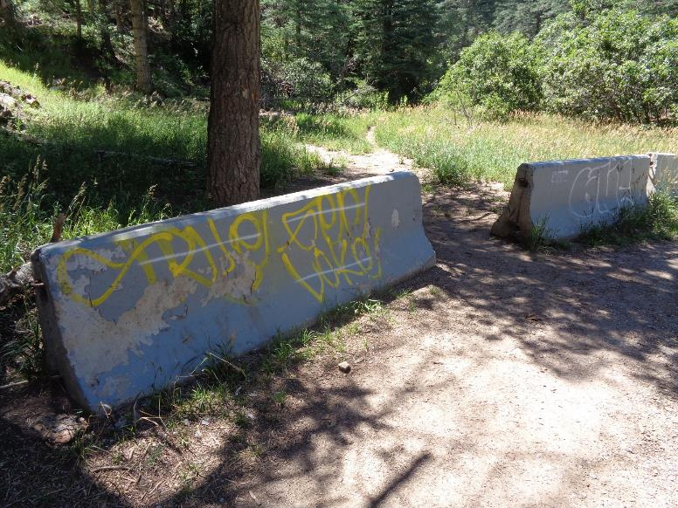

The graffiti on these three barriers on NM-165 was covered with gray paint after the crew completed the Crest work.

They are located just below Balsam Glade Picnic Area.