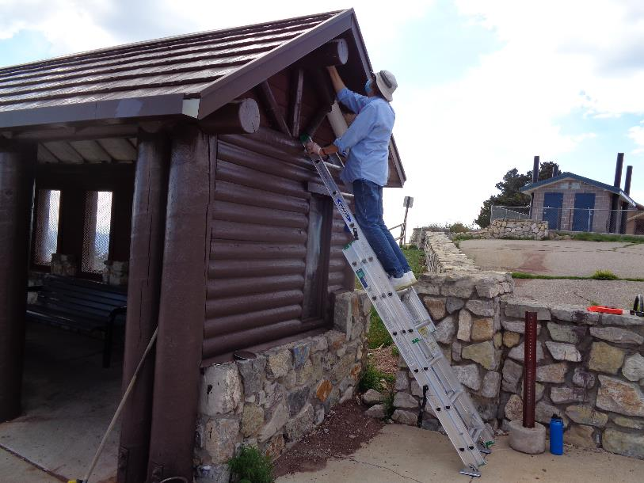

Anne Hickman painting the gable end of the shelter at the upper Crest parking lot. All photos by Sam Beard.

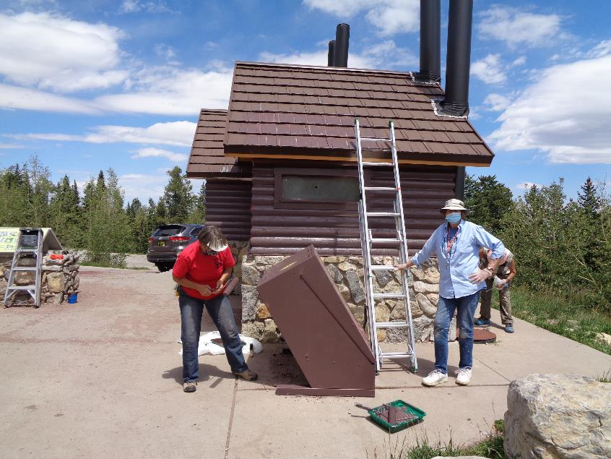

L to R: Nancy Peterson, Anne Hickman, and Jane Harrison working on the project to paint the restrooms and trash container

at the Crest lower parking lot. Graffiti on the roof left of the ladder was painted over with USFS brown paint.

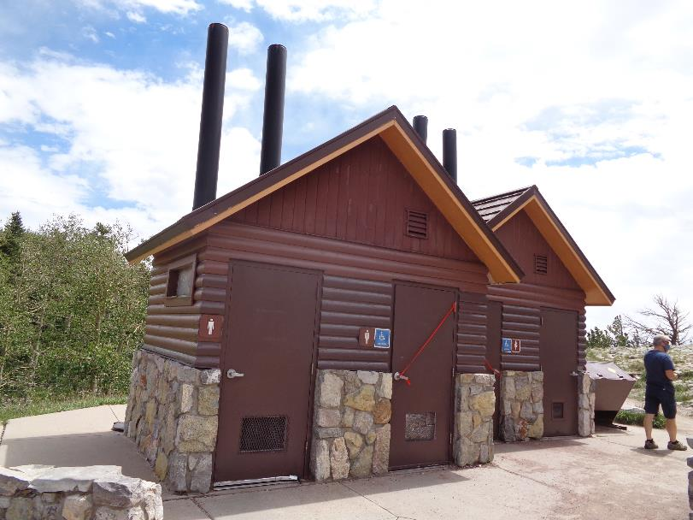

Painting of the doors and most of the wooden siding was completed.