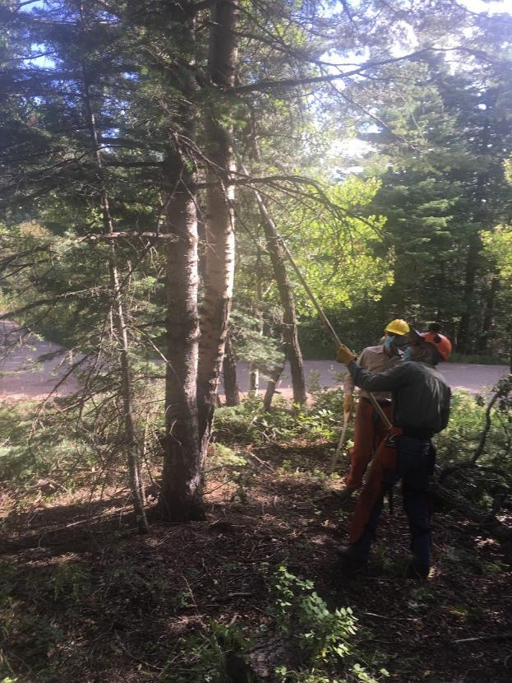

Byron Garner and Sim Cook high pruning trees before the right tree was felled

Capulin Snow Play Area. All photo by Cliff Giles unless noted otherwise.

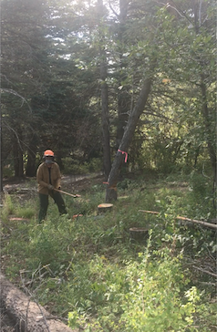

Dan Benton running away from falling tree where he as been driving a wedge.

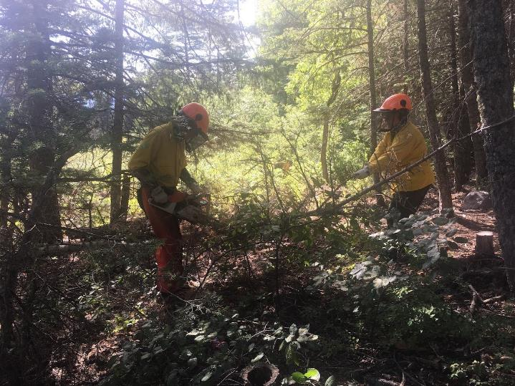

Bob and Sally Lowder limbing a tree that Bob has just felled.

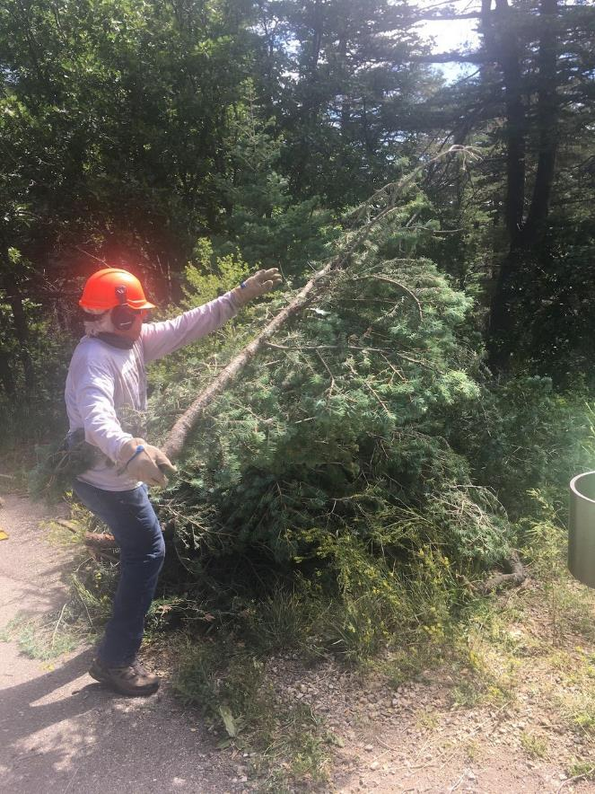

Steve Roholt throwing a branch on a pile of slash.

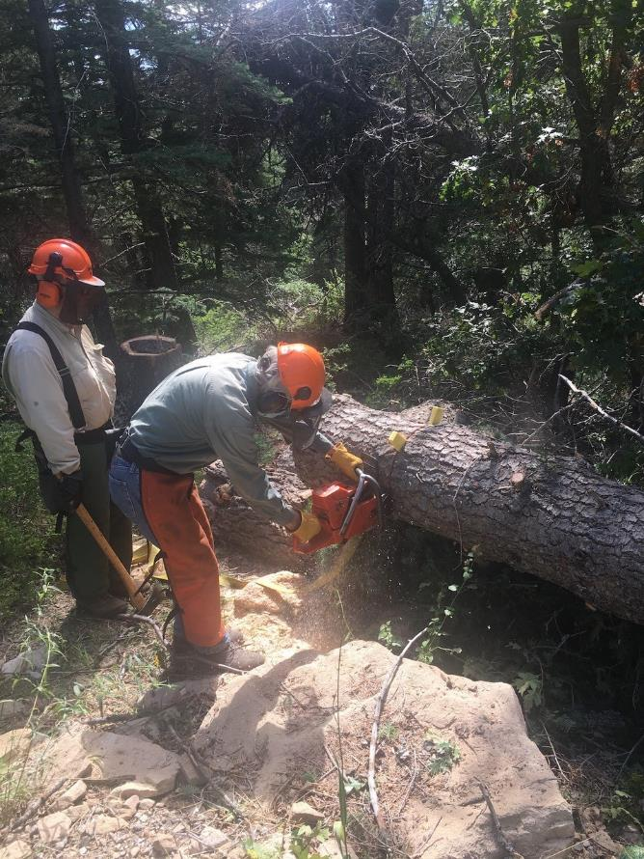

Byron Garner bucking a large tree at the Capulin lower area gate with Dennis Crowther ready to drive a wedge.

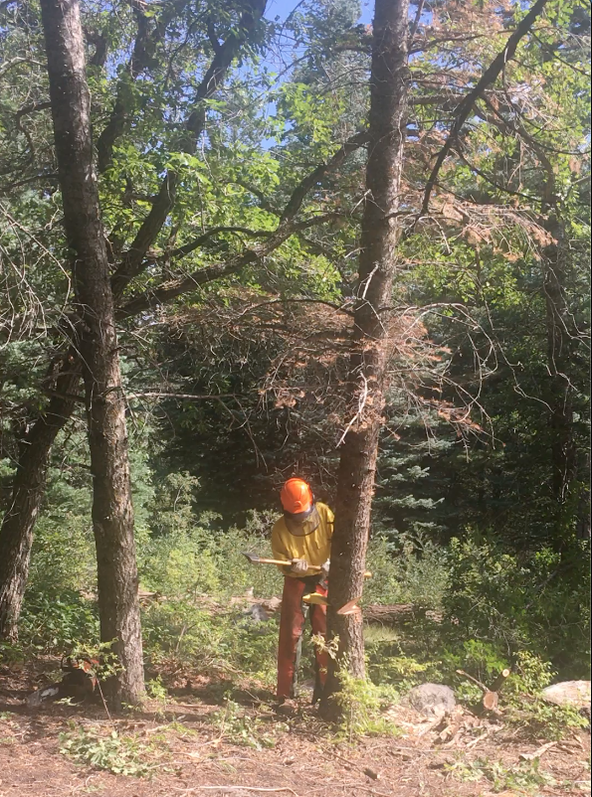

Bob Lowder driving a wedge in a tree that is beginning to fall.

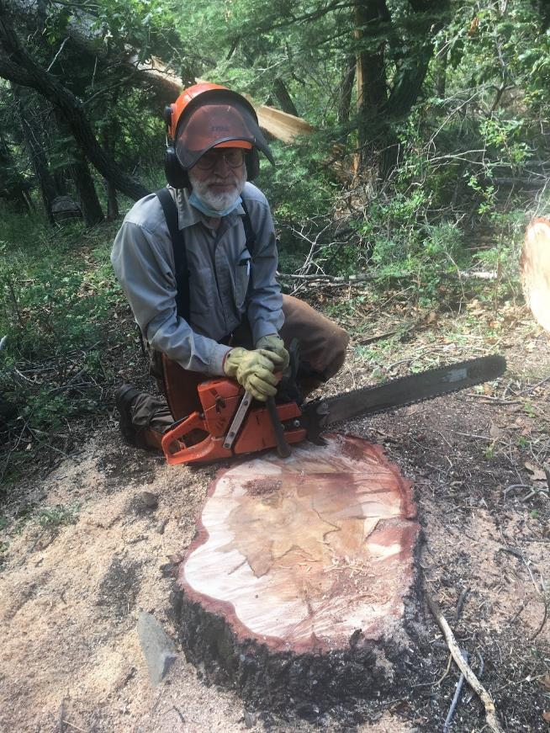

Low cutting this stump at the gate to the Capulin lower area revealed an interesting color pattern.

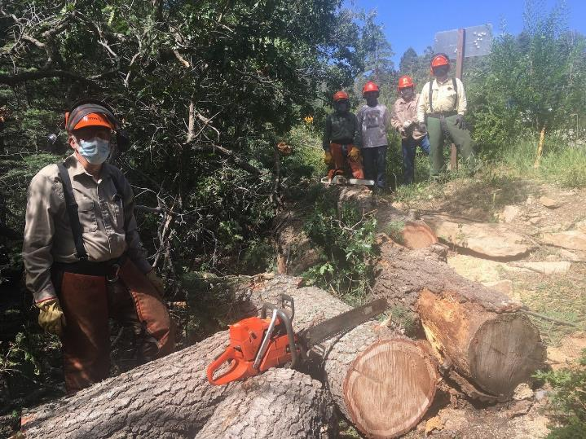

The crew that felled, limbed, and bucked this large hazard tree at the gate to the lower Capulin area.

L to R: Sam Beard, Byron Garner, Steve Roholt, Lou Romero, and Dennis Crowter.

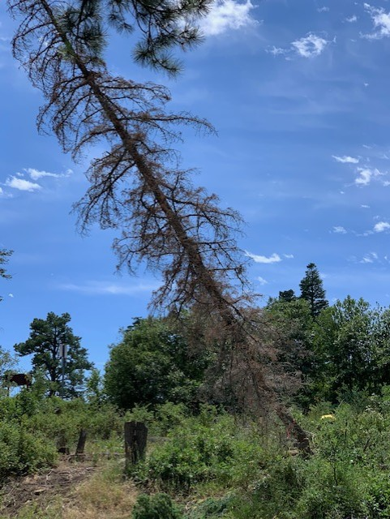

This falling tree was felled by Bob Lowder at Balsam Glade Picnic Area. Photo by Sally Lowder

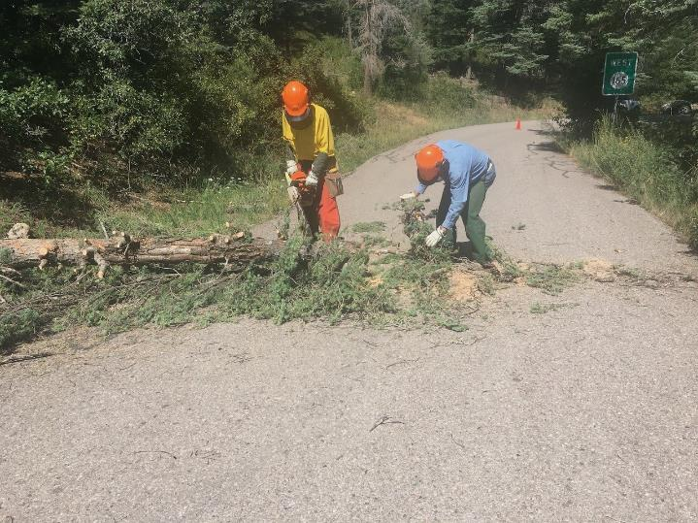

Jerry Pakerak is collecting branches while Bob Lowder is bucking the trunk of this tree.

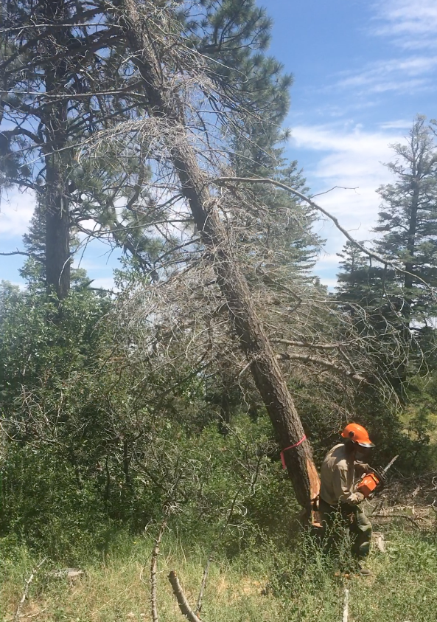

Bill Savage is running away from this tree that he has felled.

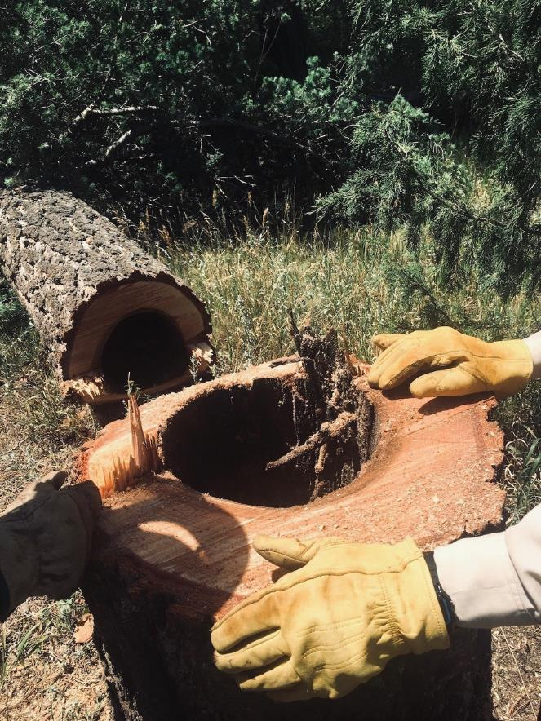

A hollowed hazard tree that was felled in Balsam Glade Picnic Area.

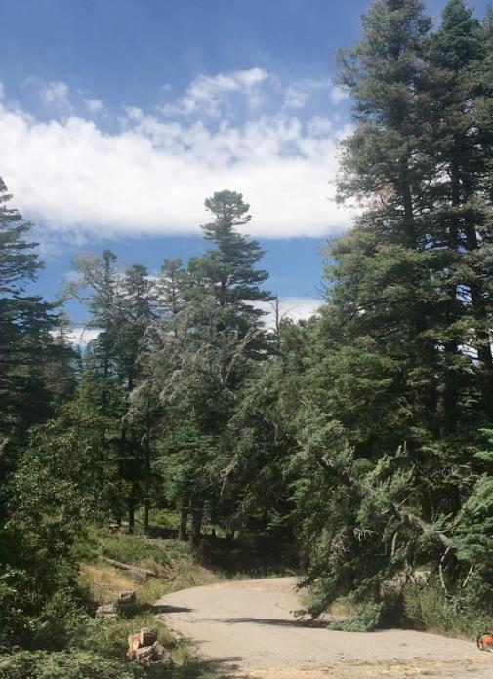

This hazard tree was felled by Bill Savage at Balsam Glade Picnic Area.

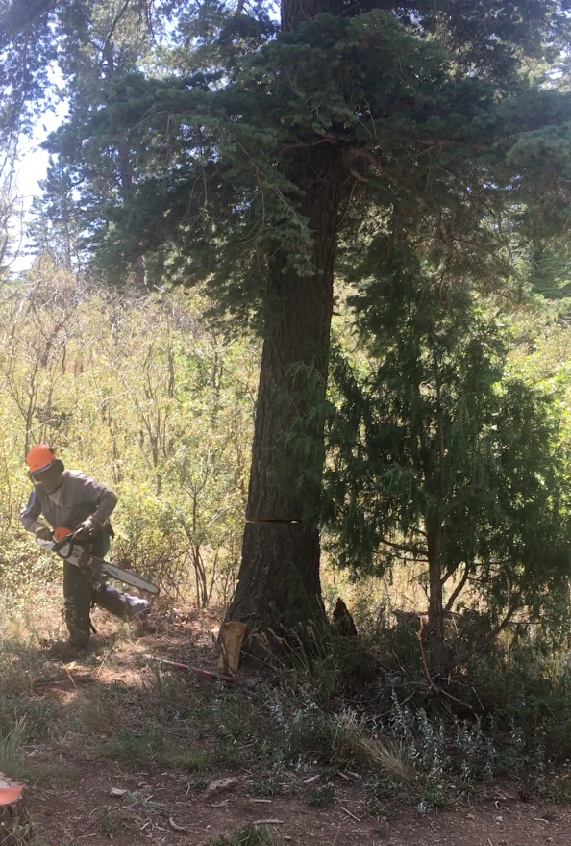

Jerry Carroll running away from a large that he has just felled.

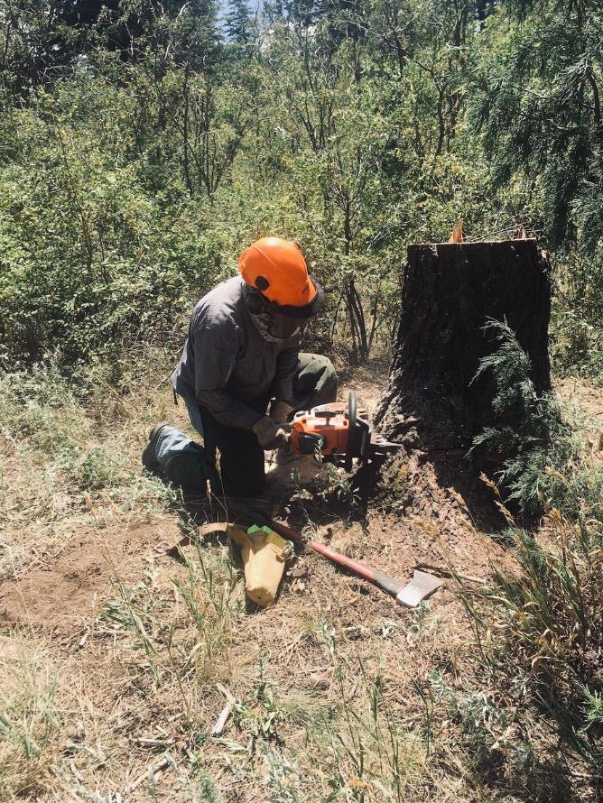

Jerry low stumping a tree that he has felled.