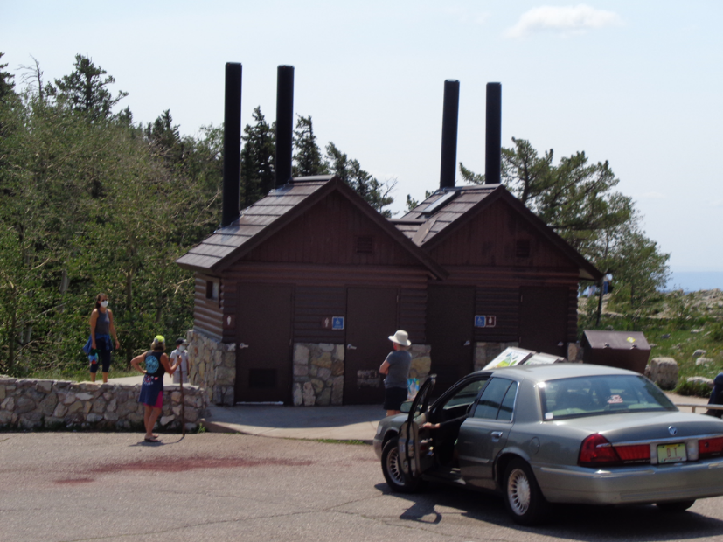

The painting of these restrooms at the large Crest parking lot was completed with Forest Service brown paint on Tuesday, Aug. 18.

All photos by Sam Beard

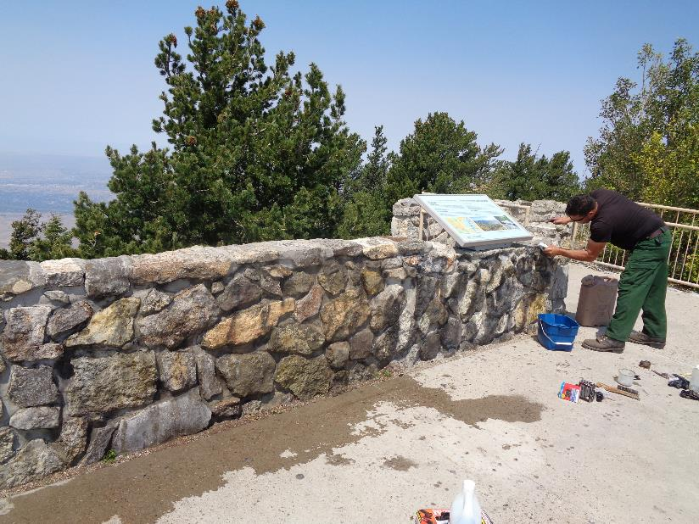

Manny Chavez is removing graffiti from this stone wall at the Crest Overlook.

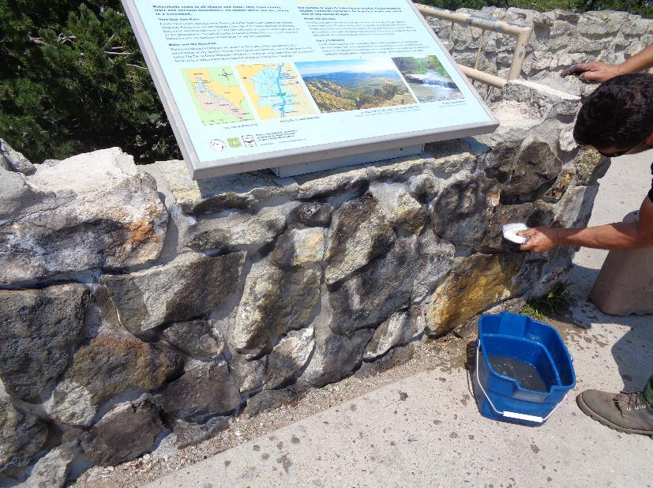

Manny is using water to wash off the graffiti that has been treated with three applications of remover. The application of the remover

has reduced the black spray paint to wide gray lines that Manny is washing off with water and a plastic bristle brush.

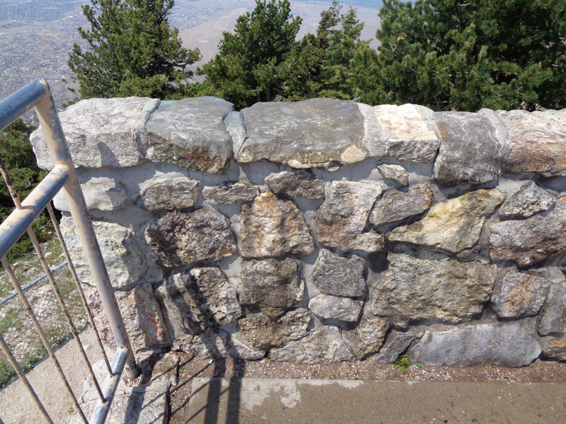

Three applications of graffiti remover and light scrubbing with the brush and water has removed most

of the black graffiti from the stone wall.