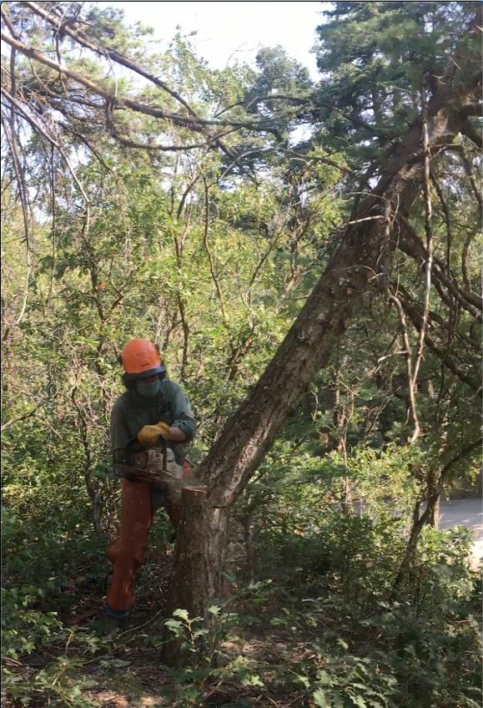

Byron Garner felling a small white fir to clear the lay for a larger fir hazard tree.

All photo by Cliff Giles

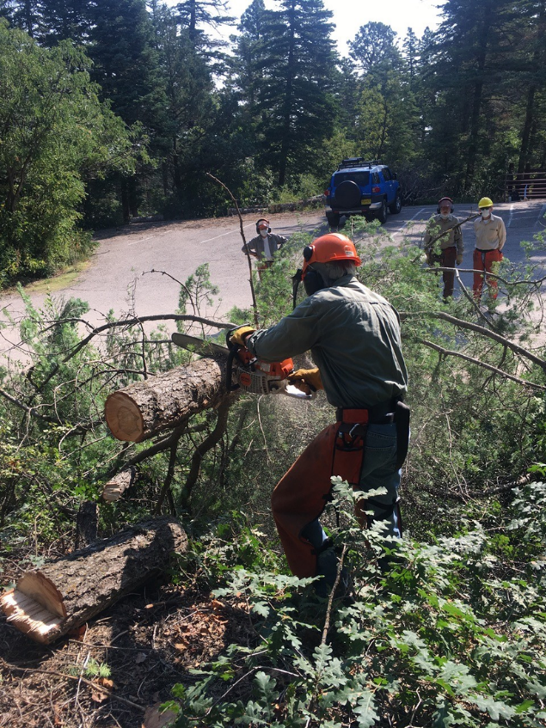

Byron bucking the tree that he has felled at the lower Balsam Glade PA parking lot.

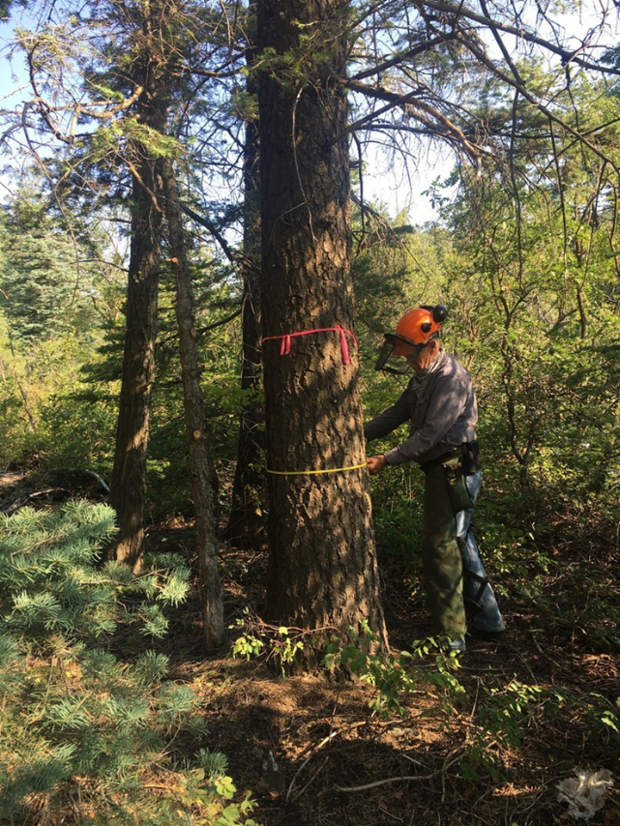

Jerry Carroll measuring the diameter of the hazard tree that he will fell.

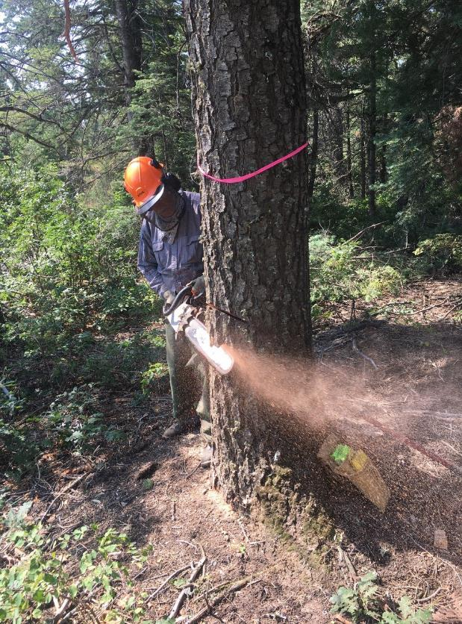

Jerry making an open face cut in the tree he will fell.

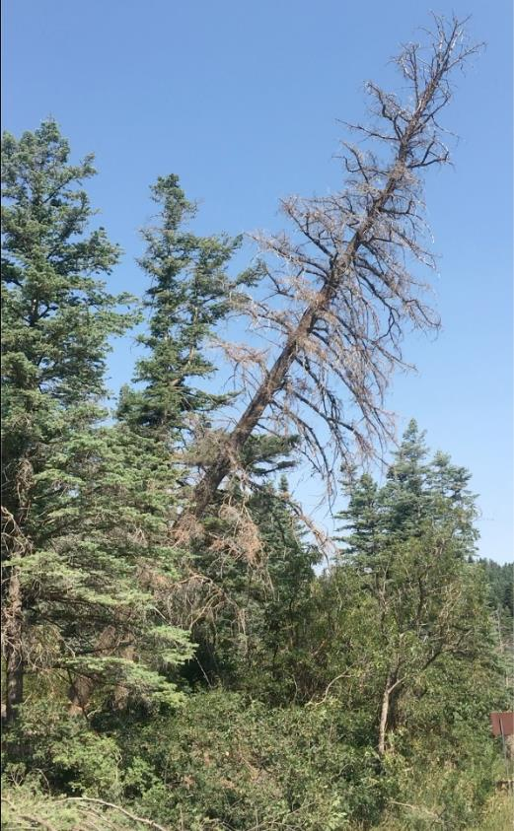

The tree that Jerry was cutting is falling.

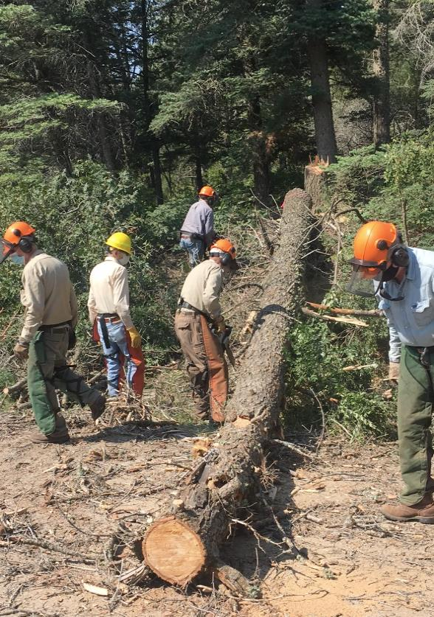

Bucking the tall tree that Jerry has just felled.

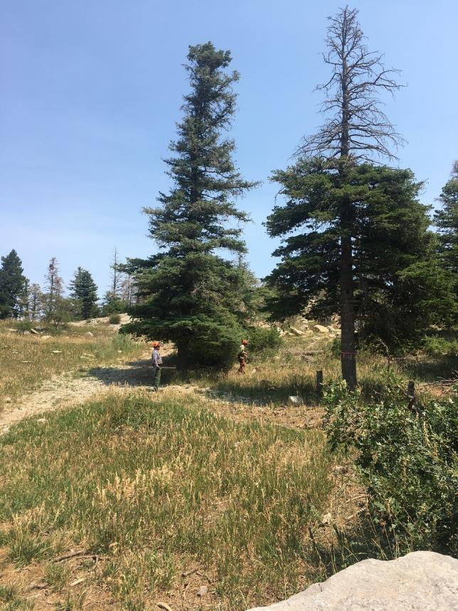

Jerry is analyzing the next tree that he will fell in the Ski Area Overflow Parking lot.

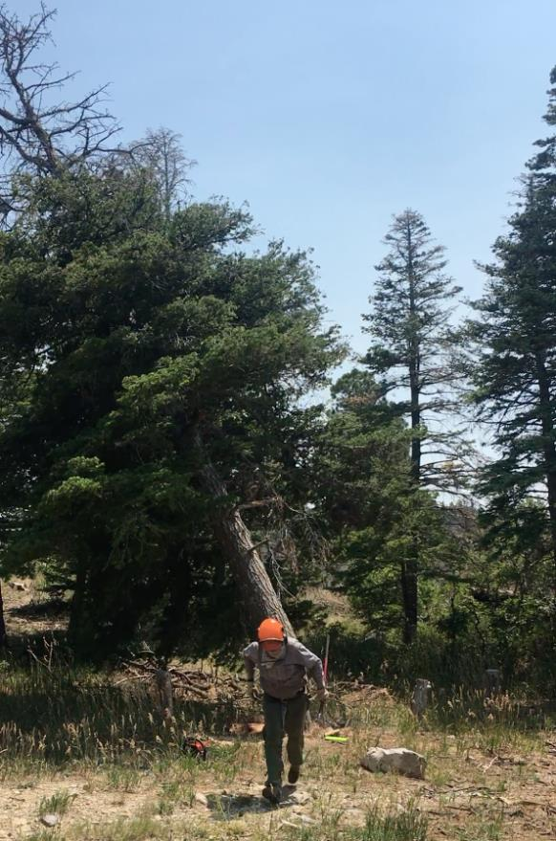

Jerry running away from the tree that he has just felled.

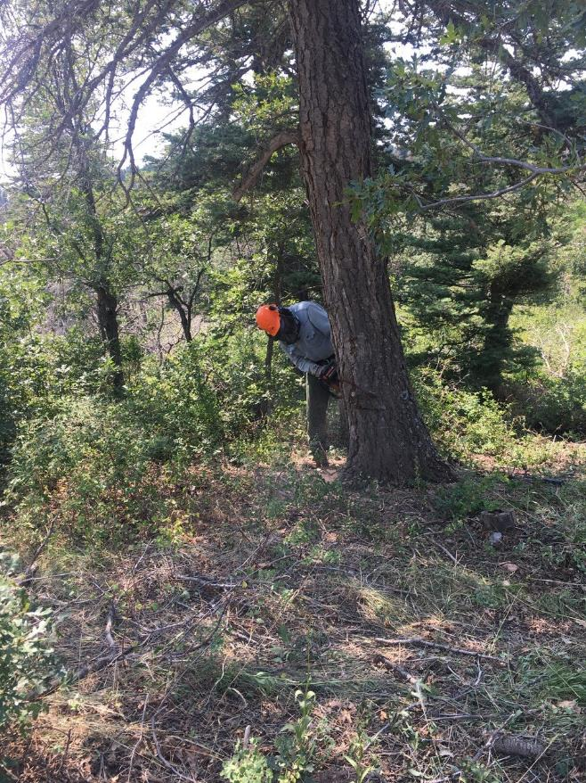

Eric Russell making a face cut in a hazard tree in the Ski Area Overflow Parking Lot.

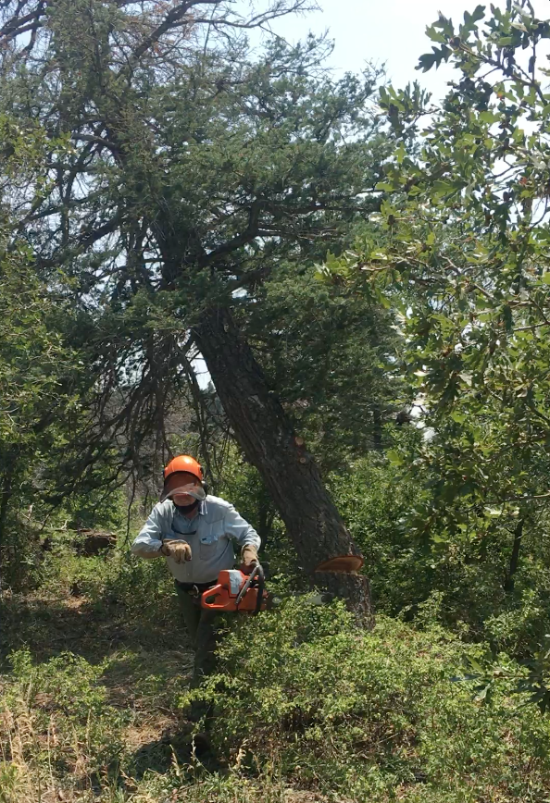

Eric running away from the tree he has just felled.