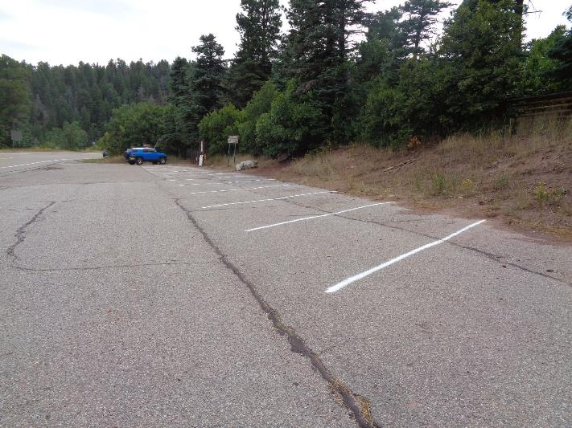

The crew painted parking stripes in the Tree Spring Trailhead parking lot.

All photos from Sam Beard

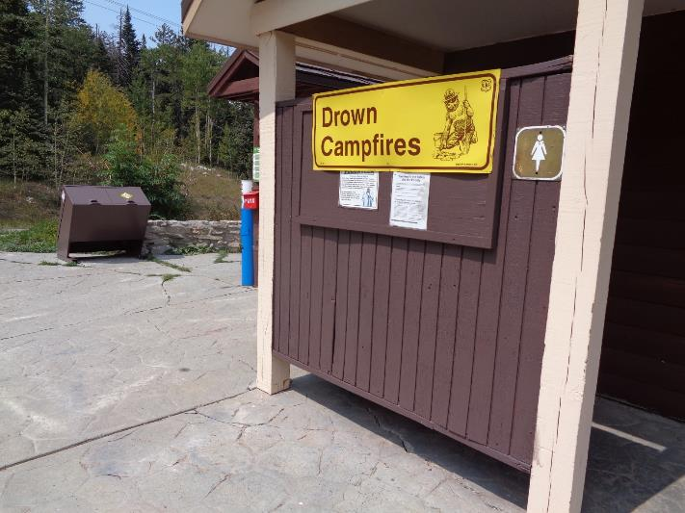

The crew painted the sign board, privacy panel, and trash container at Ellis Trailhead.

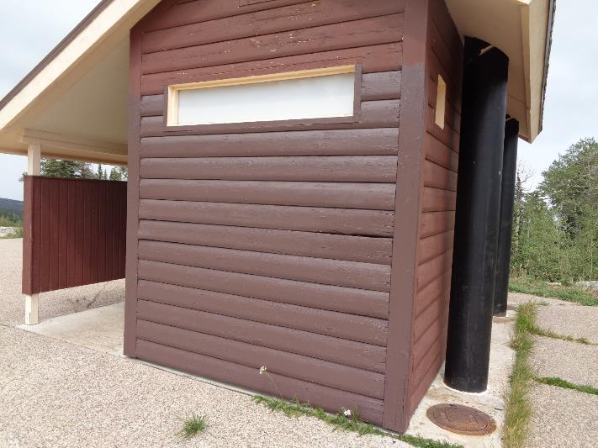

The crew painted the south wall of the restroom and a trash container at 10K Trailhead.

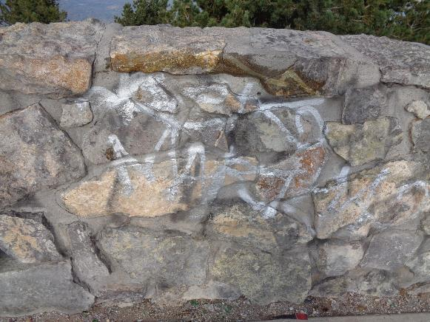

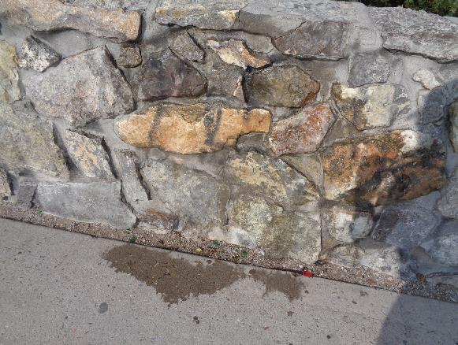

Stone wall at the Crest Overlook before and after the silver graffiti was removed.

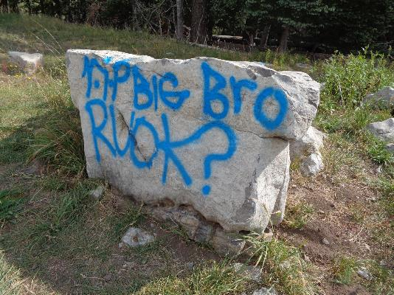

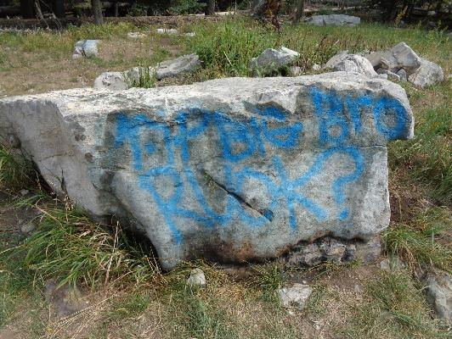

Blue graffiti on a large boulder near the 10K Trailhead parking lot before and after

graffiti remover was used in attempt to remove the blue paint. On Sandia Mountain,

this blue paint is the most difficult to remove.

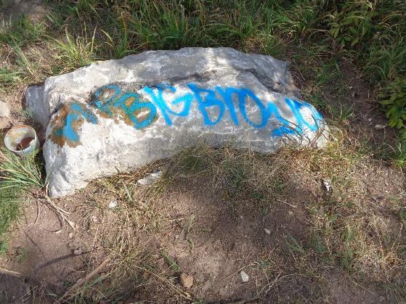

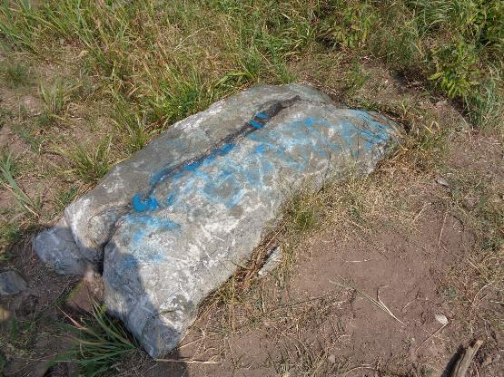

Blue graffiti on the second boulder near the 10K Trailhead parking lot before and after

graffiti remover was used to remove most of the blue paint.

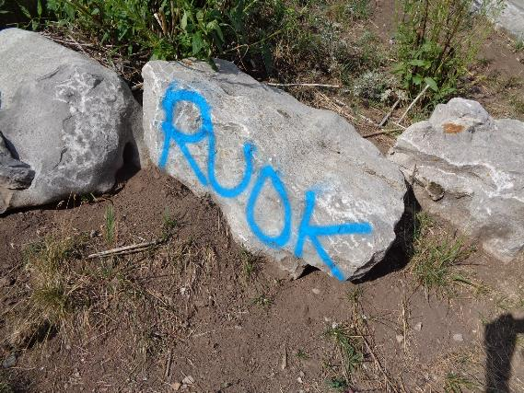

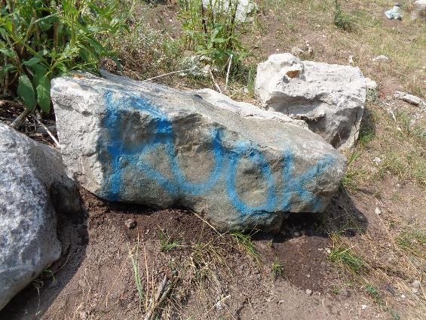

Blue graffiti on the third boulder near the 10K Trailhead parking lot before and after

graffiti remover was on partially successful in removing the paint.

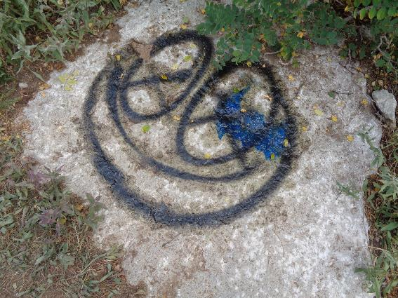

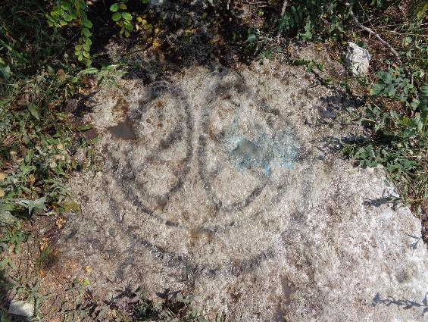

Black graffiti and a blue bat 0.2 mile from 10K TH in the old road clearing before and after

most of the paint was removed.

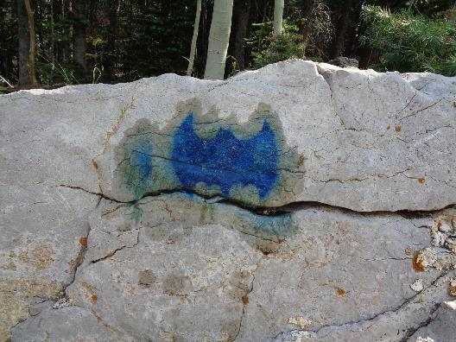

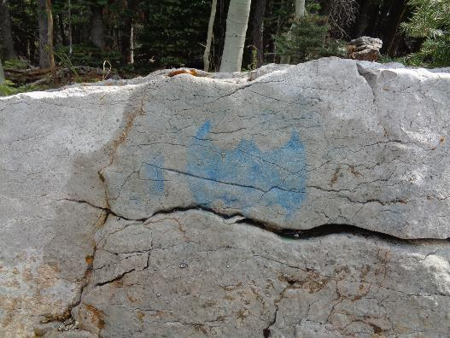

This Bet’s bat. Bet Gendron told me about this graffiti about 0.4 mile from 10K North Trailhead

on the old road clearing. The bat is about 9 inches wide. I think that it was painted with

a stencil in order to have the well-defined edges. Even though I scrubbed it with a plastic bristle

brush, I could not remove all the blue paint.