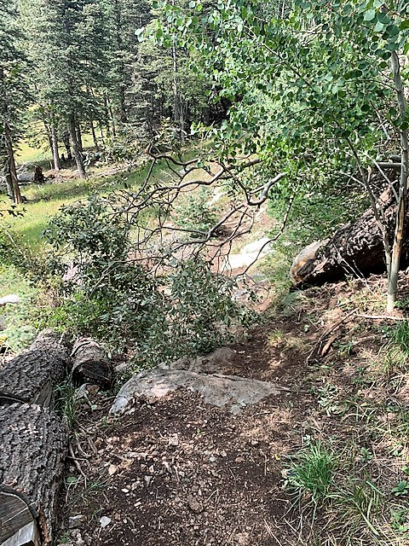
This small Aspen tree had been completely uprooted and
fell across 10K South trail above one of the ski runs.
It was removed.

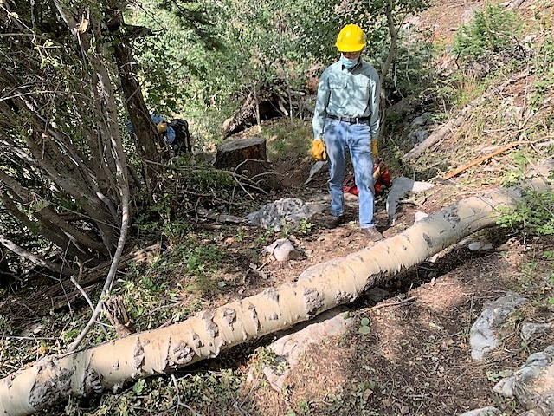
Byron studies an 8-inch diameter Aspen which had fallen over 10K South just above the tree in the previous photo. It was removed.
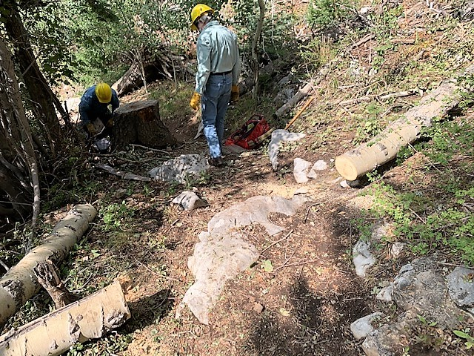
Fallen aspen in previous photo has been removed.

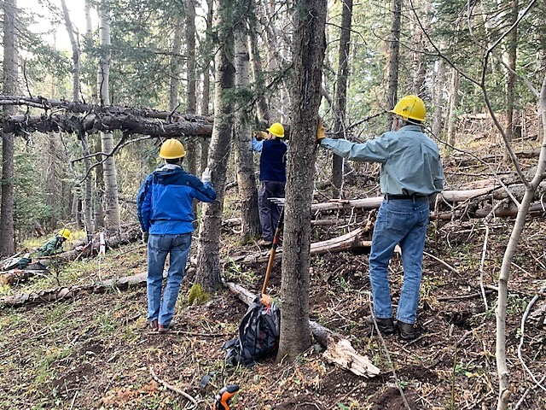
This double hangup was looming over Gravel Pit trail. It was made up of two dead fir trees, one about 3-inches in diameter and the larger one about 7-inches in diameter. It had been evaluated before, but now appeared to be moving down slightly. The cuts were made well above the trail level to provide a safer location for using the saw.
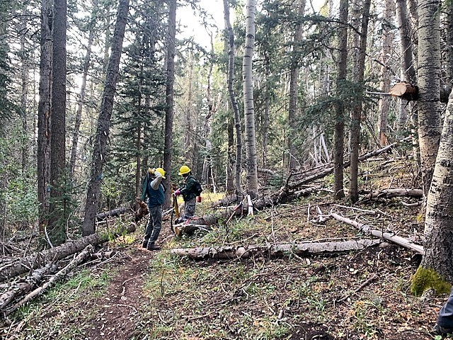
The old hangup over Gravel Pit has been removed. A cut end can be seen in the upper right of the photo.

