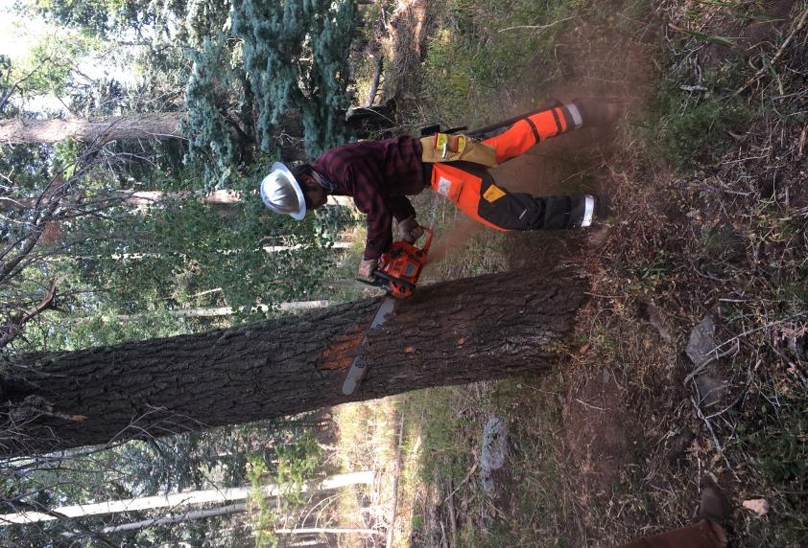

Michael Arndt slabbing the side of the fir tree to reduce the width of the tree so that

he can fell the tree with the 24-inch bar on his saw. Photo by Cliff Giles.

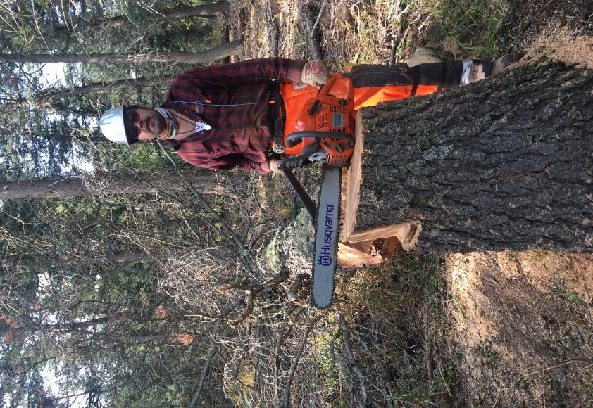

Michael, his saw, and the fir that he felled. Photo by Cliff Giles

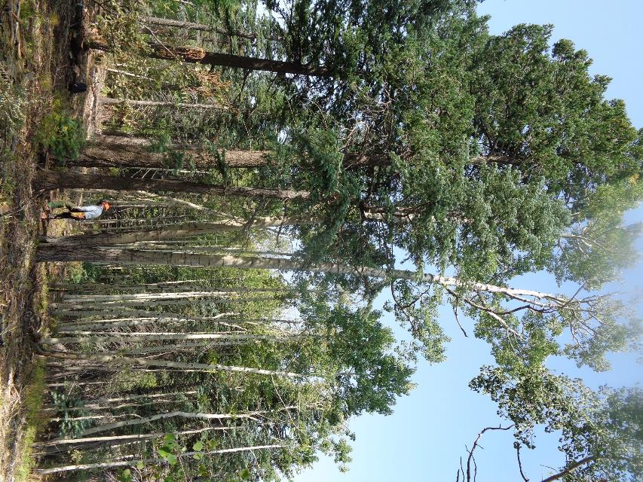

The large double trunk aspen behind Eric Russell that he and Jerry Carroll will fell. Photo by Sam Beard

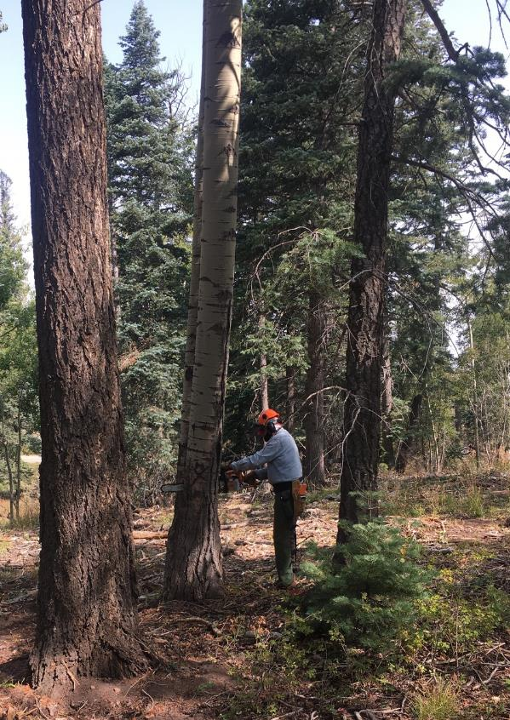

Eric making a vertical cut to separate the two trunks before he fells the first trunk.

Note the end of the bar protruding past the left side of the tree. Photo by Cliff Giles

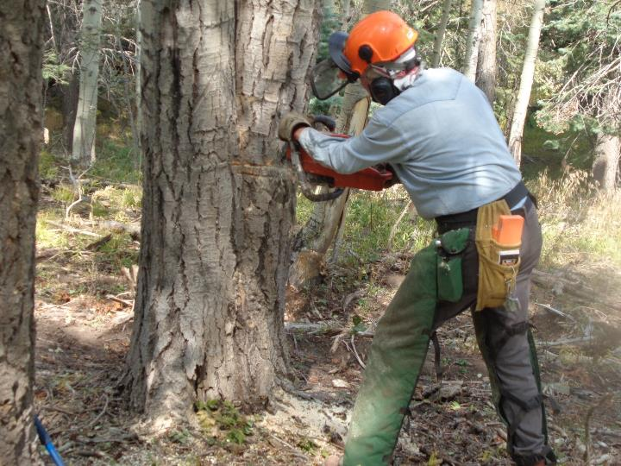

Eric cannot make a traditional back cut starting on the outside of the trunk due to the presence of the second trunk. He has made a plunge cut through the trunk and cut to the right to define the thickness

of the hinge wood. Here he is cutting to the left to finish felling the trunk. Photo by Sam Beard

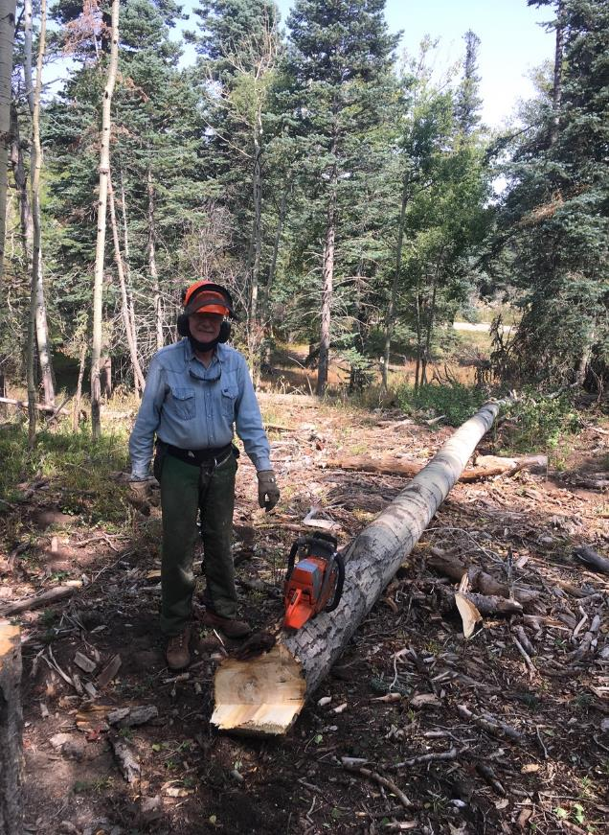

Eric and the aspen trunk that he has just felled. Photo by Cliff Giles

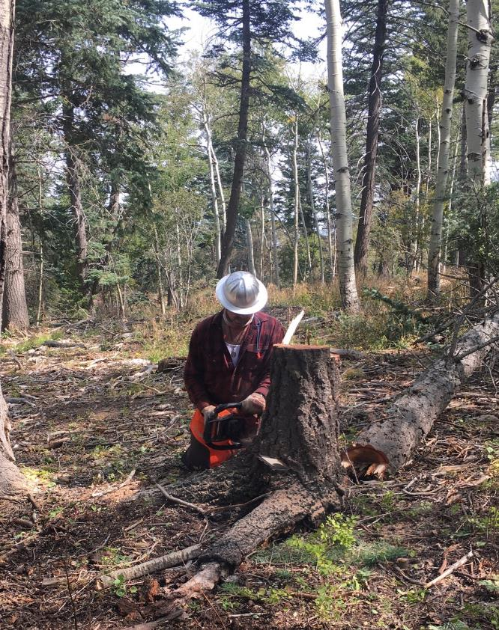

Michael low stumping the fir that he has just felled to make a clear lay for the second aspen trunk

that Jerry Carroll will fell. Photo by Cliff Giles

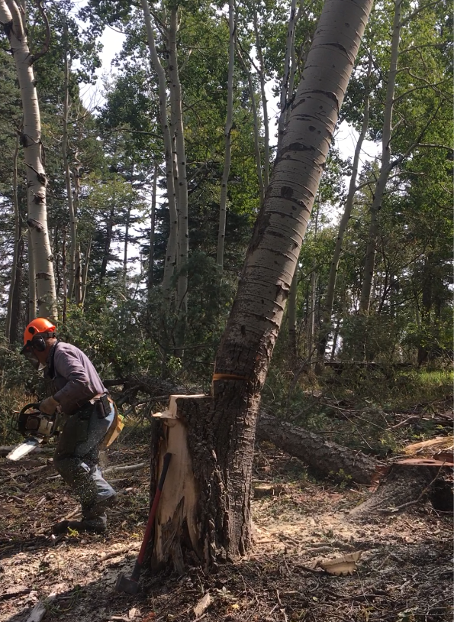

Jerry running away from the second aspen trunk that is just starting to fall. Photo by Cliff Giles.

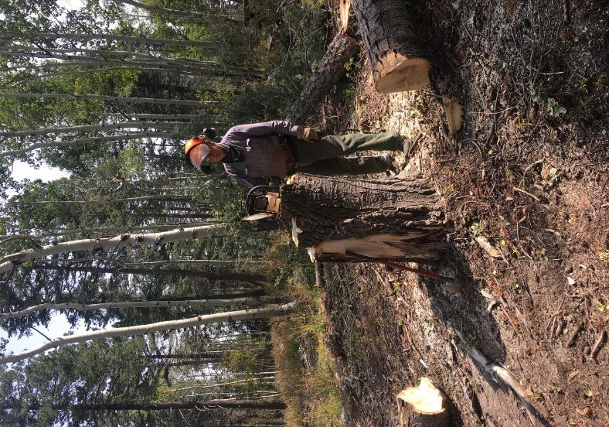

Jerry at the stump of the trunk that he has just felled. Note that the unusual stump has

four top levels. From left to right, the lowest is the first trunk face cut, the second is the plunge

back cut for the first trunk, the highest is the second trunk back cut, and finally the narrow

cut on the right is the second trunk face cut. Photo by Cliff Giles

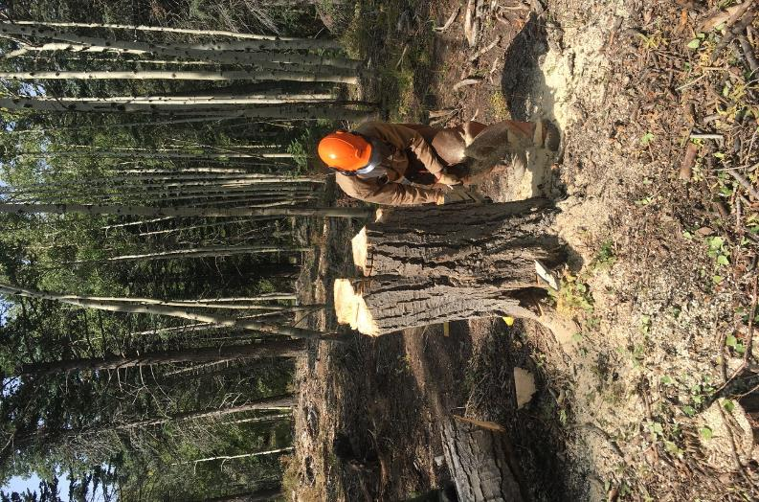

Sam Beard low stumping the double trunk aspen with the FOSM Stihl MS460 saw with a 32-inch

bar. The tip of the bar is visible at the base of the stump. The four top levels on the stump

are more visible in this photograph. Photo by Cliff Giles