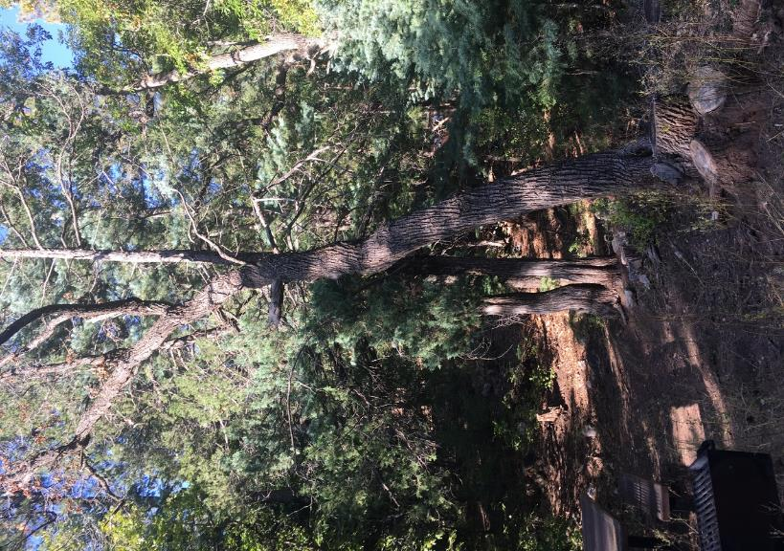

A 15-inch diameter Gambel oak adjacent to a picnic table in Sulphur Canyon Picnic Area.

Photo by Cliff Giles

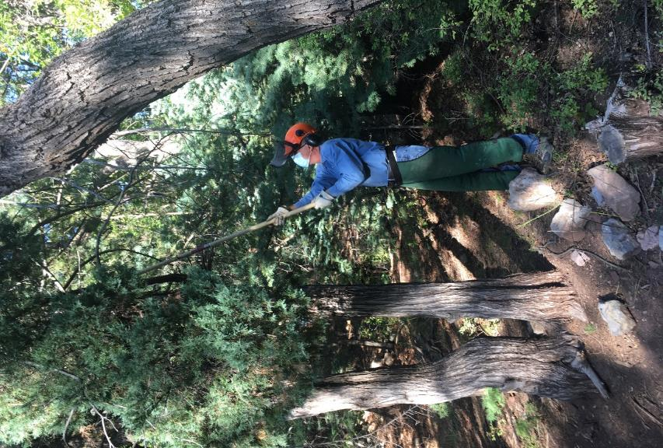

Jerry Pekarek using a pole saw to remove a juniper branch that the oak on the right

would hit when it is felled. Photo by Cliff Giles

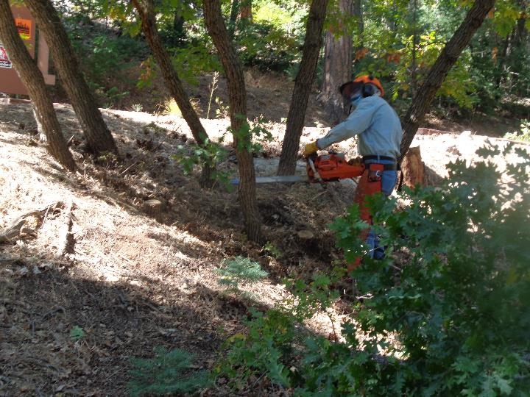

Sawyer trainee Byron Garner felling a small oak in the upper part of Sulphur Canyon Picnic Area.

Photo by Sam Beard

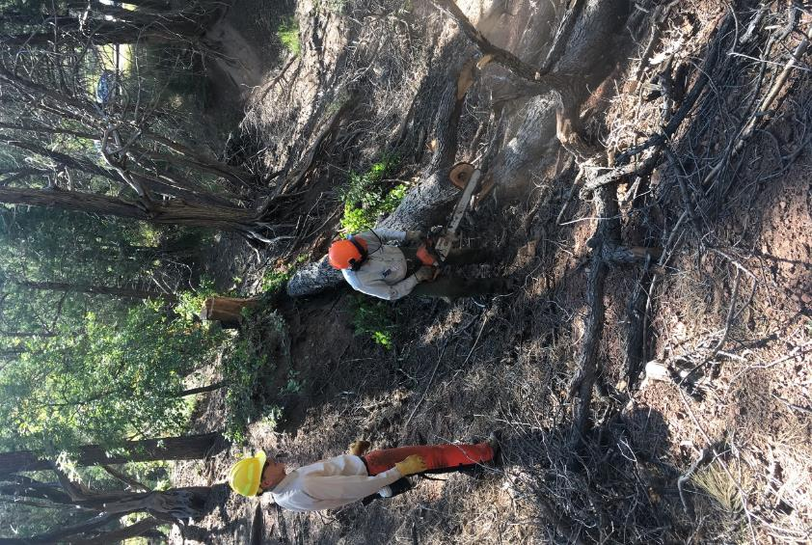

Sim Cook observing Eric Russell bucking an oak in a creek bed in Cienega Canyon Picnic Area.

Photo by Cliff Giles

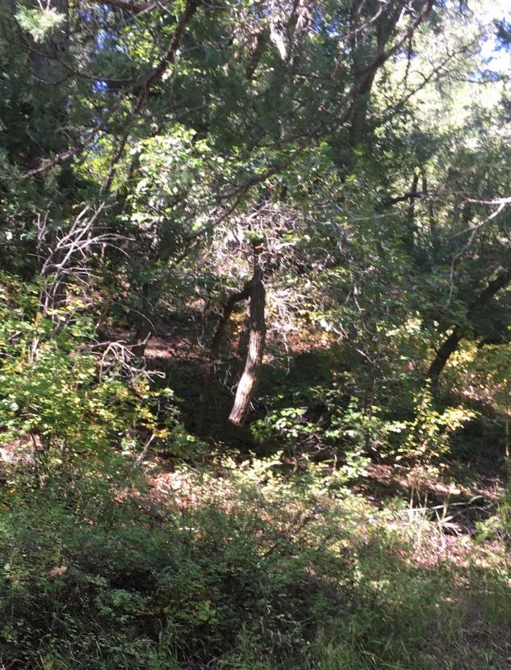

A dangerous 4-inch diameter oak trunk hanging about 4 feet from the ground in Cienega PA.

Sim Cook found it, and Eric decided to remove it by felling the two 8-inich trees that it was hanging from.

Photo by Eric Russell

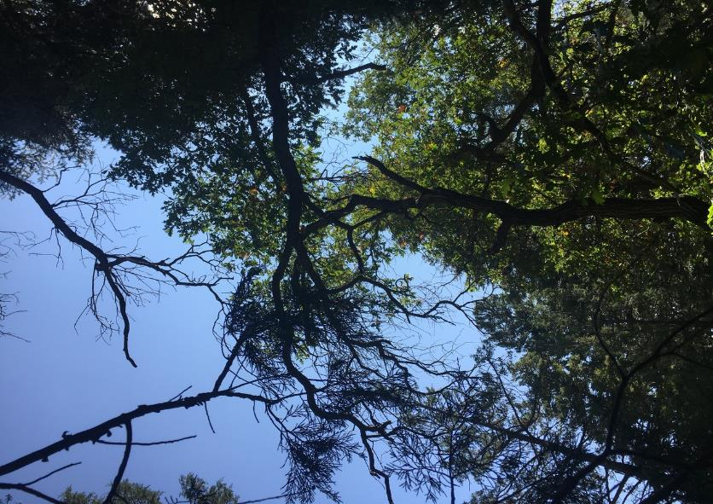

Looking up at the many dead tops on Gambel oak trees in Cienega Picnic Area.

Photo by Cliff Giles

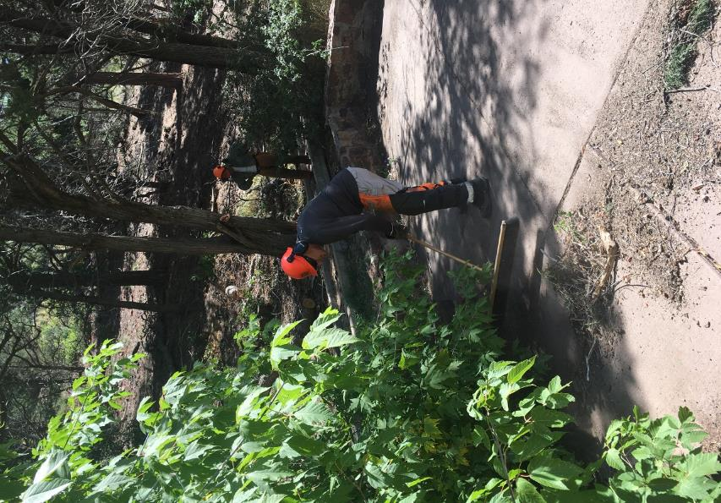

Steve Roholt sweeping dirt and debris from part of the Cienega Nature Trail that

FOSM adopted years ago. Don Carnicom is in the background. Photo by Cliff Giles

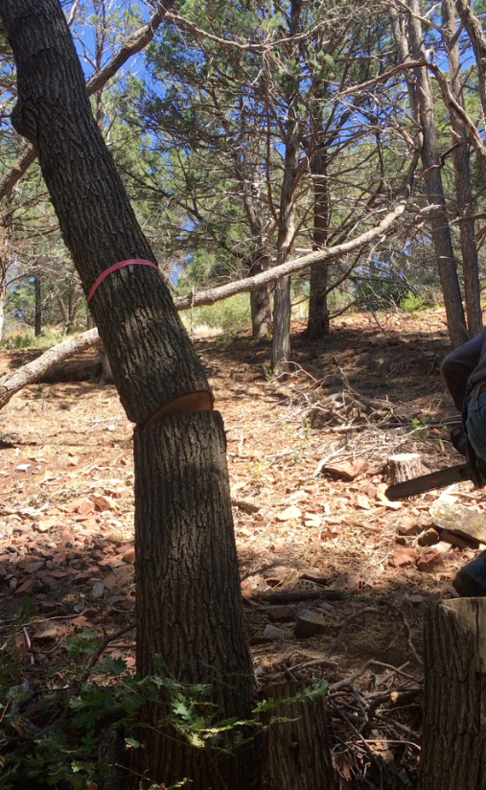

This oak along the Nature Trail is beginning to fall as sawyer Jerry Carroll runs to the right

with his chain saw. Photo by Cliff Giles

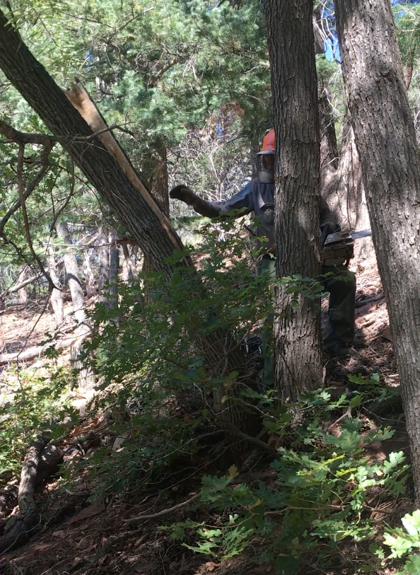

Jerry at a large oak that has naturally split vertically due to the very high tensile stress on the upper curved

surface of the tree. This phenomenon can also occur when a sawyer makes a traditional back cut

in a tree with a very heavy lean. It is known as “barber chairing” due to the resulting shape of the

tree stump with a high back. If barber chairing occurs when a back cut is being made, the upper

part of the trunk can separate and shoot back extreme rapidly and be very hazardous to the sawyer.

Photo by Cliff Giles.

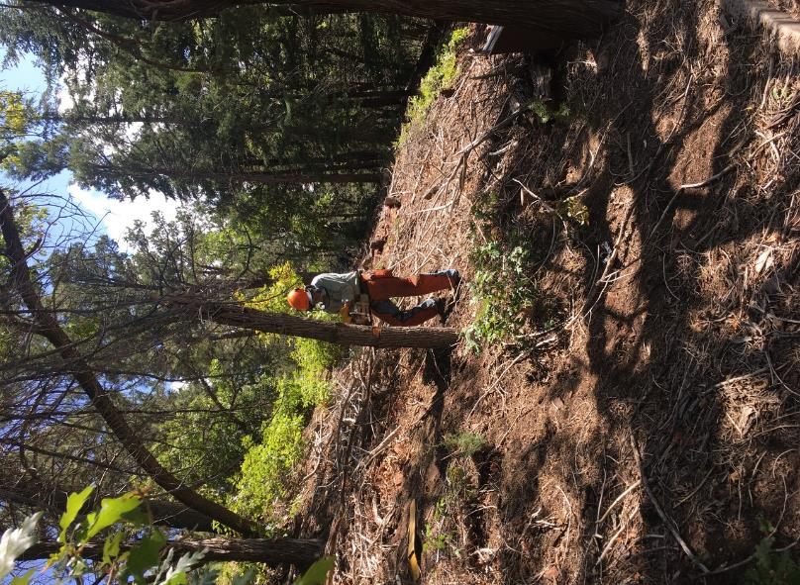

Sawyer trainee Byron Garner felling a short dead oak along the Nature Trail.

Photo by Cliff Giles

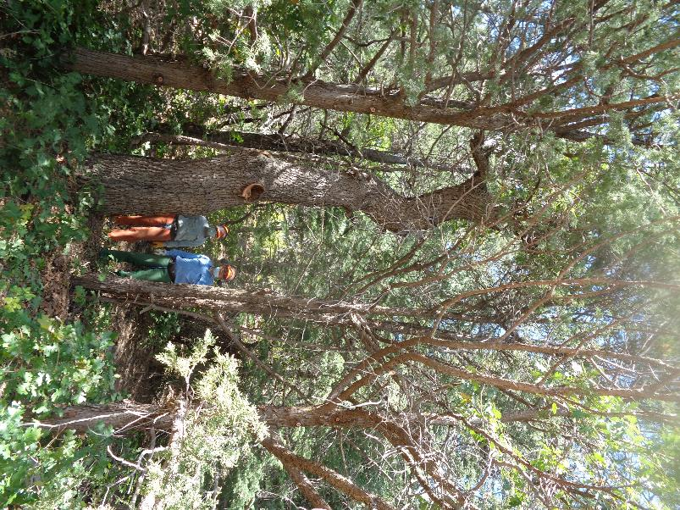

L to R: Byron Garner and Jerry Pekarek standing beside a dead 26-inch diameter Gambel oak

at the Cienega Group Picnic Area. We will fell this hazard tree next Wednesday.

Photo by Sam Beard