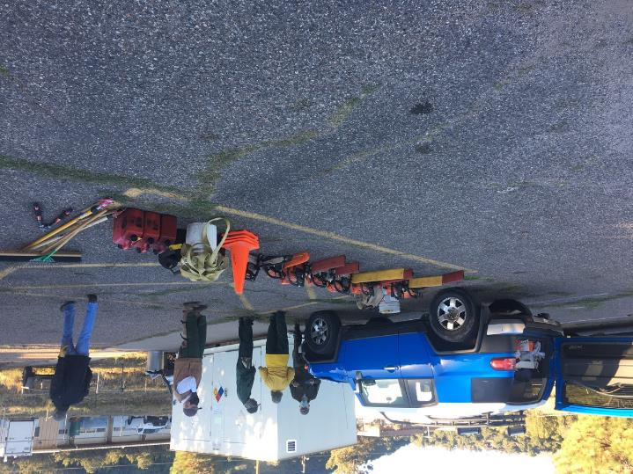

Equipment at the FOSM Guard Station ready to load on three vehicles.

All photos by Cliff Giles unless stated otherwise.

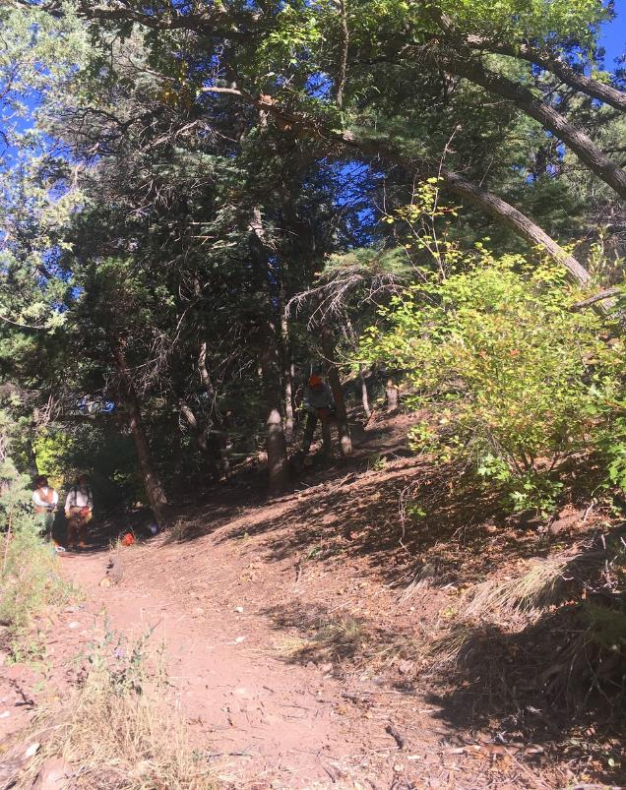

Eric Russell in the deep shade is felling an 8-inch Gambel oak onto Acequia Trail in Cienega Picnic Area.

Sawyer Trainee Byron Garner felled this hollow oak that broke into three pieces when it fell.

Photo by Sally Lowder

After Byron low-stumped the tree, I pushed the top over and dirt just poured out.

We cleared the dirt, and it showed only a 1” ring of solid wood. The dirt

continued well into the ground. Photo by Sally Lowder.

Bob Lowder beginning to fell an 18-inch oak. When this tree fell, it registered a 4

on the Richter Scale! Oak is certainly HARD and HEAVY!! Photo by Sally Lowder

Byron surveying the tree felled by Bob Lowder.

Now, where do I start to clear this mess. Photo by Sally Lowder

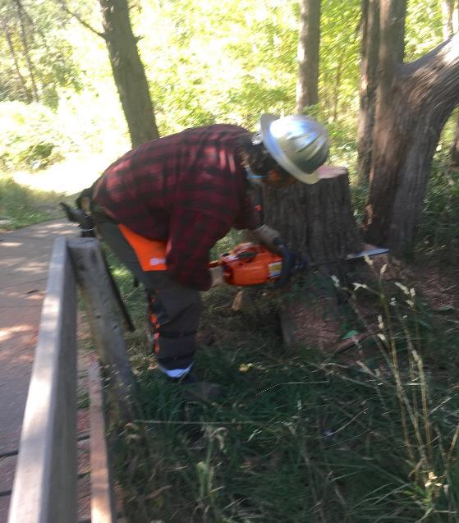

Michael Arndt low stumping where a 21-inch diameter Rocky Mountain juniper cigar butt was felled.

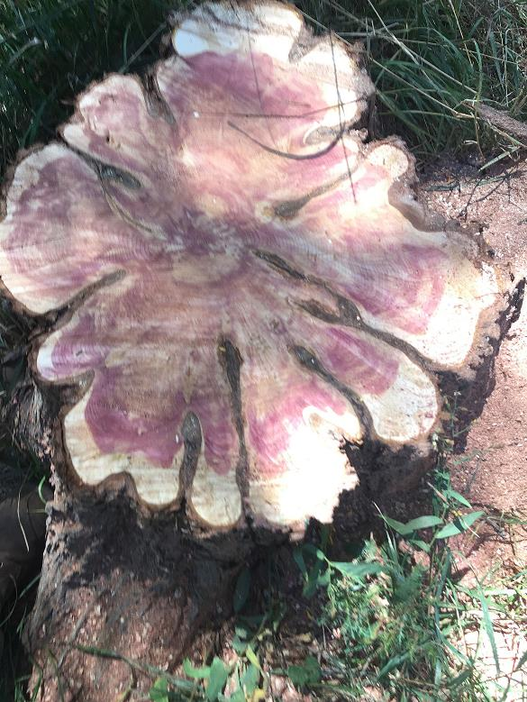

Color pattern in the large Rocky Mountain juniper that was felled. Photo by Bill Savage

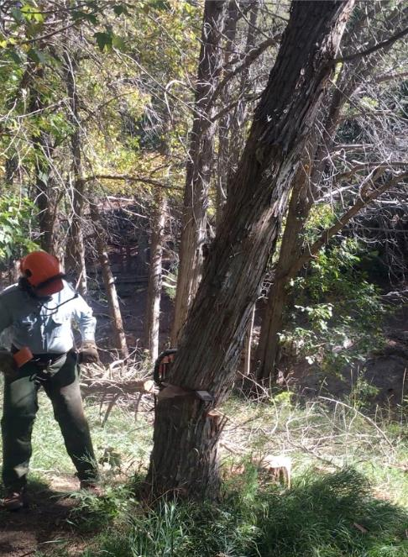

Eric Russell felling a 12-inch Rocky Mountain juniper.

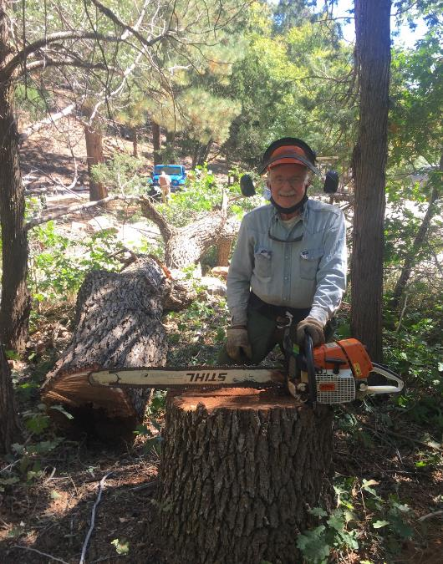

Eric at the stump of the 28-inch diameter oak that he has just felled. The saw is the FOSM

Stihl MS460 with a 32-inch bar.

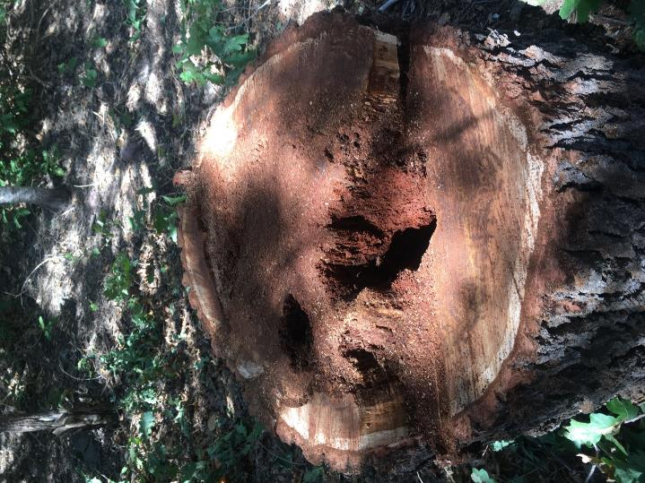

Most of Eric’s 28-inch diameter oak was rotten. The sound wood around the circumference

was only 1 inch to 2 inches thick.

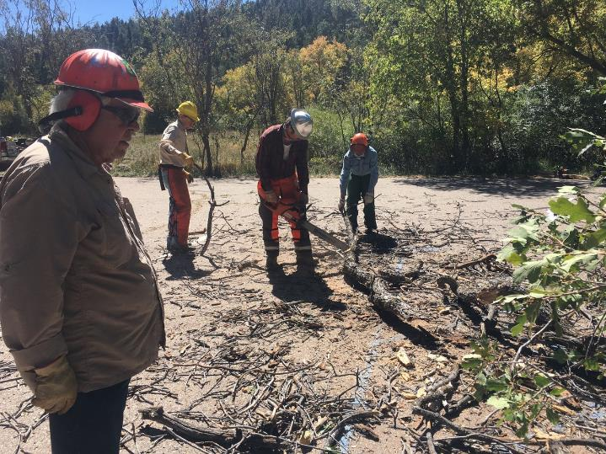

Saw Trainee Michael Arndt is bucking branches from the 28-inch oak that Eric felled.

L to R: Lou Romero, Sim Cook, Michael Arndt, and Jerry Pekarek.

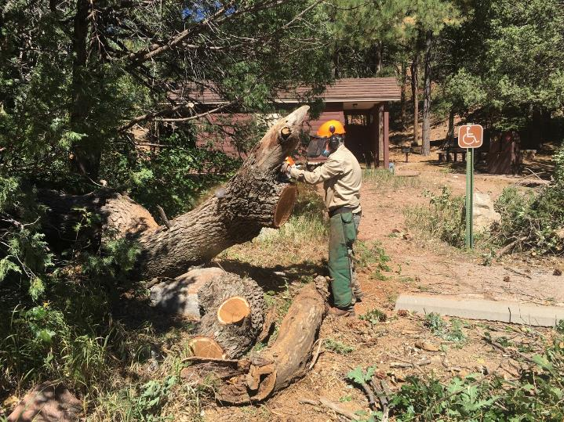

Bill Savage bucking the trunk of the large oak that Eric felled.

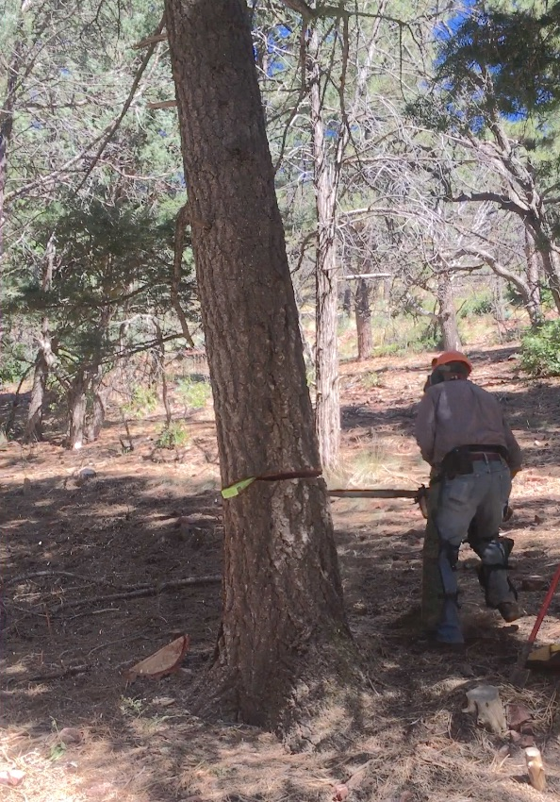

Jerry Carroll running away from the 22-inch diameter fir that he has just felled.

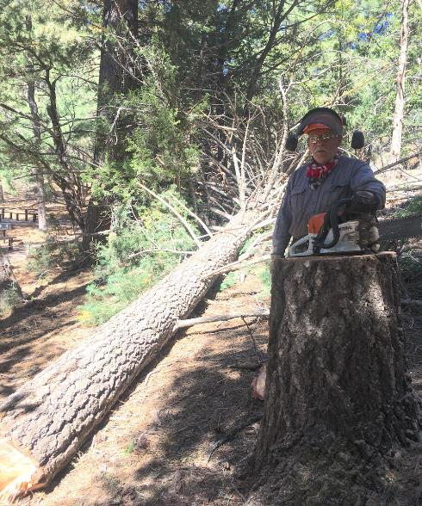

Jerry with the saw that he used to fell this dead fir.

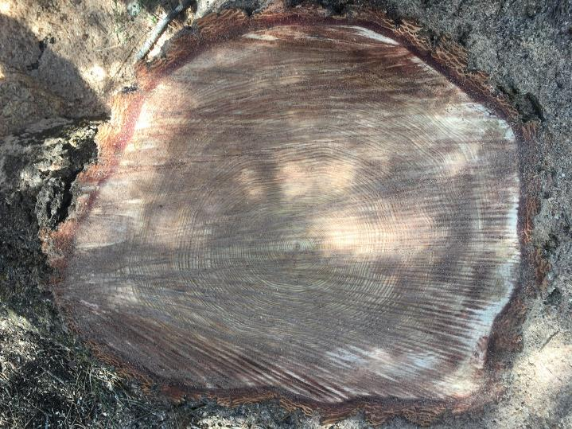

Interesting saw chain pattern in the cut made by Sam Beard when he low stumped the large fir felled by Jerry.