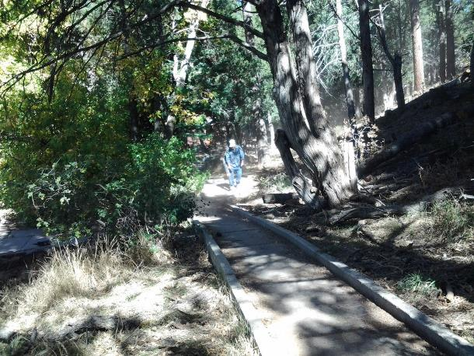

Russell Parker blowing debris off the Group Reservation Area parking lot in Cienega Canyon Picnic Area.

He then started cleaning the paved Nature Trail in the foreground. Photo by Ellie Parker

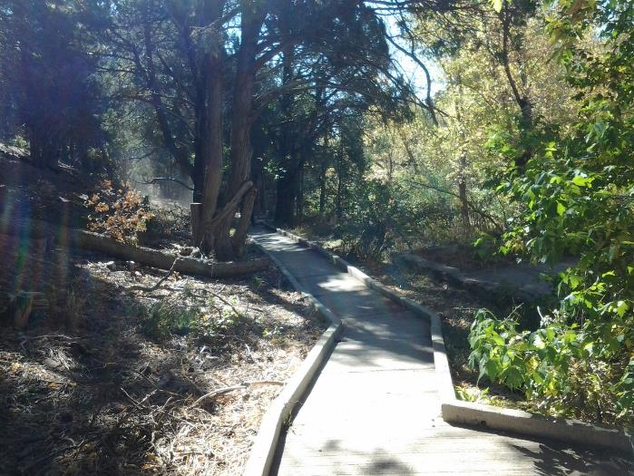

The cleaned paved Nature Trail just above the south bridge. Photo by Ellie Parker

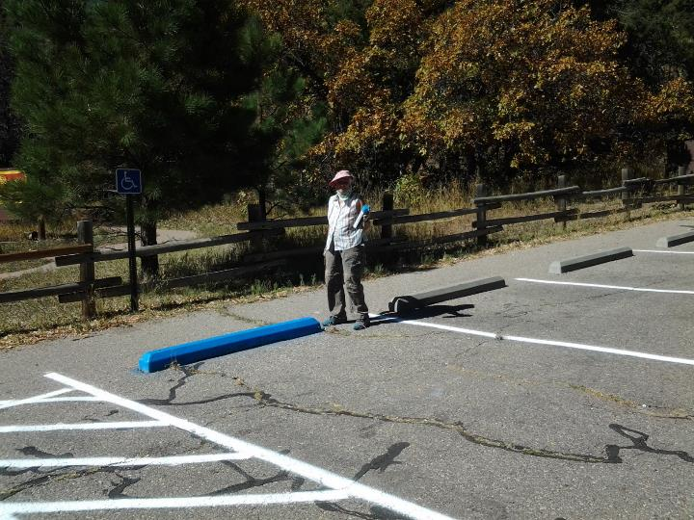

Jane Harrison after spraying blue paint on the handicapped parking space bumper at the second restroom

in Cienega PA. Photo by Ellie Parker

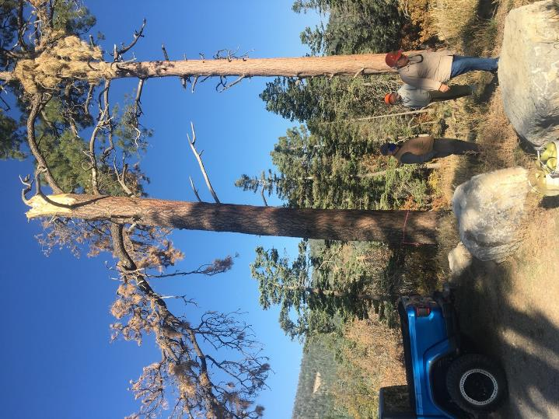

34-inch diameter dead pine that FOSM volunteers felled at the Ski Area Overflow Parking Area

on Wednesday, October 14, 2020. The top half of the tree had fallen hast year,

and FOSM volunteers bucked the trunk and hauled it to the Ranger Station. Note the pink

ribbon around the trunk that marked it as a hazard tree. All photos by Cliff Giles

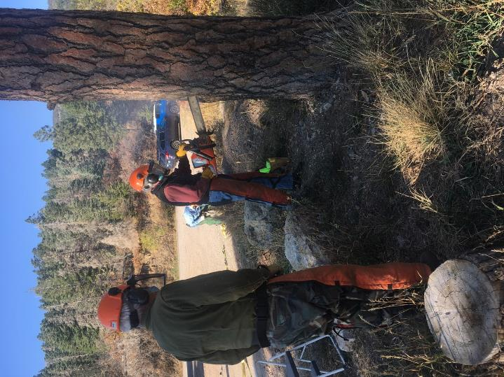

Sam Beard observing sawyer trainee Byron Garner boring the tree to determine if it is rotten or hollow.

The wood was very sound and dense.

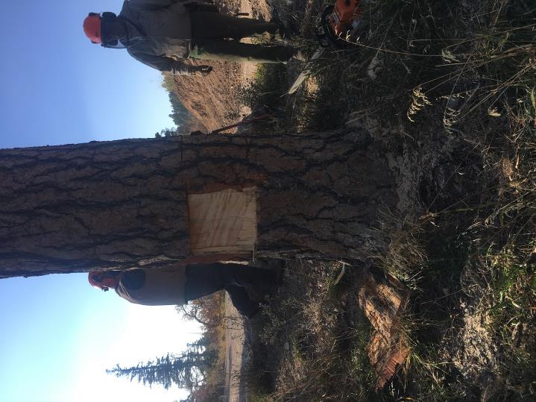

Jerry Carroll has cut a slab of wood off of each side so that the tree maybe felled with the Stihl MS-460

chain saw with a 36-inch bar. The effective cutting length of the bar is actually about 32 inches

due to the long felling dogs or bumper spikes that are stuck into the bark to help hold the saw while cutting.

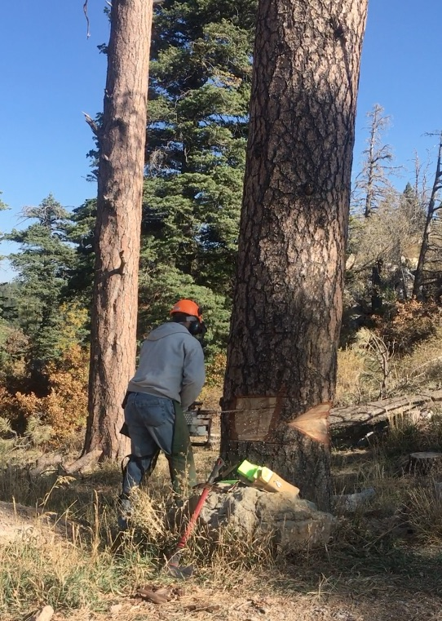

Jerry has completed the face cut on the right side of the tree and is using a plunge cut to cut all the

trunk except the hinge wood behind the face cut and a back strap. When he is ready to fell the tree,

he cuts the back strap with the tip of the bar so that he is as far as possible from the tree when it falls.

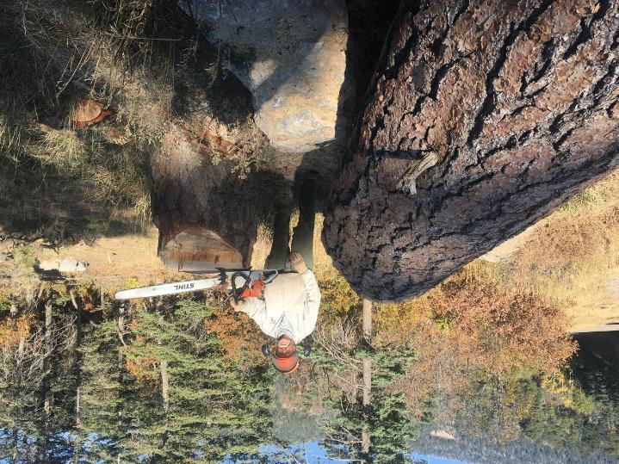

Jerry standing between the stump and trunk with the Stihl MS-460 saw with a 36-inch bar.

Apparently, the trunk fell on the boulders and rolled to the left. Four-inch poles had been placed

on the ground where the tree would fall so that the trunk would be supported off the ground

and the chains would be less likely to hit dirt when the cuts were finished.

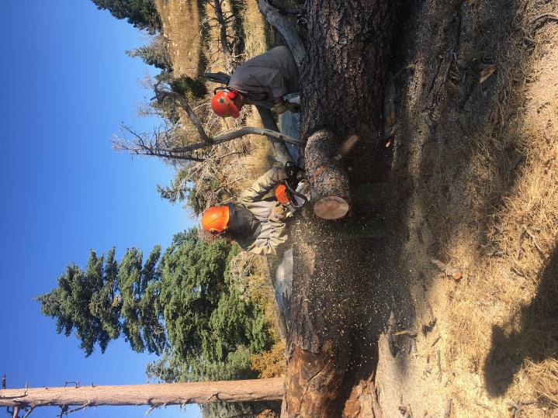

Bill Savage limbing the tree while Lou Romero marks it for bucking into 15-inich lengths.

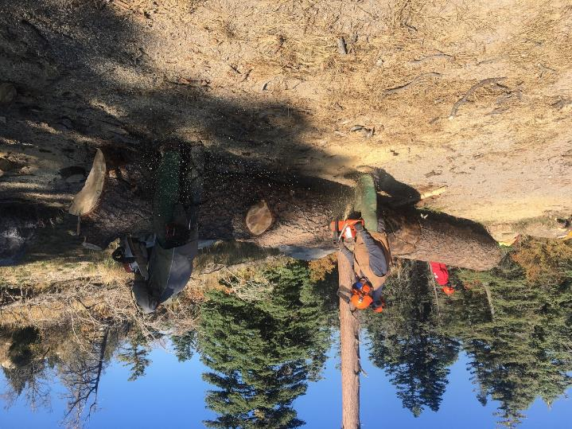

L to R: Dennis Crowther and Bill Savage bucking the trunk.

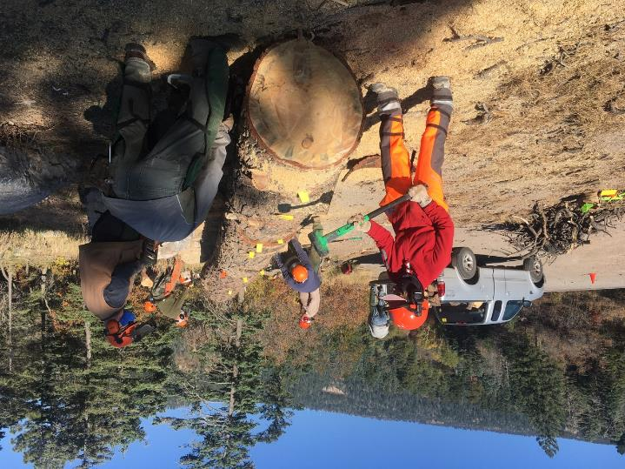

Lorna Morrow driving wedges while sections of the trunk are bucked.

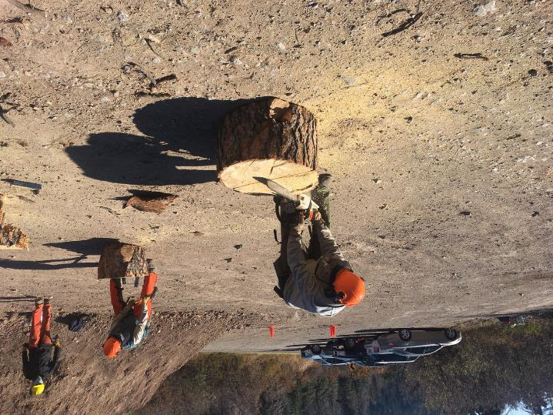

Bill scoring a round with a chain saw to make starting wedges easier.

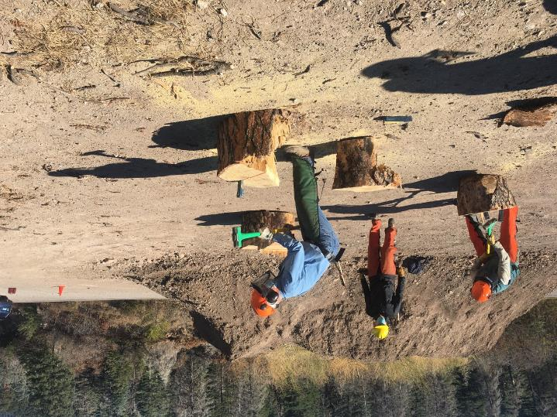

L to R: Jim Levesque, Sim Cook, and Jerry Pekarek splitting rounds with wedges and sledge hammers so the pieces are

not too heavy.

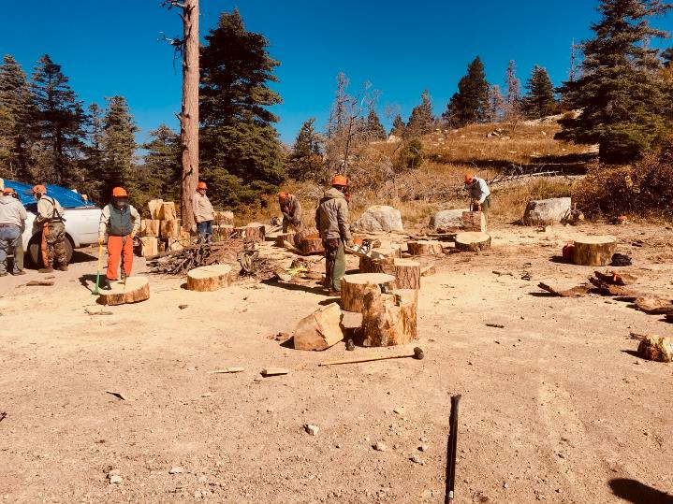

An overview of the parking lot showing the various activities – loading the truck with split rounds, splitting rounds,

scoring a round for easier splitting, and bucking the trunk.

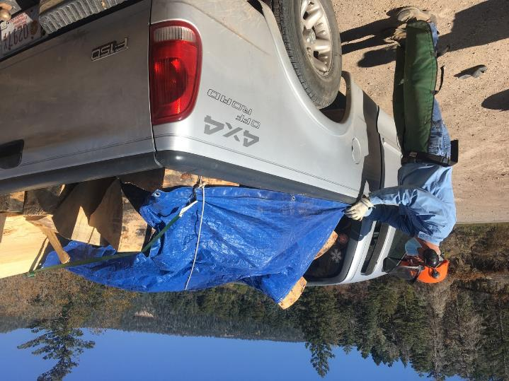

Jerry Pekarek adjusting the tarp over the load of split wood. Sam had obtained a wood hauling permit so

that the wood could be hauled to the ranger station on a private vehicle.

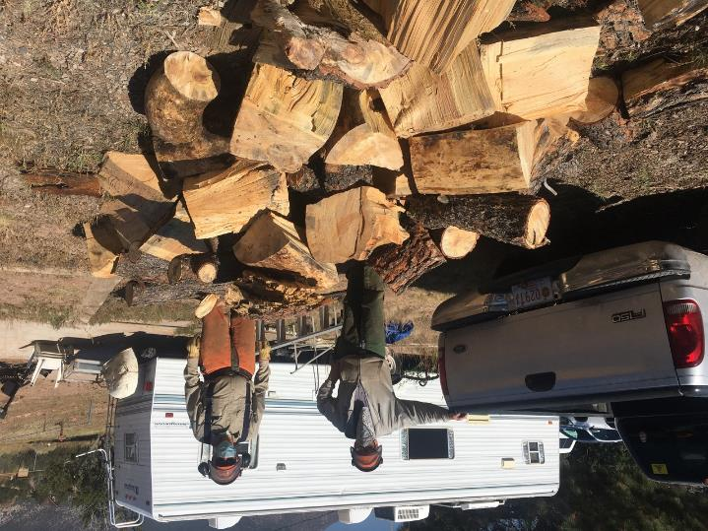

L to R: Jerry Carroll and Sam Beard after Jerry’s truck had been unloaded at the hazmat building behind the ranger station.

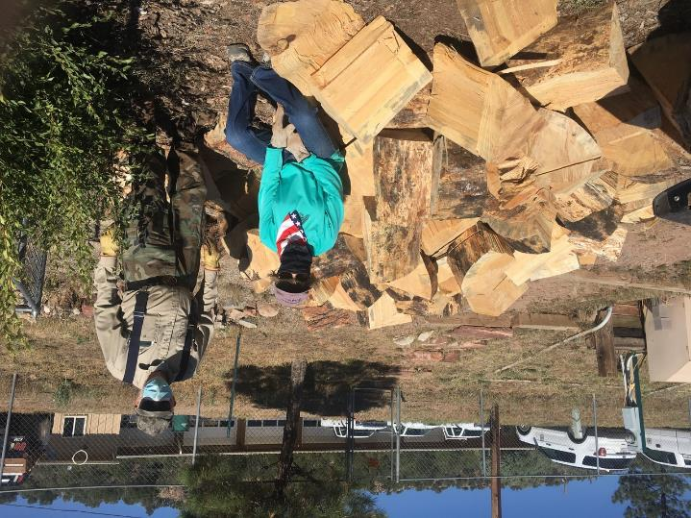

Lorna Morrow and Sam Beard at the wood pile after her truck had been unloaded.

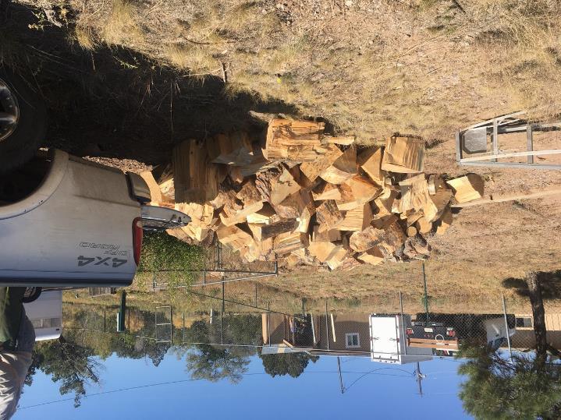

Three pickup loads of wood totaling about two cords that will be donated to the East Mountain Christian Church

Wood Ministry for distribution to needy families in the East Mountains.