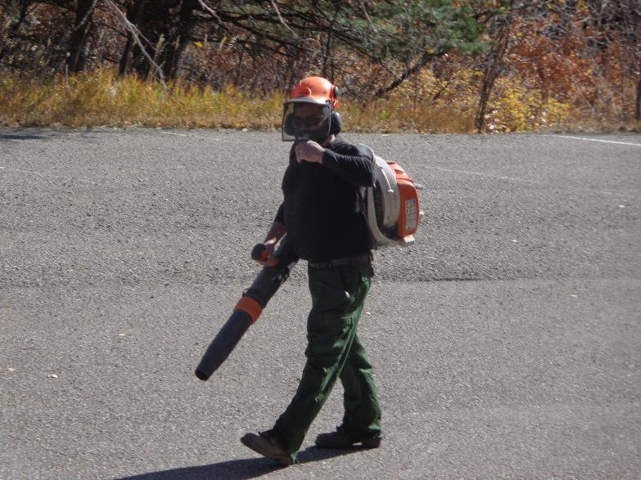

SRD employee Manny Chavez blowing dirt and gravel from the Snow Play Area parking lot so that stripes can be painted.

All photos by Sam Beard

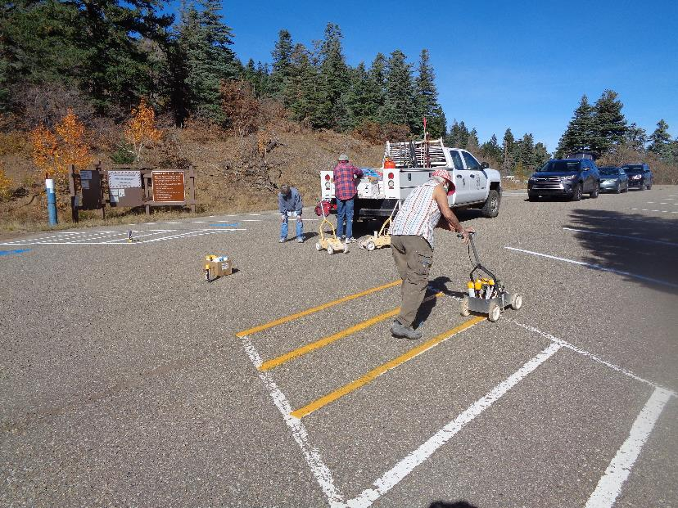

L to R: Ricki Barrett, Anne Hickman, and Jane Harrison. Jane is painting pedestrian access space with yellow paint.

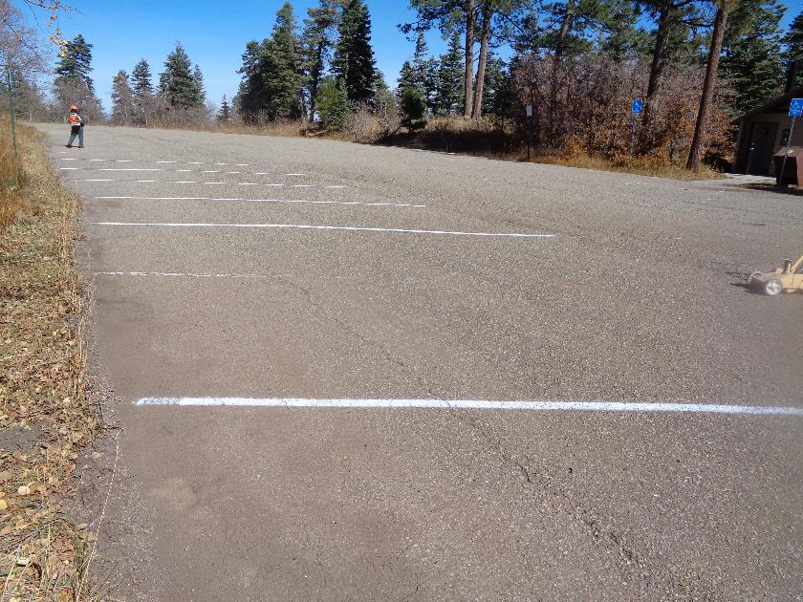

Photo before a stripe was painted in front of the paint cart. The lot was striped several years ago, and some of the lines could not be seen.

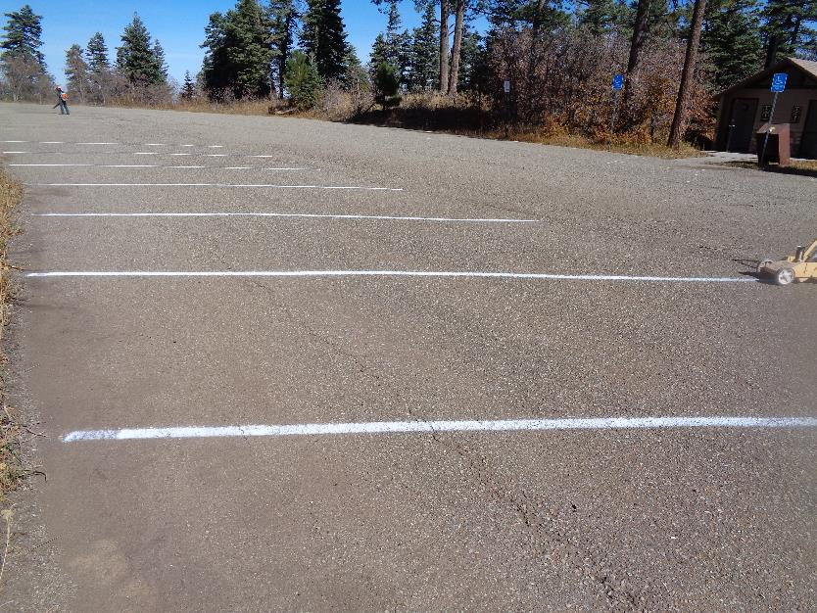

Photo after a line was painted in front of the paint cart

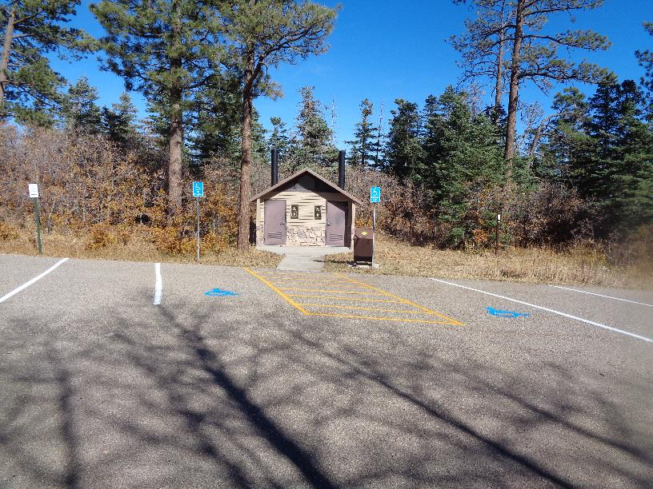

A colorful scene with white lines, blue wheel chairs markers, and yellow stripes in front of the lower restroom.

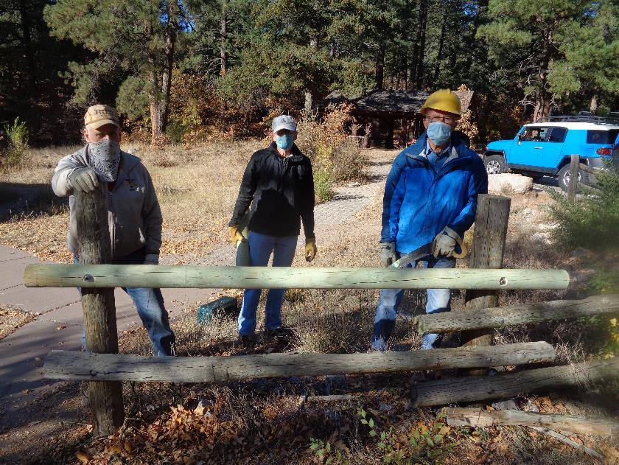

L to R: Jerry Carroll, Sim Cook, and Jerry Pekarek at one of the four poles replaced in Doc Long Picnic Area

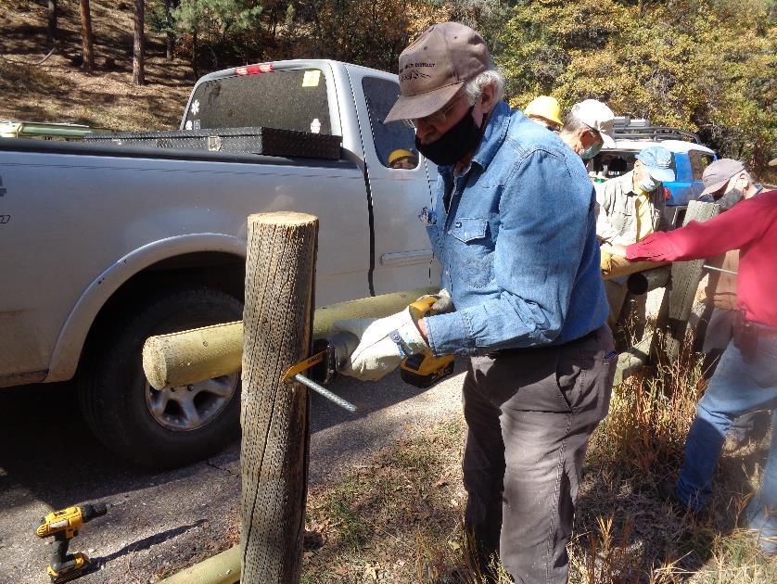

Eric Russell using the new FOSM battery-powered reciprocating saw to cut a ½-inch threaded steel rod.

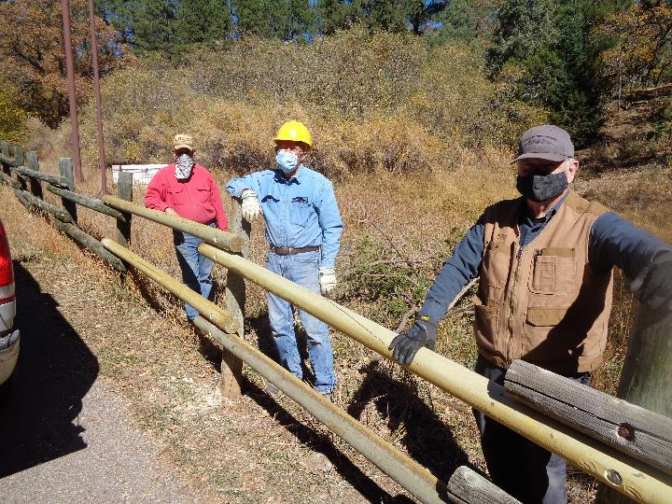

L to R: Jerry Carroll, Jerry Pekarek, and Dennis Crowther standing in Sulphur Canyon Picnic Area where

four poles were installed.

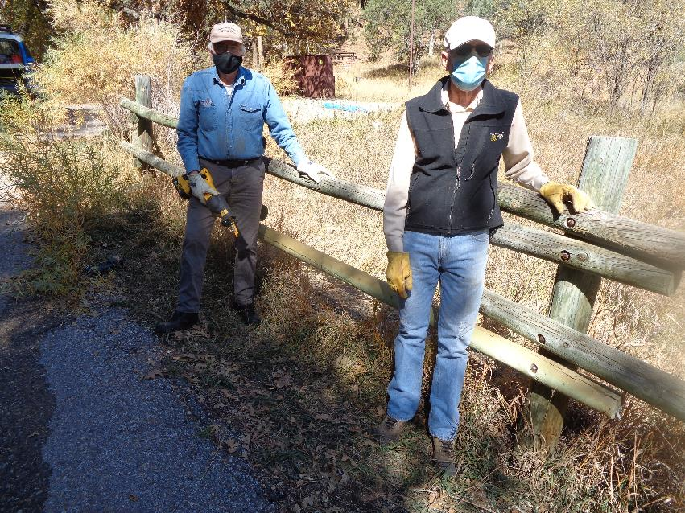

Eric (with saw) and Sim Cook at fence in Cienega PA where one pole was replaced.