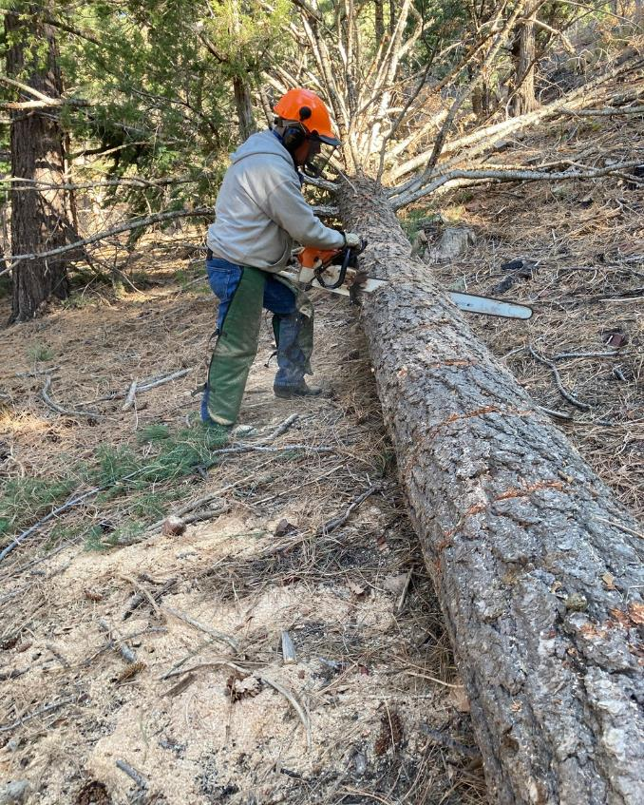

Jerry Carroll bucking a large white fir log on the hillside in the Cienega PA group area. He is using the FOSM

Stihl MS 460 with a 32-inch bar. All photos by Cliff Giles

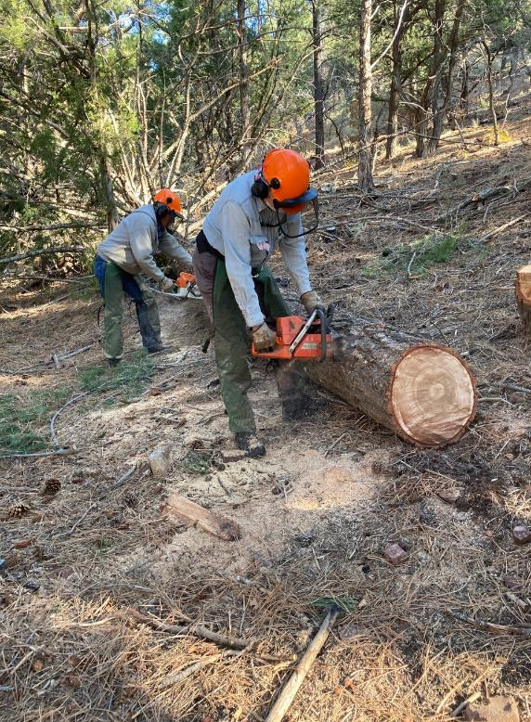

Jerry Carroll and Eric Russell bucking the large fir log.

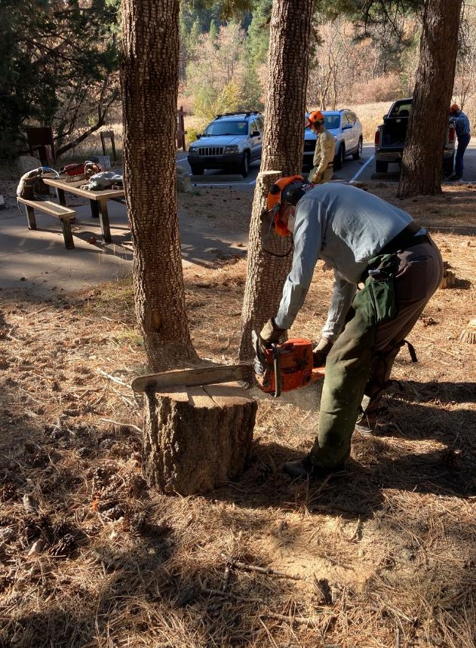

Eric scoring the top of the round to make splitting easier.

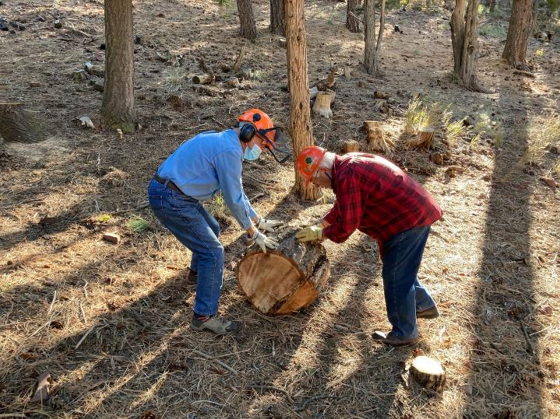

L to R: Jerry Pekarek and Lou Romero rolling large heavy round down the hill to be split.

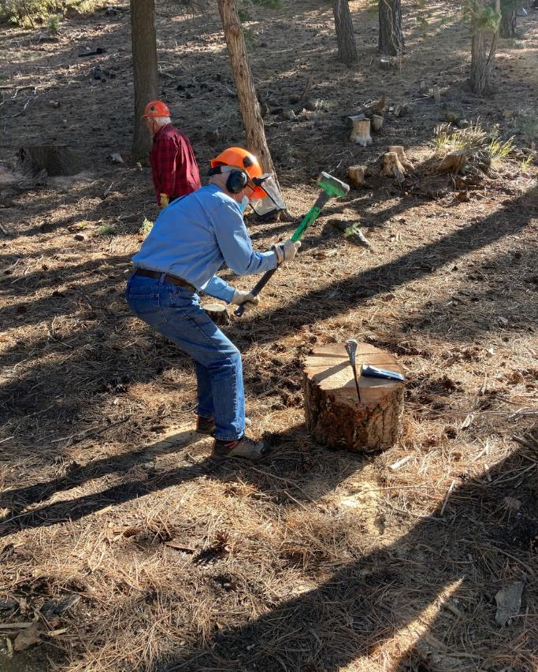

Jerry Pekarek splitting a round with a sledge hammer and steel wedbe.

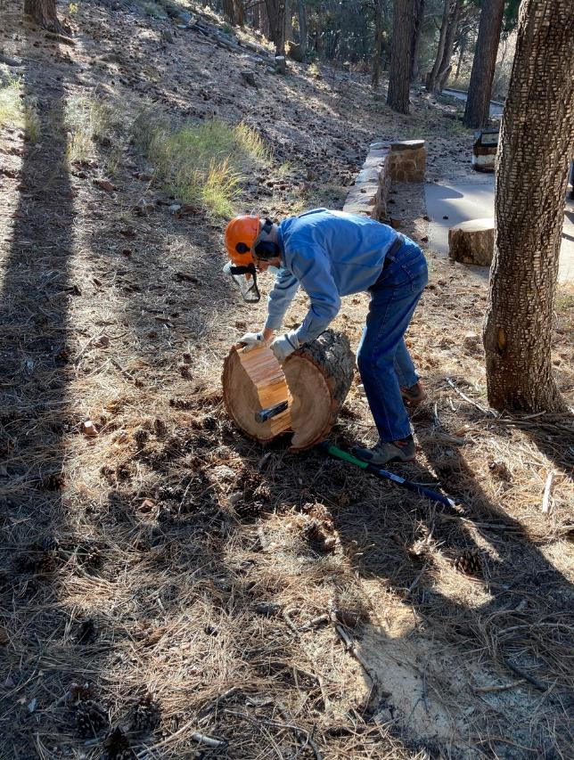

Jerry completes splitting of the round.

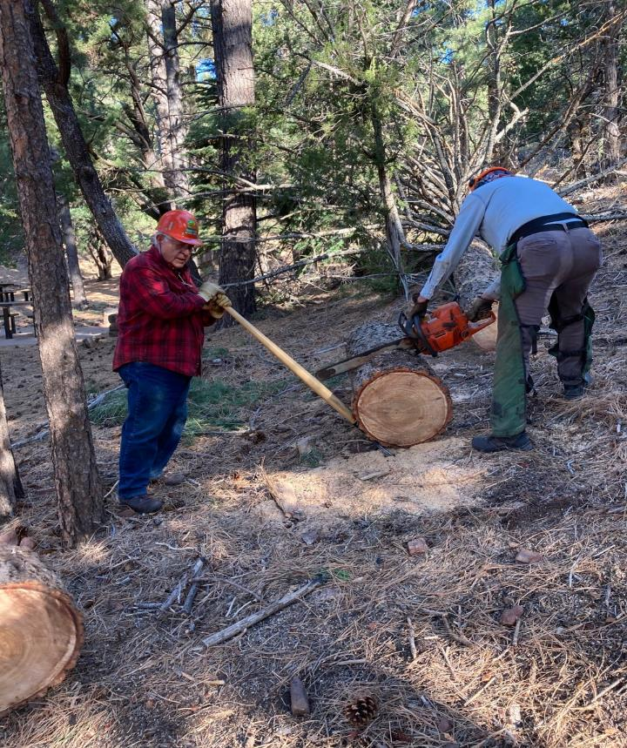

Lou Romero holding part of the log with a cant hook while Eric bucks it.

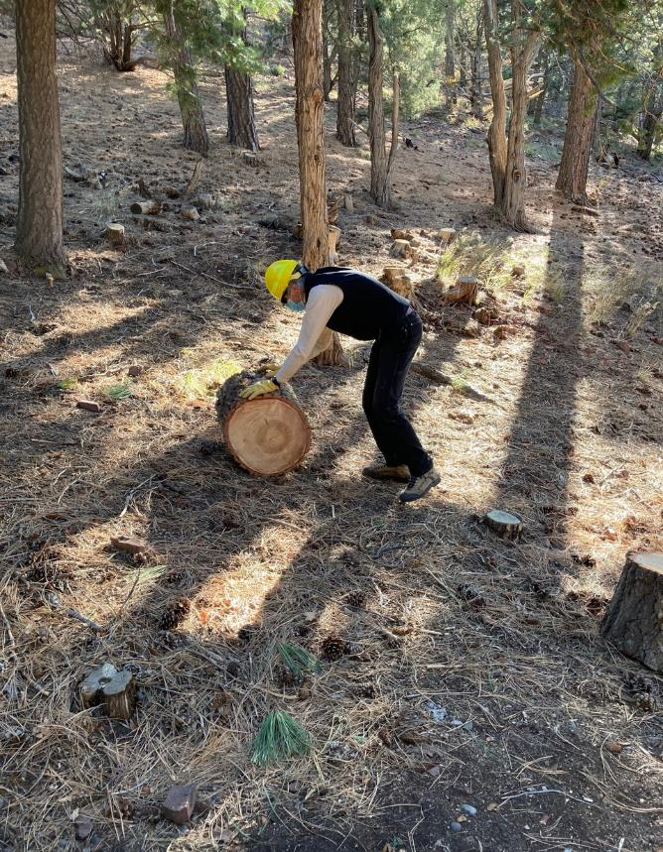

Sim Cook rolling a round down the hill to be split.

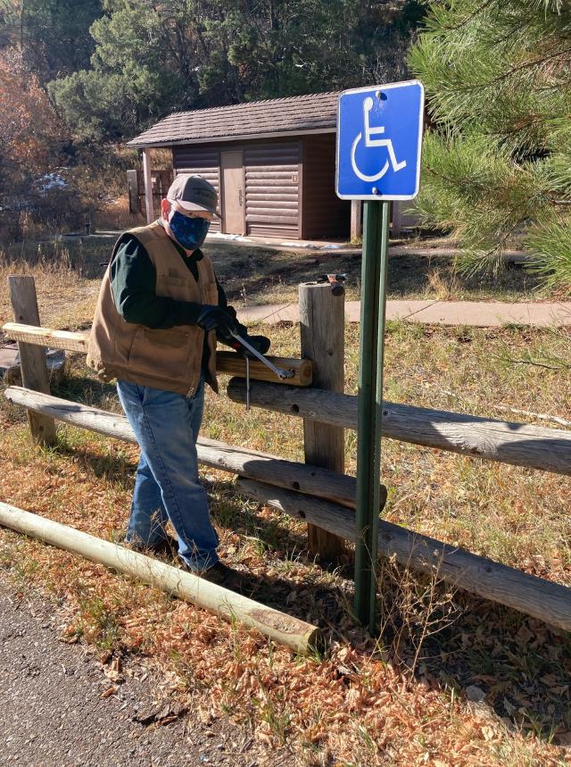

Dennis Crowther using a socket and driver to remove a bolt from a pole that is too short.

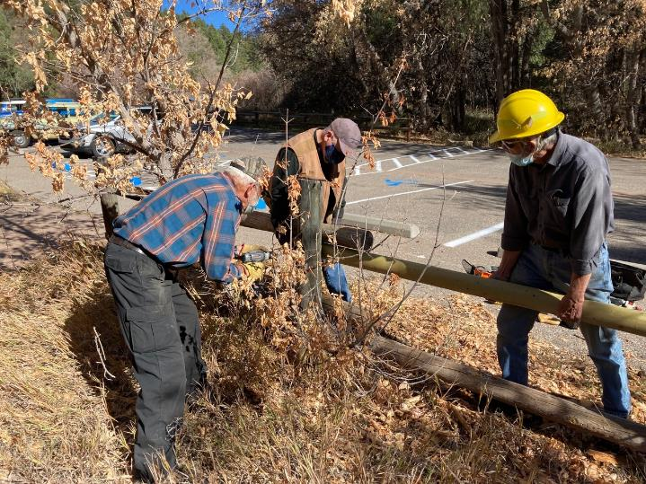

Sam drilling a hole through a pole with a battery-powered drill.

L to R: Sam Beard, Dennis Crowther, and Byron Garner.

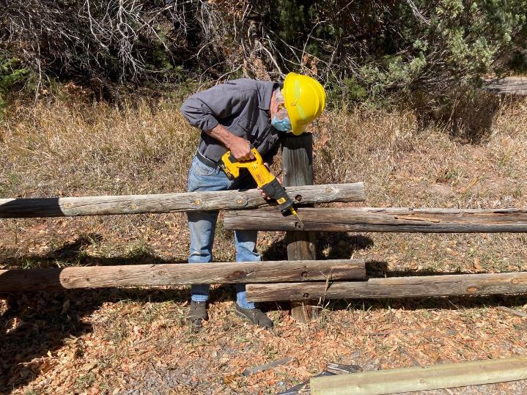

Byron Garner cutting the end off of a rusty threaded rod with the FOSM battery-powered DeWalt

reciprocating saw.

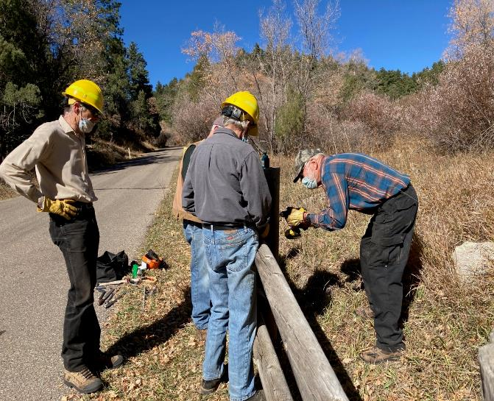

Sam using a drill and Forstner bit to countersink the back of a post.

L to R: Sim Cook, Dennis Crowther, Byron Garner, and Sam Beard.