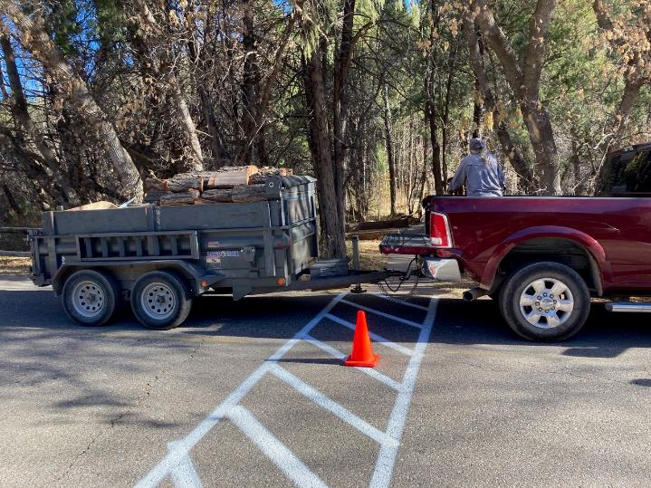

The bucked and split wood at the Cienega Group Reservation Area filled the front half of Joe Meade’s trailer.

All photos by Cliff Giles unless noted otherwise

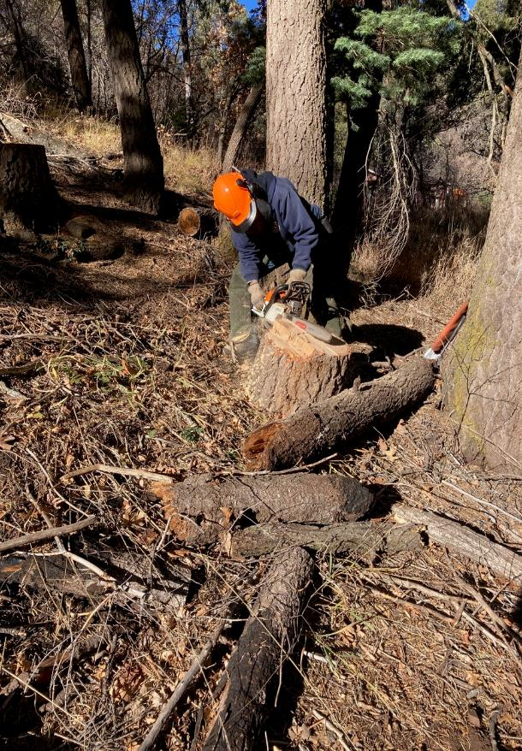

Jerry Carroll scoring a round to make it easier to split.

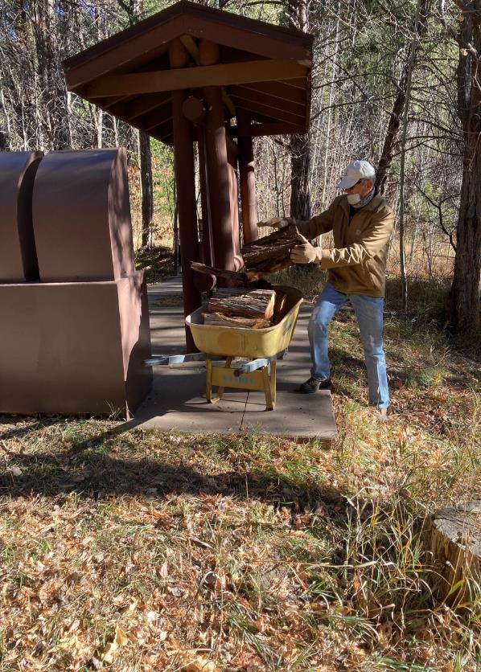

Sim Cook loading a wheelbarrow with split wood across the road from the second restroom.

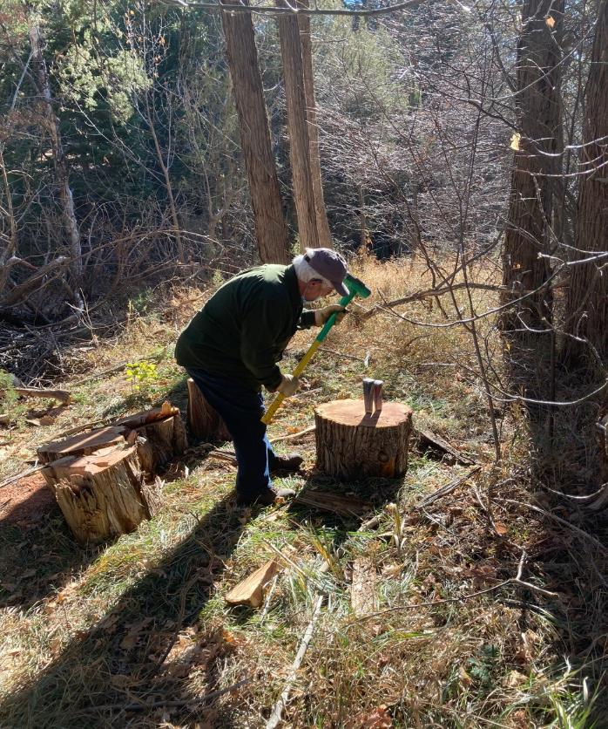

Lou Romero splitting a round to make it easier to handle.

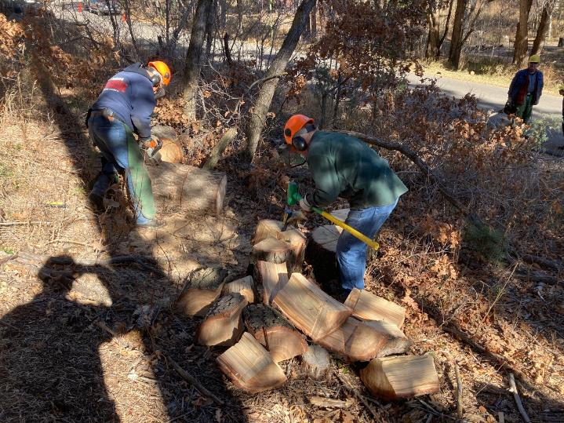

Jerry Carroll bucking a round with a chain saw and Jerry Pekarek splitting a round.

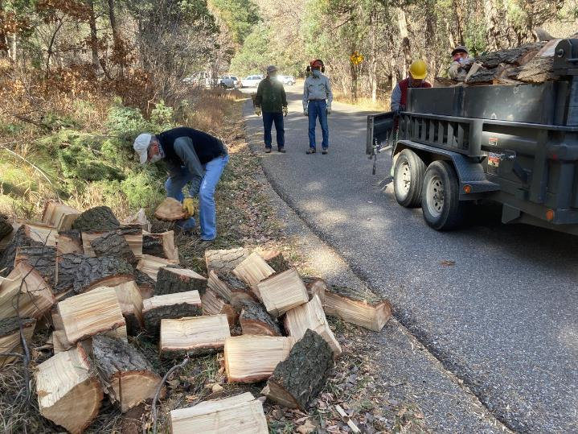

Sim Cook moving wood from the pile to trailer.

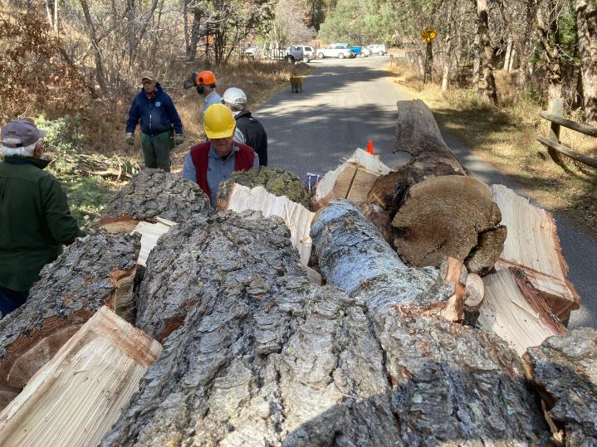

Dennis Crowther loading the last piece of wood on the trailer.

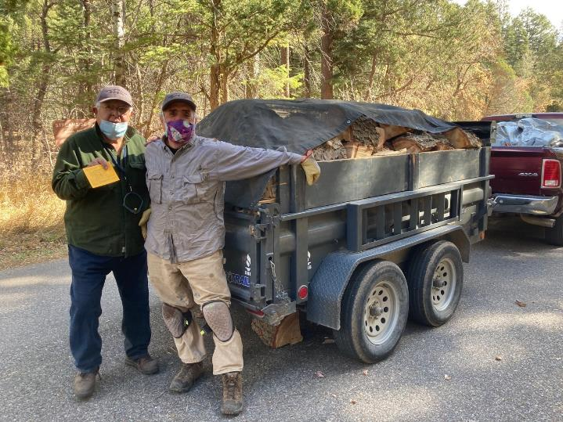

Lou Romero and Joe Meade with a trailer and pickup bed filled with fire wood for Joe.

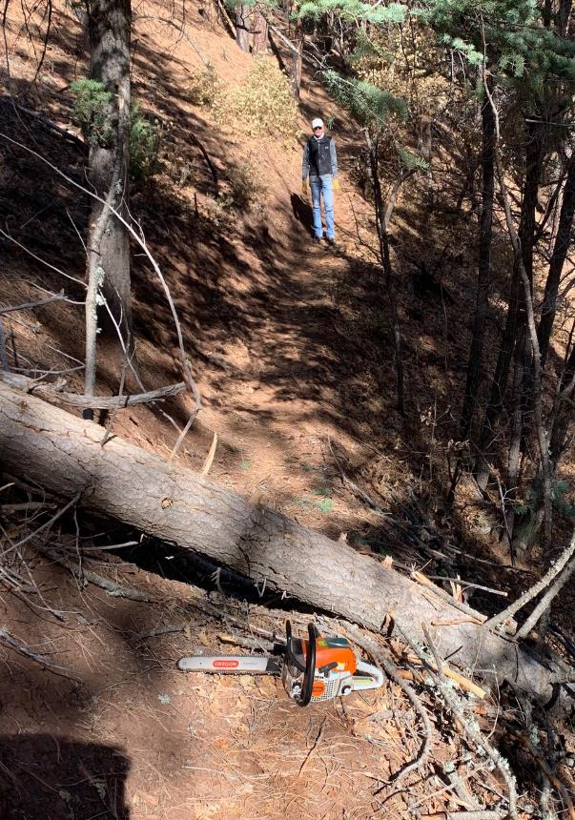

The 10-inch diameter log on the Wagon Trail that goes parallel

to the picnic area access road from the gate to Acequia Trail.

Photo by Jerry Carroll

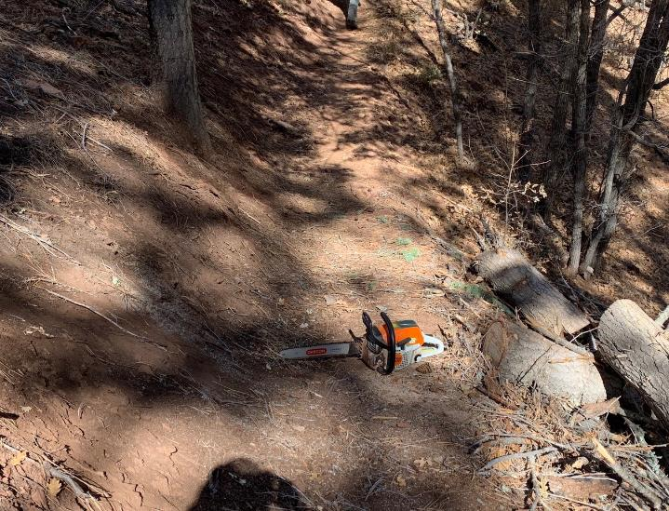

The log has been bucked and removed. Jerry Carroll’s Stihl MS-251 chain saw with an 18-inch bar is

on the cleared trail. Photo by Jerry Carroll