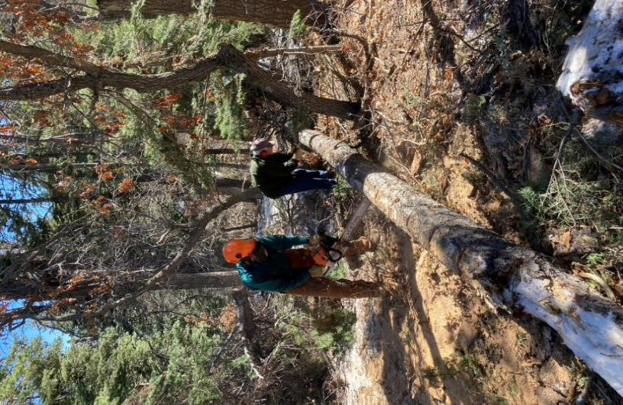

Lou Romero, in the background, is marking the log where Sam Beard will score it with

a chain saw so that the sawyer will cut the log into 12-inch pieces

All photos by Cliff Giles unless noted otherwise.

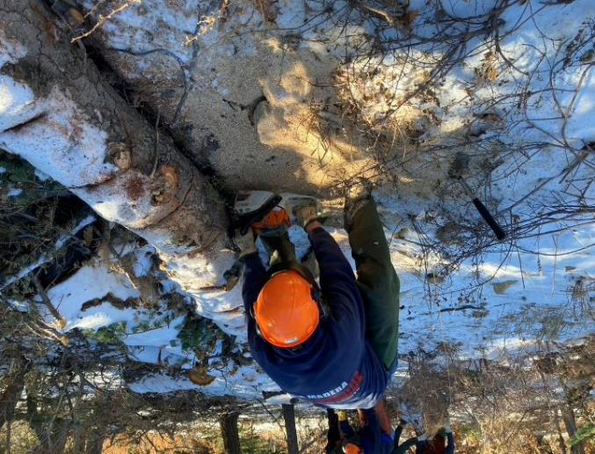

Jerry Carroll bucking the log where it has been marked.

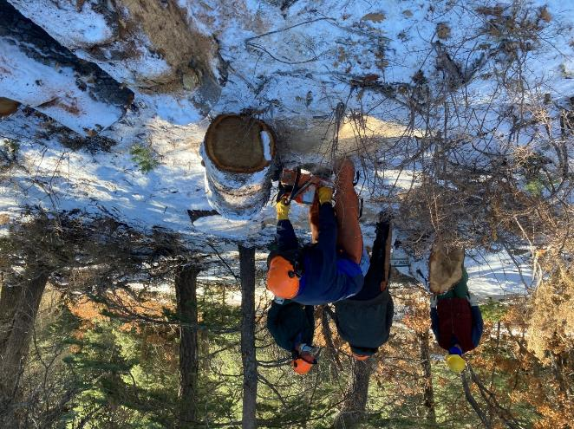

Byron Garner is bucking a log in the foreground.

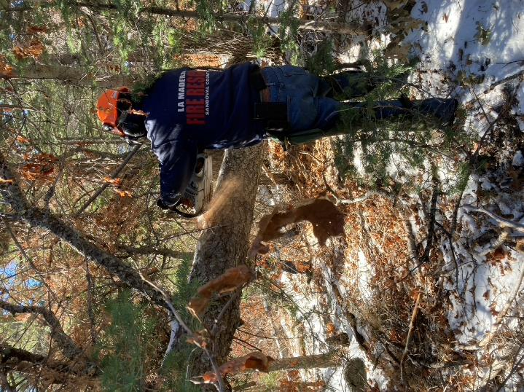

Jerry Carroll is bucking a hang-up.

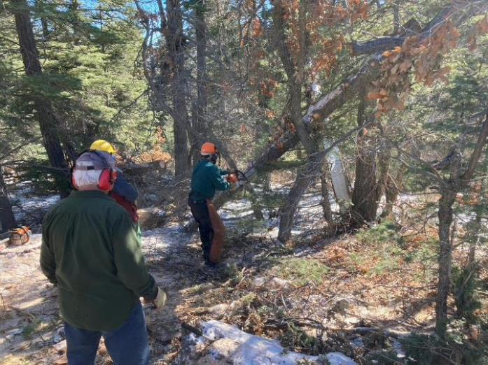

Sam is bucking a hang-up so that the lower end will fall to the ground.

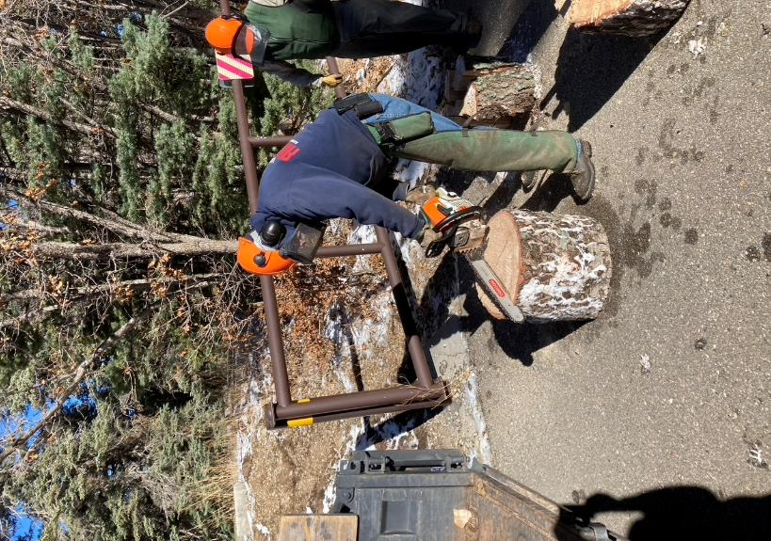

Jerry is scoring the end of a round so that it will be easier to split.

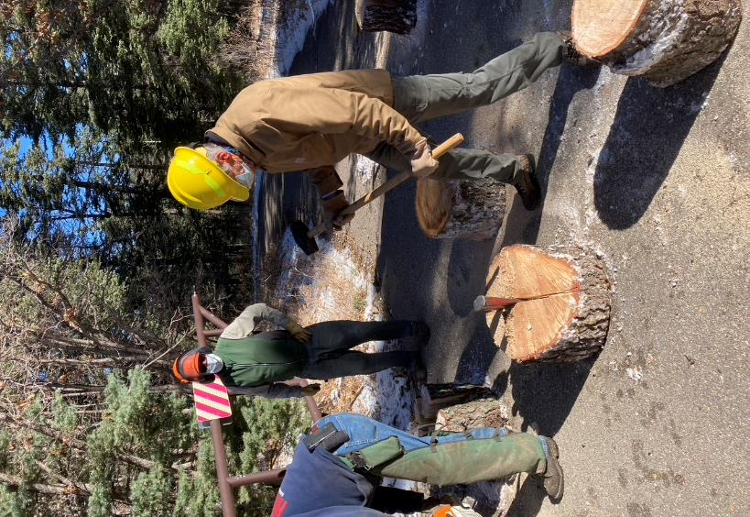

Sim Cook is splitting a round so that it will be easier to handle.

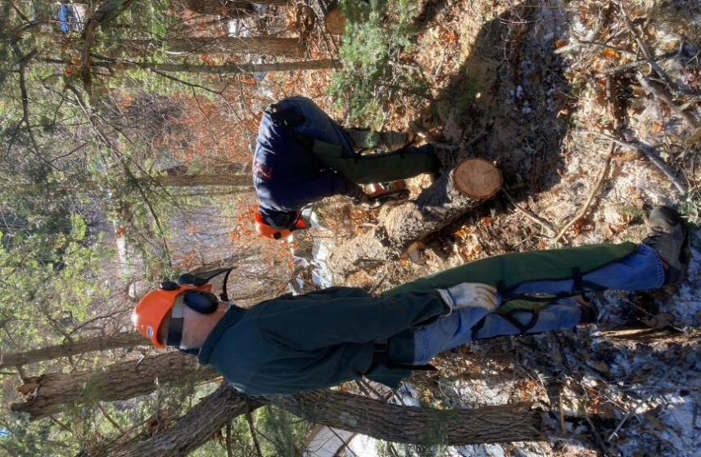

Jerry Pekarek is observing Jerry Carroll bucking a log.

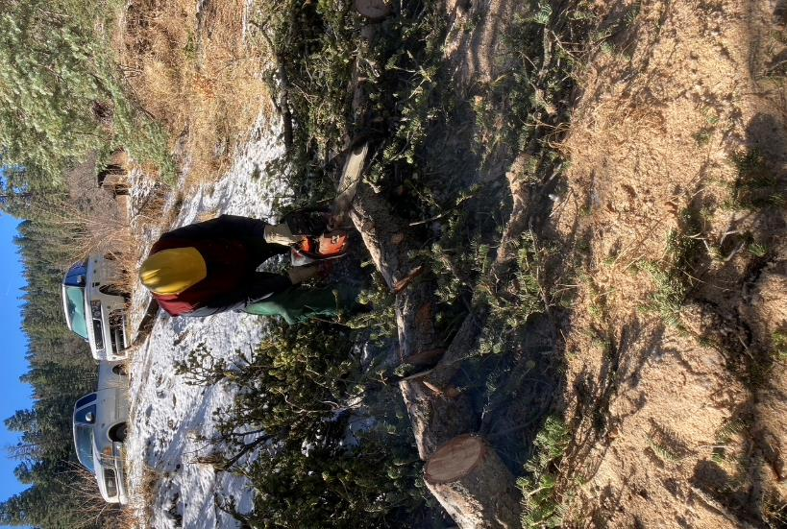

Dennis Crowther is bucking a log below the parking lot.

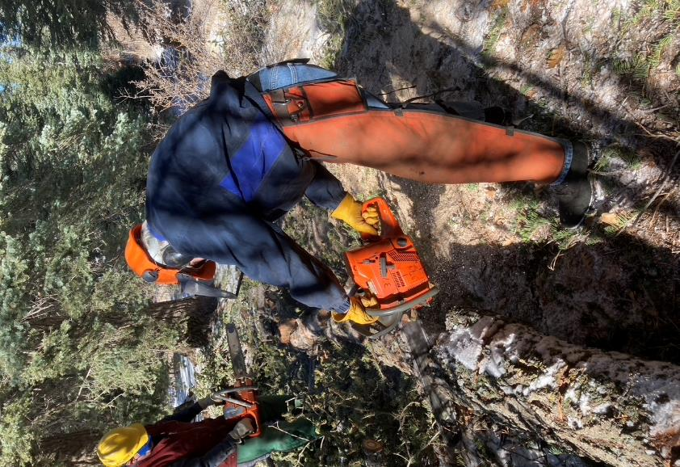

Byron Garner is bucking a log with Dennis in the background.

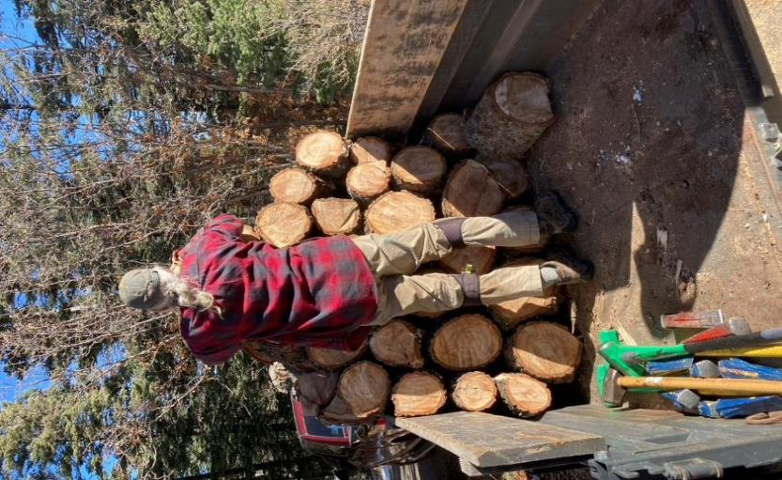

Joe Meade stacking rounds in his trailer.

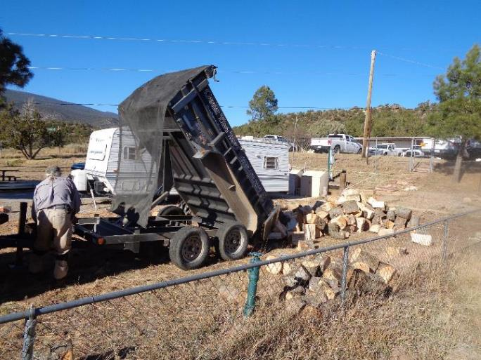

Joe has just finished raising the trailer bed to dump the donation wood at the hazmat building

behind the ranger station. Photo by Sam Beard