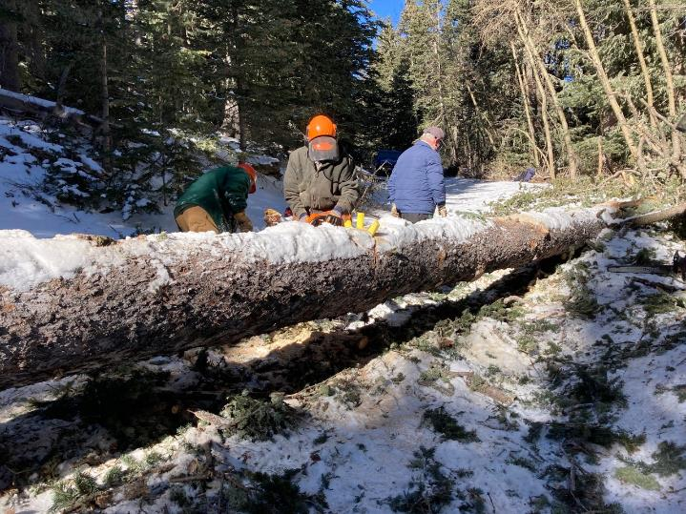

L to R: Lou Romero, Sam Beard, Dennis Crowther. Sam is making the first cut in the down spruce tree

on Kiwanis Meadow Road. All photos by Cliff Giles

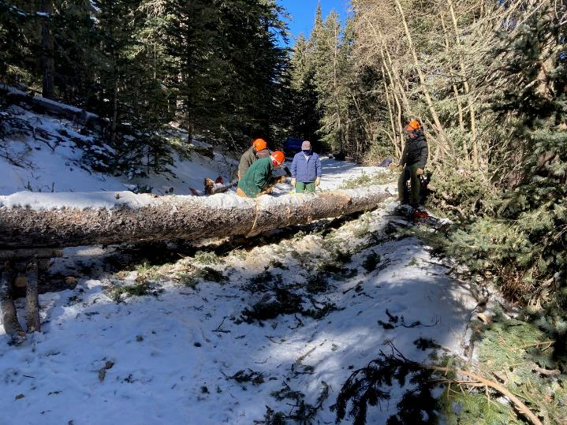

L to R: Lou Romero, Sam Beard, Dennis Crowther, and Jerry Carroll. The first cut has been completed,

and the upper piece of the tree has fallen a couple of inches.

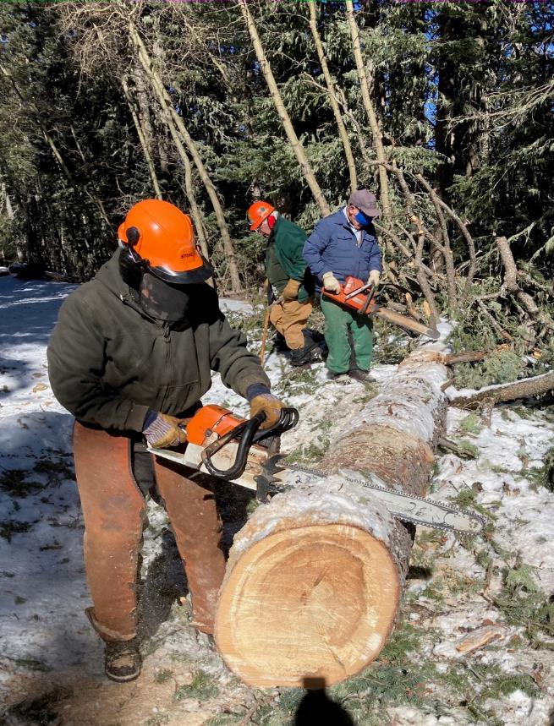

Sam and Dennis are bucking the upper part of the tree.

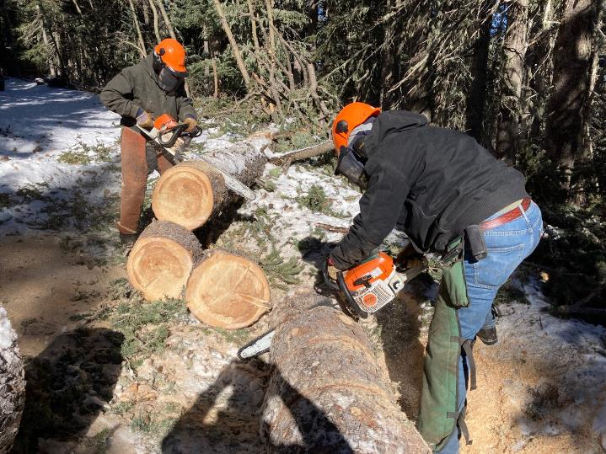

Sam is still bucking the upper part of the tree, and Jerry Carroll is bucking the piece that was cut out

of the log.

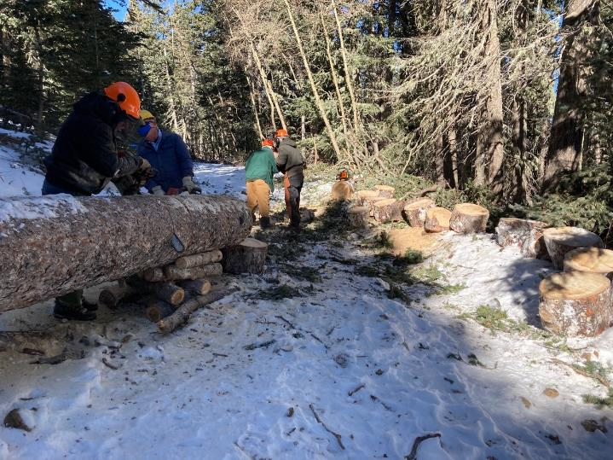

Jerry and Dennis are beginning to work on the large lower part of the tree.

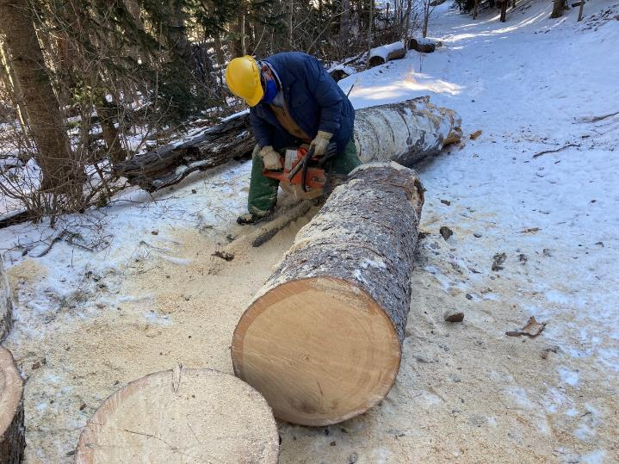

After the lower part of the tree rolled onto the road, Dennis is bucking one piece.

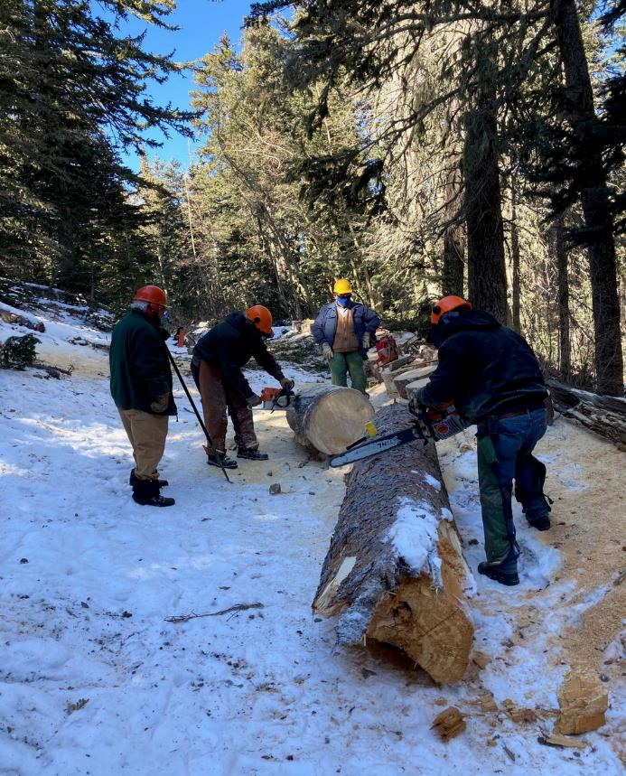

Jerry is bucking the large lower end of the tree that had broken near the ground and split vertically several feet.

ff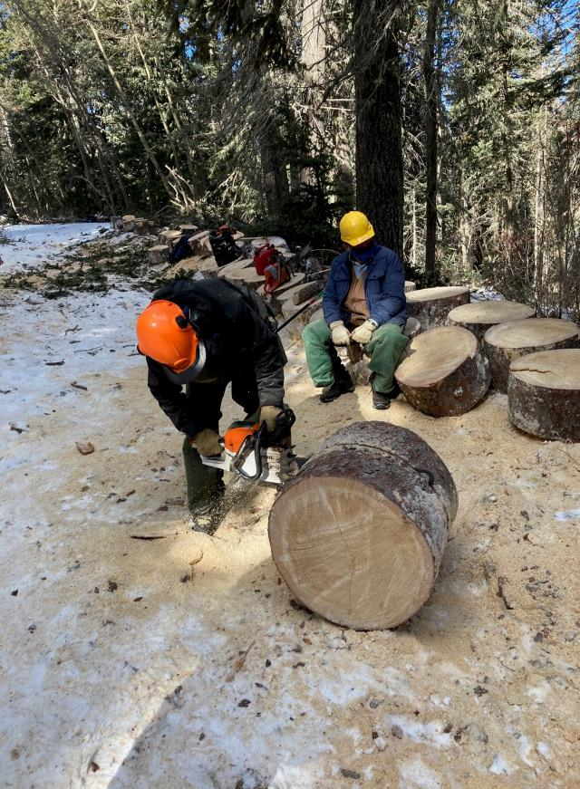

Bucking the last piece of the trunk.

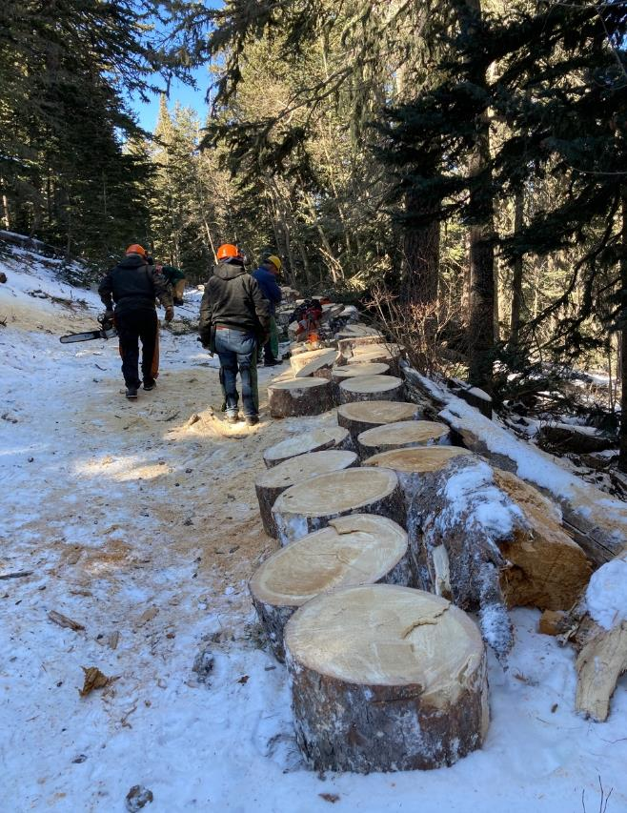

The rounds cut from the trunk, and the crew walking away with some of the equipment.

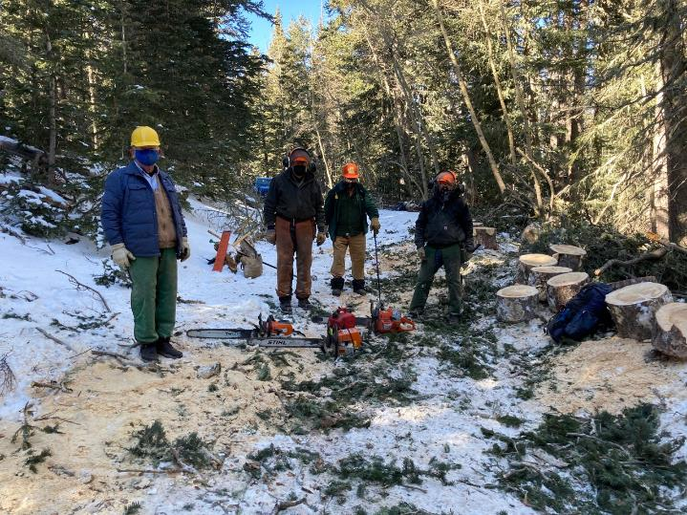

Dennis, Sam, Lou, and Jerry standing where the tree trunk had been.

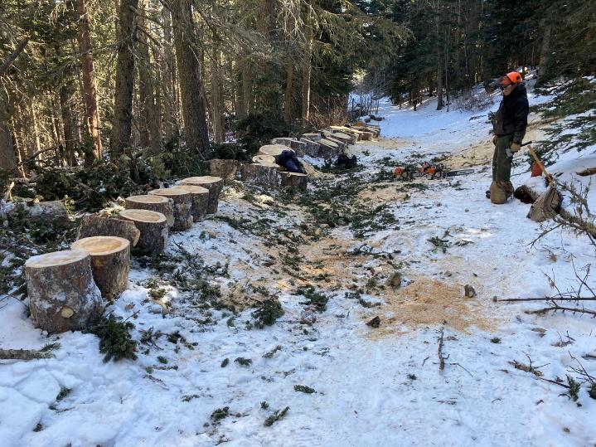

Jerry looking at the 52 rounds that were cut from the trunk.