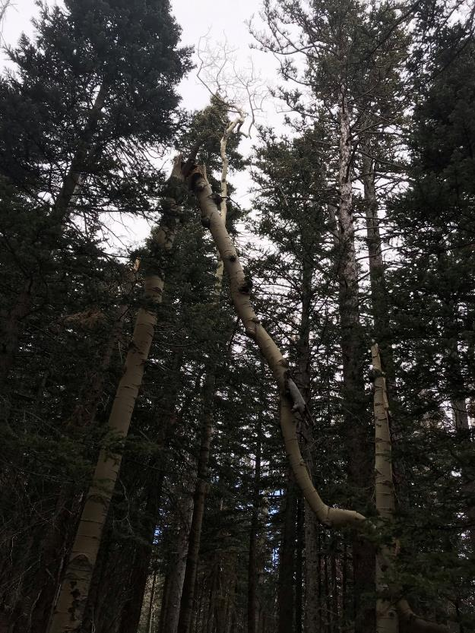

The top half of this aspen was partially broken, and the upper end of the top half came to rest on the ground.

This tree was located at the intersection of Switchback and Survey Trail. Photo by Steve Roholt.

All photos by Cliff Giles, unless noted otherwise.

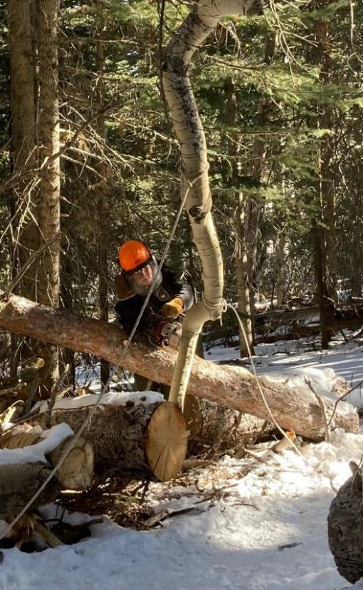

Based on past experiences with this type of dangling tree top, we planned to cut off part of the top

so that upside down part was no longer resting on the ground, but was dangling in the air. We then planned

to pull the dangling top back and forth with ropes until the hinge broke and the upper part

fell to the ground. Here Jerry Carroll is making the first cut so that the top is no longer on the ground.

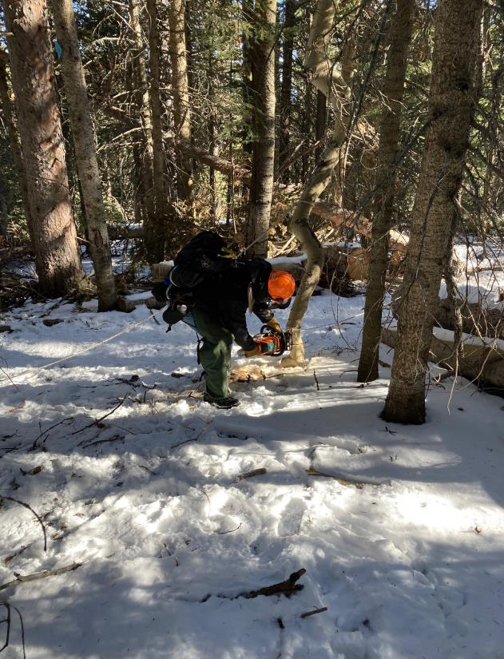

After the tip of the tree moved across the trail, Jerry is making another cut so that the tip will be off the

ground and be pulled back and forth to break the hinge overhead.

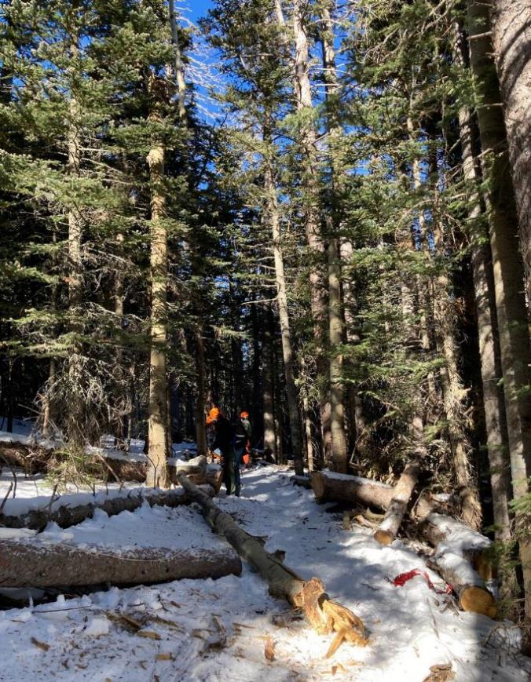

The volunteers in the background pulled the top up the trail once, and released the rope so that the top could

swing back down the trail. After this one swing, the rotten hinge broke, and the top part fell safely to the ground.

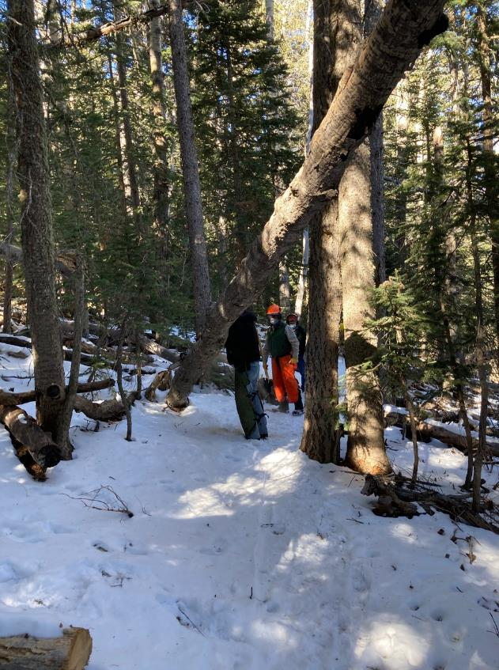

Jim Levesque’s team hiked up Survey Trail to this hang-up near the power line. Here Jerry is making

The first cut to start “walking” the lower end of the tree across the trail.

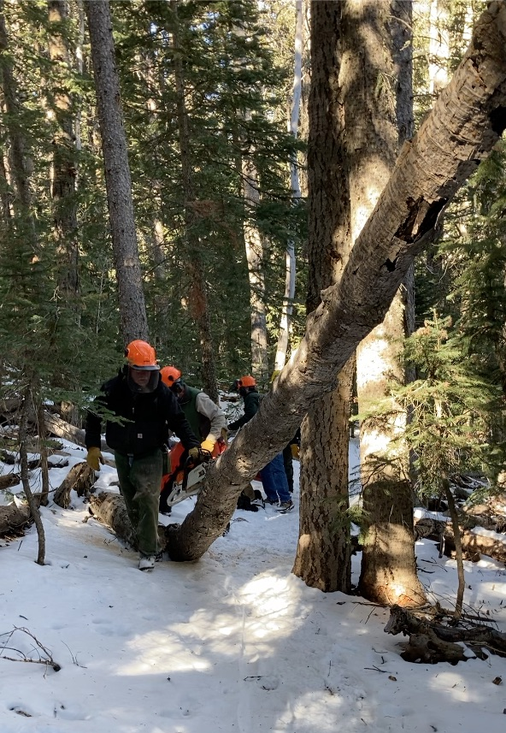

Jerry is preparing to make another cut so that the lower end will continue to move across the trail.

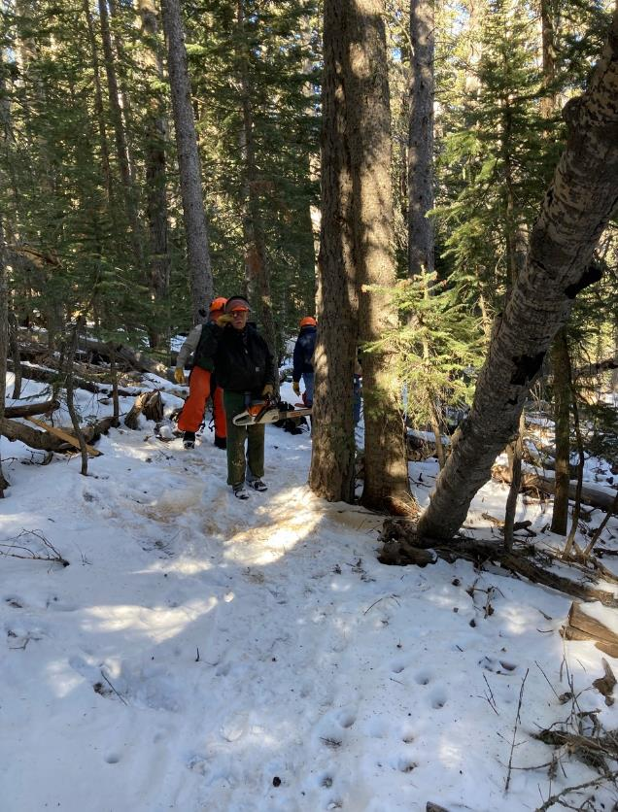

Jerry has made enough cuts so that the lower end of the tree was off the trail. The upper end of the hang-up

was stable, and the crew could leave the hang-up in this position.

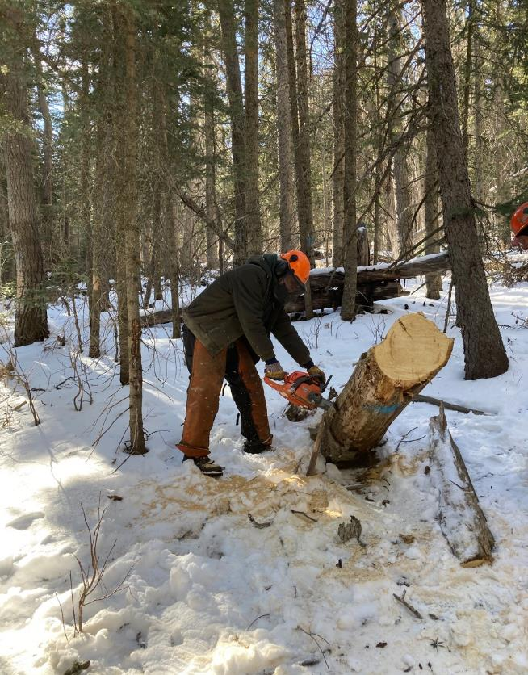

Sam Beard is making the final cut on the stump of a 16-inch hang-up on Switchback Trail near the Service

Road that was safely removed.

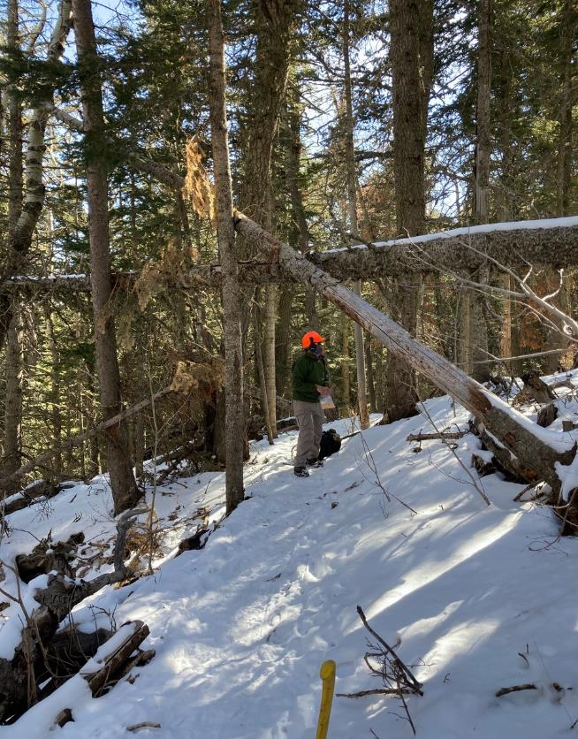

Steve Roholt then led Sam’s team to these hang-ups on Rocky Point Trail.

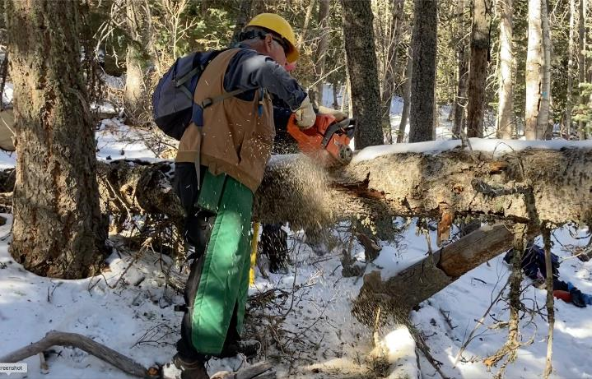

Dennis Crowther is making a cut on the larger hang-up.

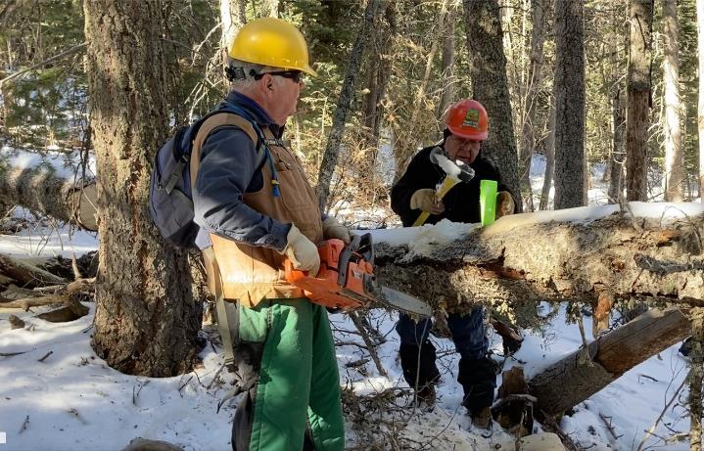

Lou Romero is driving a wedge for Dennis so that the kerf will stay open, and the tree will not bind the saw bar.

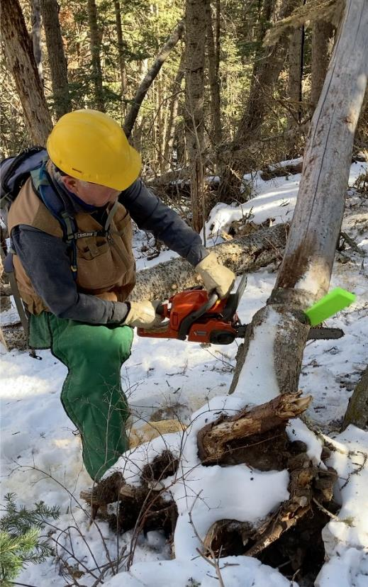

Dennis is making the first cut on the smaller hang-up.

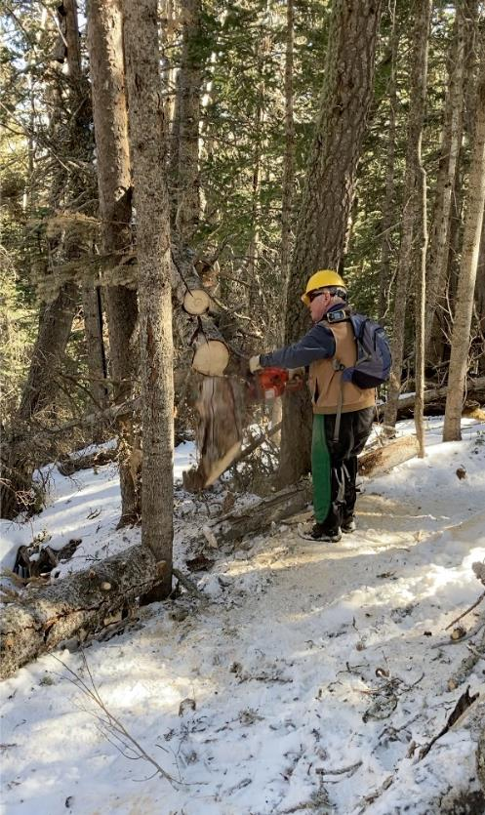

Both hang-ups have been safely removed from the trail, and Dennis is cutting the ends back

from the trail tread so that skiers can more easily pass.

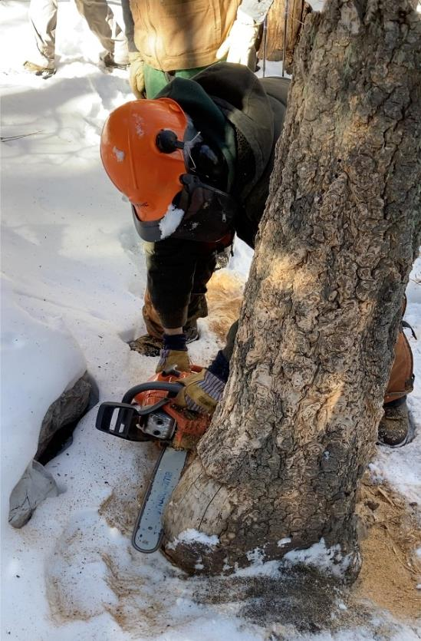

Sam is cutting the base of a 5-foot tall mostly rotten stump on the edge of the Rocky Pont trail tread.

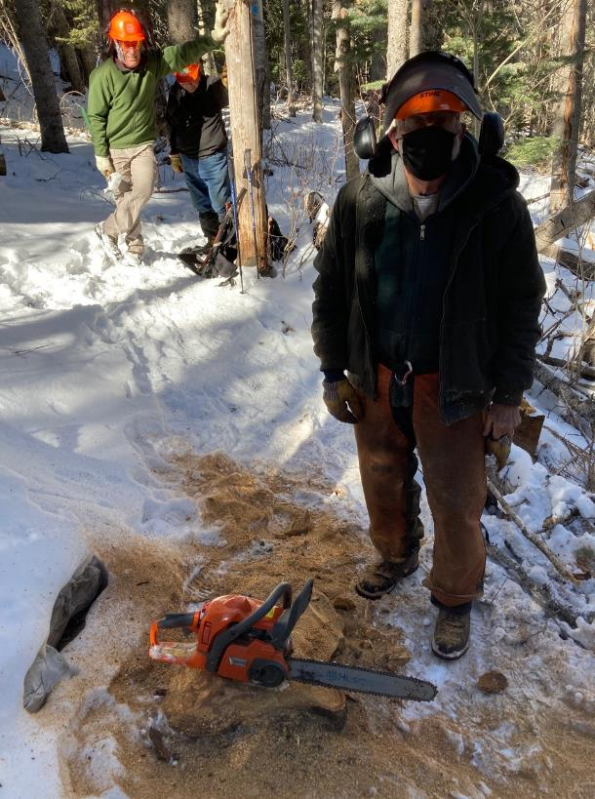

The stump has been removed, and a few short cuts were made to shape the top of the remaining wood to

the contours of the ground.

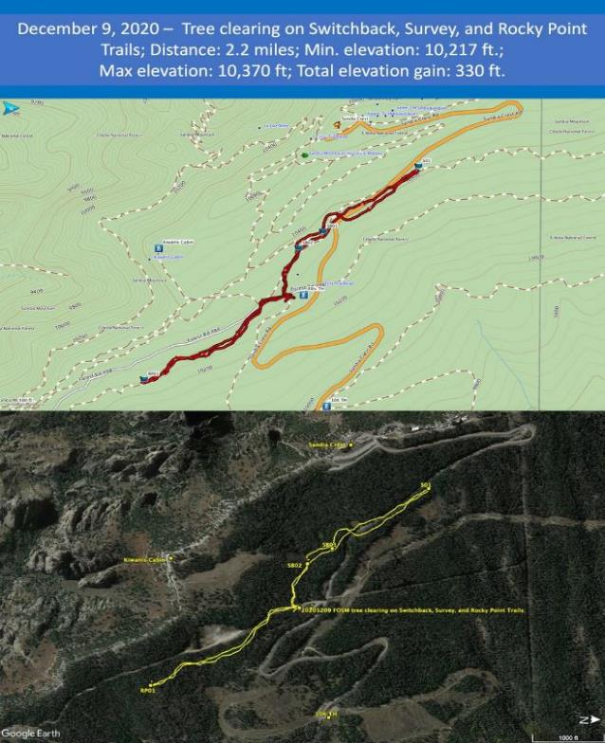

Cliff Giles recorded GPS coordinates of the routes hiked by the volunteers on this outing and printed it on a

map in the top figure. In the bottom figure, the routes are printed on a Google Earth Satellite photograph of

the upper part of Sandia Mountain. The approximate center of the routes is located at Ellis Trailhead where

the crew parked. The trace to the right is along Switchback and Survey Trails, and the trace to the left is along

Rocky Point Trail.