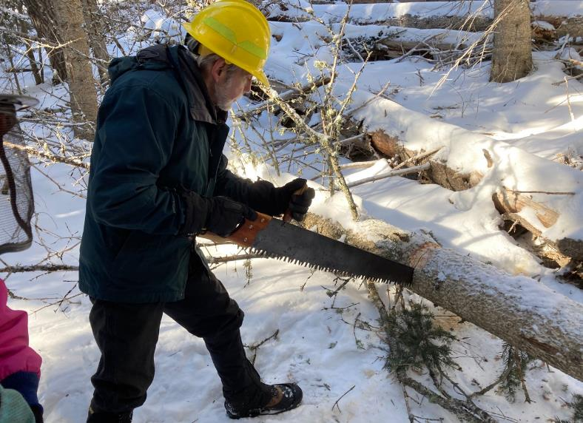

Byron Garner cutting a log with a crosscut saw. All photos by Cliff Giles unless noted otherwise.

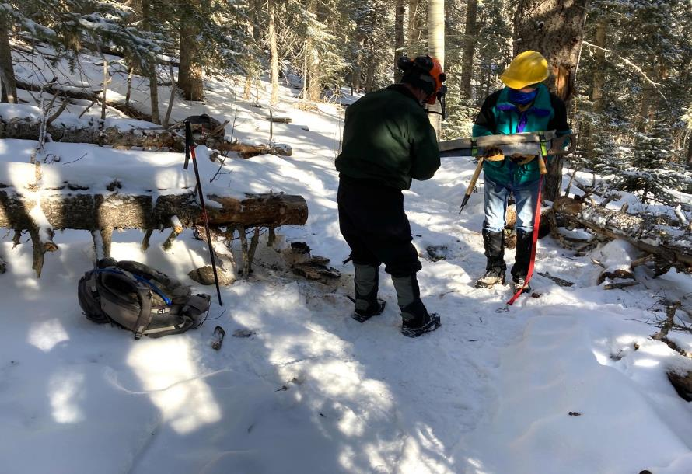

L to R: Jim Levesque putting the cover on a crosscut saw held by Jerry Pekarek.

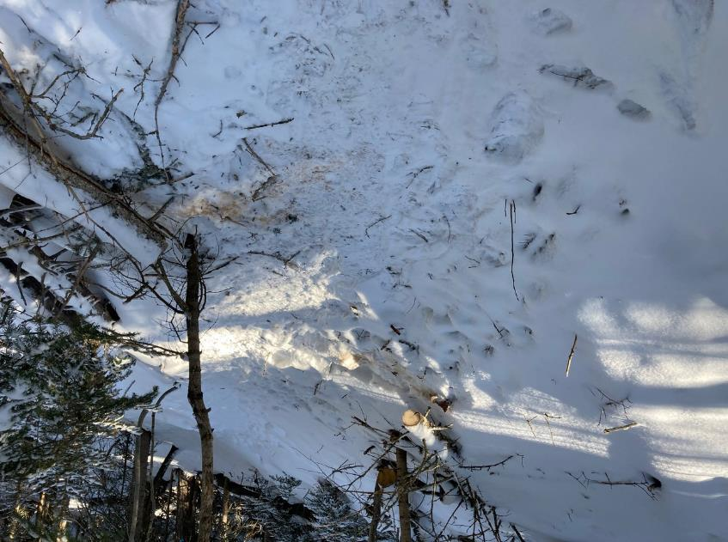

The trail is clear after two cuts were made on this small log with a crosscut saw.

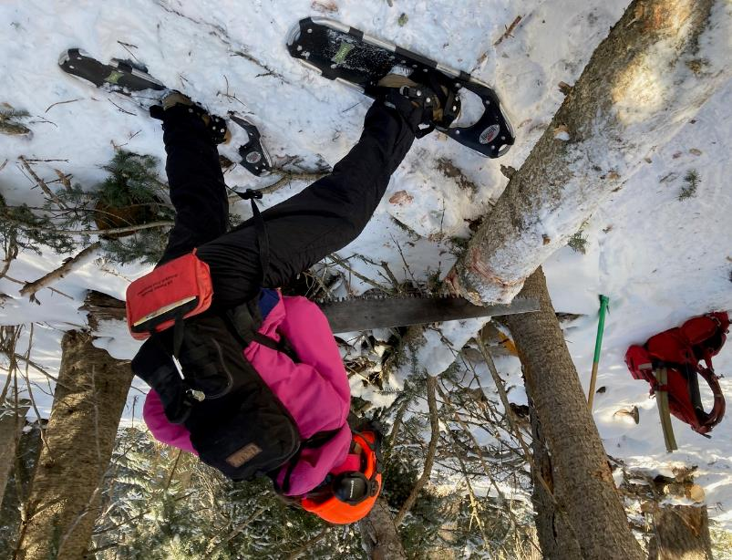

Rav Nicholson cutting a cork bark fir with a crosscut saw.

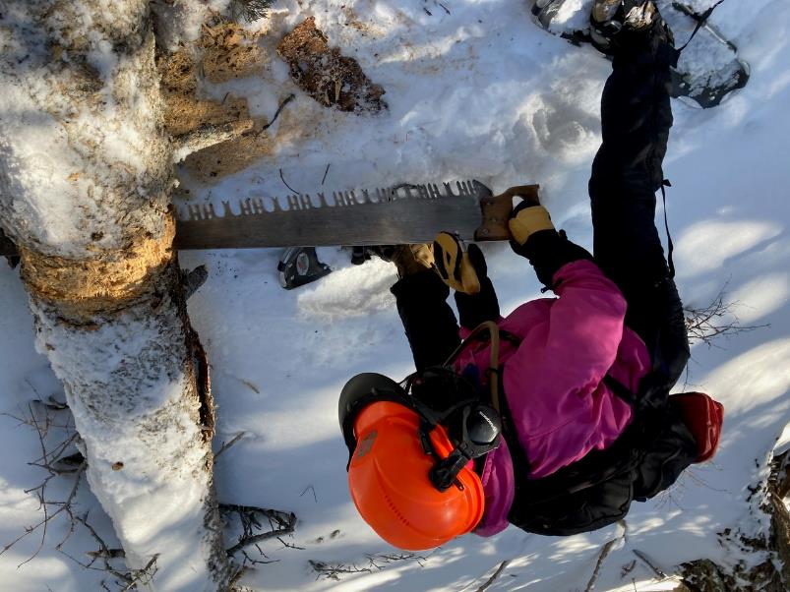

Rav cutting a larger log with a crosscut saw with a perforated lance tooth pattern.

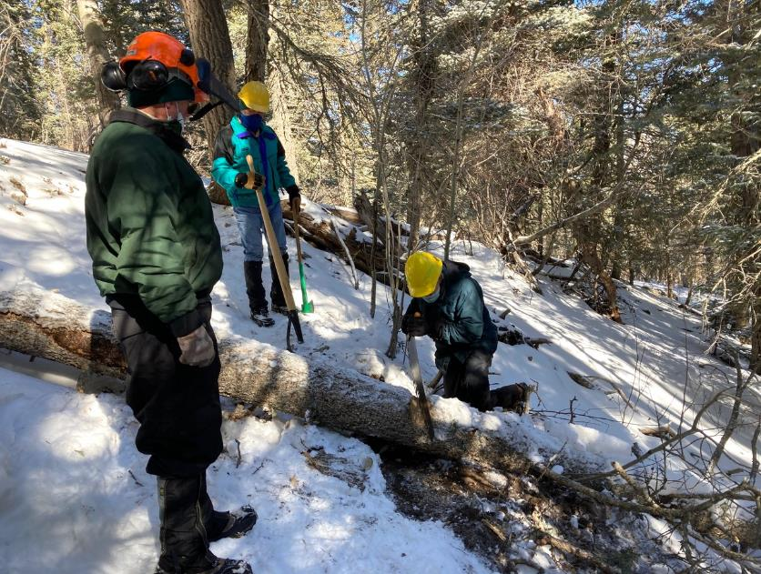

Byron cutting anther log with a crosscut saw.

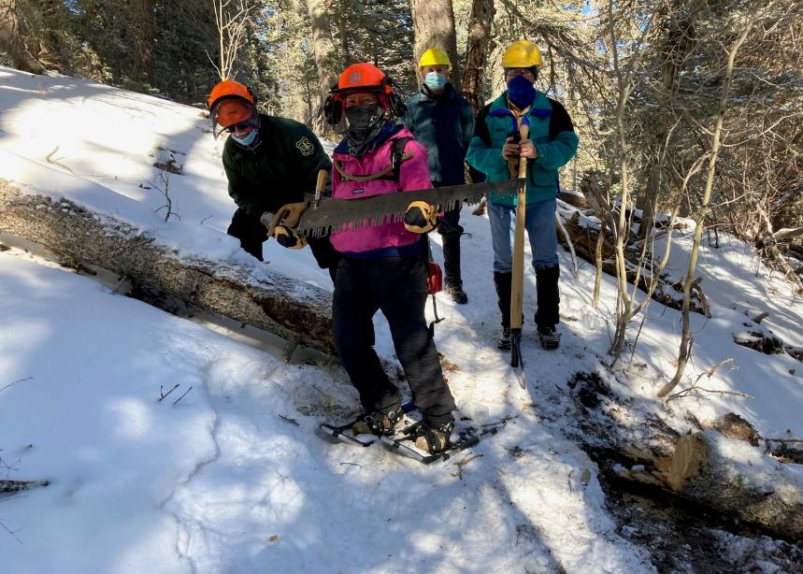

The crosscut saw crew. L to R: Jim Levesque, Rav Nicholson, Byron Garner, and Jerry Pekarek.

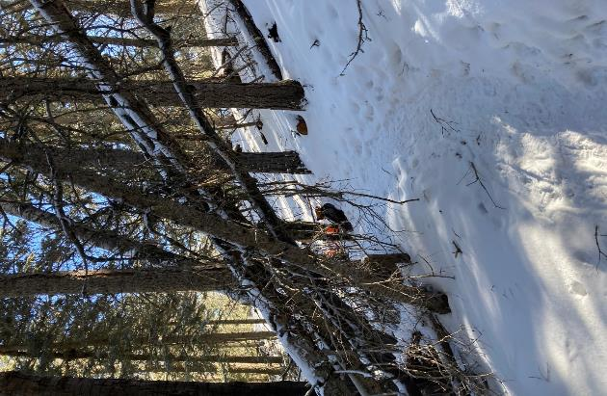

A four-tree hang-up over the trail.

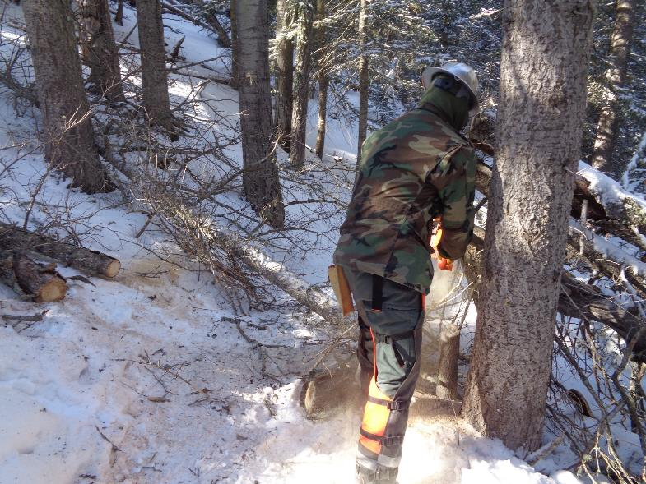

Michael Arndt cutting the four-tree hang-up with a chain saw.

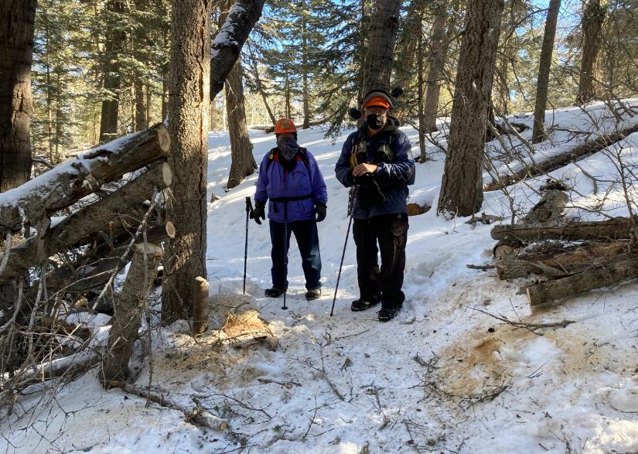

L to R: Lou Romero and Sam Beard in the cleared trail after the 4-tree hang-up was removed.

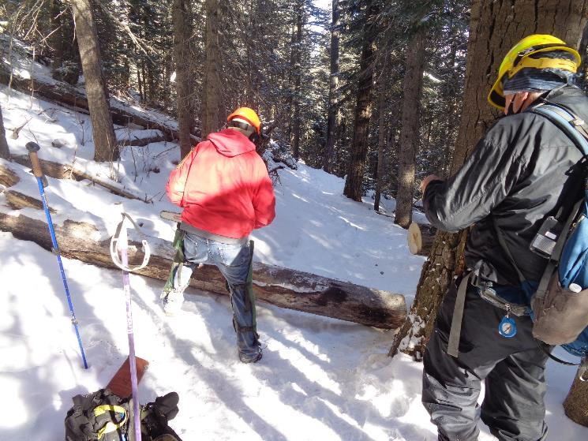

Jerry Carroll preparing to make a second cut in an 8-inch aspen with a chain saw. Photo by Sam Beard

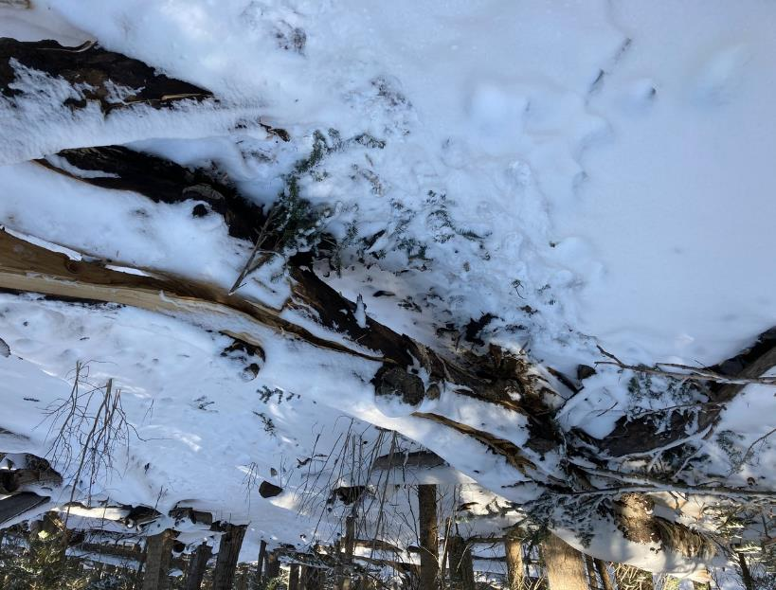

A 16-inch log across the trail.

J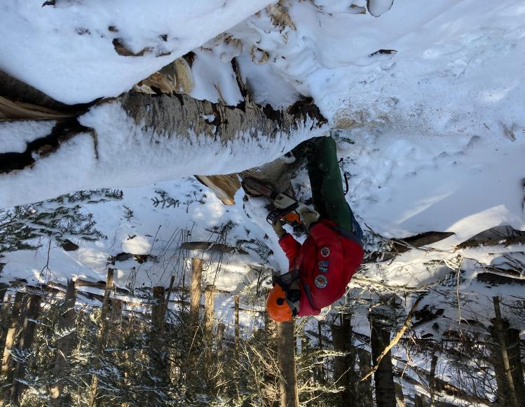

Jerry Carroll making the first of three cuts in this large log.

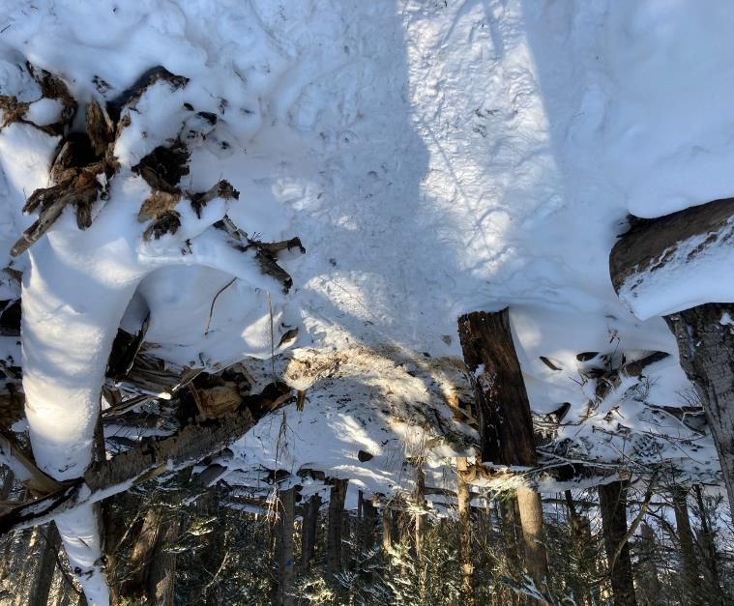

Another segment of trail is clear after a log was removed.

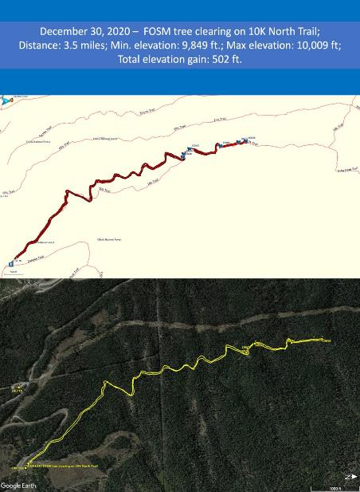

Map of hike on 10K North Trail. The middle part of the route was on a segment of the trail that was rerouted

a few years ago. This significant improvement in the route has less elevation change than the original route. Map by Cliff Giles.