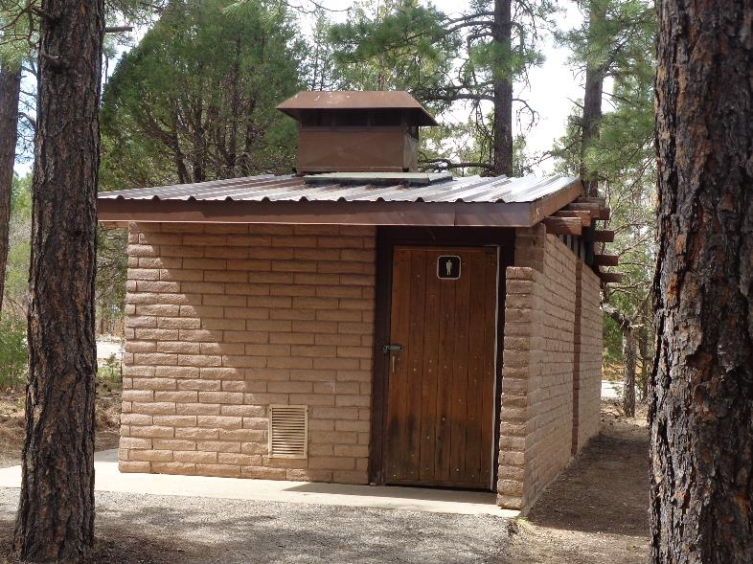

East side of Oak Loop No. 2 Restroom at Oak Flat Group Picnic Area with all the 16-foot steel roof panels installed.

The gable trim on each end and the ridge cap will be installed later to complete the reroofing of this restroom. Photos by Sam Beard

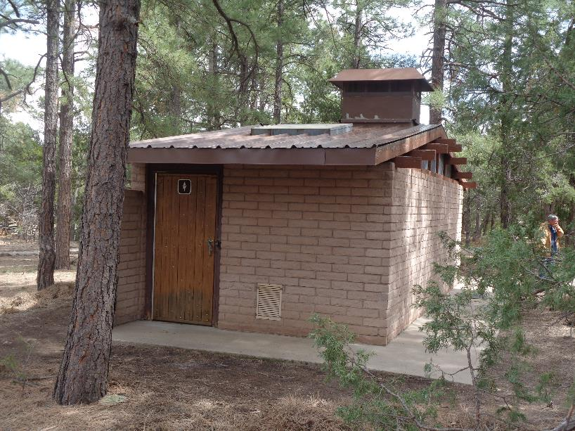

West side of Oak Loop No. 2 Restroom with all the 16-foot steel roof panels installed. We plan to restore the weathered

4x6 exposed beams on the ends of the restroom with liquid epoxy, epoxy putty, and brown paint after the steel roofs are completed.