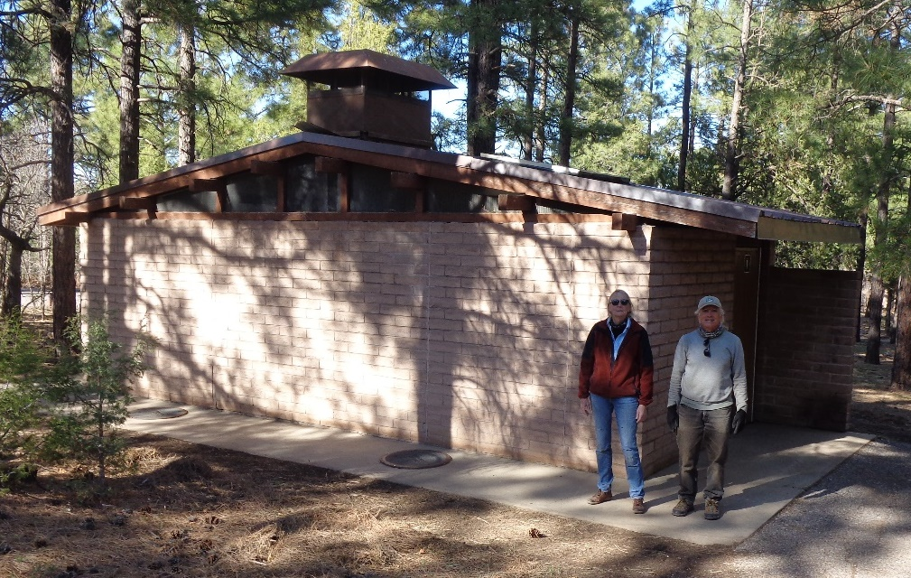

L to R: Joelle Hertel and Mike Madden. Joelle and Mike installed the 4-inch wide brown steel gable trim on both ends of this restroom

In Oak Flat Group Picnic Area.