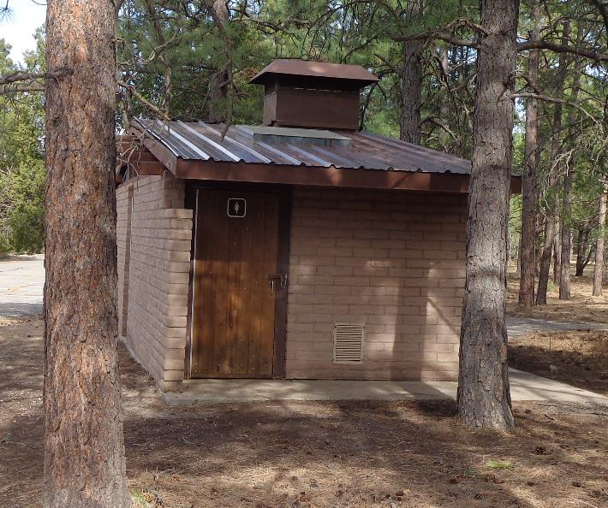

The new steel roof on the south side of the Oak Flat Group Picnic Area restroom #1. The presence of the skylight and ventilation

structure requires that eight cuts be made with a circular saw with a metal cutting blade. Also, the roof is a few inches

under 12 feet wide; therefore, about 3 inches of materials must be cut from the 16-foot long fourth 3-foot-wide panel.

Photo by Sam Beard