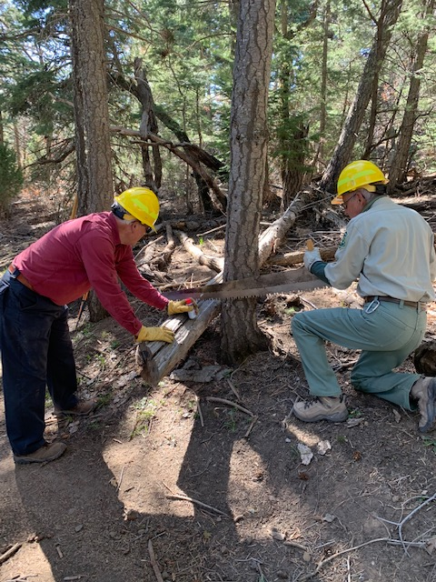

Cutting back a log that was protruding into Oso Corredor
trail. David has sprayed lubricant onto the saw and
temporarily stabilizes the log as the cut is started.
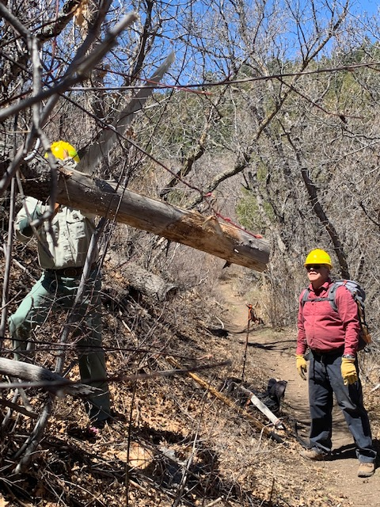

Another protruding log is cut well back from head space
on Oso Corredor.
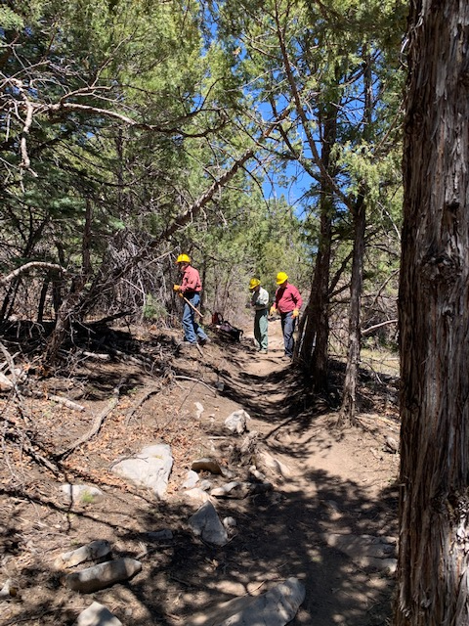

The crew is preparing to remove a poorly supported hang-up
from Oso Corredor.
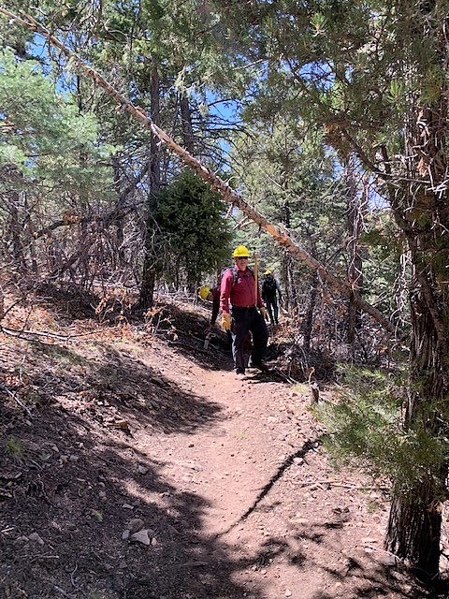

This hang-up over Oso Corredor was also removed.
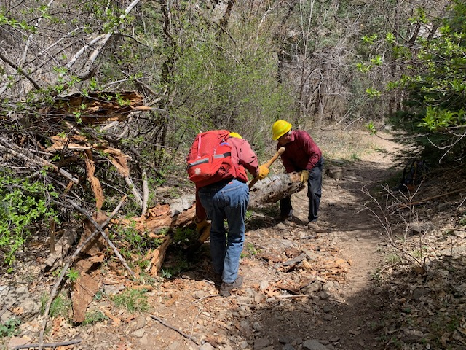

This broken tree trunk section had fallen across Bill Spring trail. It was removed.

