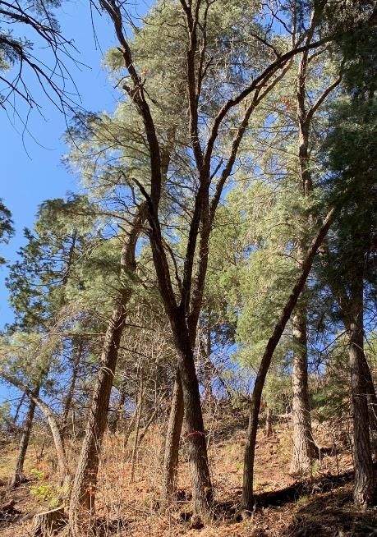

Jerry Carroll felled the 13-inch oak in the center of the photo near the two-vehicle

parking lot between the first and second restrooms in Cienega Picnic Area. Photo by Beth Carroll

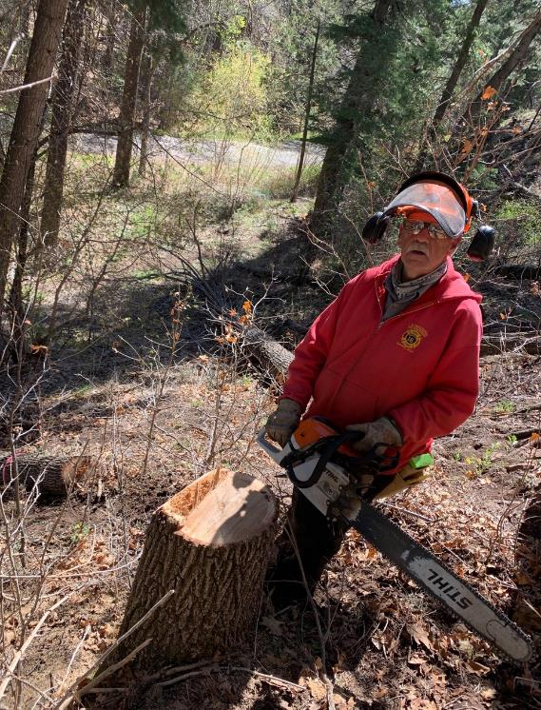

Jerry with his Stihl MS362 chain saw at the stump of the 13-inch oak he felled. Photo by Beth Carroll

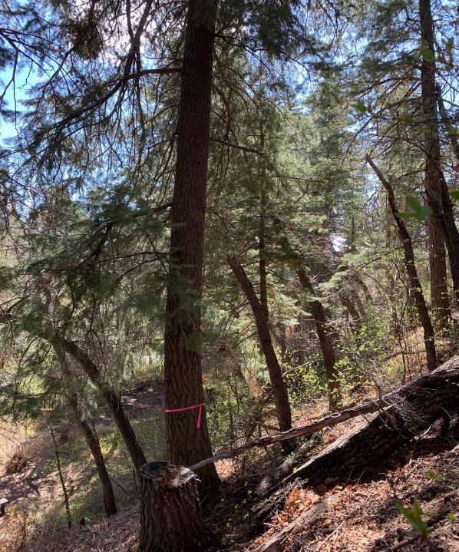

Jerry felled this 23-inch diameter white fir with a dead top. Photo by Beth Carroll

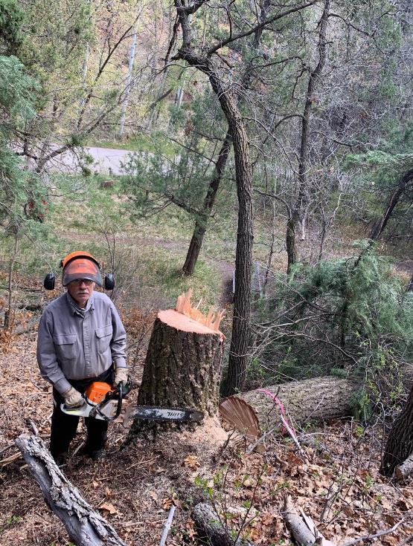

Jerry at the stump of the 23-inch fir he felled. Photo by Beth Carroll

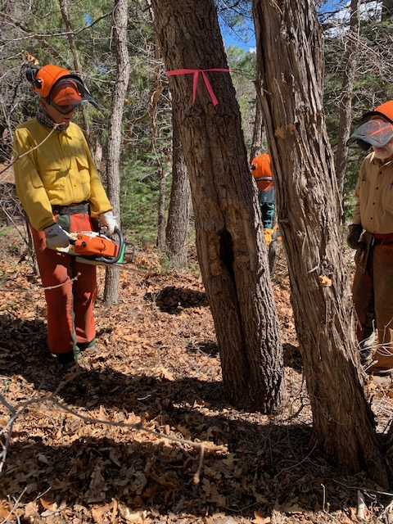

Bob Lowder preparing to fell this oak with a hollow trunk. Photo by Sally Lowder

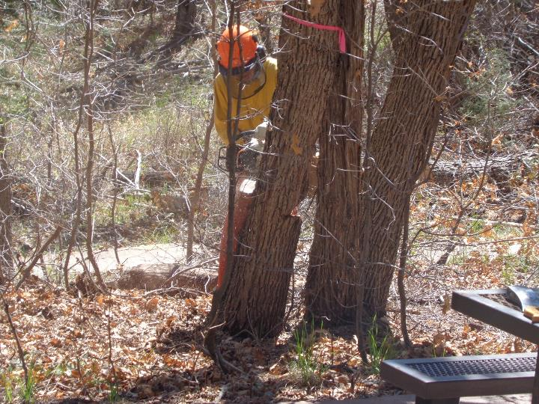

Bob making the back cut on the hollow oak up the canyon from the second restroom. Photo by Sam Beard

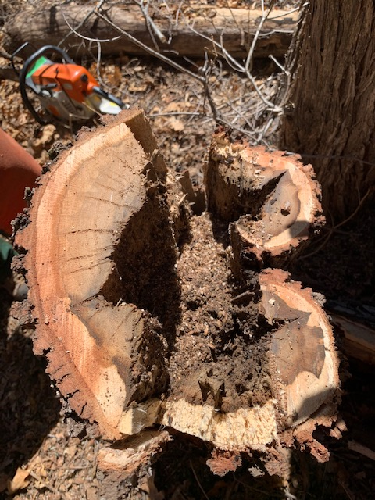

The hollow oak felled by Bob Lowder. Photo by Sally Lowder

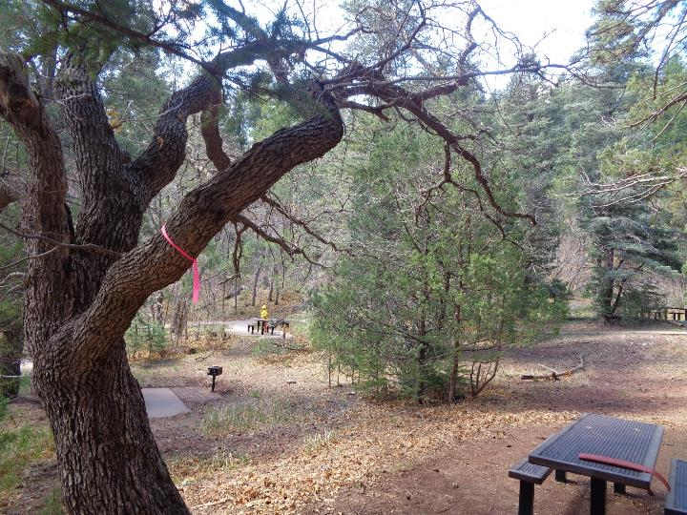

A large oak branch flagged by Russell Berman near a picnic table. Photo by Sam Beard

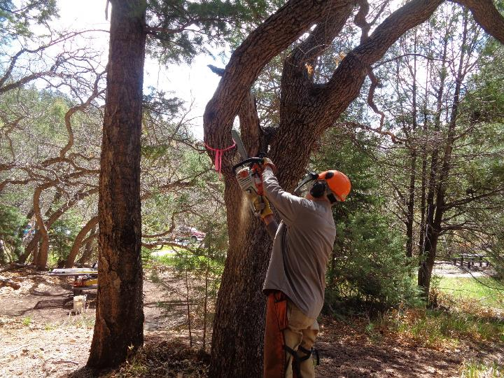

Dan Benton making a face cut in the large branch. Photo by Sam Beard

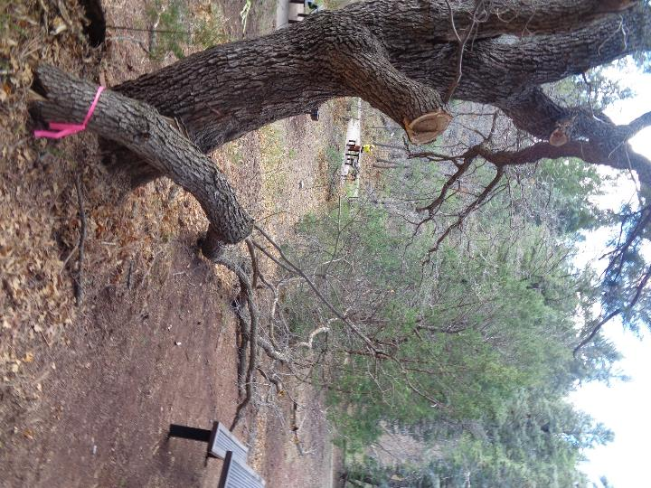

The large branch missed the picnic table when it fell. Dan, Lou, and Sam had to spend considerable time

removing the widow maker in the tree above where the large branch had been. Photo by Sam Beard