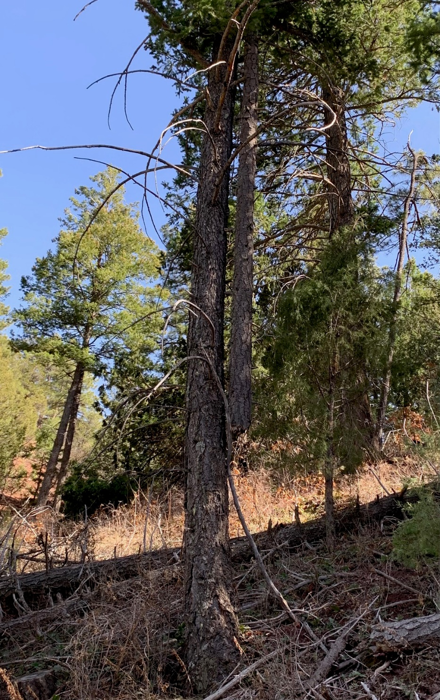
This broken treetop “widow-maker” was reported
on a tree on the Cienega Horse Bypass trail. The
crew found it to be on the ground, apparently
knocked off by wind and partially on the trail.
It was removed.

(Photo by Jerry Carroll)

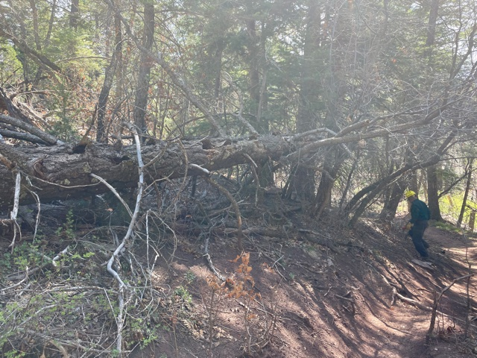
This old dead fir tree had fallen along the slope above Armijo
trail. It was being supported by a small oak tree which had bent under its weight. Since it presented a possible hazard to trail users, the crew got it safely to the ground and took steps to see that it would not fall onto the trail. Photo looking downhill.

(Photo by Cleve Sharp)
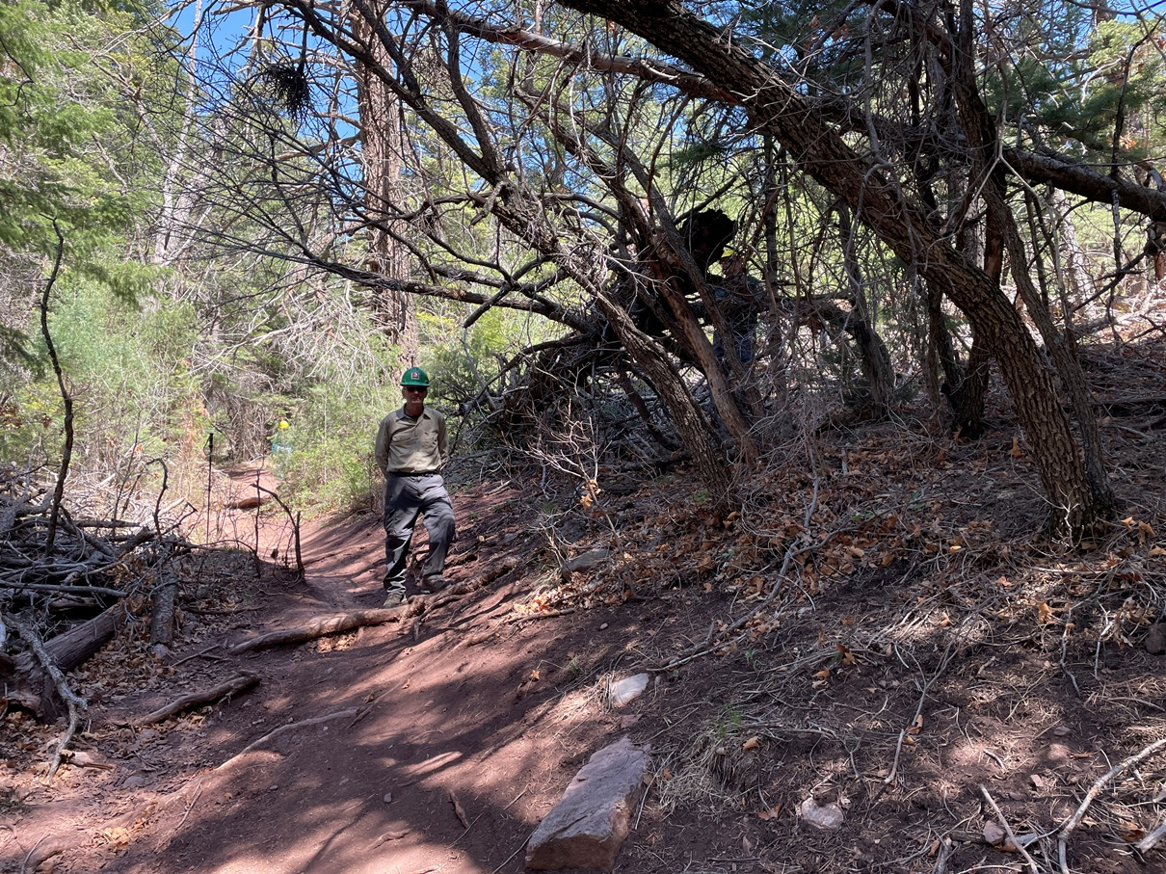
This photo again shows the large fallen fir above Armijo trail. The bent-over support oak shows in the right center of the photo. This view is uphill. Bill stands in the trail to show scale. The small oaks in the foreground are away from the large tree and are not supporting it.

(Phot by Cleve Sharp)

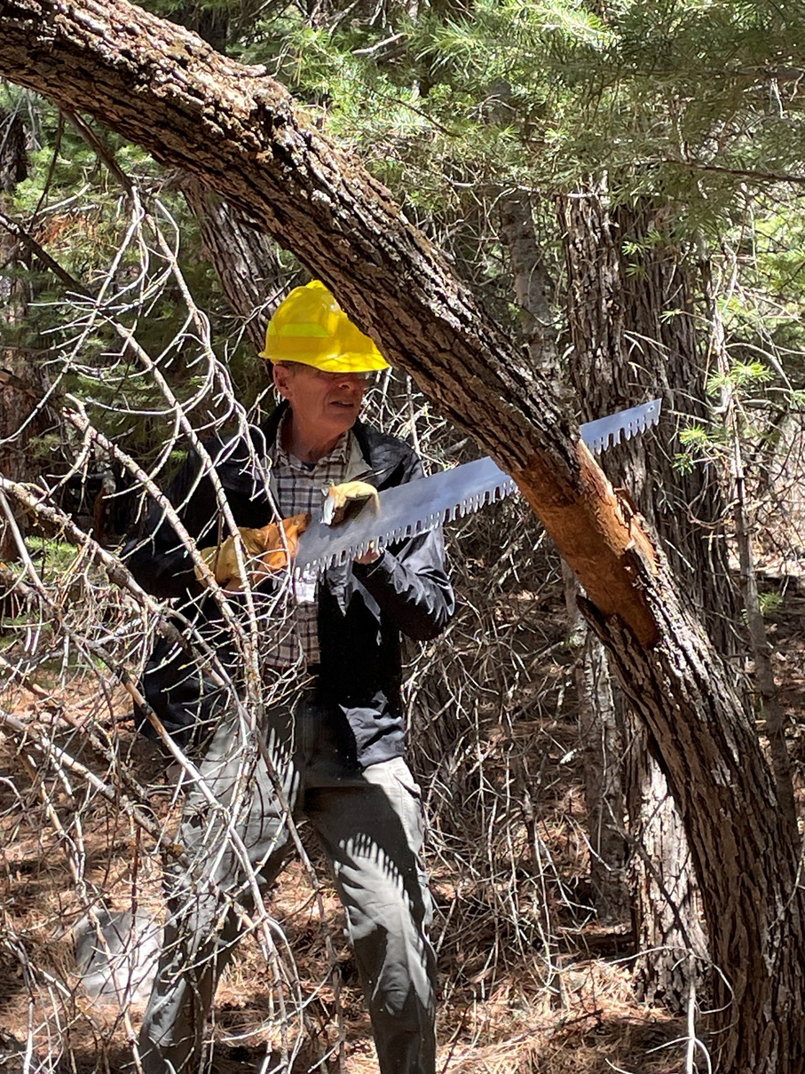
Sim cuts away an oak that arched over Armijo trail
at head height for anyone on horseback.

(Photo by Cleve Sharp)
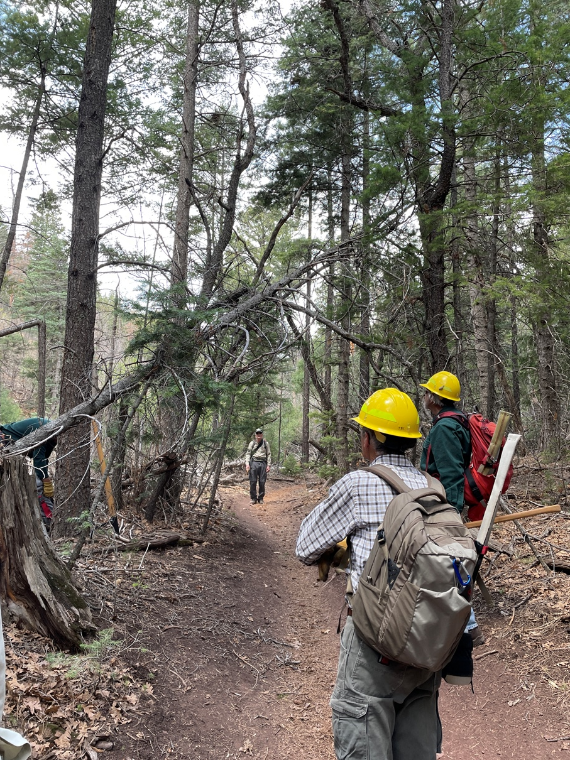
The crew studies a jumble of fallen or leaning trees
looming over Armijo trail. They were all removed.

(Photo by Cleve Sharp)

