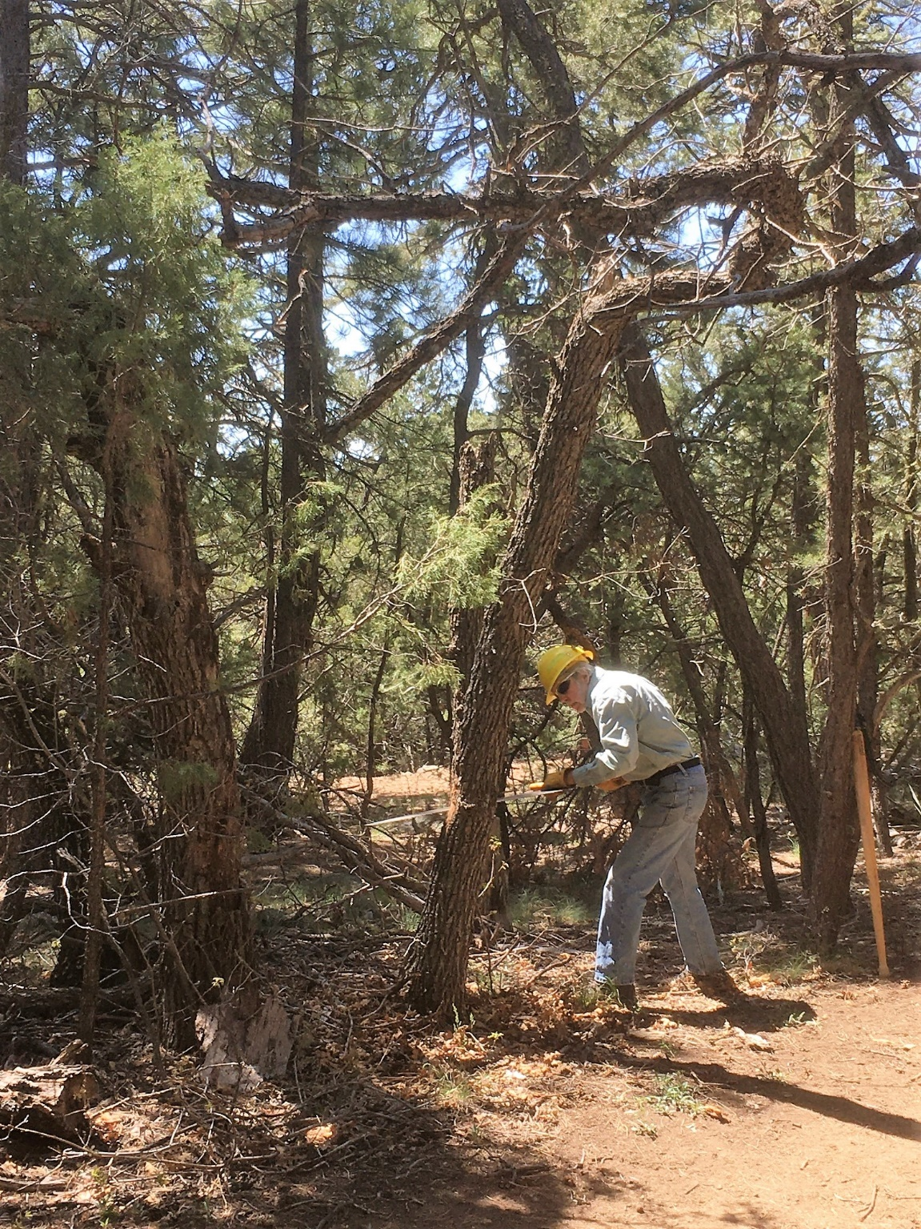
Byron starting a cut on a badly twisted small dead
oak tree whose limbs were in the headspace of anyone
passing beneath it on horseback.
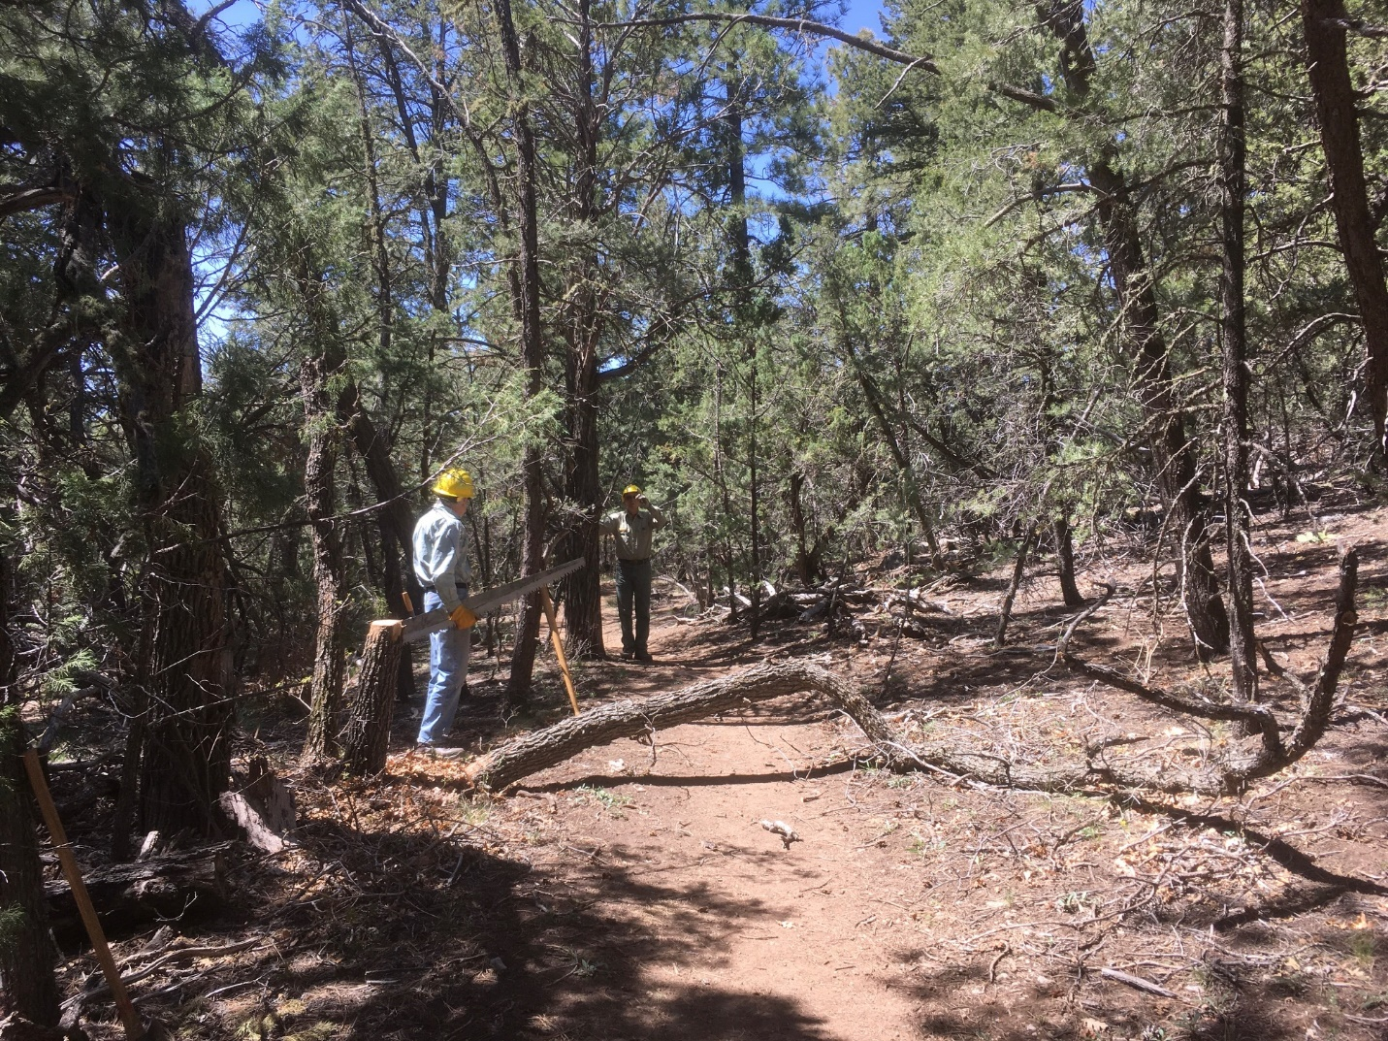
The oak hazard tree is safely on the ground. It was cut once again and moved away from the trail.

