Report of Hazard Tree Removal in Sulphur Canyon Picnic Area

On Wednesday, May 12, 2021

Sam Beard, May 14, 2021

1. Lower Sulphur Canyon PA – Eric Russell, Sim Cook, and Cliff Giles. Removed five oaks with diameters of 8, 11, and 11 inches. Removed two junipers with diameters of 4 and 8 inches.
2. Upper Sulphur Canyon PA – Dan Benton, Lou Romero, and Dennis Crowther. Removed five trees with diameters of 4 to 10 inches.
3. Road from Sulphur PA restroom bollards to traffic circle – Jerry and Ray Carroll. Removed 12 trees with the largest diameters being: oak, 14 inches, and Rocky Mountain juniper, 12 inches.
4. A total of 24 hazard trees were removed.

Photographs are presented below.

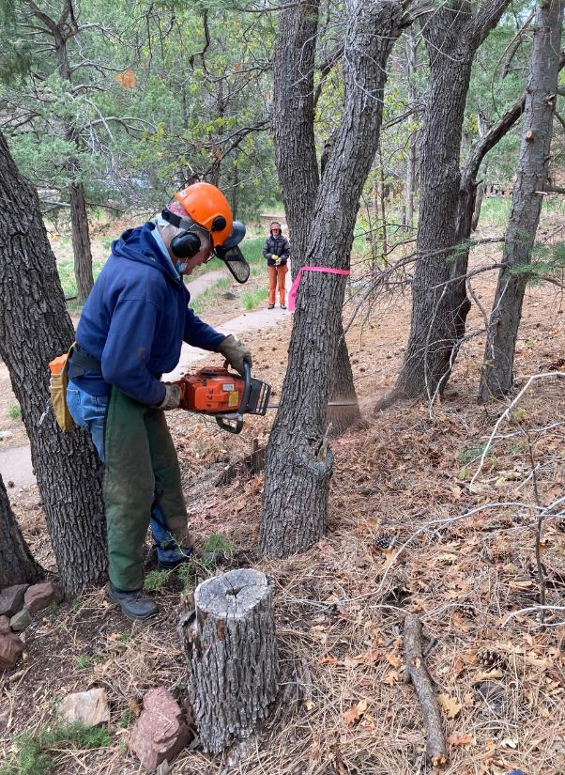

Eric Russell making the face cut in an oak hazard tree in the lower part of Sulphur Canyon Picnic Area.

Sim Cook is in the background watching for hikers. All photos by Cliff Giles unless stated otherwise.

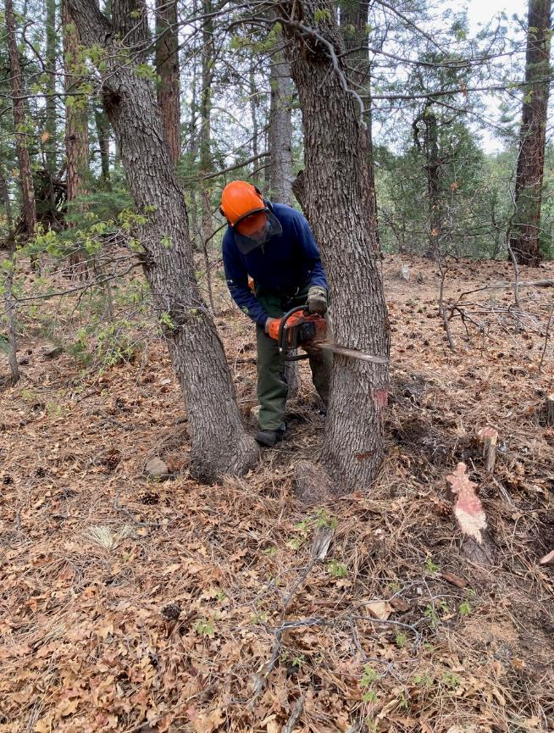

Eric making the face cut in a large oak hazard tree.

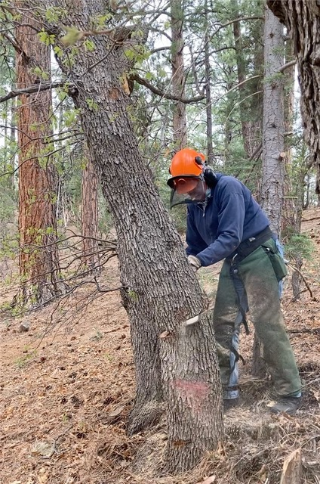

Eric making the back cut in the oak.

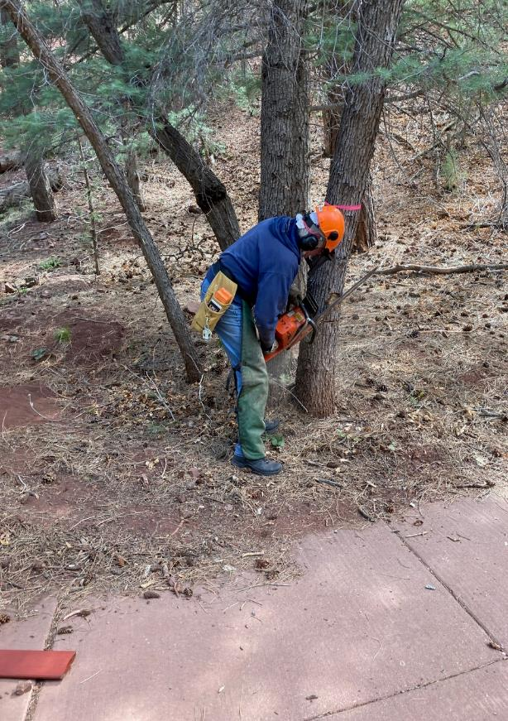

Eric completing the face cut in another oak tree.

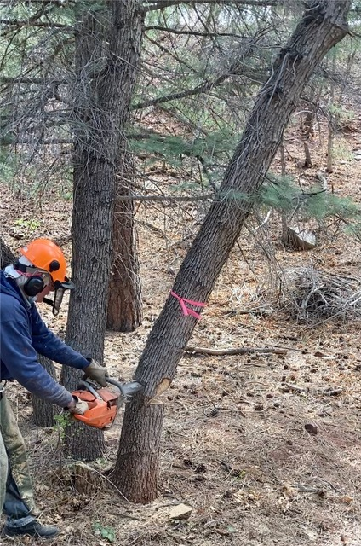

Eric completing the back cut as the oak begins to fall.

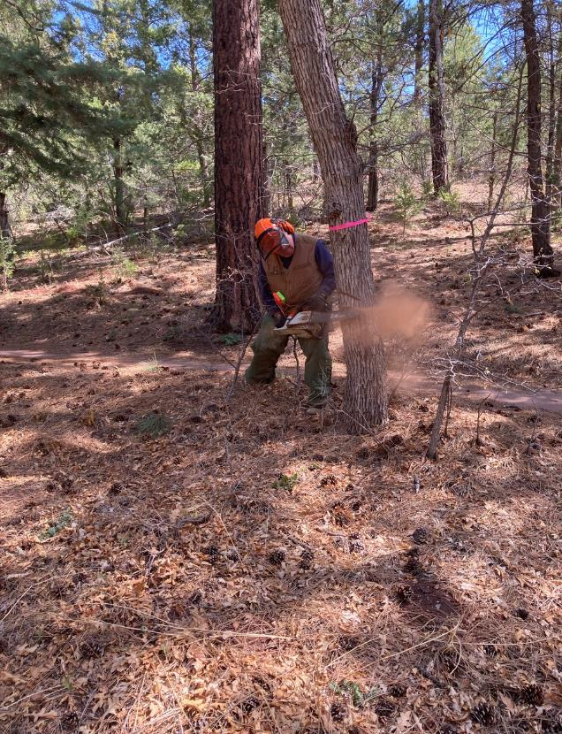

Dennis Crowther making the face cut in an oak.

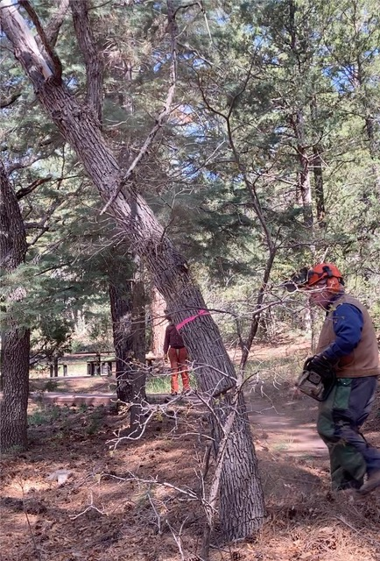

Dennis running away from the oak as it begins to fall.

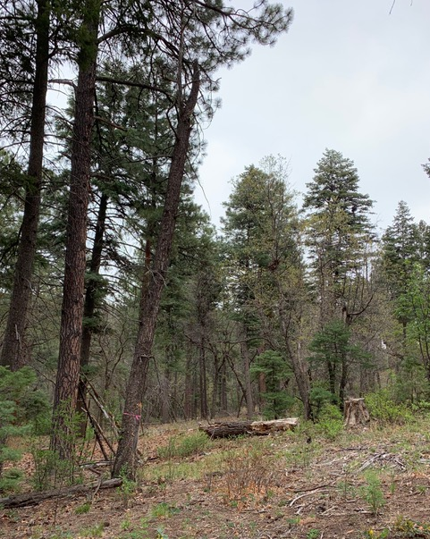

A flagged hazard tree in Sulphur Canyon Picnic Area between the restroom bollards and the

traffic circle where Jerry and Ray Carroll worked. Photo by Ray Carroll

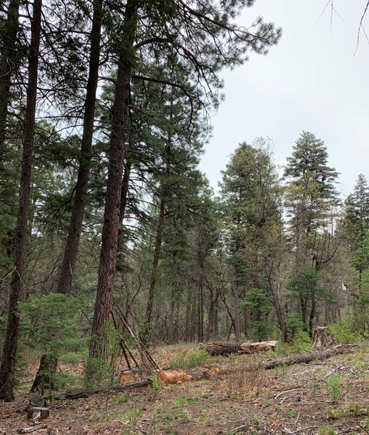

The hazard tree felled by Jerry is now on the ground.

Photo by Ray Carroll

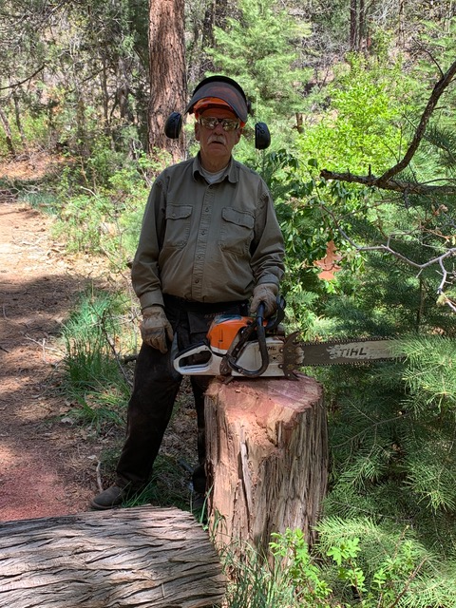

Jerry Carroll at the stump of an 18-inch dead Rocky Mountain juniper that he felled.

Photo by Ray Carroll