Report of Hazard Tree Removal in Doc Long Picnic Area

on Wednesday, May 12, 2021

Sam Beard, May 14, 2021

1. Road between second and third restrooms – Bob and Sally Lowder and Jerry Pekarek. Removed 9 oaks with diameters of 2 to 8 inches.
2. Picnic table area across road from third restroom – Michael Arndt, Sam Beard, Sim Cook, Eric Russell, and Lou Romero. Removed a 10-inch pine.
3. Old paved road near Bill Spring Trailhead – Michael Arndt and Sam Beard. Removed seven oaks with diameters of 3 to 12 inches.
4. A total of 17 hazard trees were removed.

Photographs are presented below.

Report of Hazard Tree Removal at Tree Spring Trailhead

on Wednesday, May 12, 2021

Sam Beard, May 14, 2021

1. Inside fence near upper end of parking lot – Dan Benton, Eric Russell, and Dennis Crowther. Removed one fir tree with a diameter of 12 inches.

Photographs are presented below.

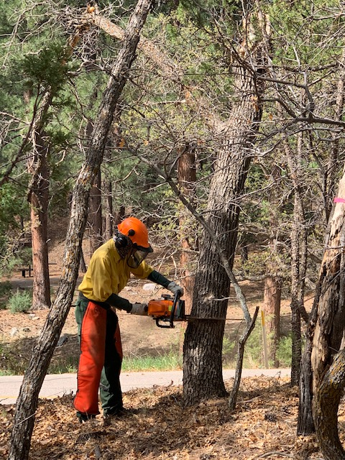

Bob Lowder starting the back cut on a large oak hazard tree in Doc Long Picnic Area between the

second and third restrooms. Photo by Sally Lowder

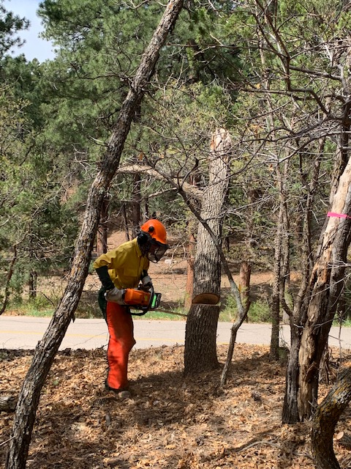

The tree begins to fall as Bob moves away from it.

Photo by Sally Lowder.

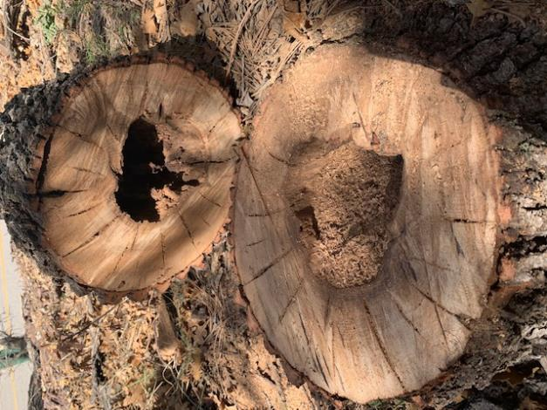

The tree felled by Bob was hollow. Photo by Sally Lowder

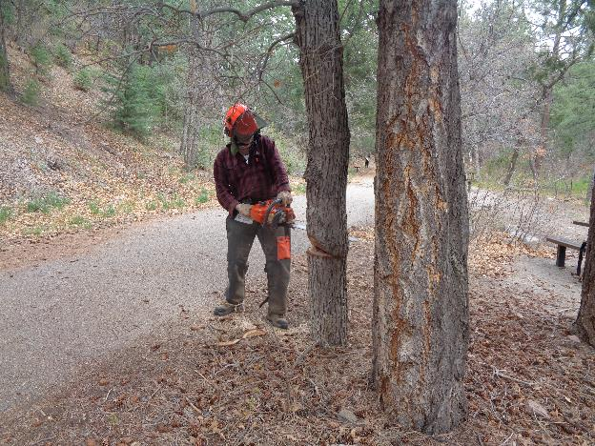

Michael Arndt beginning the back cut on a large oak on the old highway near Bill Spring Trailhead.

Photo by Sam Beard

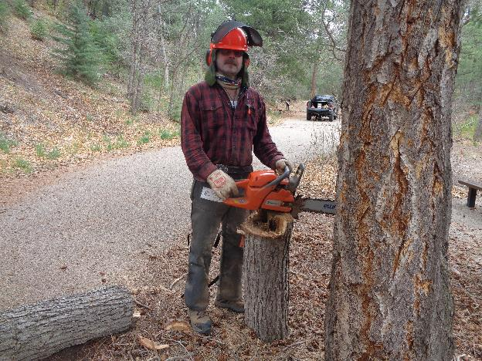

Michael at the stump of the felled hazard tree. The center of this tree was rotten, and many other oak

trees were hollow. Photo by Sam Beard

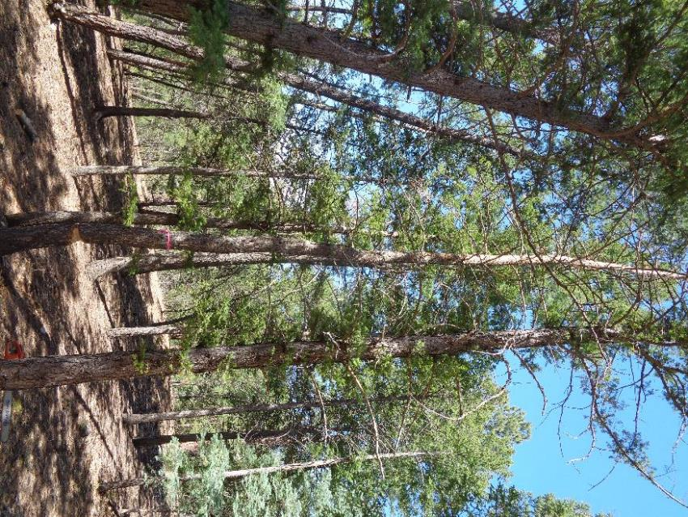

A tall dead 12-inch ponderosa pine at a picnic table across the road from the upper restroom.

Photo by Sam Beard

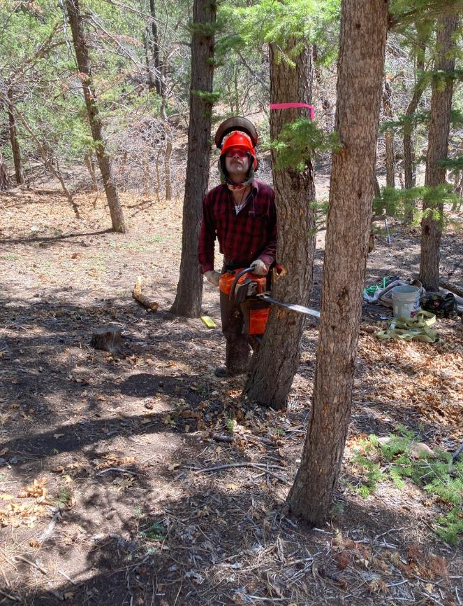

Michael Arndt making the horizontal cut of the face cut on this pine tree. This tree fell into the tops of two trees

and became a hang-up. Photo by Cliff Giles

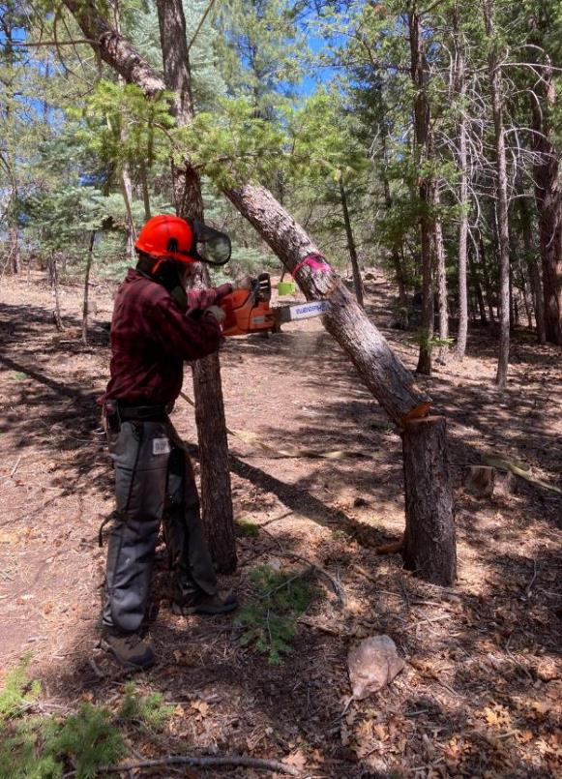

Michael making a vertical cut on the hang-up so that the lower end would fall to the ground. A wedge

was driven into the kerf so that the tree would not bind the saw. Kerry Wood, Cibola National Forest

Trails Manager, taught the volunteers to make this cut many years ago in Balsam Glade Picnic Area.

After the end of the tree was on the ground, volunteers pulled it to the right so that the tree fell to the ground.

Photo by Cliff Giles

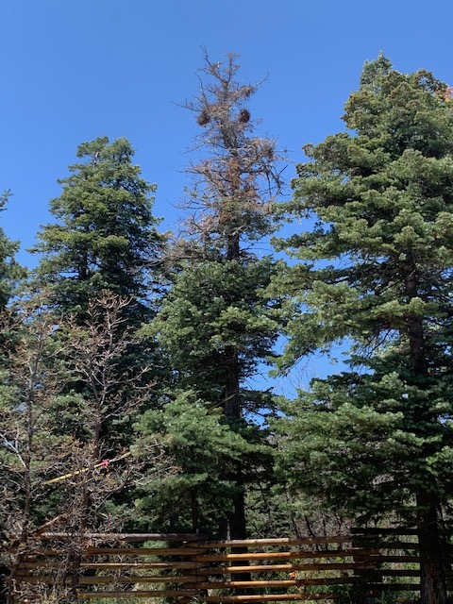

This hazard tree with a deaf top was felled away from the fence and the Tree Spring Trailhead parking area.

Photo by Sally Lowder