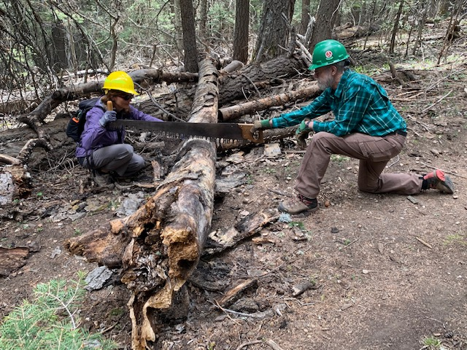
Silke and Cleve start the cut on the dead tree that was sticking out into the trail.

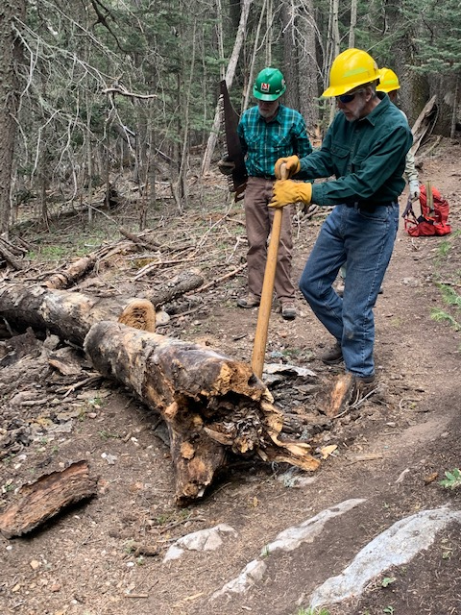
Byron uses a cant hook to roll the cut tree section off
the trail.
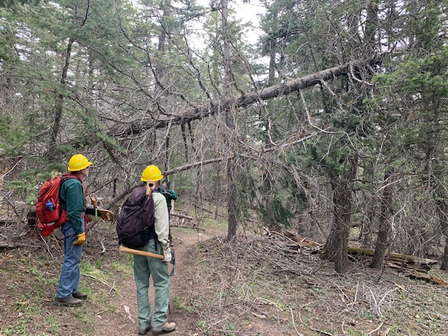
This big hangup greeted us as we approached the 10K North/Osha Loop junction. The fir spring pole tree is shown bent beneath the big dead fallen tree. (A spring pole is a small tree or a branch that has been bent over by a fallen tree or other force. Its upper side is under tension. When the object holding it down is removed, the tree or branch tends to spring back up, sometimes very quickly. It is necessary to slowly make cuts in the top of the spring pole at its bend to release the tension so the tree or branch springs back up slowly and safely.)
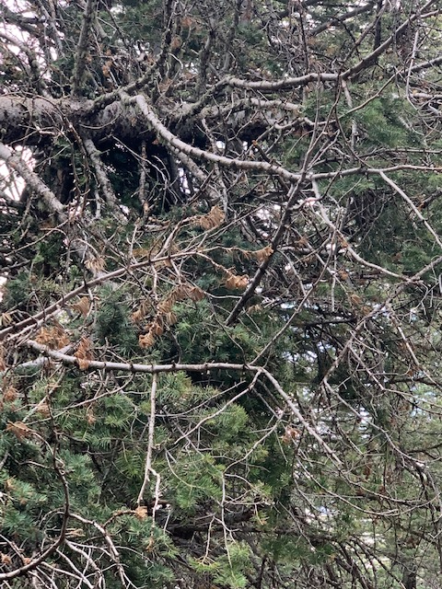
This jumble of branches, which includes the top
of the small fir spring pole tree, is the main
support for the fallen tree.
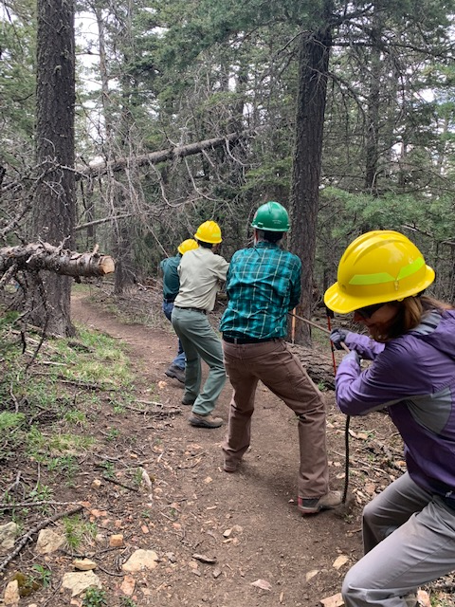
The crew uses a long rope to pull the top of the spring
pole fir out of the branch jumble with hopes that the
big tree would fall to the ground. It didn’t. The spring
pole tree was removed.

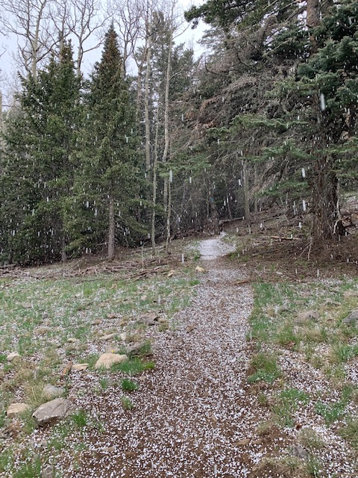
Apparently, winter does not wish to leave the Sandias
just yet.
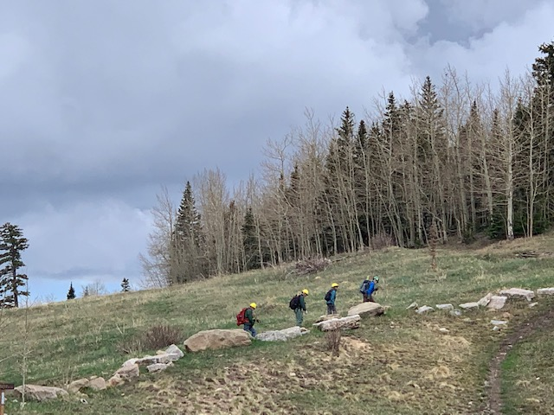
The crew trudges up Challenge trail to the Ellis trailhead starting point after a long day. We had not planned to return this way, but the weather changed our minds.

