Felling Hazard Trees at Ellis Trailhead and in Nine Mile Picnic Area, Balsam Glade PA, and

at the Ski Area Overflow Parking Area on May 19, 2021

Sam Beard

May 22, 2021

On Wednesday, May 19, nine FOSM volunteers felled a total of 22 hazard trees or dead trees for a safe lay at four sites on the upper part of the Crest Highway.

At Ellis Trailhead, Michael Arndt, Dan Benton, Lou Romero, Eric Russell, and Sam Beard felled seven trees with diameters ranging from 4 inches to 15 inches. The 15-inch tree was near the highway, and the other trees were near the restroom and red gate on the Service Road.

At Nine Mile Picnic Area, Sam’s crew felled four 9-inch to 10-inch diameter aspens in the lower part of the picnic area, and near the traffic circle, they felled a 12-inch fir and an 18-inch fir.

In Balsam Glade Picnic Area, Jerry Carroll, Byron Garner, Sim Cook, and Jerry Pekarek felled three trees. The trees felled in the low area near NM-165 were 17 inches and 19 inches in diameter, and at the lower parking area the hazard tree was 8 inches in diameter.

In the Ski Area Overflow Parking Area, Jerry’s crew felled hazard trees with diameters of 8, 10, and 12 inches. Three dead trees with diameters of 4 to 6 inches were felled to create a safe lay for the 12-inch tree.

All the trees were limbed and bucked to 8-foot lengths.

Photographs of Wednesday’s project are presented below.

Sam Beard, Projects Chair

Friends of the Sandia Mountains

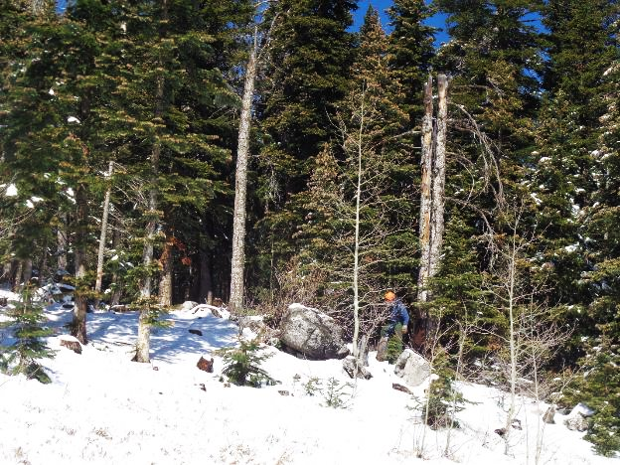

Eric Russell preparing to fell a twin-trunk dead fir cigar butt tree at Ellis Trailhead.

All photos by Sam Beard unless noted otherwise

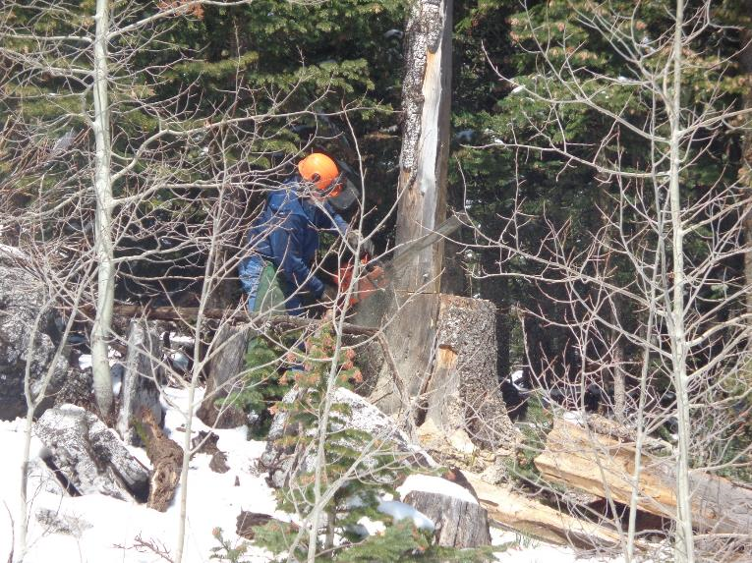

Eric making the back cut on the second trunk.

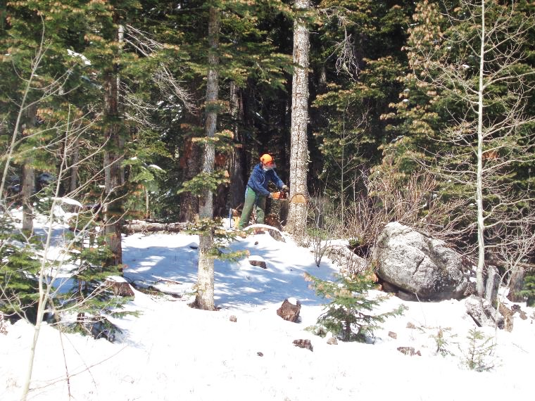

Eric making the back cut on a 13-inch dead fir at Ellis Trailhead.

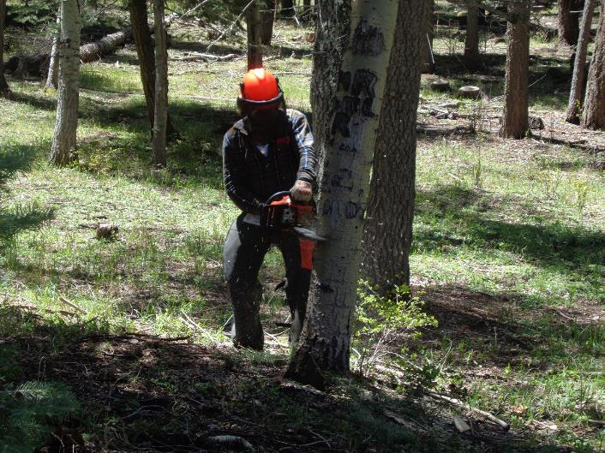

Michael Arndt making the back cut on a dead aspen in Nine Mile PA.

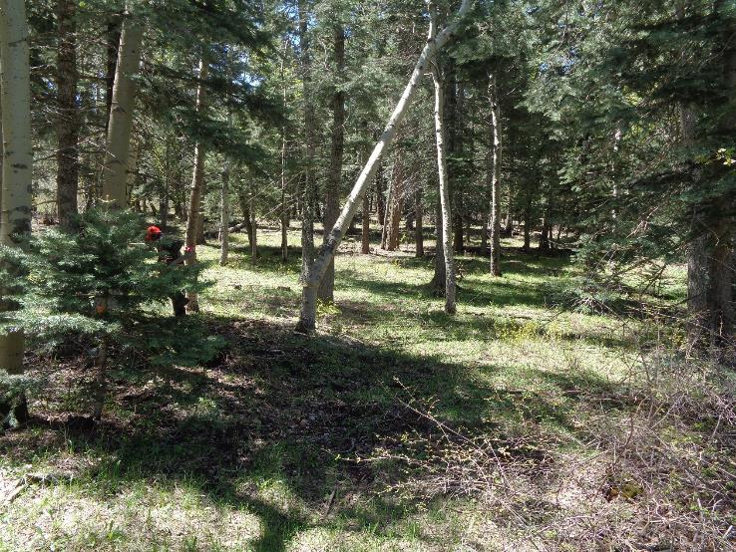

Michael running from the falling aspen.

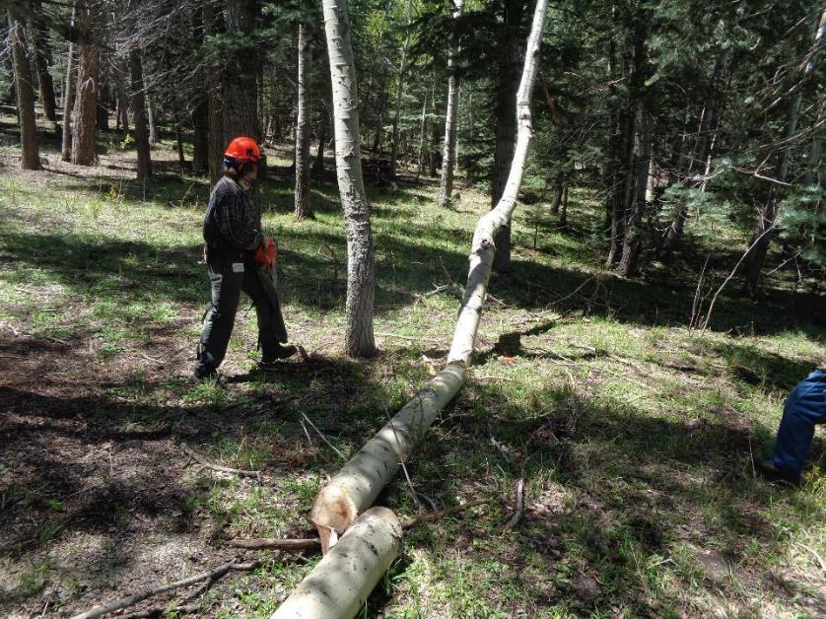

Michael has made two bucks in the hung-up aspen.

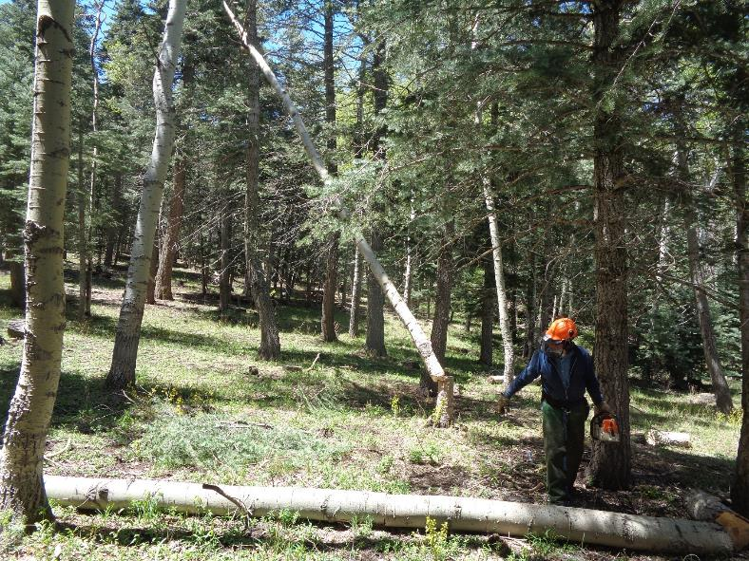

Eric Russell running from the aspen he has felled.

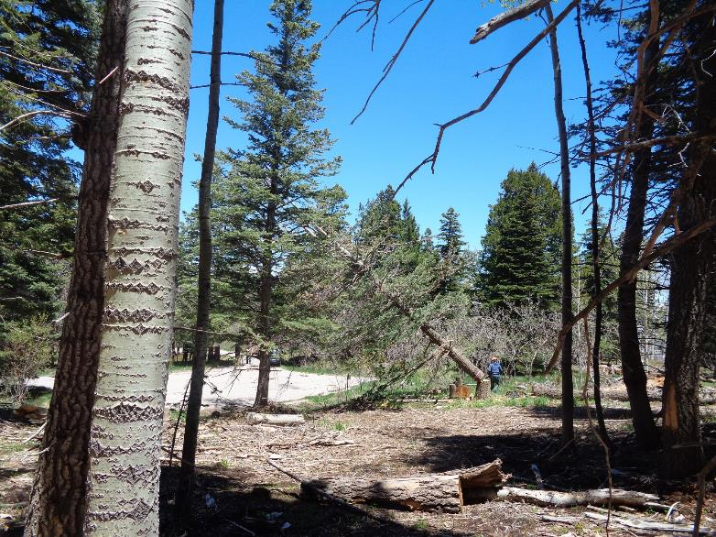

Eric running from the falling white fir with a long dead top in Nine Mile PA. He felled the tree with a plunging back cut.

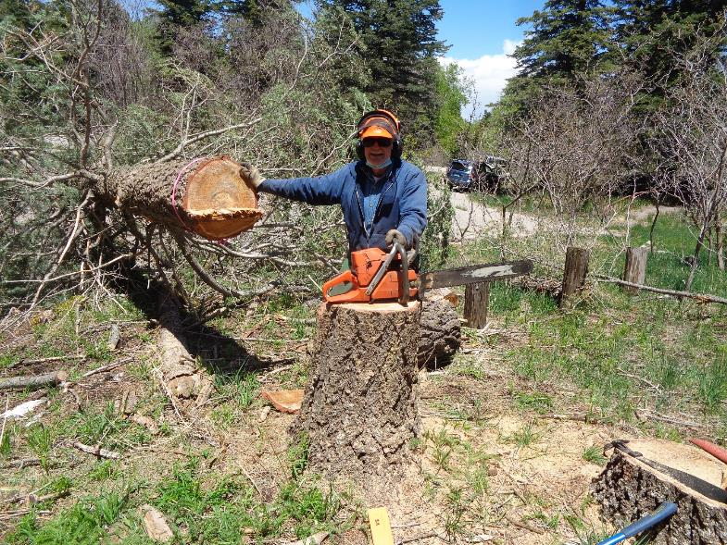

Eric at the stump of the 18-inch white fir he has just felled.

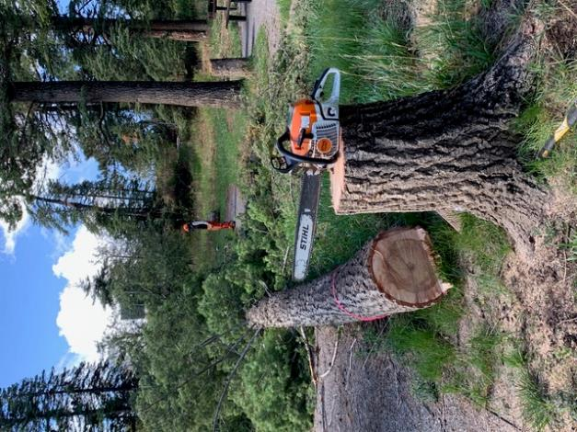

Flagged 19-inch fir felled by Jerry Carroll in the lower part of Balsam Glade Picnic Area.

All photos at Balsam Glade PA and Ski Area Overflow Parking Area are by Jerry Carroll.

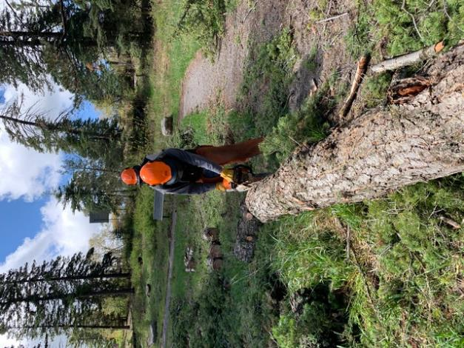

Byron Garner limbing the fir felled by Jerry Carroll.

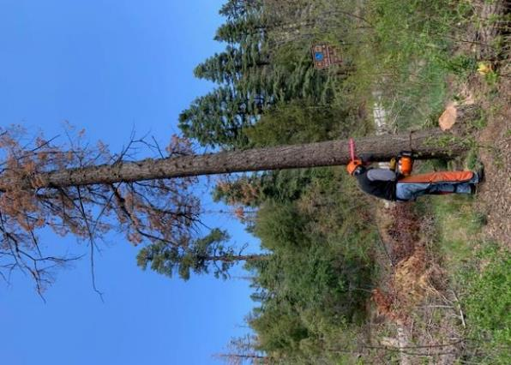

Byron making the back cut on a 17-inch fir in the lower part of Balsam Glade PA.

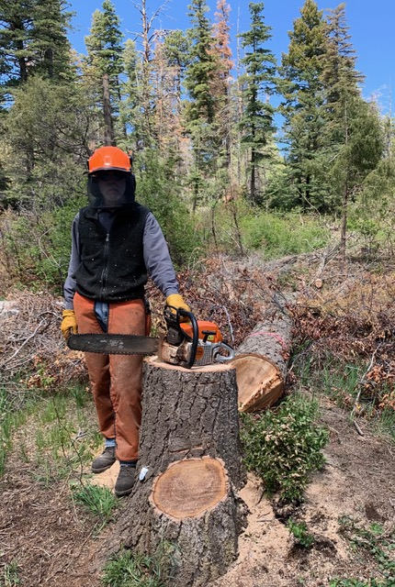

Byron at the stump of the fir he has just felled.

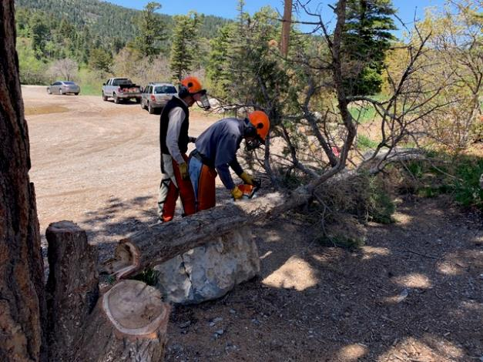

Byron limbing the 8-inch fir he has just felled at the Ski Area Overflow Parking Area.