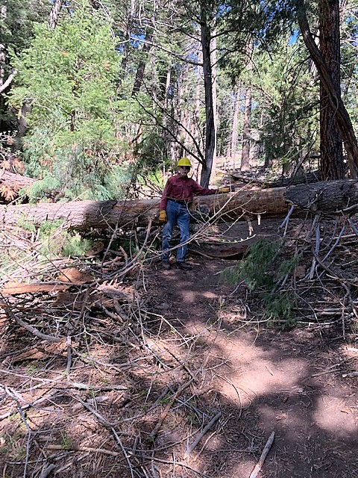
Byron next to large fallen tree blocking Armijo
trail just below the Faulty junction. Tree was
recently fallen and no significant walk-around
had yet developed. The tree extends 15 – 20 feet
beyond each of the edges shown in the photo.

(Photo by Bob Lowder)

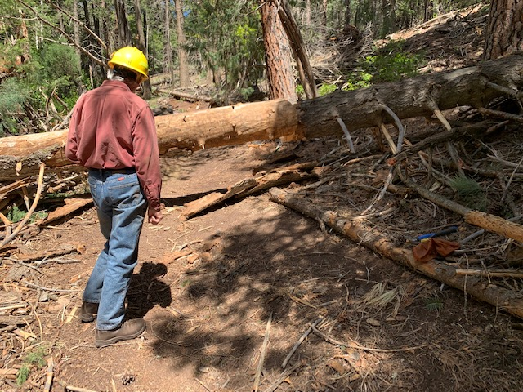
Debris has been removed from the trail and the fallen tree is being prepared for cutting. Bark sections on the ground are there to protect the crosscut saw if it falls through the kerf
when the cut is completed. The tree was 18 inches in diameter where it was cut.

(Photo by Bob Lowder)
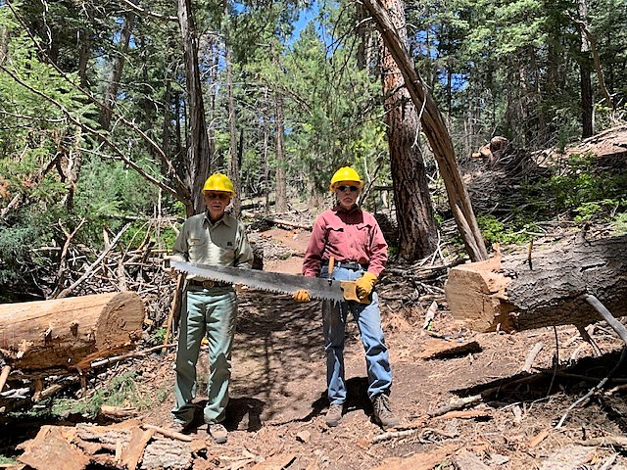
Fallen tree has been removed from Armijo trail.

(Photo by Cleve Sharp)

