Report on Paint Projects at Doc Long and Balsam Glade Picnic Shelters

and Repair of Doc Long Kiosk on Tuesday, May 25

Sam Beard

May 28, 2021

On Tuesday, May 25, the paint crew of Sim Cook and Sam Beard repaired the kiosk at the first restroom in Doc Long Picnic Area and painted some of the low beams on the picnic shelters in Doc Long and Balsam Glade PAs.

The first photograph below shows the space that had developed between the tops of the vertical boards and the top beam on the kiosk. The following photographs show the repairs that were made to the kiosk to stabilize the vertical boards and cover the space on the front side.

The photograph on page 6 shows the red primer paint that was exposed after rain washed off the wet brown paint that had been applied a week earlier on a low beam on Shelter B in Doc Long PA. Brown paint was reapplied on all the low Doc Long shelter beams where it was needed.

The photograph on page 8 shows the poor condition of the paint on the low beams on the Balsam Glade picnic shelter. In the following photograph, brown paint has been applied to the beam.

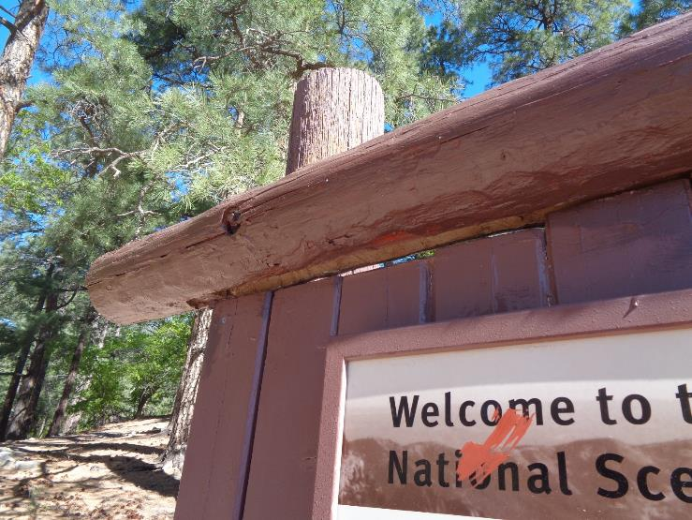

A one-inch space had developed between the top beam and the ends of the vertical 2x6 boards in the kiosk at the first restroom

In Doc Long Picnic Area. The vertical boards at each end of the kiosk were loose at the top. All photos by Sam Beard unless noted otherwise

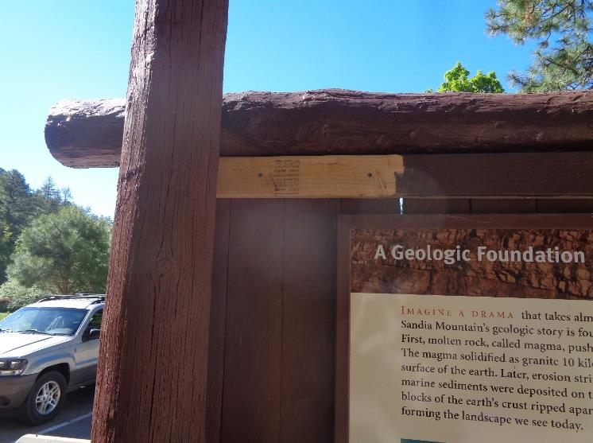

The loose boards at each end of the kiosk were stabilized by screwing them to a 2x4 across the back of the sign. The left end of the 2x4

Is the unpainted wood near the top of the photograph. Painted wood is just to the right of the unpainted segment.

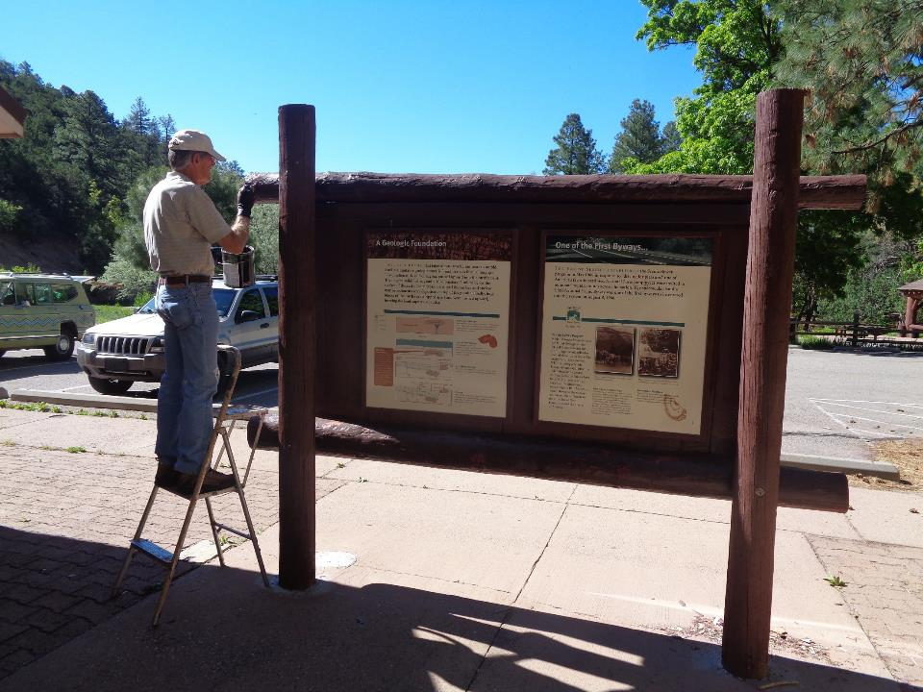

Sim Cook is painting the kiosk with USFS brown Behr paint. The painted 2x4 is shown just below the top beam.

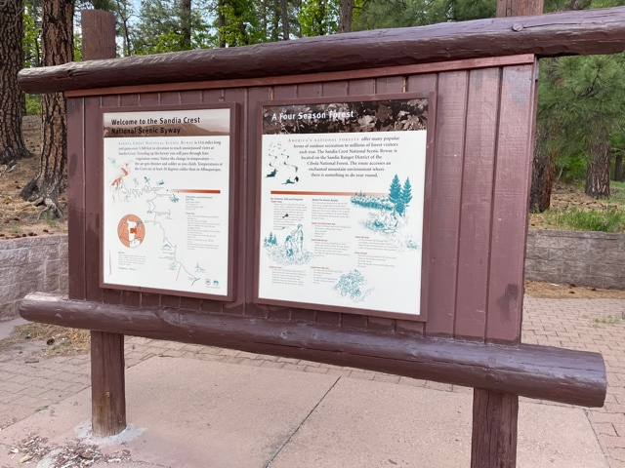

Don Carnicom screwed the 1x2 piece of wood across the top of the vertical boards to cover the opening on the front side of the kiosk

on Wednesday, May 26, and painted it brown. Photo by Don Carnicom

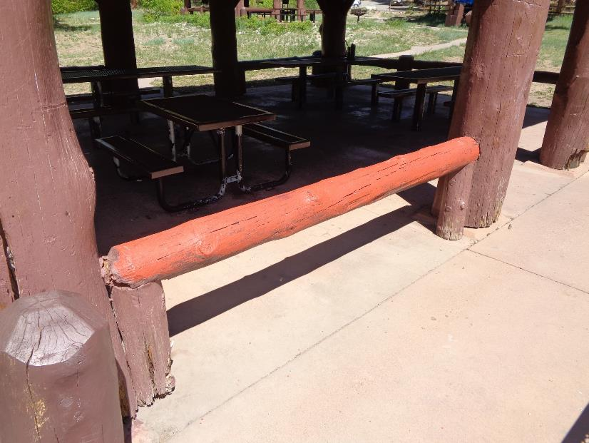

On Tuesday, May 18, rain washed off the still-wet brown paint applied to some of the low beams on Shelter B in Doc Long Picnic Area,

revealing the red primer paint.

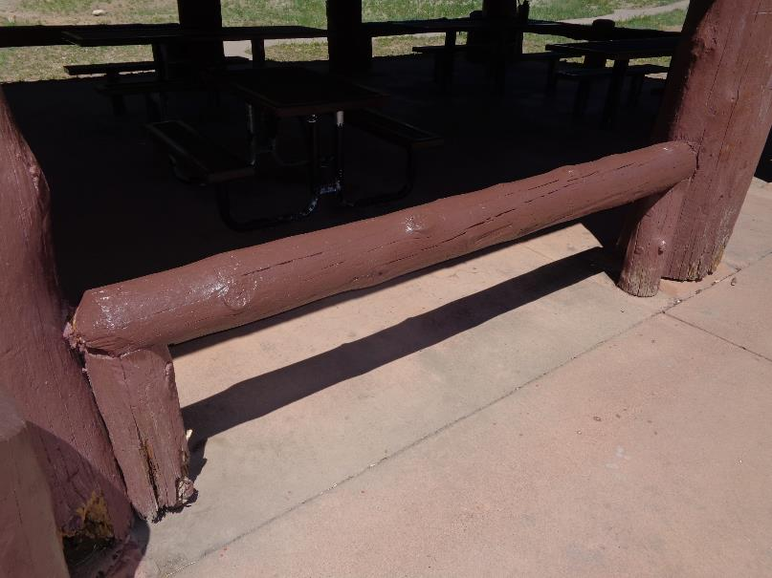

On Tuesday, May 25, USFS brown paint was applied over the red primer on a few of the low beams on Shelter B.

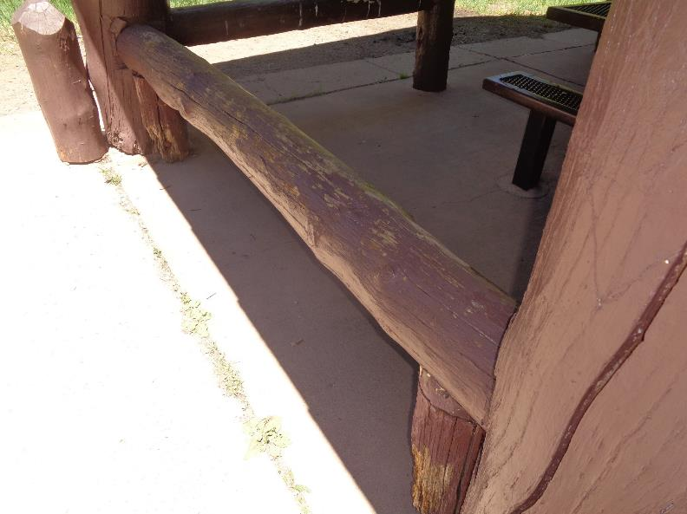

The paint on all the low beams on the Balsam Glade picnic shelter was in poor condition.

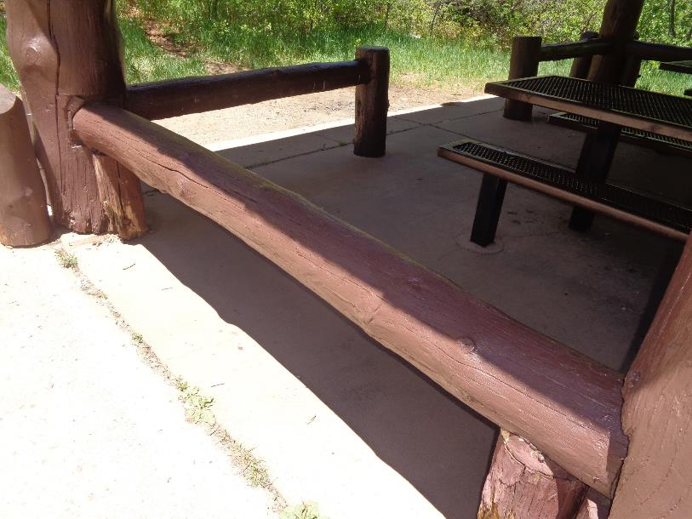

The beam in the above photograph after brown paint was applied.