Report on Removal of Hazard Trees in Capulin Picnic Area, Lower Picnic Area,

and Snow Play Area on Wednesday, May 26, 2021

Sam Beard

May 29, 2021

On Wednesday, May 26, nine FOSM volunteers removed 24 hazard trees from Capulin PA, Lower Picnic Area, and Snow Play Area. In Balsam Glade PA, a broken tree top was limbed, and a cigar butt tree was felled.

The following crews removed trees:

1. Picnic Area – Dan Benton and Cliff Giles – 6 trees with diameters of 5” to 10 “
2. Lower Picnic Area – Jerry Carroll and Lou Romero – 2 trees with diameters of 17” and 20”
3. Snow Play Area – Bob Lowder, Sally Lowder, and Byron Garner – 9 trees with diameters of 3” to 13”
4. Snow Play Area – Dan Benton and Cliff Giles – 3 trees with diameters of 5” to 16”
5. Snow Play Area – Dennis Crowther and Sam Beard – 4 trees with diameters of 8” to 12”
6. Balsam Glade PA – Dennis and Sam – At lower parking lot, removed a broken tree trunk and 16” diameter tall cigar butt stump.

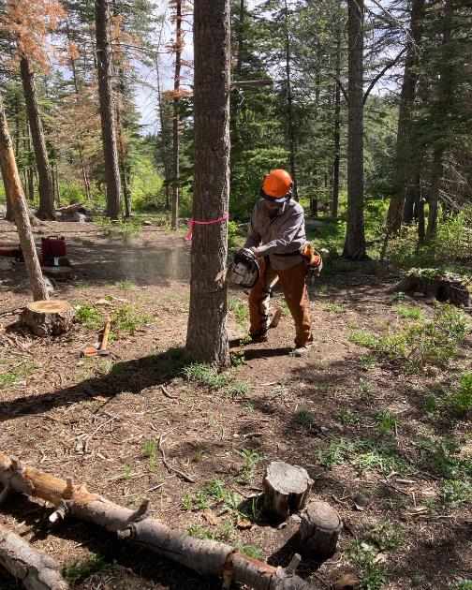

Dan Benton making face cut on tree in Capulin Picnic Area.

Photo by Cliff Giles

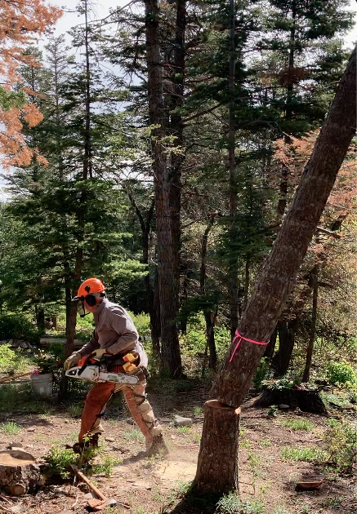

Dan running away from falling tree. Photo by Cliff Giles

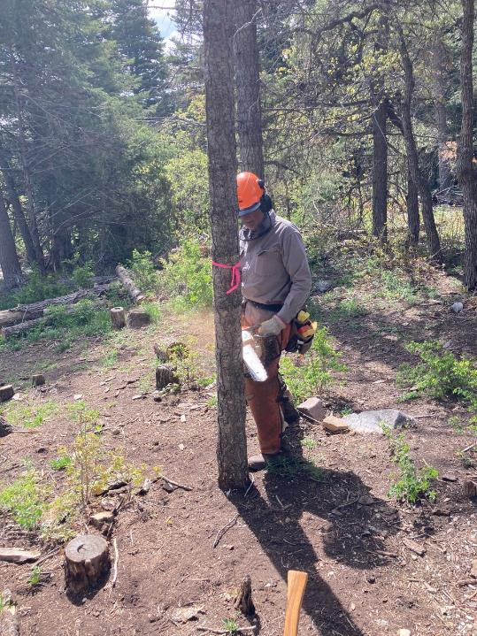

Dan starting a face cut on a smaller tree in Capulin PA. Photo by Cliff Giles

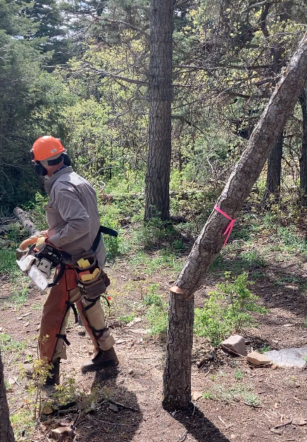

Dan running away as tree falls. Photo by Cliff Giles

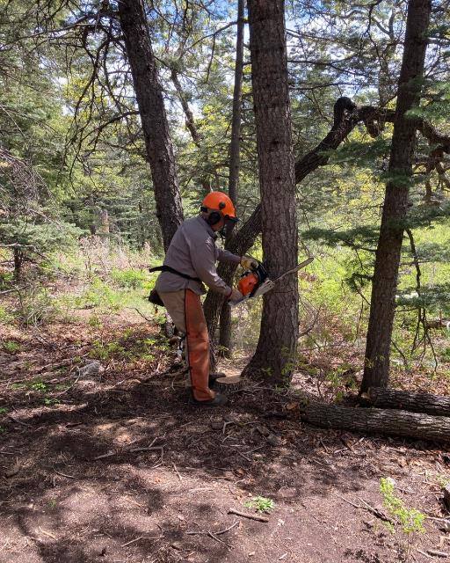

Dan starting the face cut on a 10-inch tree. Photo by Cliff Giles

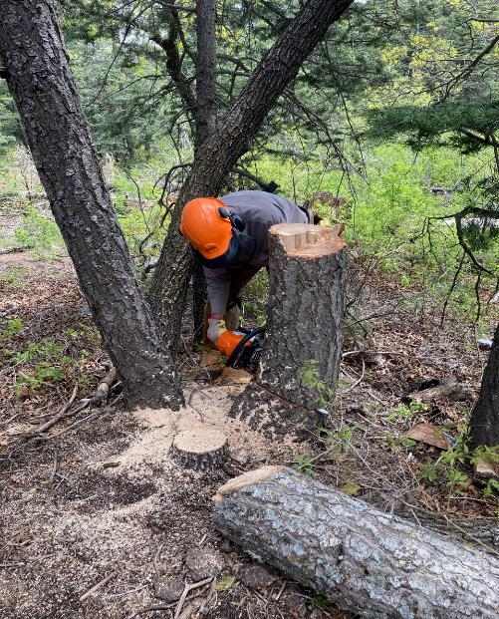

Dan low stumping where he has just felled the tree. Photo by Cliff Giles

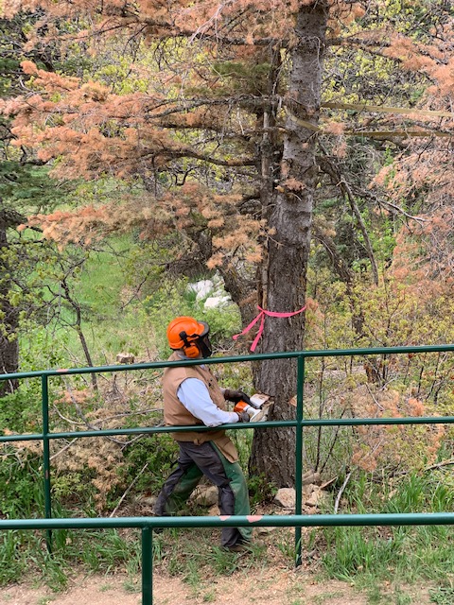

Dennis Crowther making the back cut on a 12-inch tree beside the railing in the Snow Play Area.

Photo by Sally Lowder

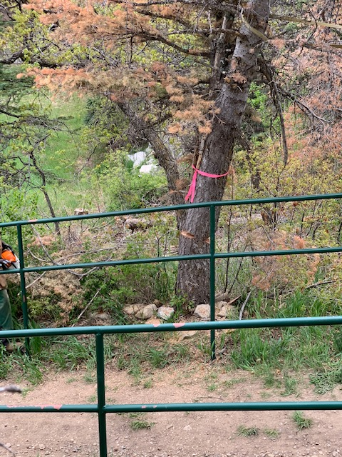

The tree starting to fall as Dennis is running away from the tree. Photo by Sally Lowder

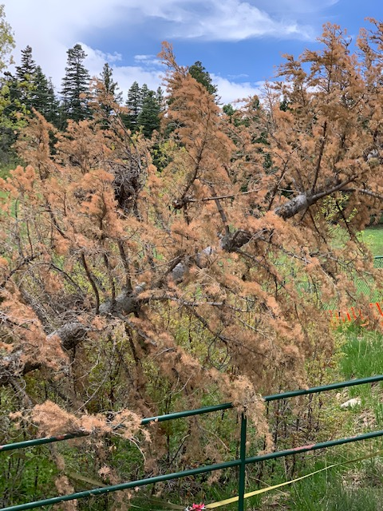

Dead white fir falling beside the railing. Photo by Sally Lowder

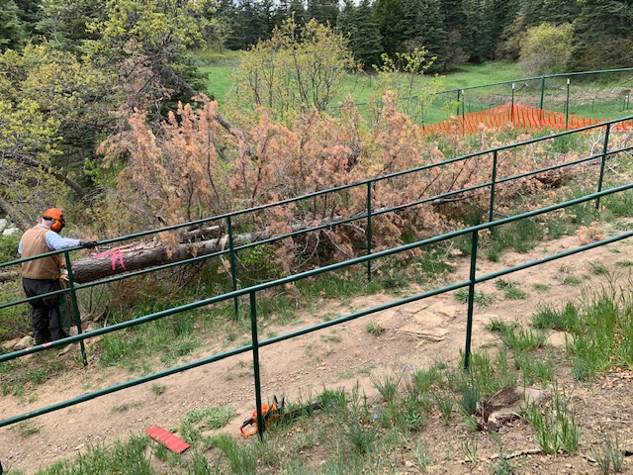

The tree is safely on the ground. Photo by Sally Lowder

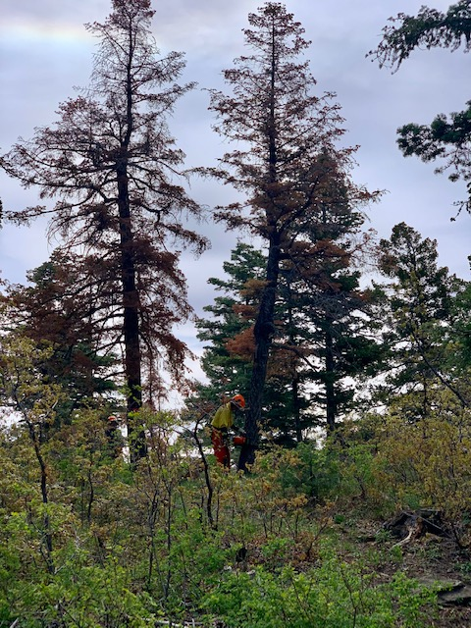

Bob Lowder felling a dead fir near the Snow Play Area shelter. Photo by Sally Lowder

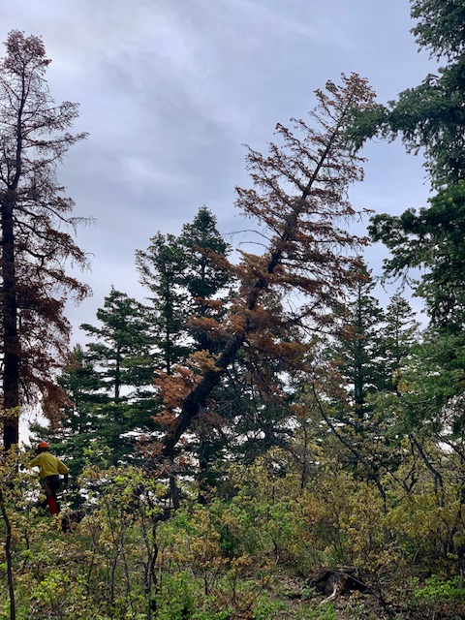

The white fir is falling. Photo by Sally Lowder

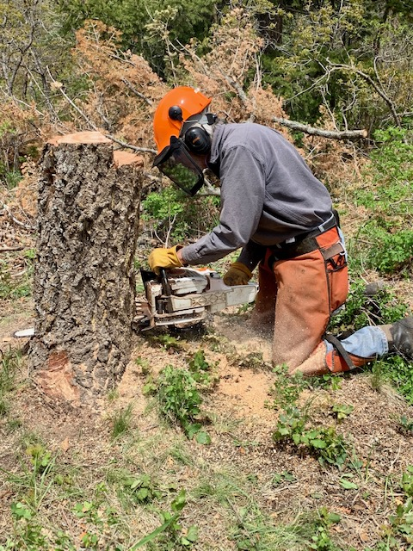

Byron Garner low stumping the tree he has just felled. Photo by Sally Lowder

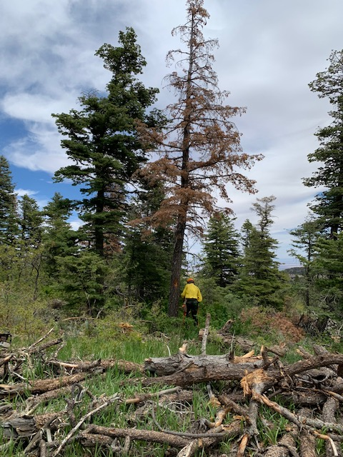

Bob starting to fell the last hazard tree on the hill. Photo by Sally Lowder

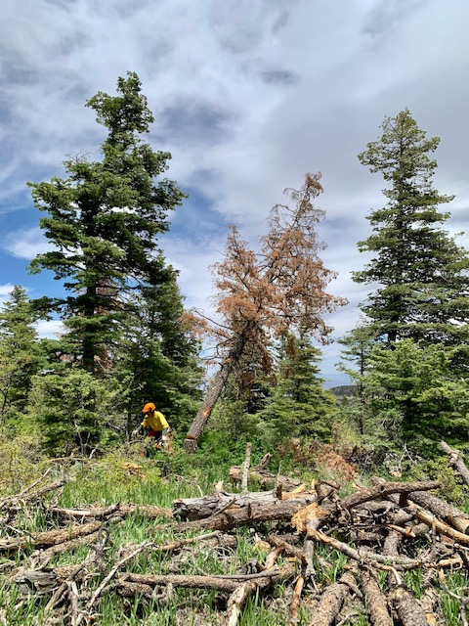

Bob is running away as the tree is falling. Photo by Sally Lowder

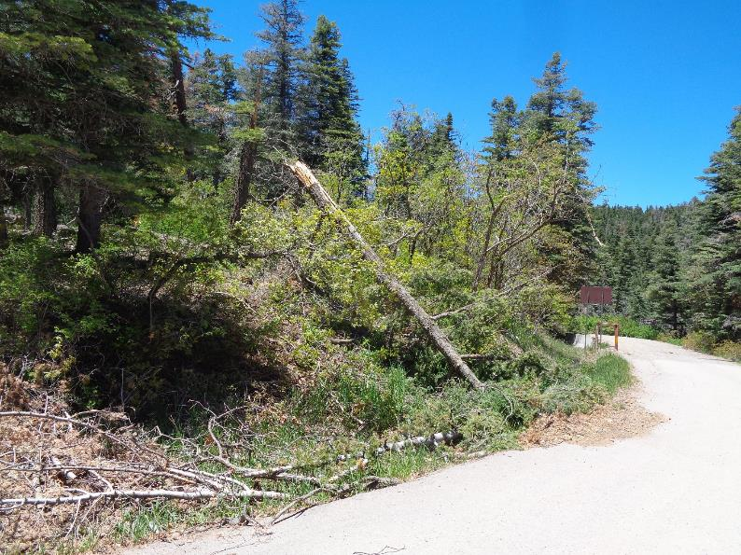

Broken white fir trunk and high cigar butt base at Balsam Glade PA lower parking lot.

Photo by Sam Beard

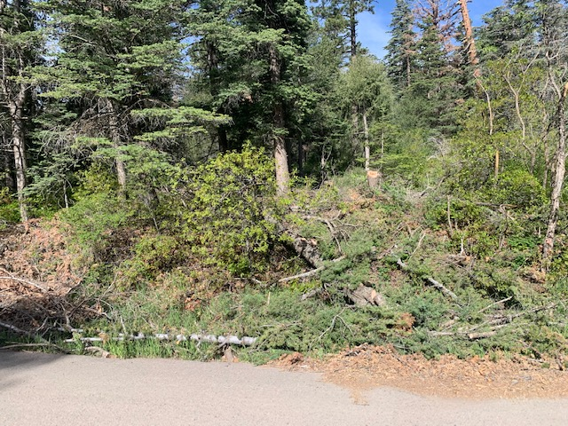

Trunk has been limbed and cigar butt has been felled.

Photo by Dennis Crowther