Report of the FOSM Paint Crew Project to Paint the Fascia of Two Picnic Shelters

in Oak Flat Reservation Picnic Area on Tuesday, June 1, 2021

Sam Beard

June 4, 2021

On Tuesday, June 1, 2021, FOSM paint crew members Anne Hickman, Sim Cook, Silke Bletzer, and Sam Beard painted the 2x6 fascia below the edge of the roofs of picnic shelters in the Yucca and Pine sites in Oak Flat Reservation Picnic Area.

Photographs and a narrative about the project are presented below. In general, the condition of the paint of the fasciae was very poor and approximately half of the fascia surface areas was not covered with old paint. Apparently, these fasciae had not been painted in a couple of decades.

As the photographs show, the contractor who built the Yucca shelter failed to install a galvanized steel drip edge on the edge of the roof. A drip edge consists of three parts: a flat part that goes between the wooden sheath and the felt/shingles (usually 1.5 inches wide), the vertical part of the drip edge that goes down over the edge of the sheath and the fascia (usually 1.5 inches wide), and a 0.5-inch-wide steel edge that is turned out at an angle of 45 degrees to direct water away from the fascia.

At several places around the edge of the shingles, we lifted the edge of the shingles back a few inches and found no nails. The lack of nails means that there is room to insert the upper tab of a drip edge around the edge of the roof. The drip edge would be secured with a 1.5-inch roofing screw with a plastic washer to form a seal under the head of the screw. We made the decision to purchase custom-made brown drip edges and install them next Tuesday.

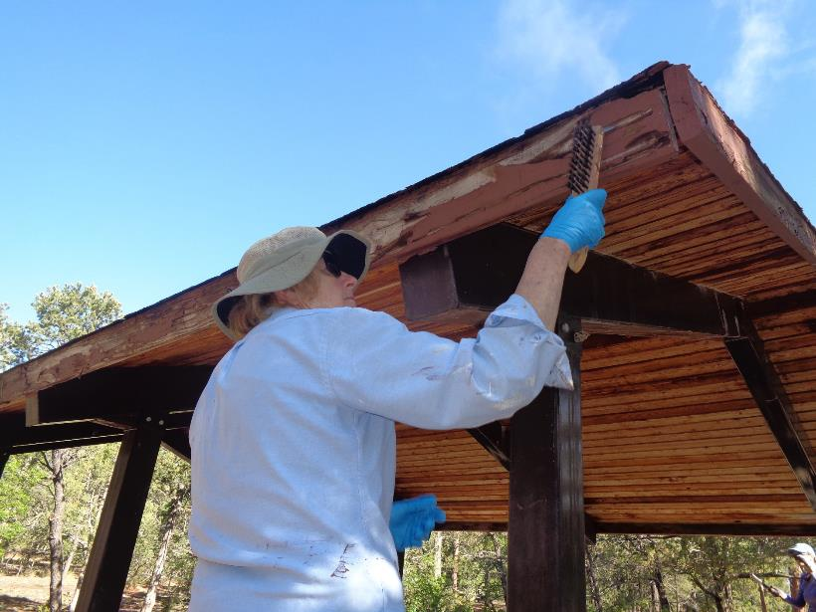

Anne Hickman scraping old paint off the fascia of the Yucca shelter in Oak Flat Reservation Picnic Area on June 1, 2021.

All photos by Sam Beard

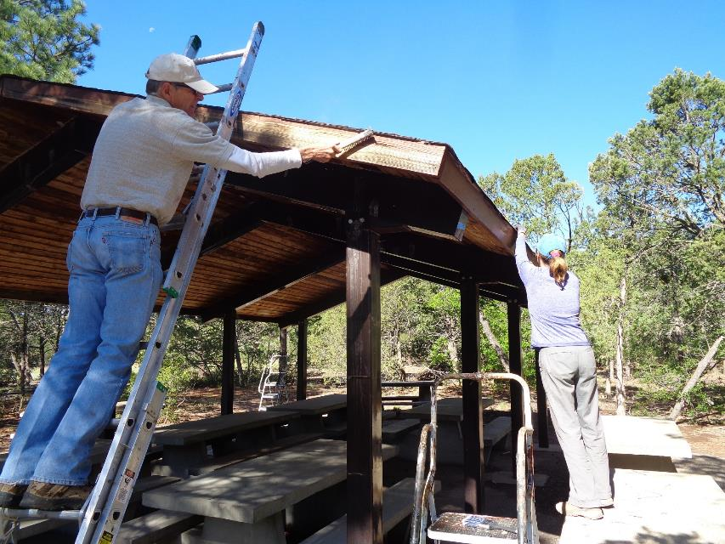

Sim Cook and Silke Bletzer using steel wire brushes to remove old paint on the Yucca shelter.

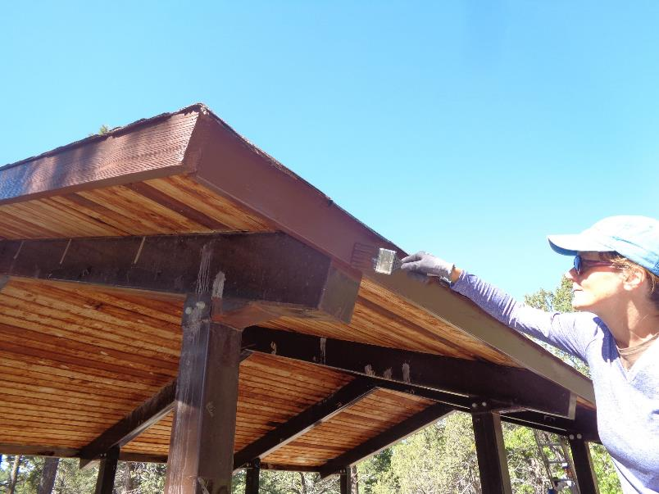

Silke applying USFS brown paint to the fascia of the Yucca shelter. Please note that the contractor neglected to install a steel drip edge over the

edge of the 2x6 tongue and groove wooden sheath before putting on the shingles. The drip edge would have protected the sheath and

fascia by directing the water away from the fascia.

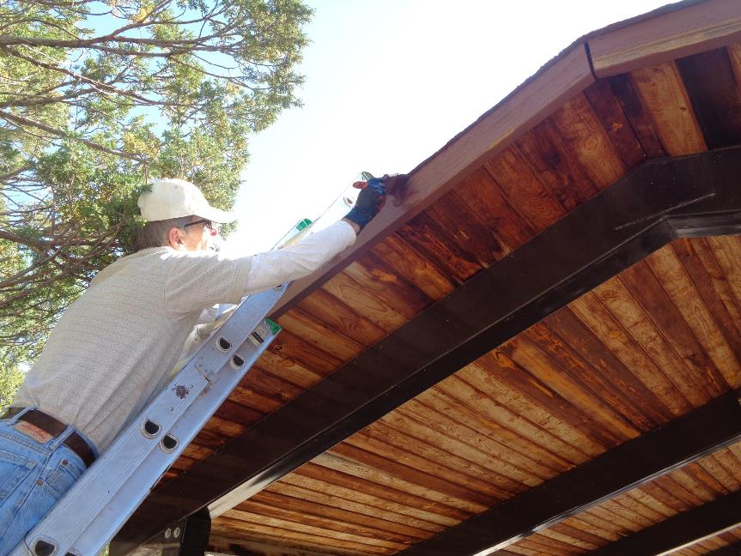

Sim painting the high gable end of the Yucca shelter.

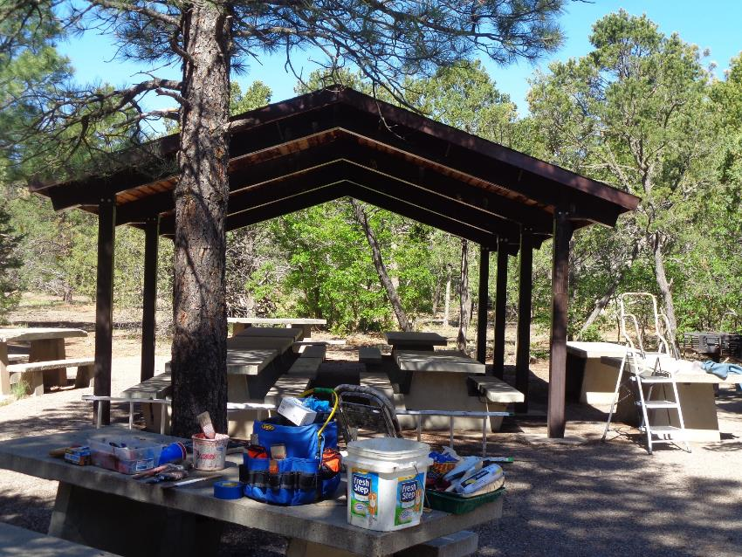

The Yucca shelter with the painted fascia. Next Tuesday the crew will install custom-made 3-inch-wide drip edges on this shelter.

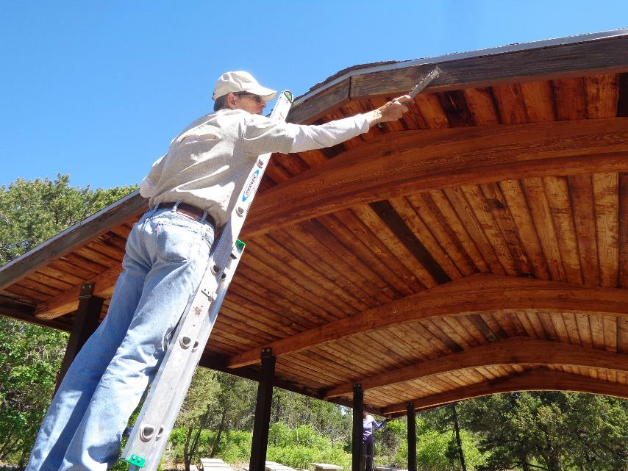

Sim removing loose paint from the Pine site shelter gable end fascia.

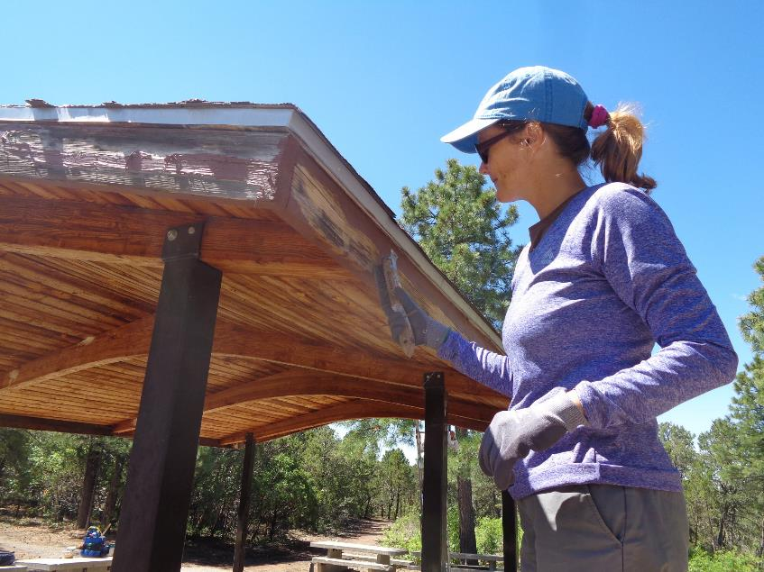

Silke removing loose paint from the fascia just below the steel drip edge. Note that this shelter does have a galvanized steel drip edge

to protect the wood below the edge of the shingles.

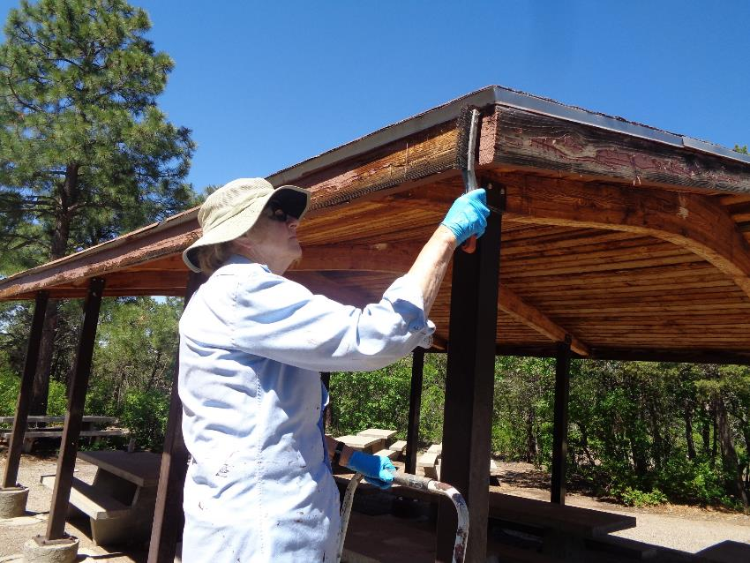

Anne Hickman removing loose paint on the Pine site shelter fascia.

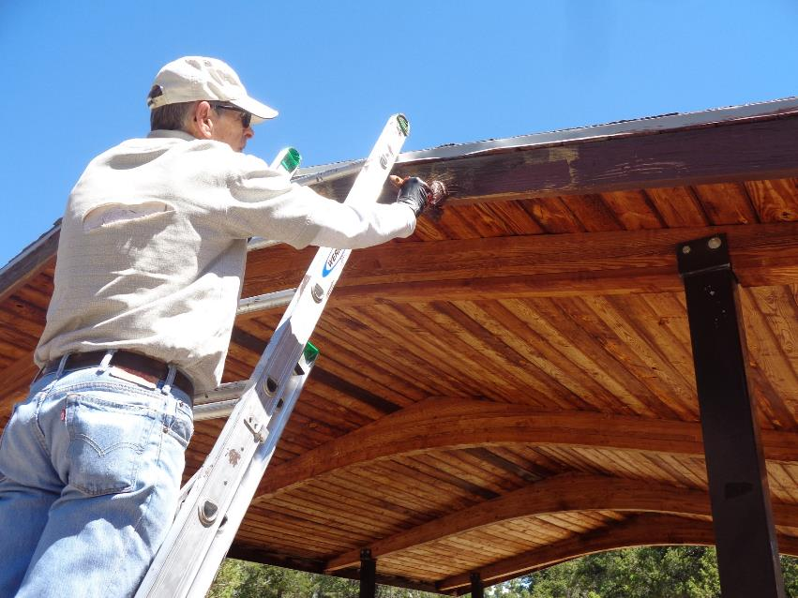

Sim applying paint to the gable end fascia.

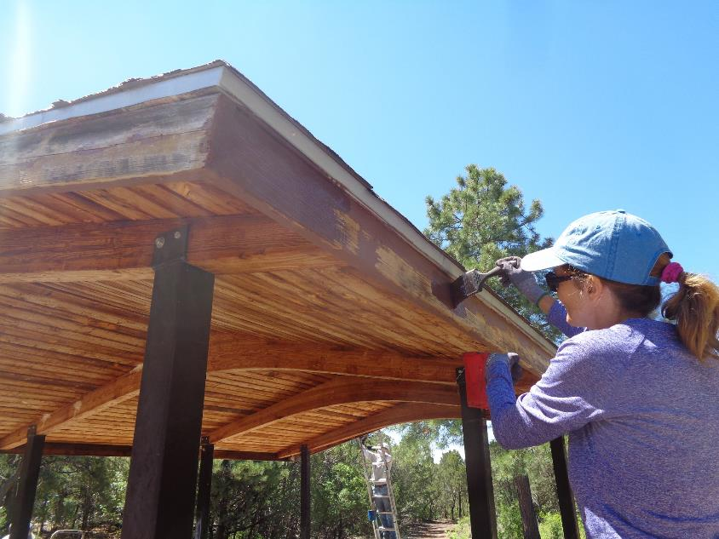

Silke painting the eve fascia.

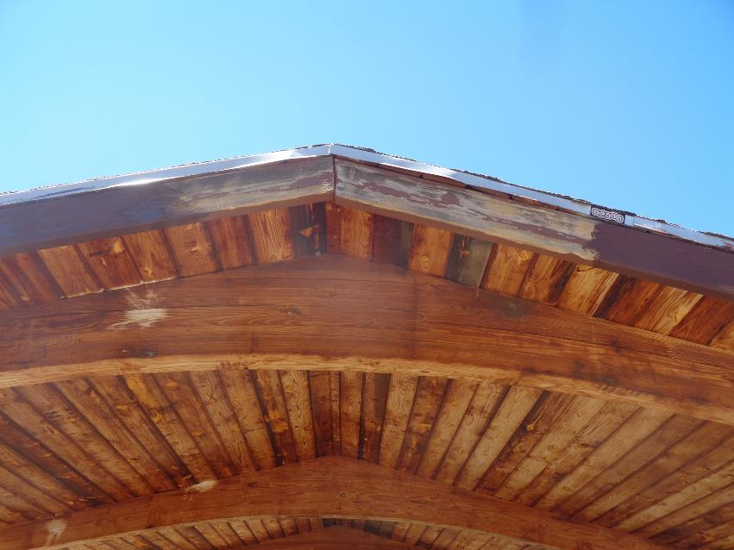

This photo shows that the 2x6 wooden fascia was protected by very little paint before the new paint was applied.

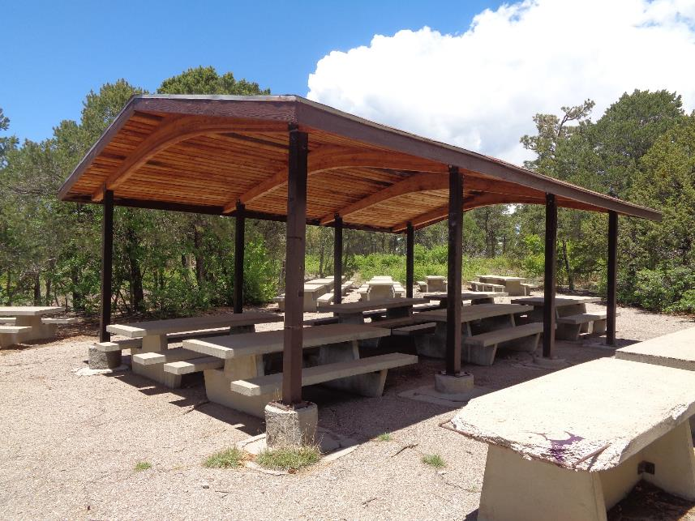

The Pine site shelter with the newly painted fascia.