Report of the FOSM Project to Split and Haul 1.8 Cords of Donation Wood

from Kiwanis Meadow Road to a Church Wood Ministry Location on June 2, 2021

Sam Beard

June 4, 2021

On Wednesday, June 2, seven FOSM volunteers manually split 1.8 cords of large Engelmann spruce rounds into quarters and hauled the wood to a Mountain Christian Church Wood Ministry location in a family corral west of NM-14 about one-half mile south of the Triangle at the intersection of NM-14 and NM-536.

This large tree fell across Kiwanis Meadow Road last fall, and FOSM sawyers and swampers bucked it into 50 rounds with a length of 12 inches. FOSM member Joe Meade donated the use of his large truck and dump trailer to haul the wood from the Crest area to the Wood Ministry location.

At the Kiwanis Meadow Road location near the meadow, the rounds were partially scored to help with starting steel wedges, and the rounds were split manually with steel wedges and sledge hammers. Lou Romero backed the truck and trailer from the Crest area gate to the wood pile, where Joe stacked the wood in the trailer after others carried the pieces to the trailer.

At the storage location, Lou drove into the corral and backed to the north side of the corral. Joe operated the dump control, and the wood was dumped. Paul Brouse, chair of the Wood Ministry Committee was very happy to get the split wood.

Photographs and additional narrative are presented below.

The hard-working volunteers were Jerry Carroll, Sim Cook, Cliff Giles, Lou Romero, Joe Meade, Dan Benton, and Sam Beard.

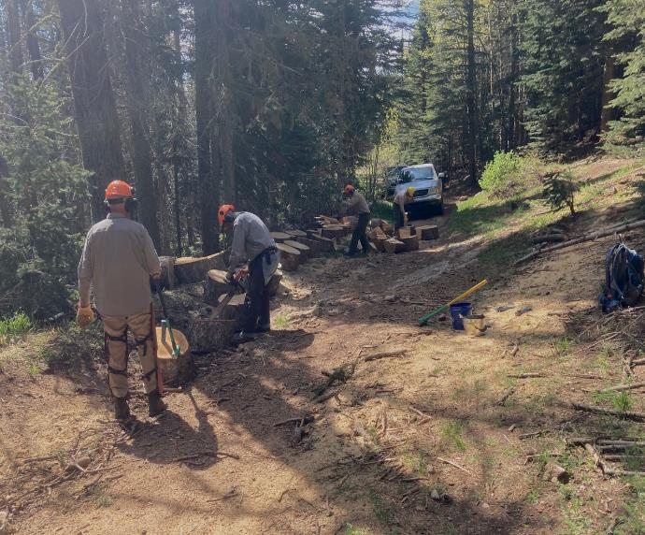

L to R: Volunteers splitting large spruce rounds were Dan Benton, Jerry Carroll, Sam Beard, and Sim Cook.

The tree fell across Kiwanis Meadow Road last fall, and FOSM volunteers bucked it into 50 rounds.

All photos by Cliff Giles unless stated otherwise

\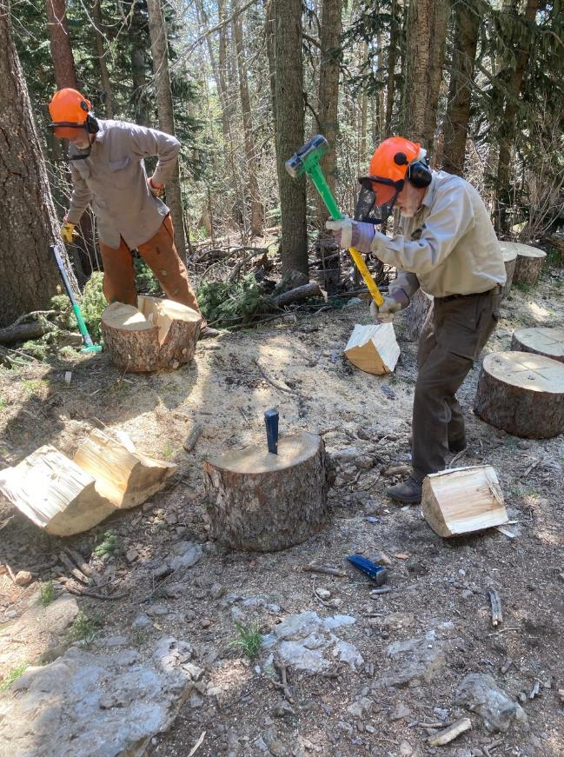

Dan and Sam splitting rounds into quarters with steel wedges and sledge hammers.

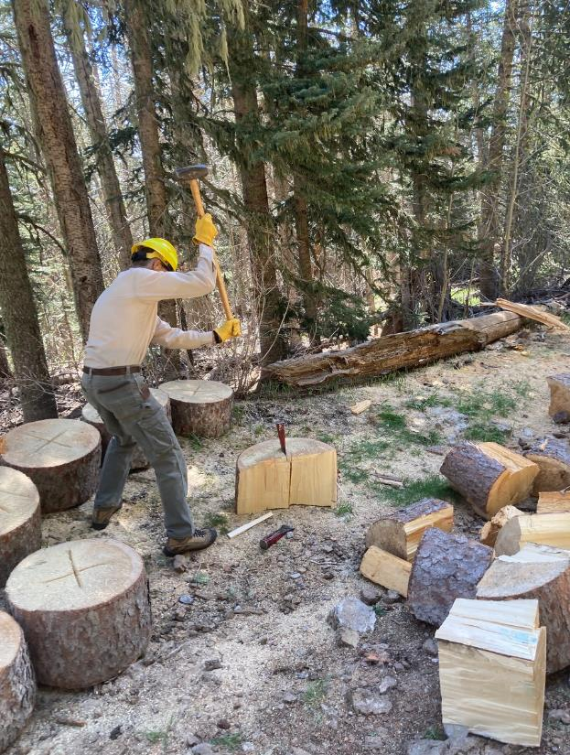

Sim Cook using Lou Romero’s 10-pound sledge hammer to split wedges. The rounds had been scored by Jerry

Carroll with his chain saw.

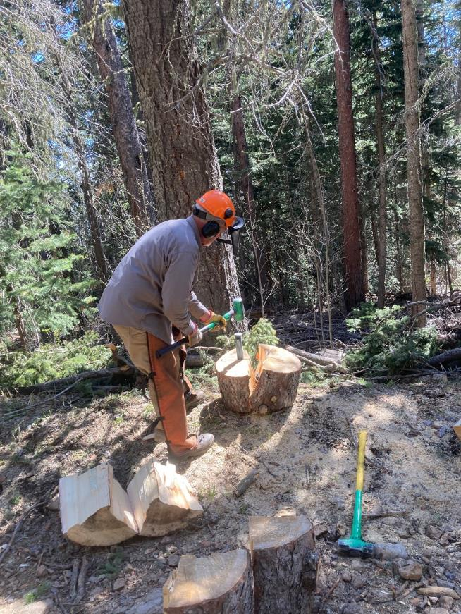

Dan splitting rounds into quarters.

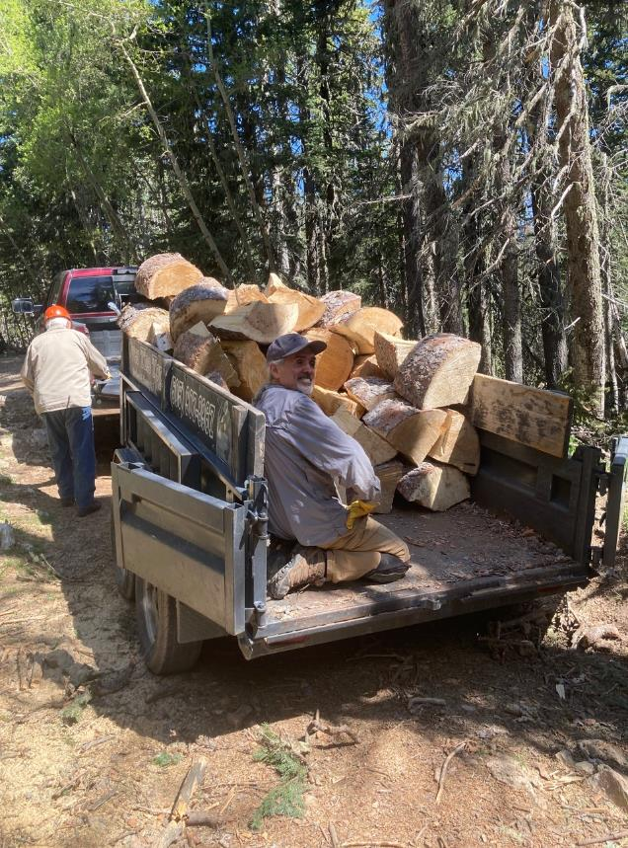

L to R: Lou Romero and Joe Meade. Lou backed Joe’s truck and trailer from the gate on Kiwanis Meadow Road

to the wood. Joe stacked all the wood in the trailer.

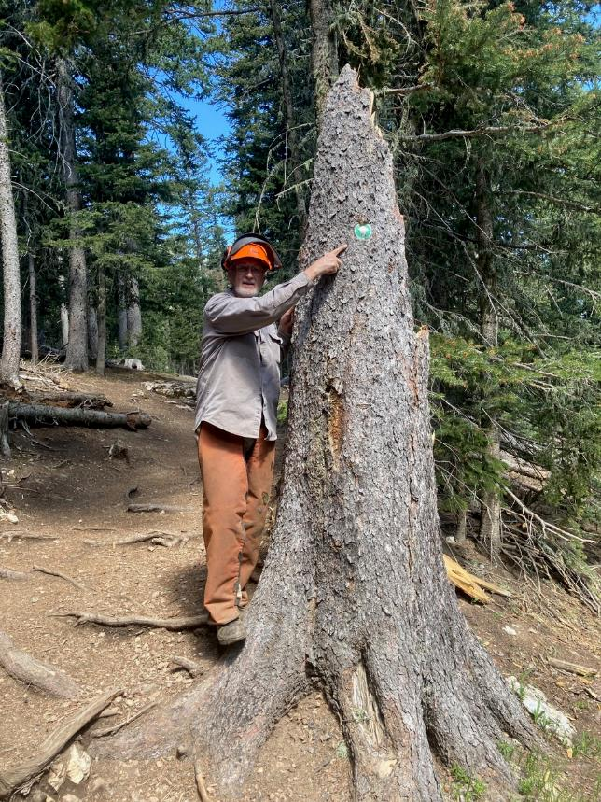

Dan pointing to the hiking trail marker beside the South Crest Trail on the stump of the spruce tree that fell

last fall.

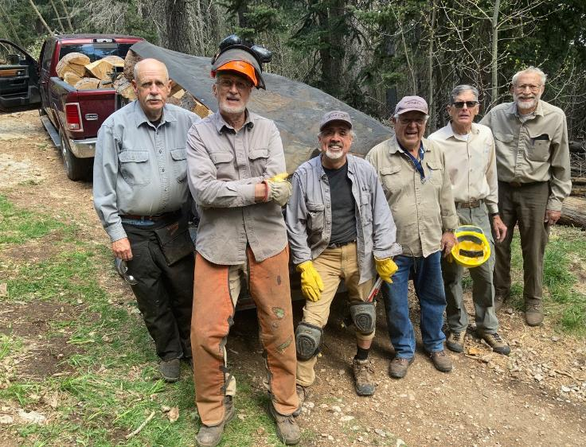

The FOSM crew that split and hauled the wood. L to R: Jerry Carroll, Dan Benton, Joe Meade, Lou Romero, Sim Cook

and Sam Beard.

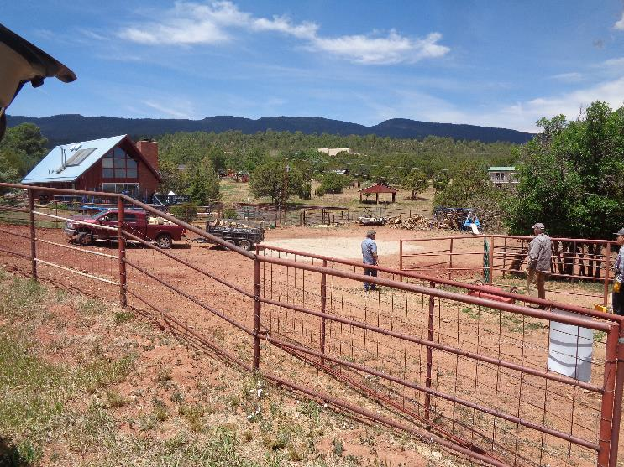

The Mountain Christian Church Wood Ministry wood storage lot in the corral at church member’s house located

On the west side of NM-14 about ½ mine south of the Triangle. Photos by Sam Beard here and below.

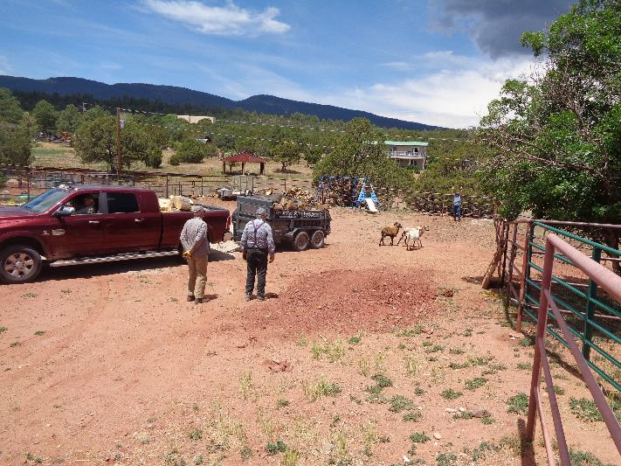

Lou is backing the truck and trailer to the dump spot in the background. The family uses this area as a goat corral.

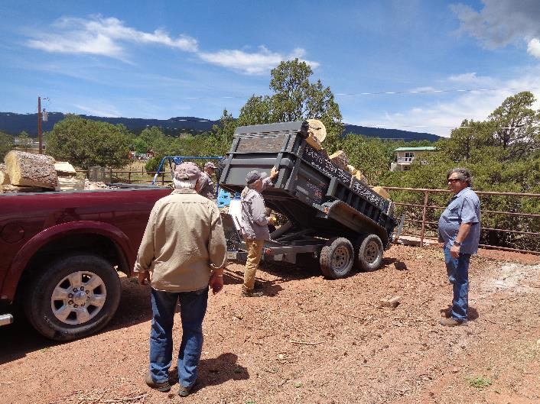

L to R: Lou Romero, Dan Benton, Joe Meade, and Paul Brouse, the chairman of the Wood Ministry Committee.

Joe is using the controller to dump the wood. The volume of wood was about 1.8 cords.