Locations of Trees on SNSC Groomed Trails to Be Felled

Locations are based on a map from Jeff Huser, who is in charge of trail construction

Locations where trees will be felled by FOSM sawyers. Site numbers are defined in the map below.

* Site I – One tree.
* Site 3 – One 15-inch tree.
* Site 4 – A few trees.
* Sites 4 to Site 5 – A few trees.
* Site 6 – A few trees.
* Site 7 – Numerous trees in dense forest.

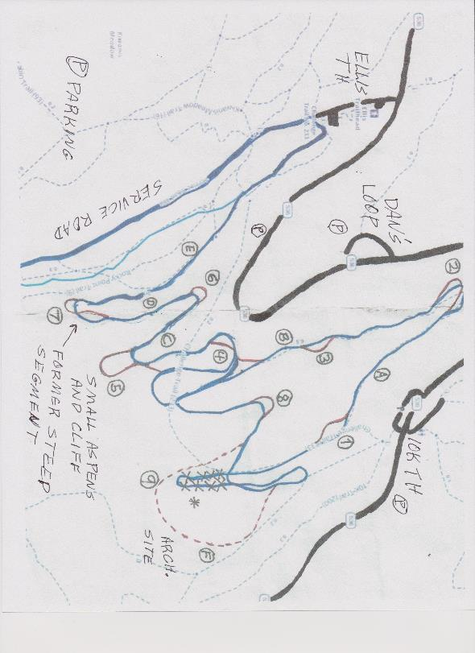

Map of segments of the SNSC groomed trails that will be rerouted (red color). Parking options are shown as a P in a circle.

Trees for FOSM to fell at the following sites: Numbers 1, 3, 4, 5, 6, and 7. Map by Jeff Husser, SNSC.

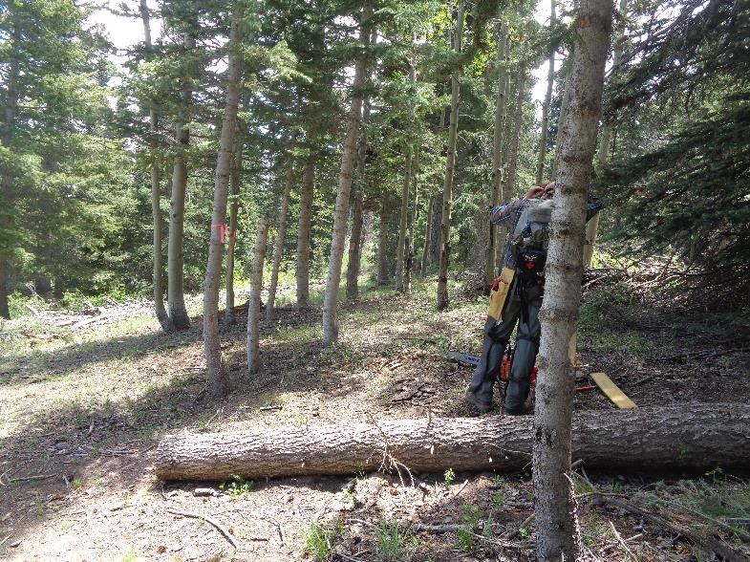

Segment of trail near No. 3 where Michael Arndt, Sam Beard, and Jeff Huser felled 8 trees on June 6 with diameters of 3 inches to 9 inches.

Pink flag is the lower edge of the trail that will be about 10 feet wide. Photos by Sam Beard

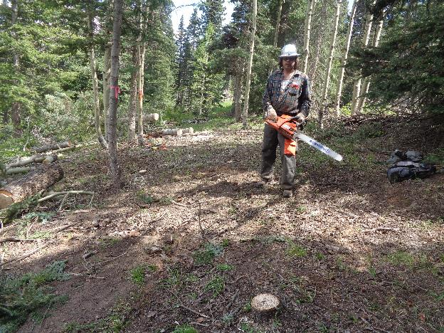

Segment near No. 3 after 8 trees were felled by Michael Arndt. Jeff moved the slash to the left to cover the former route.

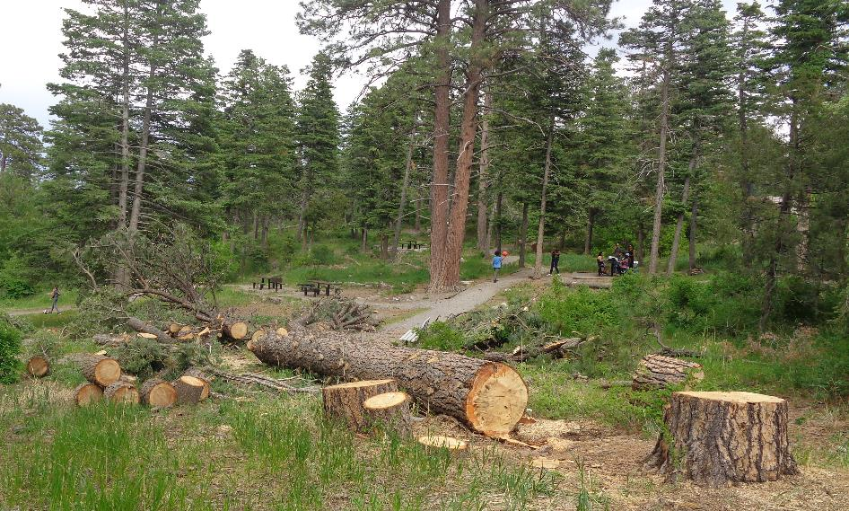

Kerry Wood recently felled this 36-inch diameter pine hazard tree in the lower part of Balsam Glade Picnic Area.

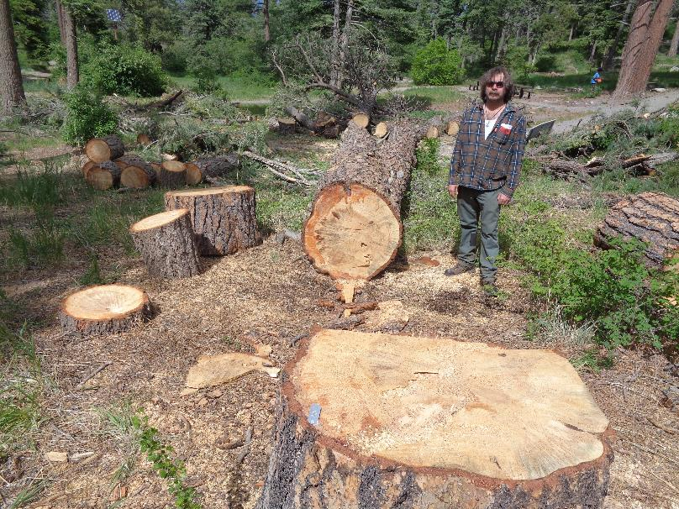

Kerry also felled a 20-inch diameter white fir in order to have a clear lay for the large pine.

The low-cut fir stump is on the left side of the photograph.

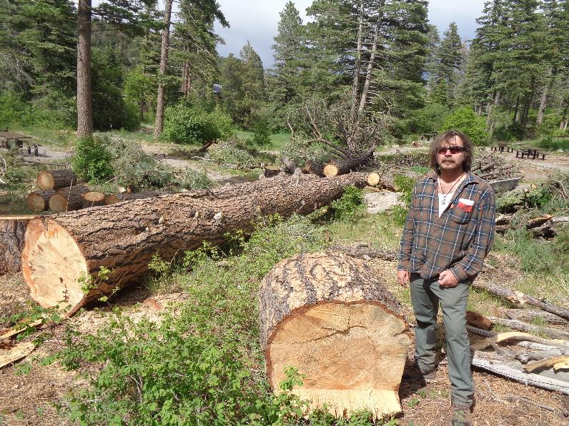

Another view of the felled trees. Kerry bucked the trunks in the upper part of photograph in order to clear a picnic area path.