Report on Felling Trees along Sandia Nordic Ski Club Groomed Trails on June 9, 2021

Sam Beard, June 10, 2021

On Wednesday, June 9, 2021, five FOSM volunteers felled trees along segments of planned Sandia Nordic Ski Club’s groomed trails that will be constructed later. Michael Arndt and Sam Beard had hiked the trails with Jeff Huser and Scott Dietrich on Sunday, June 6. The trees to be felled were marked with a blaze in the bark. This trail system is located between 10K South Trailhead and Ellis Trailhead.

Pictures of the project are presented below. A total of 24 trees were felled. The diameters of two of the trees were 12 inches and 15 inches, and diameters of 22 trees ranged from 3 inches to 8 inches. The trees were limbed, bucked, and thrown off the trail.

The sawyers and swampers were Dennis Crowther, Jerry Carroll, Cliff Giles, Sim Cook, and Sam Beard.

Sam Beard, Projects Chair

Friends of the Sandia Mountains

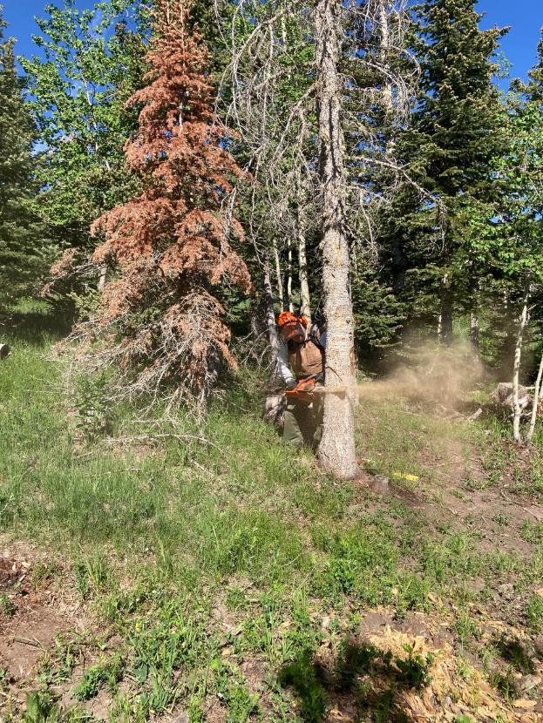

Dennis Crowther making a face cut on a dead white fir along one of Sandia Nordic Ski Club’s groomed ski trails.

Photos by Cliff Giles

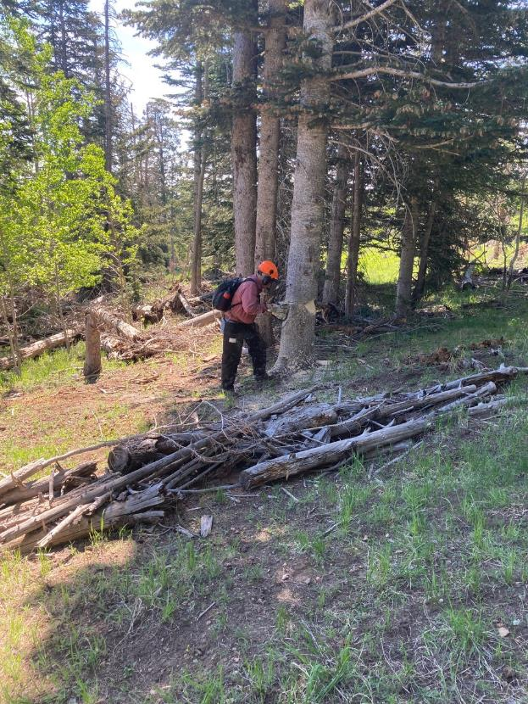

Jerry Carroll making a back cut on a fir tree along one of the groomed ski trails.

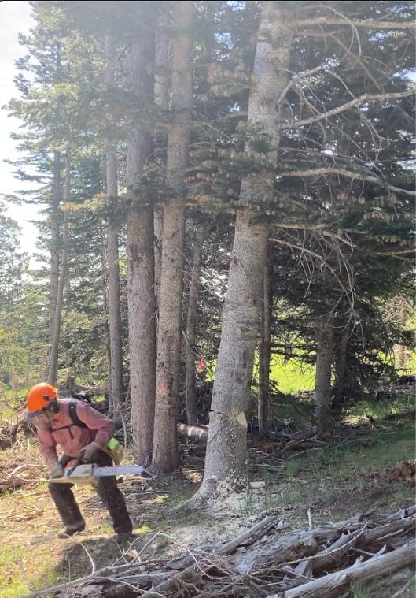

Jerry Carroll running away as the tree falls.

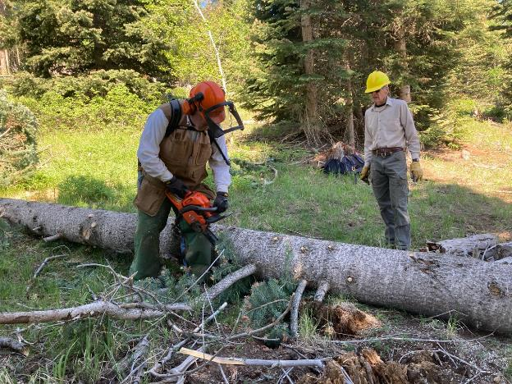

Dennis limbing and bucking the tree as Sim Cook waits to move the branches.

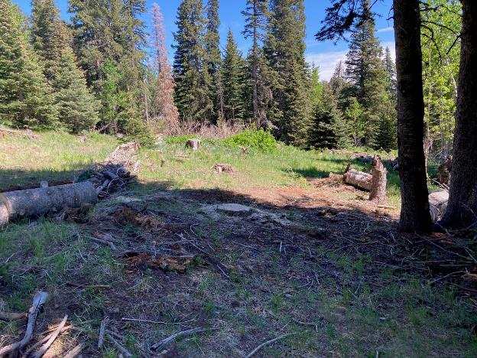

After the fir was felled, the trail is wide enough to be groomed.

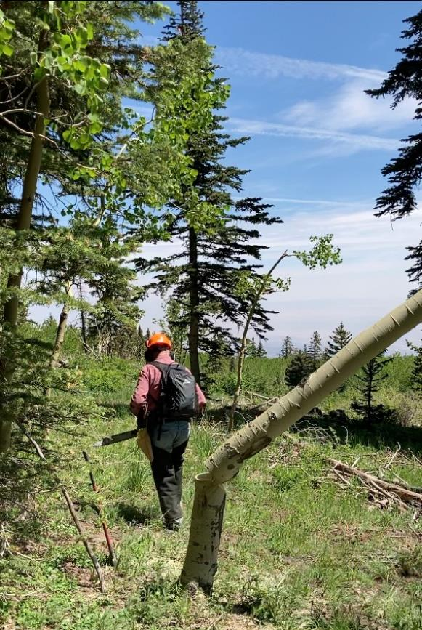

Jerry moving away from the aspen that he has just felled.

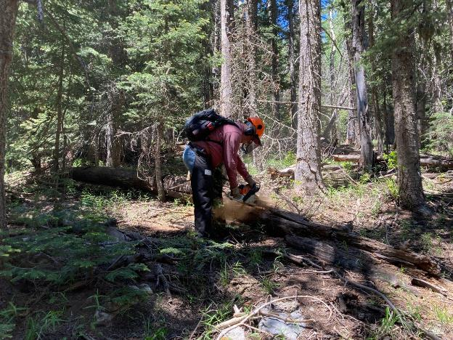

Jerry bucking a log across the trail.

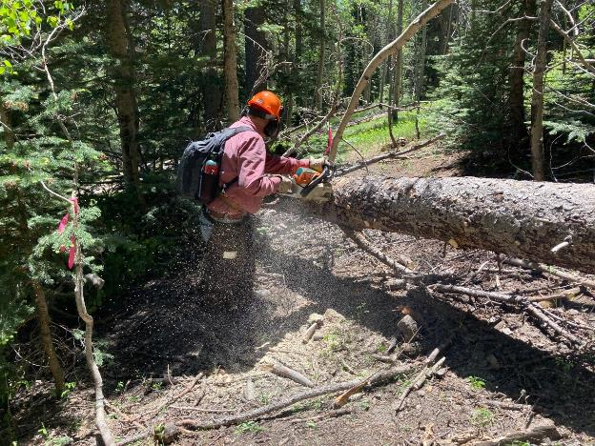

Jerry bucking a large tree across a rerouted segment of trail.

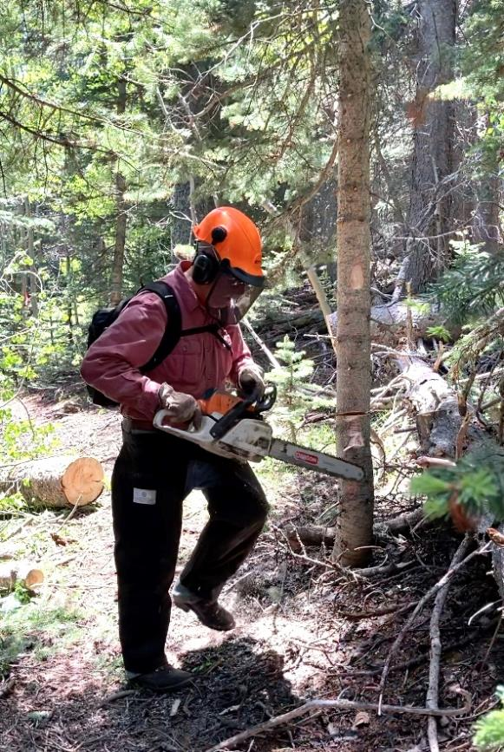

Jerry running away from a small aspen he has just felled.

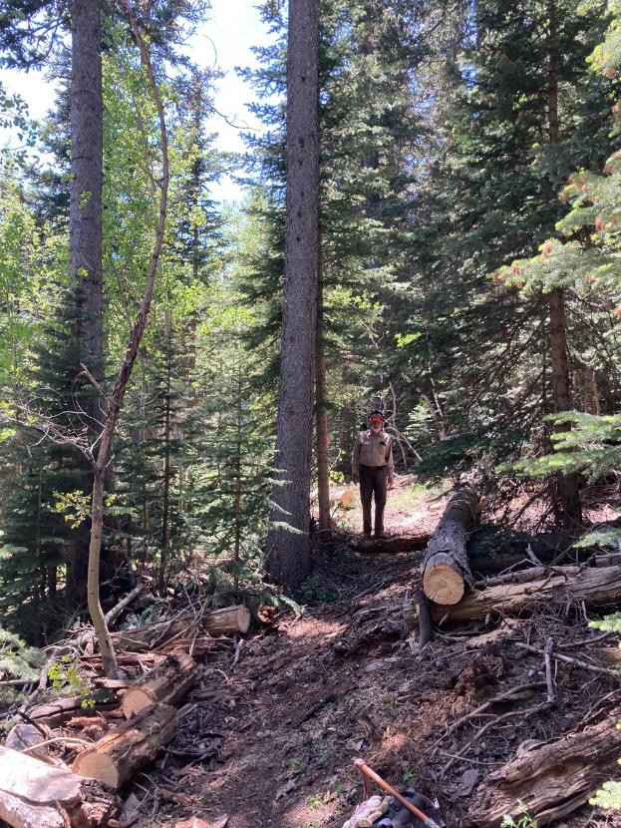

Sam standing on the trail route that has just been partially cleared.

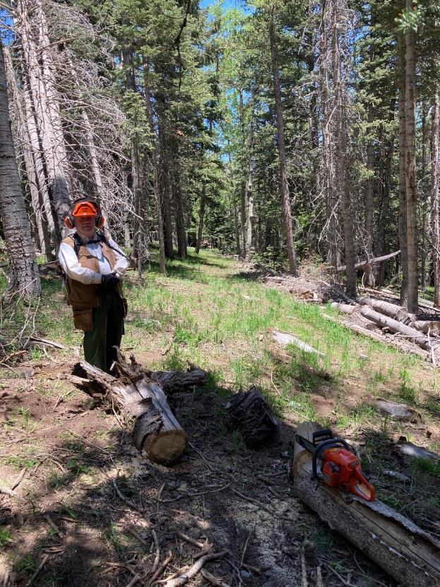

Dennis standing beside a log that has removed from the trail.

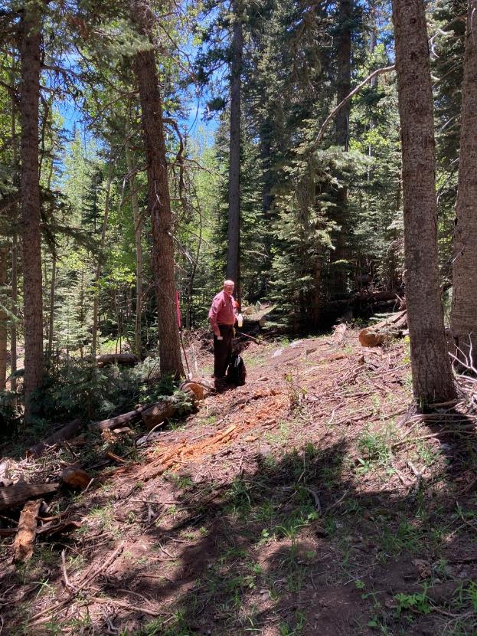

Jerry on a segment of trail that has been cleared.

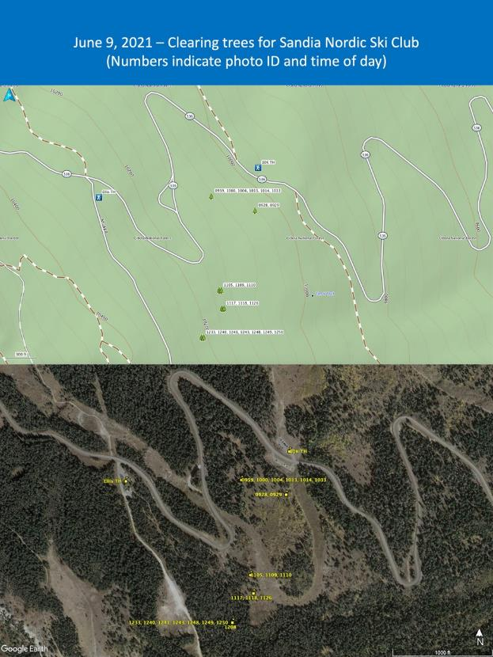

Maps of work sites Wednesday where trees were removed based on GPS data.