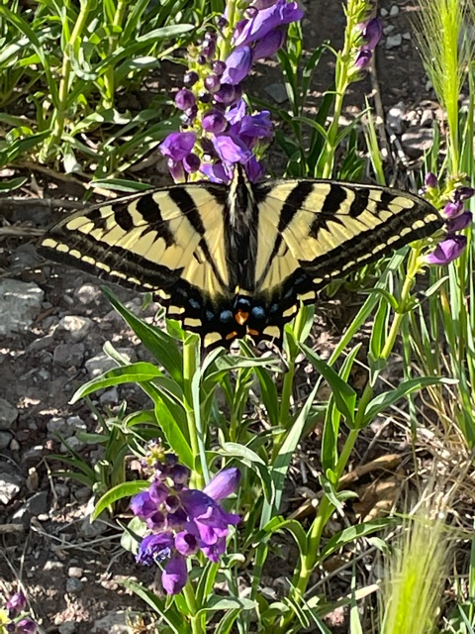
Cleve Sharp captured this photo of a Two-Tailed Swallowtail
butterfly during our maintenance hike yesterday.

(Photo by Cleve Sharp)
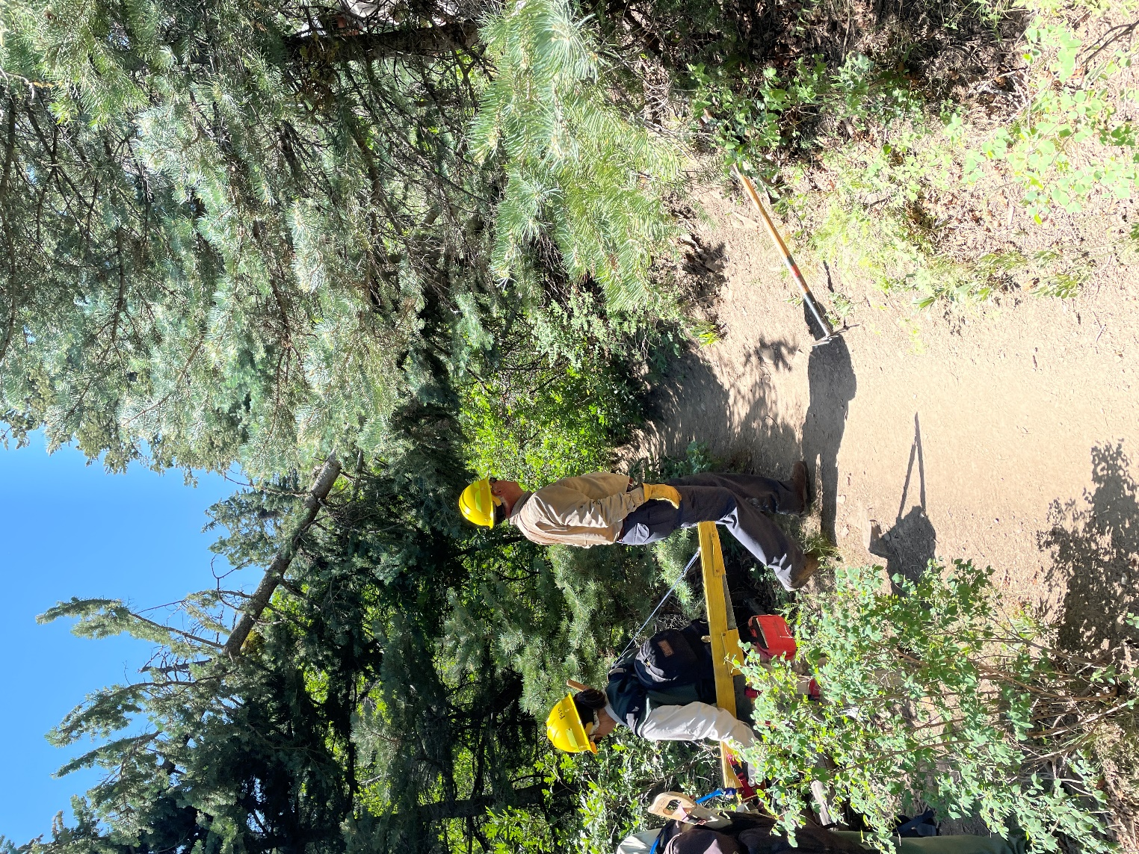
This fallen two-tree hangup in the background was looming
over Tree Spring trail. The 7-inch diameter fir tree
had taken a 3-inch diameter fir down with it creating
a spring-pole. The branches from the trees were hanging
down just above head height for an average person walking under. Both trees were live.

(Photo by Cleve Sharp)
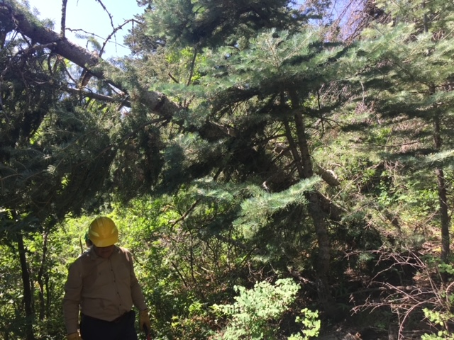
This is a closer view of the hangup in the background behind David. The smaller bent-over fir spring pole shows below the
larger tree.

(Photo by Bill Savage)
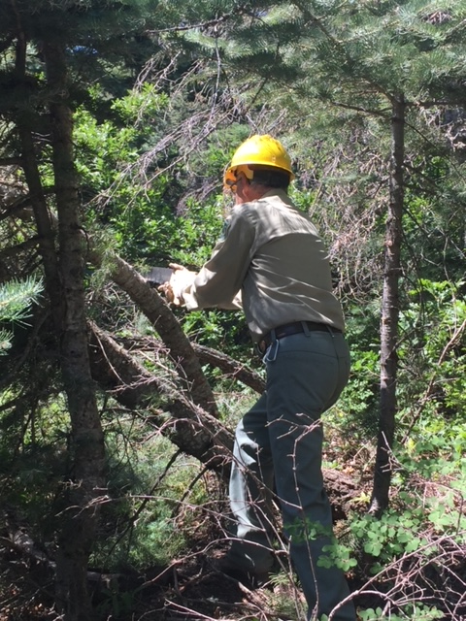
Bob is making a series of cuts on the spring pole
fir to slowly release the tension so that the cut end
does not spring up quickly. When the cut was completed,
the smaller tree fell to the ground.

(Photo by Bill Savage)
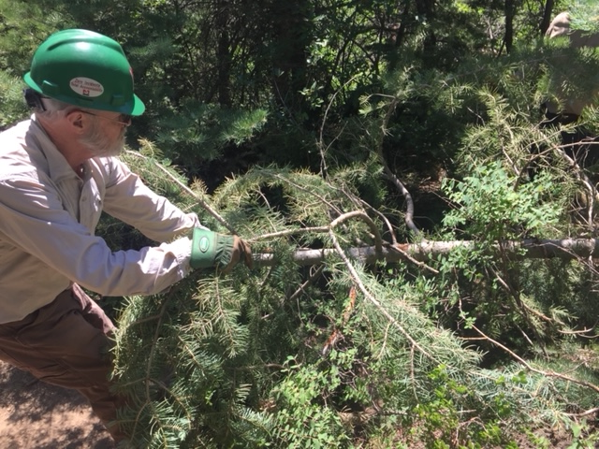
Cleve is dragging the just cut smaller fir away from the trail.

(Photo by Bill Savage)
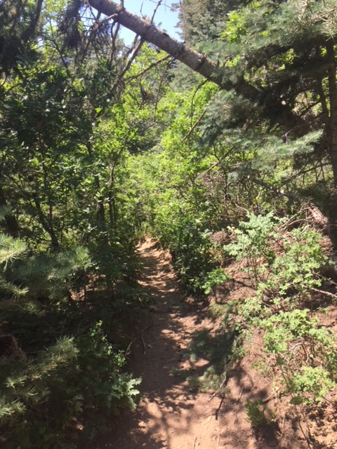
The smaller fir is now cleared away. The larger tree will
be cut next.

(Photo by Bill Savage)
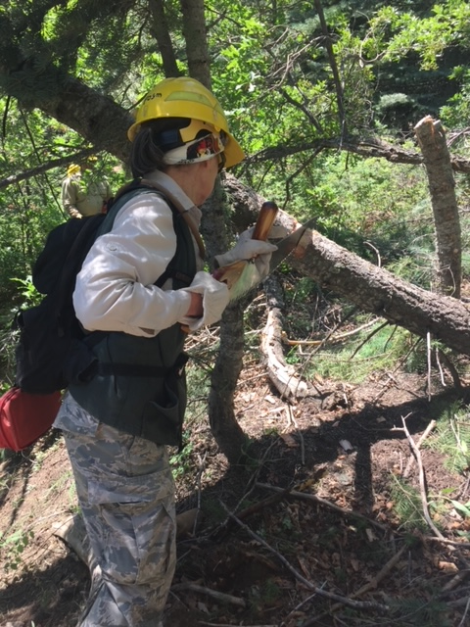
Rav is making the cut on the larger tree. Once the tree
was on the ground, it was cut into smaller sections and
moved away from the trail. Compare the cut stump in the
right of this photo with the same tree in the photo where
Bob is cutting it. It is a good illustration of how much
tension can exist in a spring pole tree (or branch).

(Photo by Bill Savage)

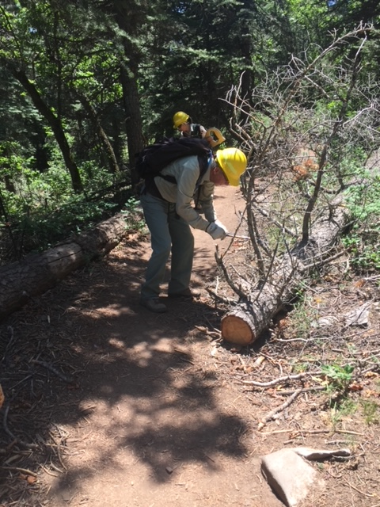
This tree at the bottom end of Tree Spring had
been previously removed. The trail was clear to pass
through at this point, but the crew cut back some remaining protruding branches.

(Photo by Bill Savage)

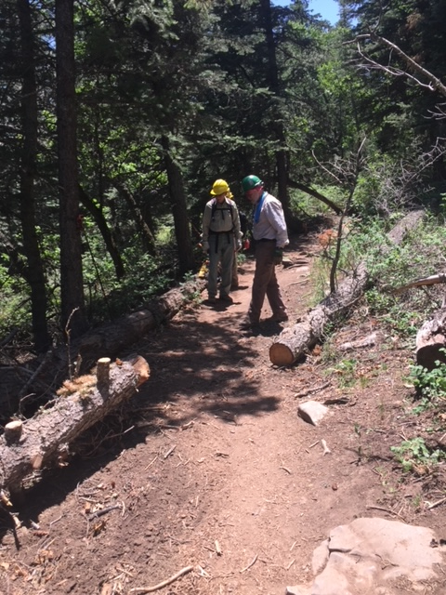
The branch cleanup in the prior photo has been completed.

(Photo by Bill Savage)

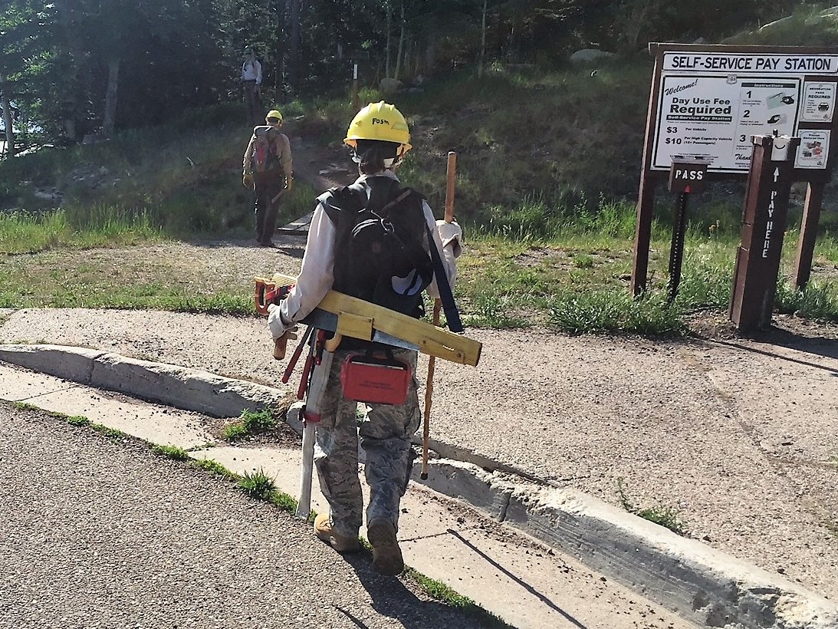
While participating in our trail maintenance projects, Rav sometimes jokingly refers to herself as a “walking hardware store”. Who can argue that??

(Photo by Bill Savage)

