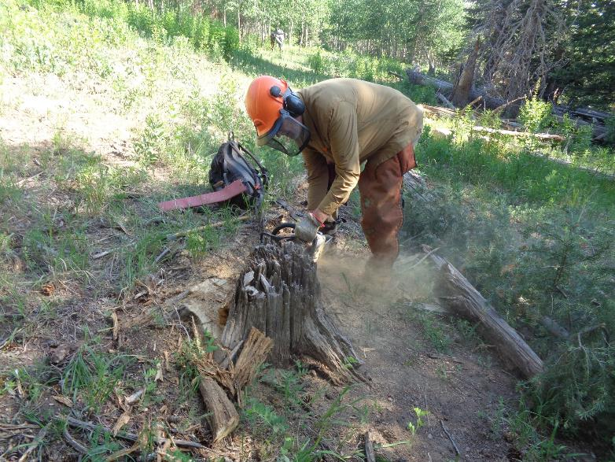

Dan Benton low cutting an old stump. Photos by Sam Beard

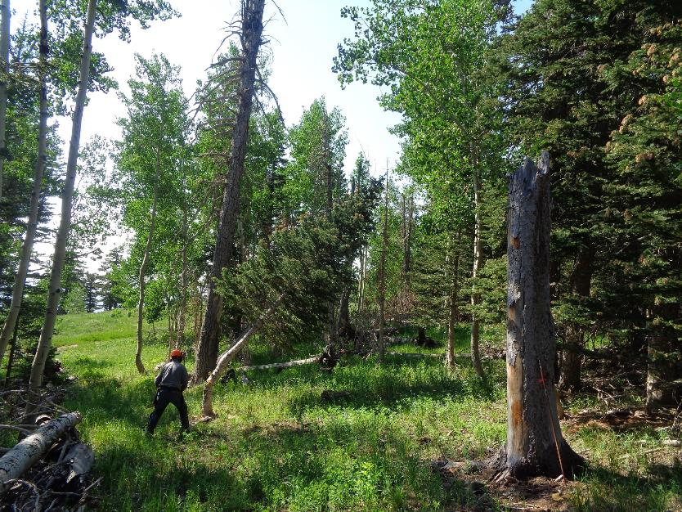

Jerry Carroll felling a fir tree in the trail corridor.

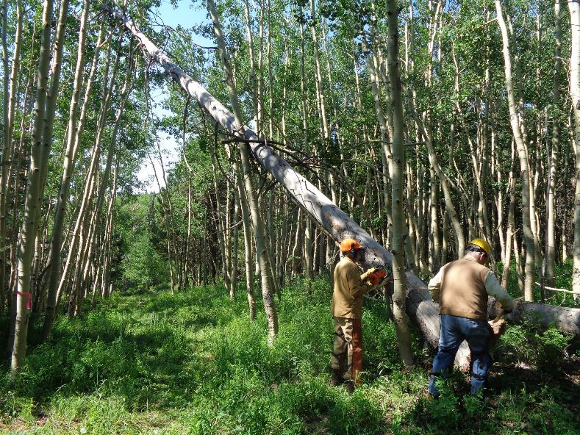

Dan making the first cut in a very long hang-up so it will fall from over the trail.

Dennis Crowther is moving to the other side of the tree to drive a wedge.

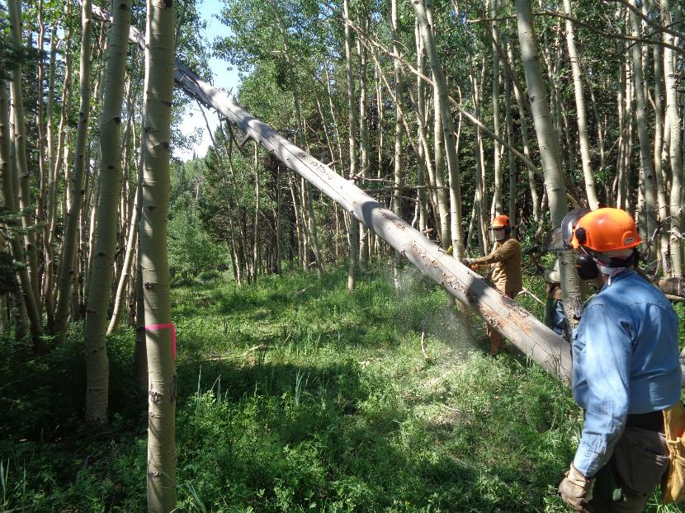

Dan is making the third cut in the process of “walking” the base of the tree forward so that the upper end will eventually fall to the ground.

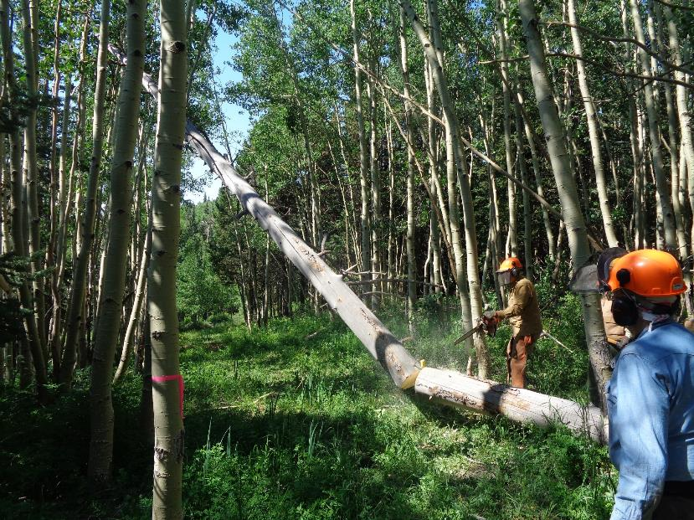

Dan has finished his cut and both pieces of the tree is falling to the ground.

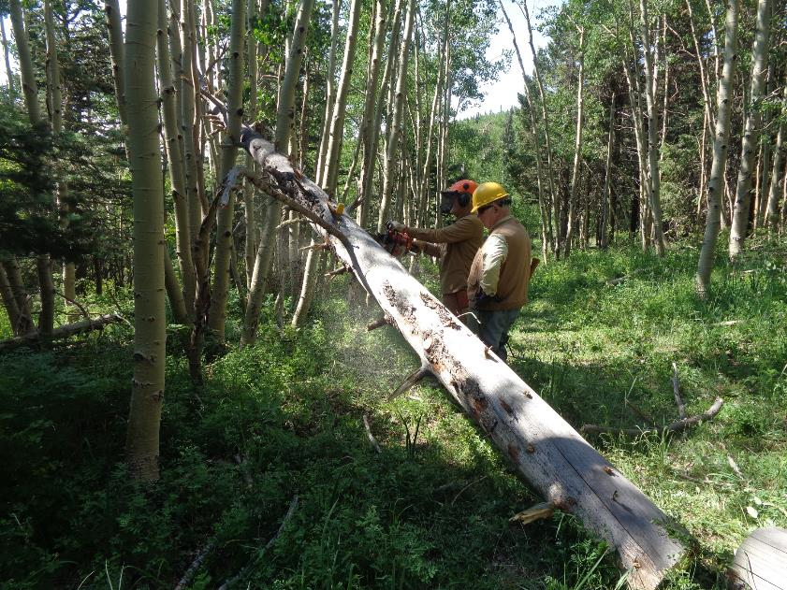

The upper part of the tree has fallen low enough for Dan to cut it near the upper end.

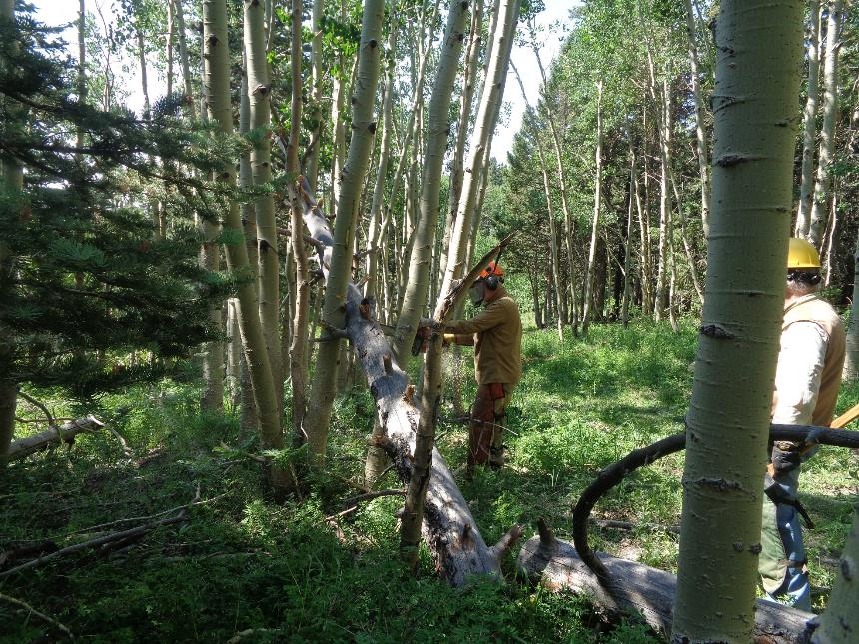

Dan continues to make cuts higher on the tree in an effort to make the top fall.

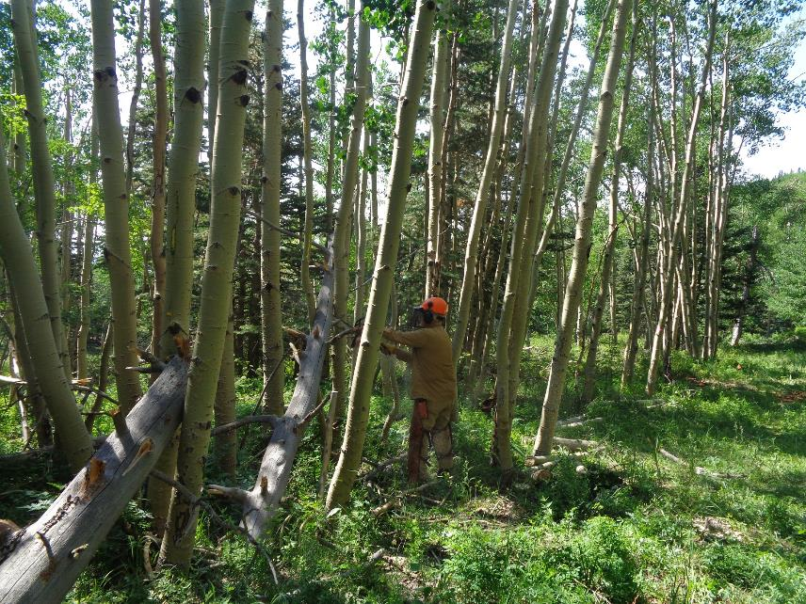

Dan is making the final cut so that the whole tree is on the ground.

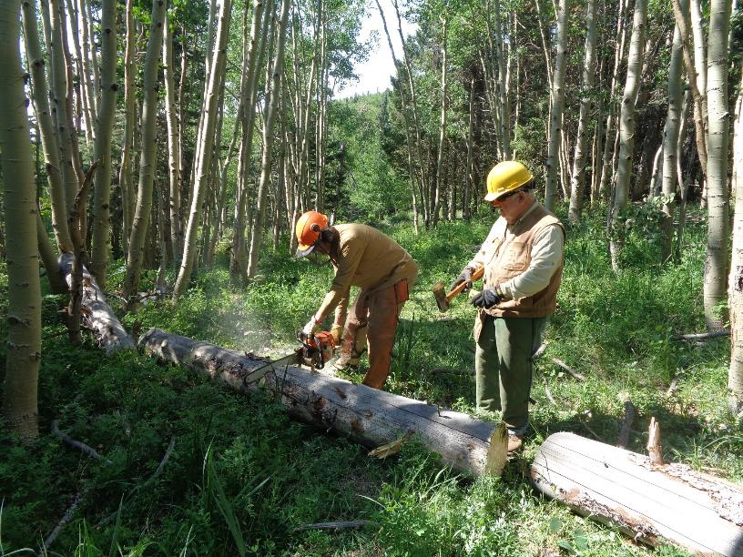

Dan bucking the log so the pieces can be moved from the trail. Dennis will drive a wedge if it is needed.

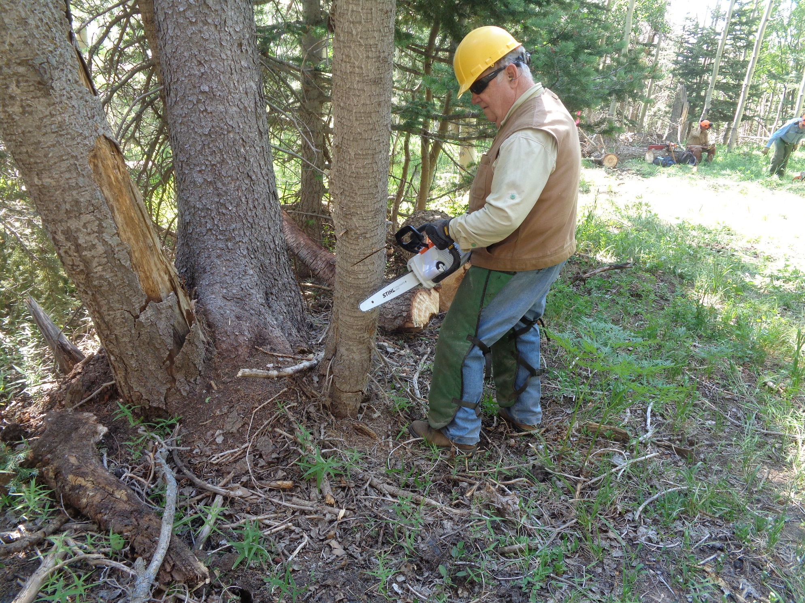

Dennis Crowther using his battery-powered chain saw to fell a dead tree beside the trail.

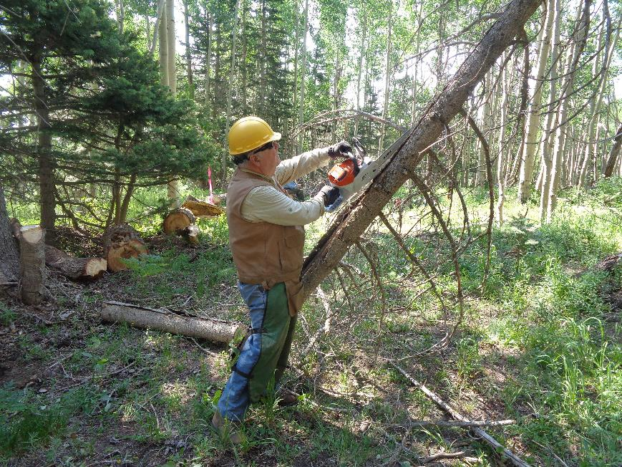

Dennis limbing the tree he felled.

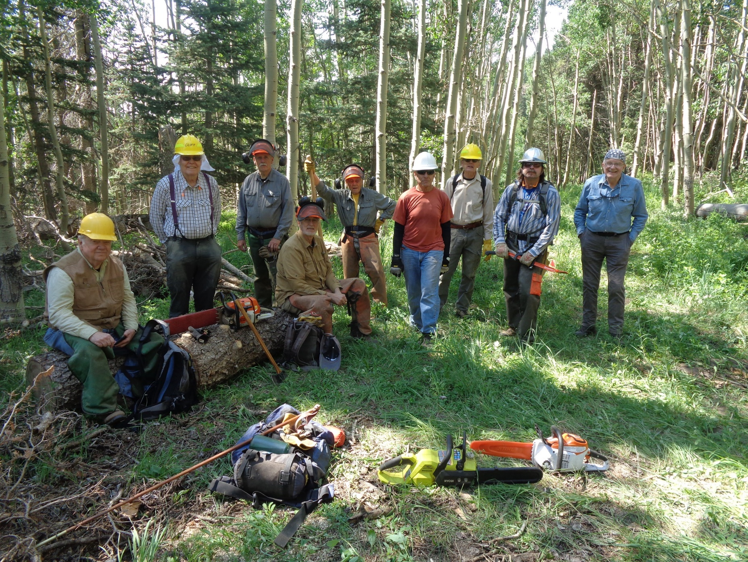

The FOSM crew waiting the required one hour after using a gasoline-powered chain to confirm that no wild fire was started.

L to R: Dennis Crowther, Cliff Giles, Jerry Carroll, Dan Benton, Don Carnicom, Steve Roholt, Sim Cook, Michael Arndt and Eric Russell.

Note Steve’s green battery-powered chain saw and Dennis’s orange/white battery-powered saw on the grass.