Report of FOSM Project on Sandia Nordic Ski Club Groomed Trails

on Wednesday, June 23, 2021

Sam Beard, June 24, 2021

On Wednesday, June 23, nine FOSM volunteers cleared a segment of corridor for a groomed trail being developed by the Sandia Nordic Ski Club (SNSC) in the area between 10K South Trailhead and Ellis Trailhead. Steve Roholt, SNSC representative, directed the volunteers to the work sites.

Due to the Stage II Fire Restrictions, gasoline chain saws were used to fell trees and buck logs until 10 am. Later, battery-powered chain saws were used to fell smaller trees and buck logs. Approximately two dozen trees were felled with diameters ranging from 4 inches to 12 inches. Numerous logs were bucked so that they could be moved to the side of the corridor. The project was completed by lunch.

The FOSM volunteers were Michael Arndt, Steve Roholt, Eric Russell, Dennis Crowther, Cliff Giles, Jerry Carroll, Sim Cook, Dan Benton, Don Carnicom, and Sam Beard.

The following photographs were taken by Cliff Giles.

Sam Beard, Project Chair

Friends of the Sandia Mountains

.

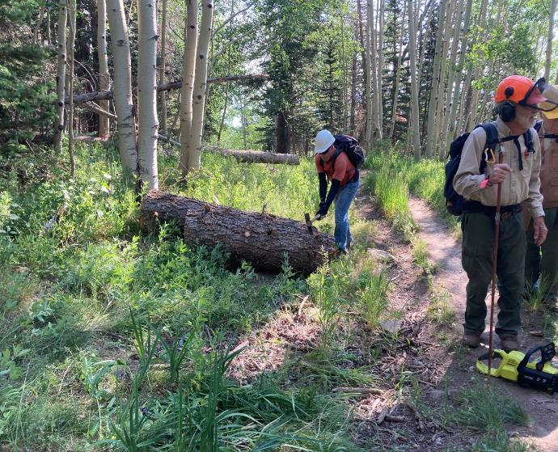Steve Roholt moving a large log off the trail corridor with his pick mattock.

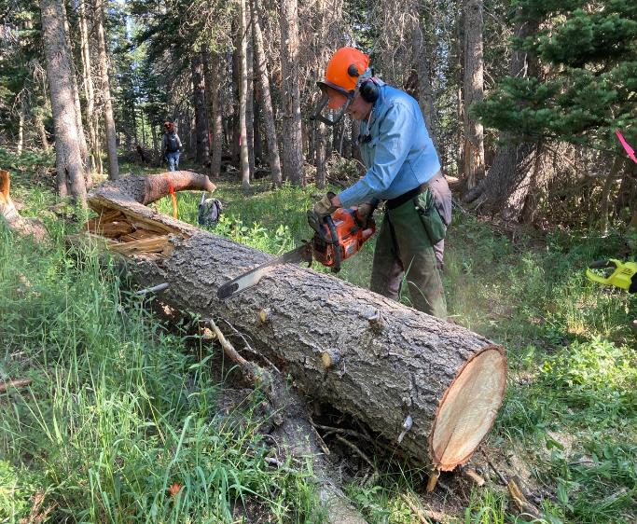

Eric Russell bucking a large log so that it can be moved from the trail corridor.

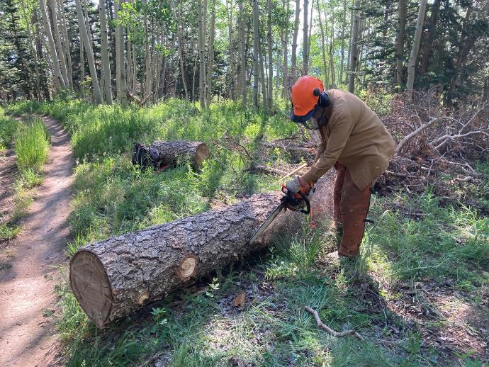

Dan Benton limbing a large log so that it can be rolled off the trail.

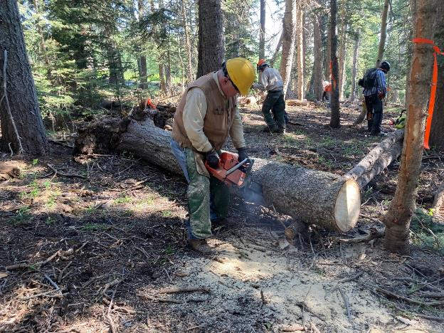

Dennis Crowther bucking a large log in the trail corridor.

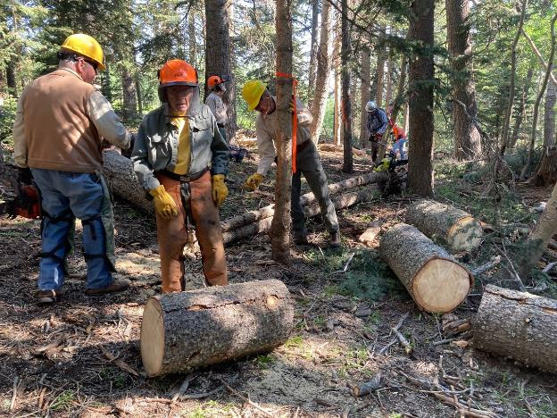

Several volunteers removing logs and small trees from the corridor.

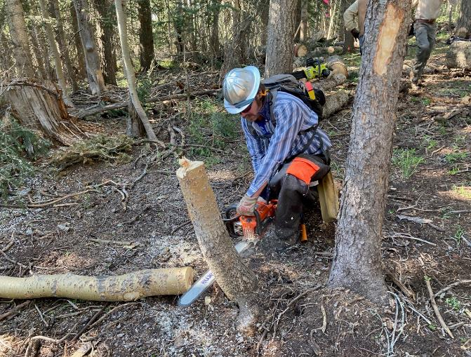

Michael Arndt low cutting a stump low so that it will not interfere with the grooming equipment or skiers.

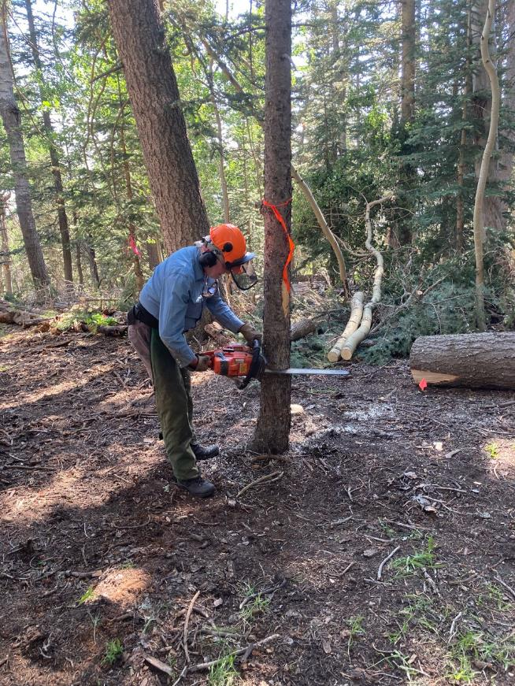

Eric making a back cut to fell this fir tree in the trail corridor.

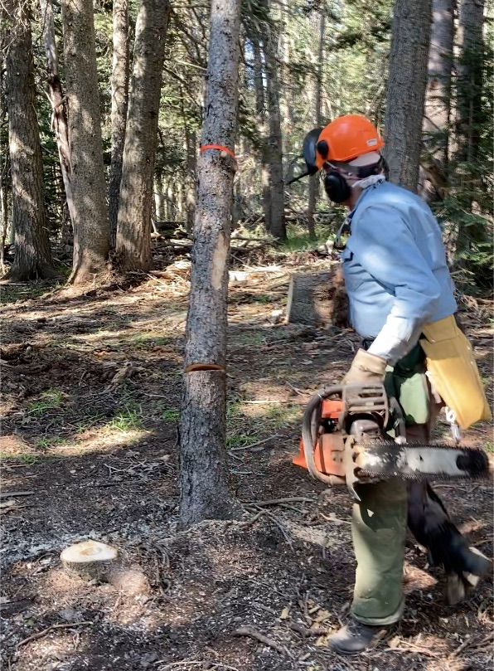

Eric moving away from the falling tree.

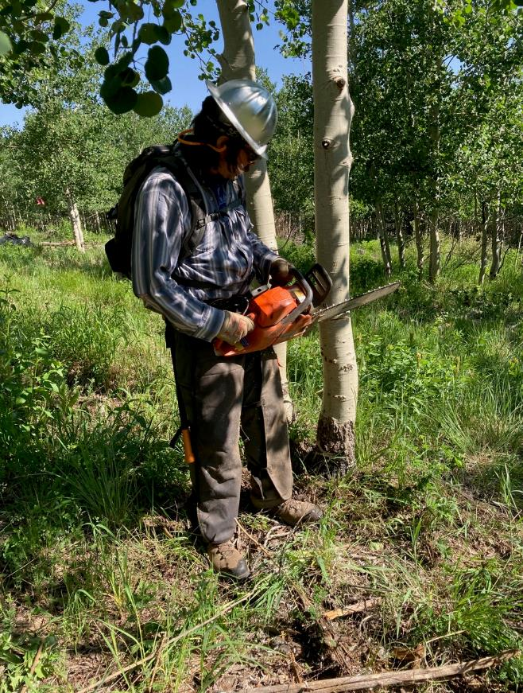

Michael Arndt making a face cut in a small aspen.

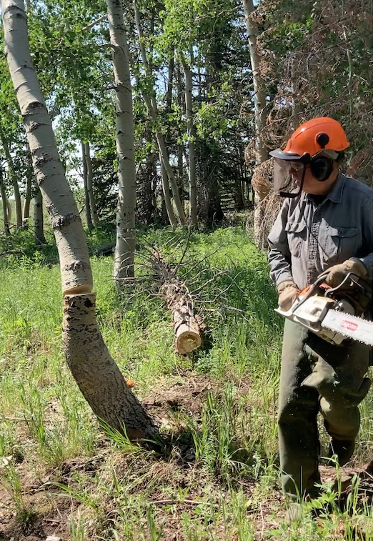

Jerry Carroll moving away from a falling tree.

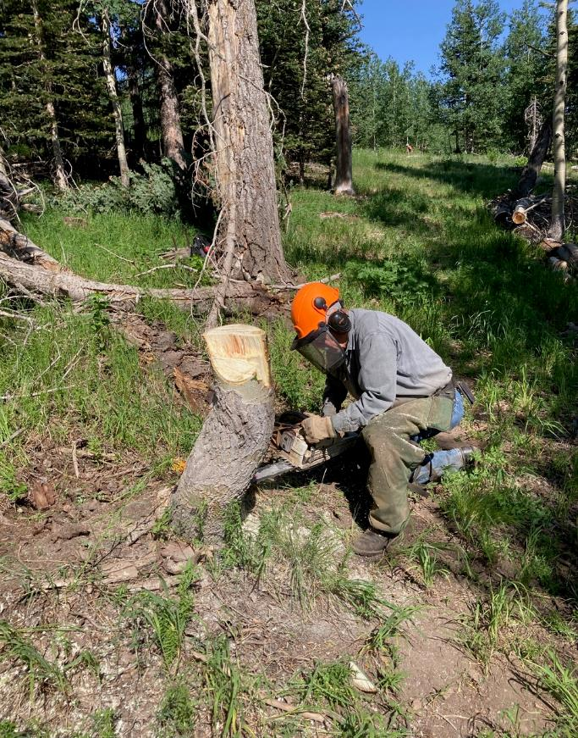

Jerry low cutting a stump.

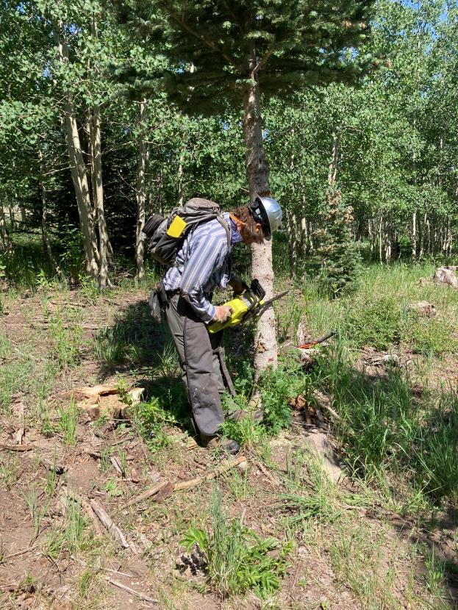

Michael making a face cut with an electric chain saw after 10 am.

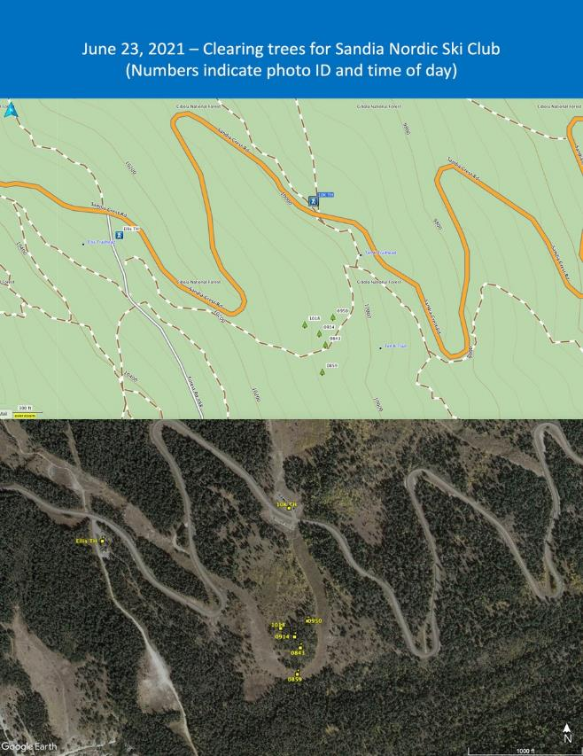

Map by Cliff Giles with yellow print in the lower center of the photograph where the crew was working

about one-quarter mile south of 10K South Trailhead.