**Report on Removing Trees from New Sandia Nordic Ski Club Trail**

**near Ellis Trailhead on Saturday, June 26, 2021**

Sam Beard, June 27

On Saturday, June 26, Michael Arndt and Sam Beard removed trees from the corridor of a new Sandia Nordic Ski Club (SNSC) trail near Ellis Trailhead.

This trail was planned and marked by Kerry Wood, Cibola NF Trails and Wilderness Manager, in cooperation with Scott Dietrich and Jeff Huser, SNSC representatives. It starts at the Ellis Trailhead and goes south parallel to and east of the Service Road to the Tram. One segment of this trail goes through the forest above Challenge Trail so that the two trails do not intersect.

Photographs of Michael felling trees in the new trail corridor are presented below. The new cross country ski trail will be groomed with equipment owned and operated by SNSC members.

FOSM chain sawyers will fell the remaining trees in the corridor on a later work day.

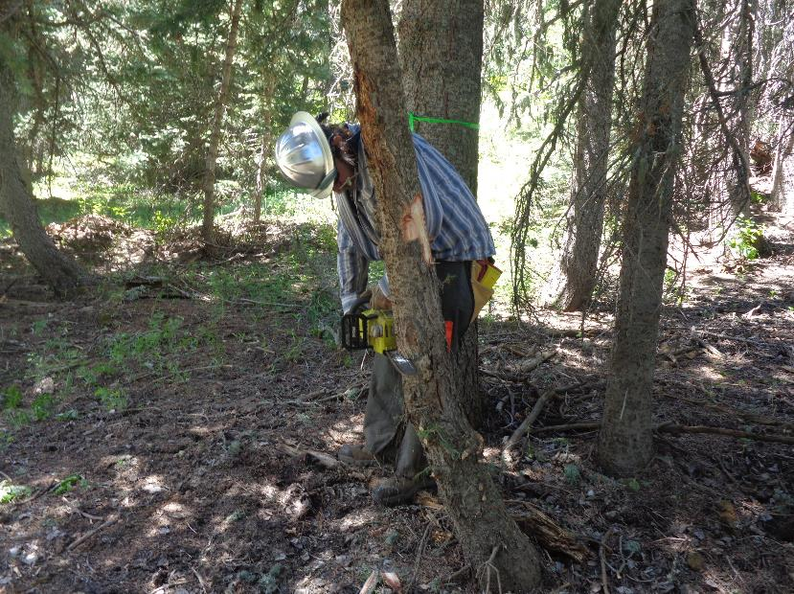

Michael Arndt beginning to make a face cut on this tree that was in the trail corridor. Note that Michael is using a Ryobi battery-powered

chain saw. Before 10 am, he used his gasoline-powered chain saw. All photos by Sam Beard

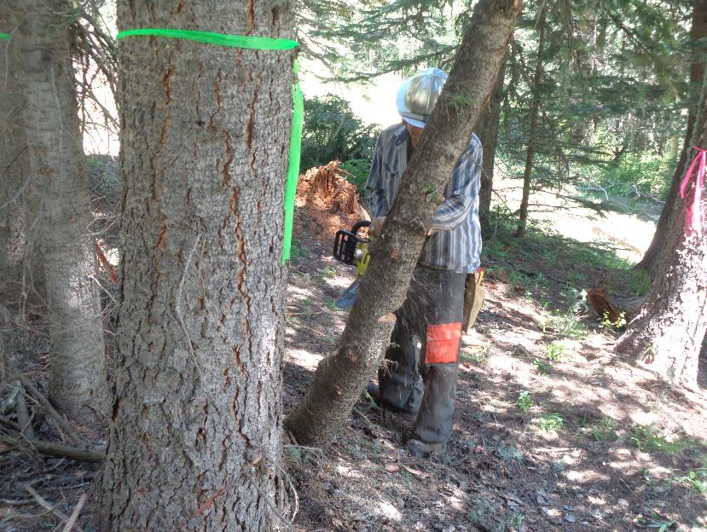

Michael is starting the back cut on this tree. Note that the green tape marks the upper side of the corridor,

and the pink tape marks the low side of the corridor.

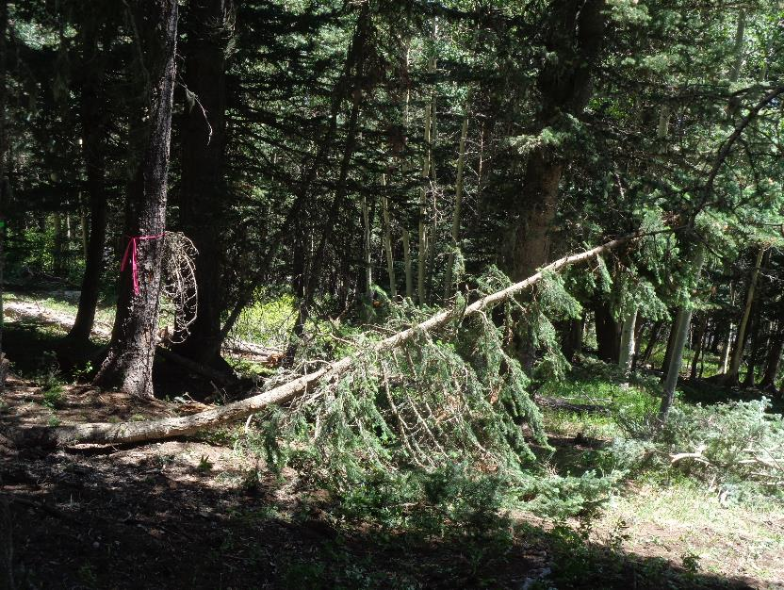

The tree has been safely felled to help clear the new trail corridor.

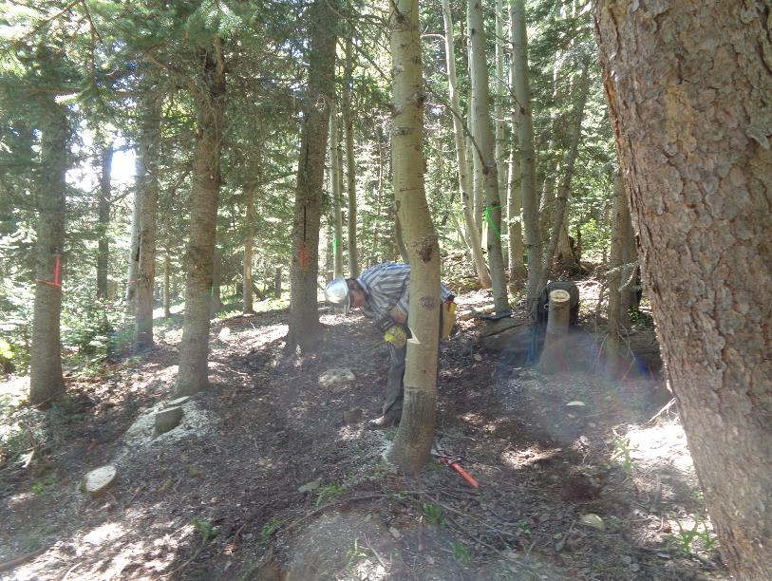

Michael has completed the face cut on this aspen. The pink flag is on the left low side of the corridor, and the green flag

Is on the upper side of the corridor. Note that there are three large trees in the trail corridor in the center of the photograph –

two 12-inch trees and one 10-inch tree. FOSM sawyers will fell these trees on a later work day here.

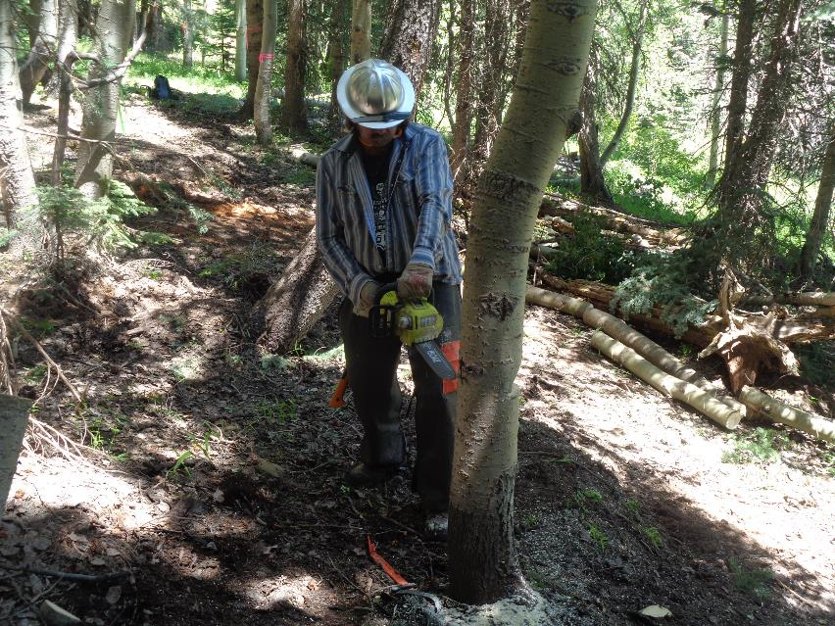

Michael is starting his back cut on this aspen. Note the logs on the low side of the corridor from trees that were felled earlier.

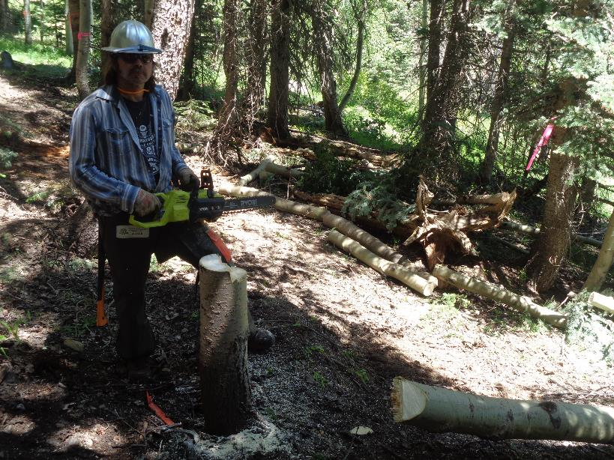

The felled aspen is lying across the corridor, and Michael is holding the electric chain saw behind the stump.